
MID-TERM PROJECT REPORT SUMMER 2025-2026

Project Title | Student Result Management System
Student Name | Moynul Islam Siam
 | Samia Rahman
 | Mahfuj Ul Alam
Student ID | 25-61444-1
 | 25-61673-1
 | 25-61216-1
Course / Section | Programming In Python [Sec: D]
Instructor | Md. Tanzeem Rahat
Date of Submission | 25/07/26

Executive Summary
This project is a simple Student Result Management System made with Python. The main purpose of this project is to manage student result information easily. The user can add a new student, search a student, update marks, delete student information and see all student records. The program also calculates the total marks, percentage, grade and pass or fail status automatically. We used classes and objects to organize our code. We also used file handling so that the student information is saved even after closing the program. NumPy was used to calculate the highest percentage, lowest percentage and average percentage of all students. This project helped us understand how different Python topics can be used together to build a simple real-life application.

Analysis Methodology
We made this project using Python. We divided the program into different files to keep the code simple and organized. We used classes and objects to manage student information. File handling was used to save and load student data from a text file. We also used exception handling to stop the program from crashing if the user enters wrong input. NumPy was used to calculate the highest, lowest and average percentage of the students. The whole project is menu-driven, so it is easy to use from the terminal.

Program Output and Interface
When the program starts, it shows the main menu. From the menu, the user can choose different options like Add Student, View Students, Search Student, Update Student, Delete Student, Save Data, Show Statistics and Exit.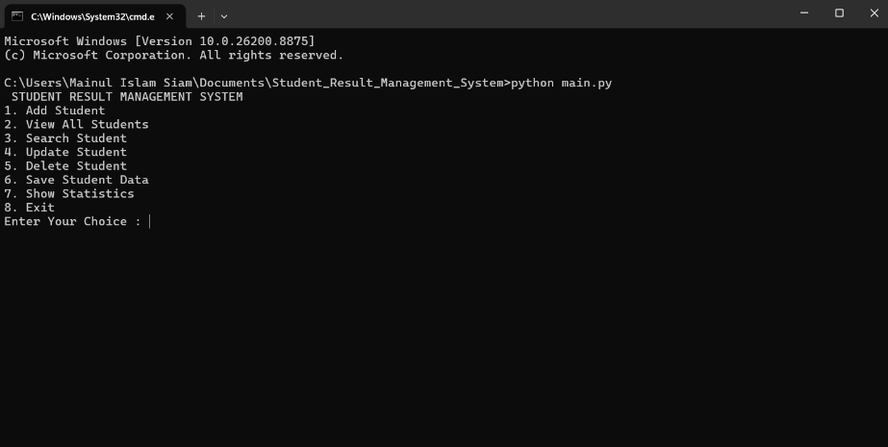
When the user selects Add Student, the program asks for the student ID, student name and marks of three subjects. After entering all the information correctly, the student is added successfully.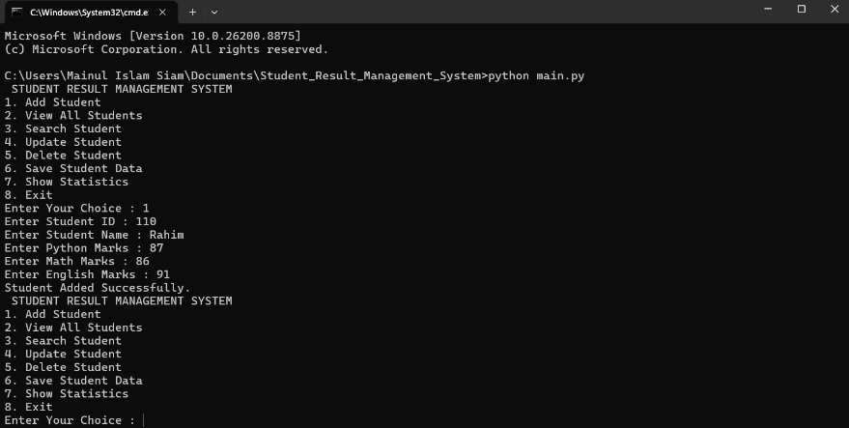
When the user selects View All Students, the program shows all student information including ID, name, marks, total marks, percentage, grade and result.
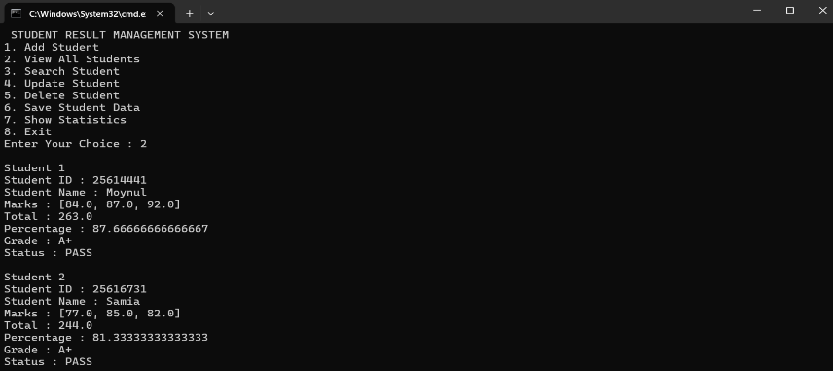
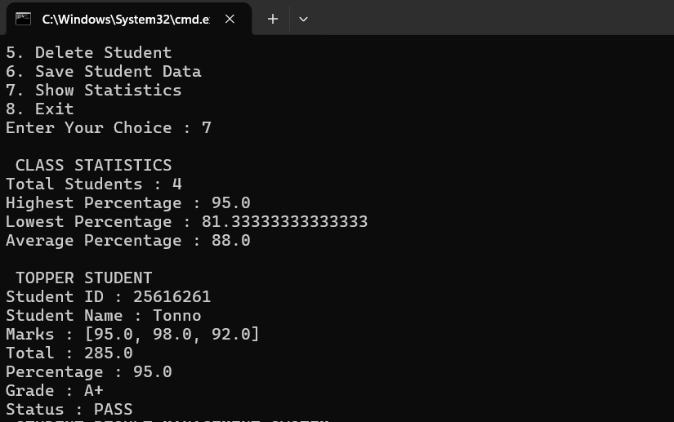
When the user selects Show Statistics, the program uses NumPy to calculate the highest percentage, lowest percentage and average percentage. It also shows the topper student.
When the program is opened again after closing, it loads all previously saved student information from the text file. This shows that the file handling is working correctly.
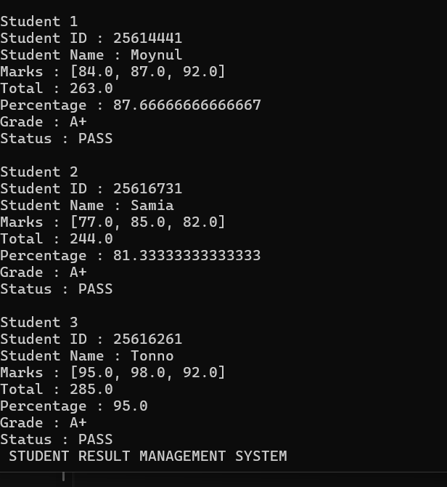.

Key Findings
• The program can add, search, update and delete student information easily.
• The system automatically calculates total marks, percentage, grade and pass or fail result.
• NumPy helps to find the highest, lowest and average percentage quickly.
• Student information is saved in a text file, so the data is not lost after closing the program.
• The menu-driven system makes the program simple and easy to use.

Limitations
Our project works well, but there are still some limitations. First, the project only works in the terminal because we did not make any graphical user interface (GUI). Second, there is no login system, so anyone can use the program. Finally, we used a text file to save data instead of a database, so it is more suitable for small projects.

Conclusion
We successfully completed a Student Result Management System using Python. In this project, we used classes, objects, file handling, exception handling and NumPy. The program can perform all the basic operations needed to manage student results. This project helped us improve our programming skills and understand how the concepts learned in class can be used to build a practical application.

Final Submission Checklist
☑ I included my GitHub repository link in the Google Sheet provided by the instructor.

☑ I attached the project report as a separate file.

☑ My report includes project objective, methodology, program output, key findings, limitations, and conclusion.

☑ My code uses the NumPy library meaningfully.

☑ All placeholder text has been replaced before final submission.

