SCAN-Clim: A tool to support pest climate suitability analysis based on climate classification

Title: SCAN-Clim – Supporting Climate suitAbility aNalysis based on Climate Classifications
Version: 1.0
Date: November 2021
Depends: R (>= 4.0.5)
Needed R packages (in bracket the versions used in SCAN-Clim): sp (>=1.4.5), raster (>=3.4.10), readxl (>=1.3.1), httr (>=1.4.2), XML (>=3.99), rlist (>=0.4.6.1), rmarkdown (>=2.8), knitr (>=1.33), rasterVis (0.50.2), latticeExtra (0.20-44), rgeos (0.5-5). These R packages are installed automatically by the tool if not yet installed
Description: tool to support pest climate suitability analysis based on climate classification
Authors: Andrea Maiorano
Review and testing: Caterina Campese
Maintainer: Andrea Maiorano - andrea.maiorano@efsa.europa.eu
License agreement: Creative Commons Attribution 4.0
Cautionary note on the use of the tool: This tool allows the user to match climates in areas of known presence of a pest and climates in other parts of the world where the organism does not occur. The quality of the climate matching depends on the resolution of the source data, and it is user’s responsibility the correct use of the tool, interpretation of the results for instance by checking the consistency with observations and the organism biology and physiology.

Introduction
Climate suitability analysis is an important element to analyse the likelihood of potential establishment of a pest in an area. Different approaches exist (e.g. Species Distribution Models, and CLIMEX). One of them is based on the comparison between the climate in the known distribution of a pest and the ones in the area under pest risk assessment using climate classification maps like, e.g. the Köppen-Geiger classification. This methodology is widely used in the context of EFSA pest categorisations (in 2021 it was used in more than 30 Pest Categorisations) where simplified and succinct analysis are needed. In fact, in the context of EFSA pest categorisations, due to time constraints, this approach has been commonly applied at the country level (i.e. using pest observations at the country level and considering all climates in the same country) and then refined if necessary. However, it can also be used for more detailed assessments using pest observations at higher resolution (e.g. province, grid refence coordinates, or latitude/longitude). SCAN-Clim is a tool designed to support climate suitability analysis based on climate classifications, i.e. evidencing the occurrence of climates in a specific area. This document describes the first prototype of the tool, developed in the R language.

Objectives
The main objective of SCAN-Clim is to ensure fast and reproducible climate suitability analysis based on climate classification in the context of pest risk assessment. SCAN-Clim was developed to improve efficiency and the transparency of the climate suitability assessment process. In fact, the tool significantly improves the speed of map generation (it takes on average 1 minute and a half to create a map based on the records of the EPPO Global Database) guarantying a standardized map format and providing documentation about input, output data, and the review process by the users or working groups. In this way the process is also transparent to officers, experts, risk assessors and consultants examining process of pest categorisation to further improve it.

General description
SCAN-Clim is a tool to support the development of climate suitability analysis based on climate classifications. The current version described in this document, is a prototype and it was developed using the R language (R >= 4.0.5). It was designed for users with none or very basic knowledge of R or programming and with no knowledge on GIS. It requires the installation of the software R and RStudio and of specific R packages. The current state of development requires some initial support for the installation and update of specific R packages for users not familiar with R. However, after the installation process is completed, no more support is needed to run the tool.

Main elements/data included in SCAN-Clim
In this section, a list and description of the main elements/data included in the tool is shown. Next section shows how they are connected in the tool and the interaction with the user.

Raster file with the climate classification map
Currently, SCAN-Clim output is based on the Köppen–Geiger classification based on the period 1986-2010 (25-years period) and on a 10 km grid from the Institute for Veterinary Public Health of the University of Vienna based on Kottek et al. (2006) rescaled after Rubel et al. (2017) (Figure 1). However, SCAN-Clim can be easily updated with different climate classifications (similar raster files).
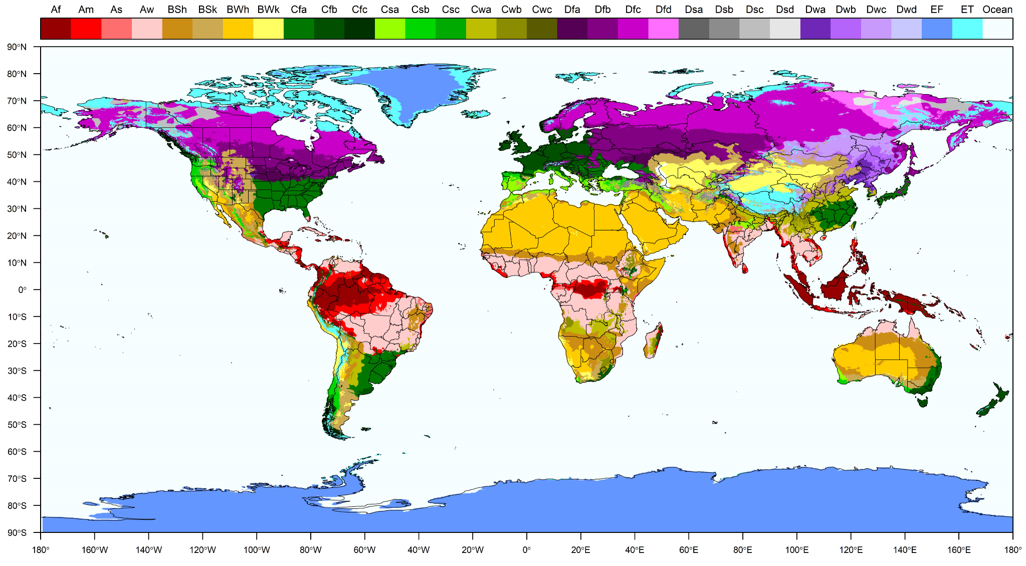
Figure 1. Köppen-Geiger climate classification. Different colors represent different climates. Climates are described in the top legend with a standard 2 or 3 letter code

GIS layers including administrative boundaries of the world at different administrative unit level (country to province/county)
Administrative boundary layers are used to identify areas of observation of the organism.
Available layers include the FAO GAUL layers, and a layer (based on the FAO GAUL layers) including the administrative units used by the European and Mediterranean Plant Protection Organization (EPPO).
Layers from FAO (GAUL):
- FAO GAUL level 0: Country level
- FAO GAUL level 1: Region level (or states for big countries like US, China, Brazil, or Canada)
- FAO GAUL level 2: province/county level
Layer based on the EPPO administrative subdivision:
- EPPO-like layer: this is a layer based on the FAO GAUL level 0 but including further subdivisions for certain countries compared to FAO GAUL level 0 (e.g. for Russian Federation, US, China, India, etc…)
All the layers are included as RData files (i.e. a data format designed for R) in the Data/rdata folder. Figure 2 shows three examples of available layers.
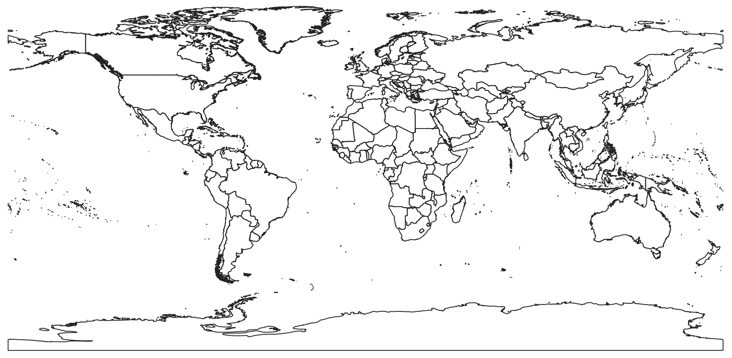  A | 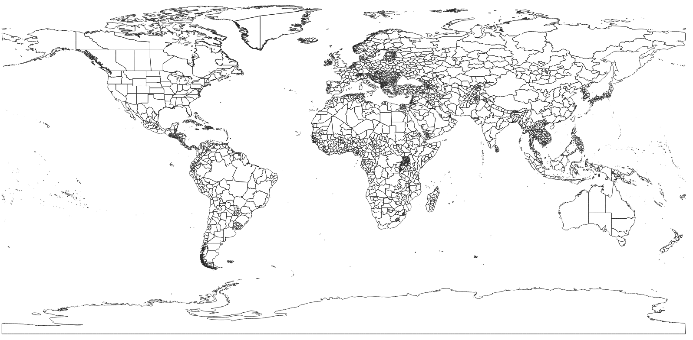  B
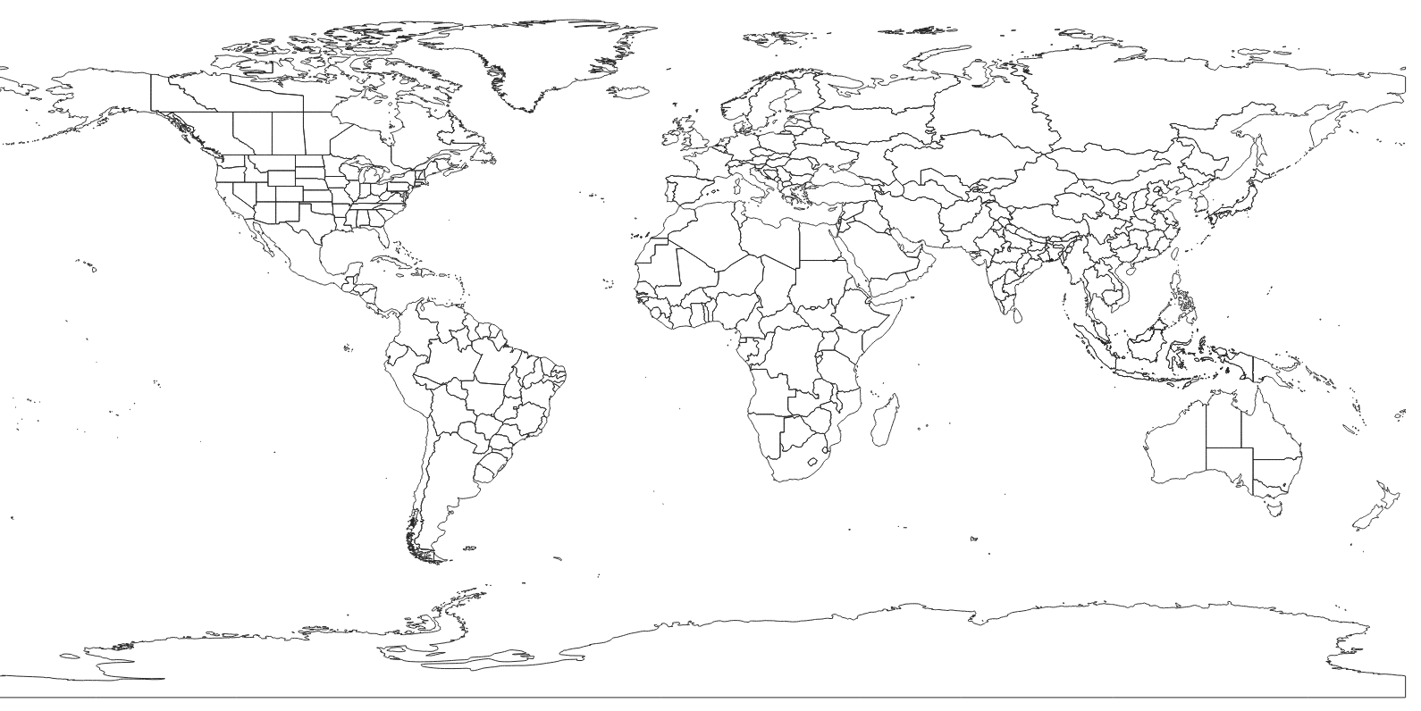
C
Figure 2. Examples of layers for administrative units at different administrative level. A = FAO GAUL level 0; B = FAO.GAUL level 1; C = EPPO-like administrative layer;

List of relevant climates for the organism
The list of the climates that are relevant for the organism can be either defined by the user or automatically extrapolated by SCAN-Clim based on distribution (Section 6).

List of organism geographic distribution
The list of pest geographic distribution can be defined by the user or downloaded from the EPPO global database (Section 6). The pest distribution in the EPPO global database is at the country level. The user can define the geographic distribution at different levels, from the country to the province/county, or even single point if geographic coordinates are provided.

Structure and description of the source package
The tool is distributed as a source package organized in folders including files and sub-folders. Figure 3 shows the structure of the source package whose use is described in detail in Section 6. Table 1 describes the content of the main folder, including files and subfolders and specifying which of them are intended to support the functionalities of the tool or which are to be used, opened, or modified by the user. An R expert user can modify any of the files included in the tool.
Figure 3. Structure of the SCAN-Clim source package

Table 1. Content of the main SCAN-Clim folder. In grey files and folders which include interaction with the user
File/Folder | Name | Description | User interaction
Folder | Data | Includes R data files with spatial data (climate classification raster, administrative units layers) | No
Folder | R_scripts | Includes R scripts | No
Folder | Documentation | Includes csv files with tables with information useful to run the tool | Yes
Folder | Configuration | Includes the SCAN-Clim Excel configuration file | Yes
Folder | PESTS | For each analysed pest includes a folder with outputs of SCAN-Clim | Yes
File | SCAN-Clim.Rproj | R Project file. The RStudio session must be opened with this file (more information below) | Yes
File | SCAN-Clim_Main.r | From the RStudio session this is the only file that must be opened. User only need to run the script by clicking on the button “source”. (more information below | Yes
File | SCAN-Clim_basic.r | R file that run the basic version of the tool (i.e. no automatic reporting) | No
File | SCAN-Clim_Report.Rmd | R file that run the version of the tool that outputs also an html report | No

Data/rdata folder
The Data folder includes RData files including mapping elements of SCAN-Clim.
Figure 4. SCAN-Clim Data folder (detail from Figure 3)
No user interaction is required for running the tool.

PESTS folder
Every time that SCAN-Clim is run for an organism, a folder called with the name of the organism is automatically created inside the folder PESTS. This folder includes the folders Output and Review.

PESTS folder: Output subfolder
The Output folder is the folder where users can find the outputs of SCAN-Clim. It includes:
- an html report including the main outputs (distribution, relevant climates, and the Köppen–Geiger map of the organism in a low resolution, for illustration purposes).
- the Output/Koppen-Geiger folder with the climate suitability map at high resolution and the list of relevant climates
- the Output/Distribution folder includes the EPPO distribution table for the organism in csv format. The EPPO distribution table is saved only if no user-defined distribution table was saved in the REVIEW.Distribution folder (see Section 6)
- the Output/GIS folder, including raster and shapefiles of the maps that can be used in GIS software

Figure 5. SCAN-Clim Output subfolder of the PESTS/[Pest.name] folder (detail from Figure 3)

PESTS folder: Review subfolder
In the Review subfolder users can save csv files specifying the list of climates that are to be included in the map, or a user-defined distribution table:
- in the folder REVIEW.Climates users can save the list of climates that are to be included in the assessment. If such a list is included, SCAN-Clim will use only this list for the final output. The file must be a csv file with one column and one header called “Climate”
- the folder REVIEW.Distribution where users can save a user-defined distribution table. The table can include entries at different administrative unit level (Country, Region, and/or county/province) or at the point level specifying geographic coordinates. A facsimile distribution table is available in the Documentation folder.

Configuration folder
The Configuration folder include the SCAN-Clim Excel configuration file with different type of input in each sheet:
- Authors sheet: list of authors to be included in the final html report
- Pest_list sheet: list of organisms (scientific name) to be analysed
- Pest_status_to_be_included sheet: type of observations from the EPPO observed distribution table to be considered in the analysis. Default list includes: “Present, no details”, “Present, widespread”, “Present, restricted distribution”, “Present, few occurrences”. This is relevant only if SCAN-Clim connect to the EPPO Global database, i.e. a distribution table is not provided by the user.
- Climates_to_be_removed sheet: List of climates generally not relevant for the analysis. Default includes “Ocean”, “Dsb”, “Dsc”
- Other settings sheet: user can select
  - Remove from the output all the climates not present in EU (yes/no)
  - Select region to map: dropdown list currently includes Global, America, Asia, Australia, Caribbean, Europe, Oceania, USA, Peru, South East Asia, China, South East China. Other countries, or specific regions can be added (contact the developer).
  - Recalculate EU27 climate list: yes/no. In the case a new climate classification map is used, the recalculation is necessary
  - EPPO API token: To connect to the EPPO Global database users need to have an account registered in the EPPO Data Services (https://data.eppo.int/). After login, the token can be copied from the personal home page
  - Print html report (yes/no). Selecting “no” reduces the time for map generation to around 40-45 seconds
  - Save GIS layers (yes/no)
- tech sheet (hidden sheet): hidden sheet, not to be modified by the user, including info/data needed for the dropdown menus included in the configuration file itself.

Running SCAN-Clim: scenarios of analysis
Figure 6 shows a general representation of the tool workflow. There are basically four main scenarios to run the tool based on the information given as input: 1) Basic configuration, 2) climate list defined by the user, 3) pest distribution defined by the user, 4) climate list and pest distribution defined by the user. The steps included in the basic configuration are common to all the scenarios.
Figure 6. SCAN-Clim general workflow

Basic configuration
In the Basic configuration the only needed input is the scientific name of the organism under assessment. SCAN-Clim connects to the EPPO Global Database through a dedicated REST API (https://data.eppo.int/documentation/rest, registration and token is needed), downloads the pest distribution table, retrieve the list of relevant climates overlapping the cropped administrative layers (based on the distribution list) and the Köppen-Geiger raster file, and outputs a climate suitability map based on information at country level (i.e. resolution of EPPO GD distribution table). In Table 2 a step-by-step guide to run SCAN-Clim is available.

Table 2. Steps for running the basic configuration of SCAN-Clim
Step # | Step description | File
01 | Open the configuration file  Open Pest_list sheet and write the scientific name(s) of the organism(s)  Optionally fill the Authors excel sheet | Configuration folder, excel file
02 | Double click on the SCAN-Clim.Rproj file (R project file). The tool should always be opened from this file as this open an R Studio session based on the file system of the tool. If file extensions are not visible, the name of the file is just SCAN-Clim and it is the file with the icon shown in this table | 
03 | A R Studio session opens.  - Focus on the bottom-right panel (black rectangle).  - Check that the main SCAN-Clim directory is selected or navigate to it (step 1, red rectangle)  - Single click on the SCAN-Clim_Main.r file (step 2, blue rectangle)  - Click on the button Source to run the tool (step 3, orange rectangle) | 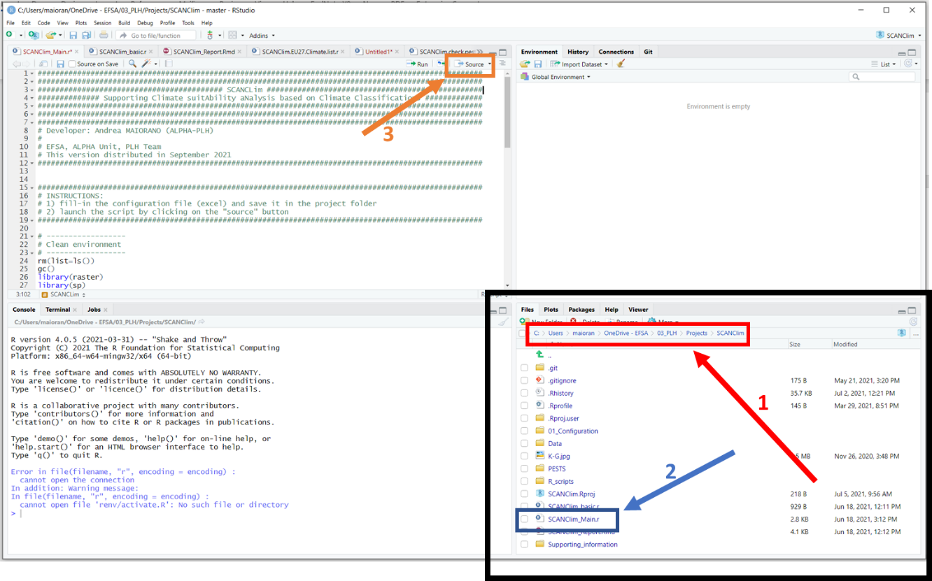

User-defined climate types list
Before the steps described for the Basic configuration, users can specify the list of climates to be included in the final output in a .csv file, including a single column with header “climates” and the list of the codes of the climates. Figure 7 shows an example file opened in Windows Notepad. An example .csv file is also included in the folder Documentation. Such file is to be saved in the folder PESTS/[Pest name]/Review/REVIEW.Climate. The steps described in the Basic configuration are then to be executed.
SCAN-Clim connects anyway to the EPPO Global Database to retrieve the distribution table but the climates shown in the final map are the ones listed by the user.
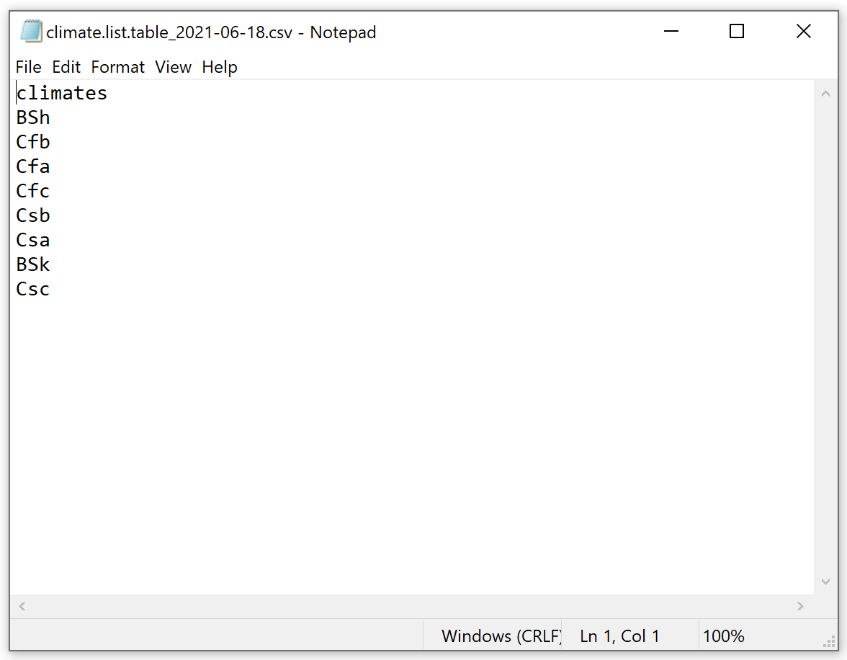
Figure 7. Example .csv file including the list of climates to be mapped. The file is shown as visualized in Windows Notepad.

User-defined pest distribution

Before the steps described for the Basic configuration user can define a pest distribution table in a .csv file which is to be saved in the folder PESTS/[pest.name]/Review/REVIEW.Distribution.

An example distribution file is included in the Documentation folder, however if the tool is firstly run with the basic configuration, a distribution table is automatically created including the records from the EPPO Global Database and is saved in the folder PESTS/[pest.name]/Output/Distribution. This table can be copied and pasted to the review folder and modified with user defined occurrences.
The table must include the fields listed below. Not all the fields need to be filled in for the correct running of the tool, however they are present for completeness of information on the pest occurrence records:
- Continent: filling not essential
- Country: filling not essential
- State: filling not essential
- Observation: filling not essential, this field include the name of the administrative unit where the organism was observed
- admin.source: this field can include three values: “EPPO”, “FAO.GAUL”, or “location”. See below for more information
- admin.code: this field should include the FAO.GAUL administrative unit codes. Codes are available in the FAO_GAUL_Codes_and_names.csv available in the Documentation folder.
- lat: latitude in decimal degrees (in the case of “location” occurrences)
- long: longitude in decimal degrees (in the case of “location” occurrences)
Here is a step-by-step instruction on how to fill the distribution table:
- if SCAN-Clim was run with the basic configuration a distribution table in the Output folder can be used. This table will already include EPPO records (country level). User can decide to keep those records or remove them.
- In the case specific location occurrences are available, indicate “location” in the admin.source field, and geographic coordinates in the lat and long fields
- In the case occurrences refer to administrative units (from the country level to the province/county level), indicate “FAO.GAUL” in the admin.source field, the name of the administrative unit in the Observation field and the FAO GAUL administrative code in the admin.code field. If the administrative code is not indicated SCAN-Clim run anyway trying to match the names indicated in the Observation fields with the names included in the geographic layers used for mapping. However, it is strongly recommended to specify the administrative code as it is highly possible that for some reason (e.g. local name vs international name, accents, machine international configurations) the names do not match. The administrative codes can be found in the FAO_GAUL_Codes_and_names.csv file available in the Documentation folder. This file includes a table with the different names and codes of the GAUL administrative units, organised per administrative unit level: 0 = Country, 1 = Region, 2 = Province/County.
If a user defined climate list was not included (see previous paragraph) the Koppen.Geiger climates are extracted using the user defined distribution.

SCAN-Clim Output report
SCAN-Clim output an .html report save in the folder PESTS/[pest name]/Output which include the observation table, a table including the list of climates (and their description) that were extracted based on the observations, and a map in low resolution just for checking purposes. In the case of observation records not recognised by the tool (and consequently not used to extract the climates) the report include also a specific paragraph called Observed distribution: location names that need to be checked where those records are listed. In this case it is recommended to rerun the tool with a user defined distribution table using the FAO.GAUL codes and names for those records (see previous paragraph).

Future developments
SCAN-Clim is still under development. The current version is being distributed to EFSA staff, to support working group activities, under developer assistance in order to fix minor bugs and to improve usability. External users can refer to the developer to have assistance.
Further improvement includes the development of an interactive web app based on R Shiny which will be accessible through the EFSA website (expected to be delivered in 2022). This version will greatly improve usability.

Code reuse
The optional script Tool_SCANClim.KGmap.setup.R included in the R_scripts folder is aimed at setting up the Köppen-Geiger raster file and save it as a .RData file used as input by the tool. This script was developed starting from the code published by the Climate Change & Infectious Diseases Group, Institute for Veterinary Public Health, Vetmeduni, Vienna, Austria, and freely available at http://koeppen-geiger.vu-wien.ac.at/present.htm.

References
EFSA Panel on Plant Health, Bragard, C., Di Serio, F., Gonthier, P., Jaques Miret, J.A., Justesen, A.F., Magnusson, C.S., Milonas, P., Navas-Cortes, J.A., Parnell, S., Potting, R., Reignault, P.L., Thulke, H.-H., Van der Werf, W., Vicent Civera, A., Yuen, J., Zappalà, L., Gregoire, J.-C., Malumphy, C., Campese, C., Czwienczek, E., Kertesz, V., Maiorano, A., MacLeod, A., 2021. Pest categorisation of Phlyctinus callosus. EFSA Journal 19, e06800.
Kottek, M., Grieser, J., Beck, C., Rudolf, B., Rubel, F., 2006. World Map of the Köppen-Geiger climate classification updated. Meteorologische Zeitschrift 15, 259-263.
Rubel, F., Brugger, K., Haslinger, K., Auer, I., 2017. The climate of the European Alps: Shift of very high resolution Köppen-Geiger climate zones 1800–2100. Meteorologische Zeitschrift 26, 115-125.

http://koeppen-geiger.vu-wien.ac.at/present.htm

