ASSESSMENT 2 - Website Prototype and Progress Report

Student ID number: 9461

Student name: Ngoc Mai Pham

Submission date: Friday 28/7/2023

Subject name: ADVANCED WEB

Subject code: INT1059

TABLE OF CONTENTS

1. Overview 1

2. Wireframes 1

2.1.1. Home Page 1

2.1.2. Login and Sign in Page 3

2.1.3. Book details display 4

3. Completed milestone 4

4. Next task 5

# Overview

* What the app can do:

Visitor can able to:

* Browsing books
* Choose a book by type
* Read information about the book
* Login or create a new account

# Wireframes

### Home Page

Navigation bar

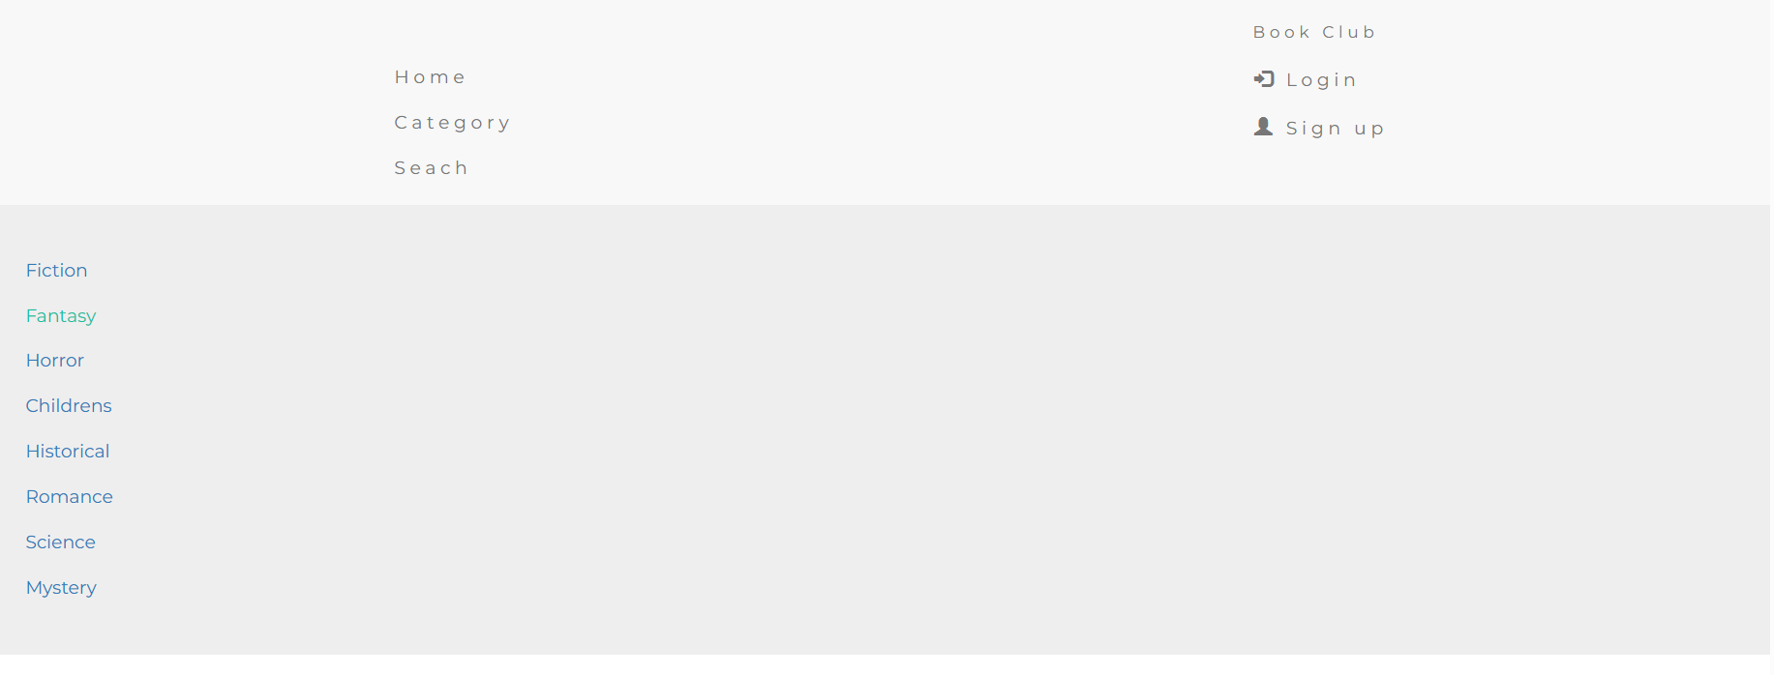

It’s working and link to different pages. The category display should Collapsible and only show when user click to “Category” on navigation bar. It will be fix in next assignment.

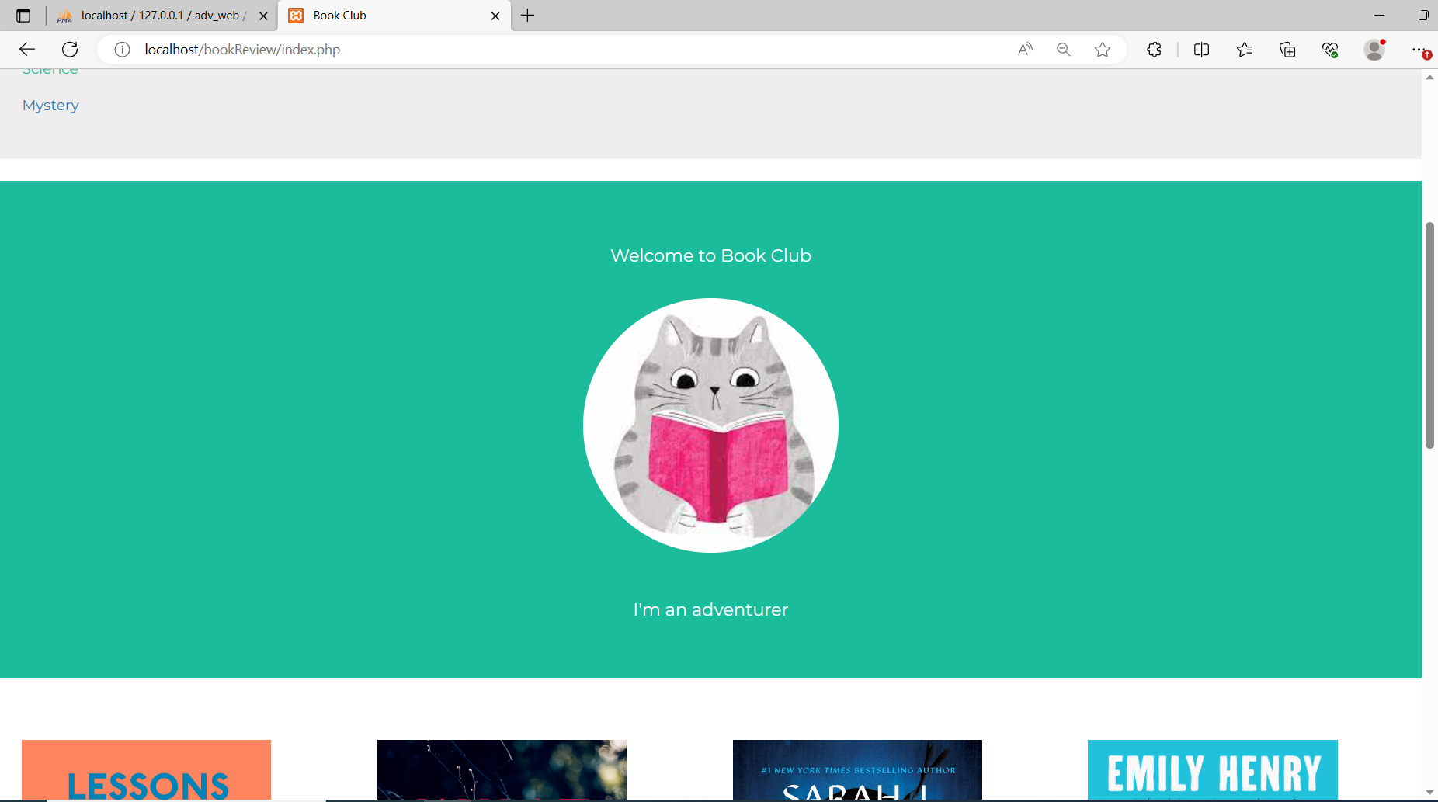

Book display

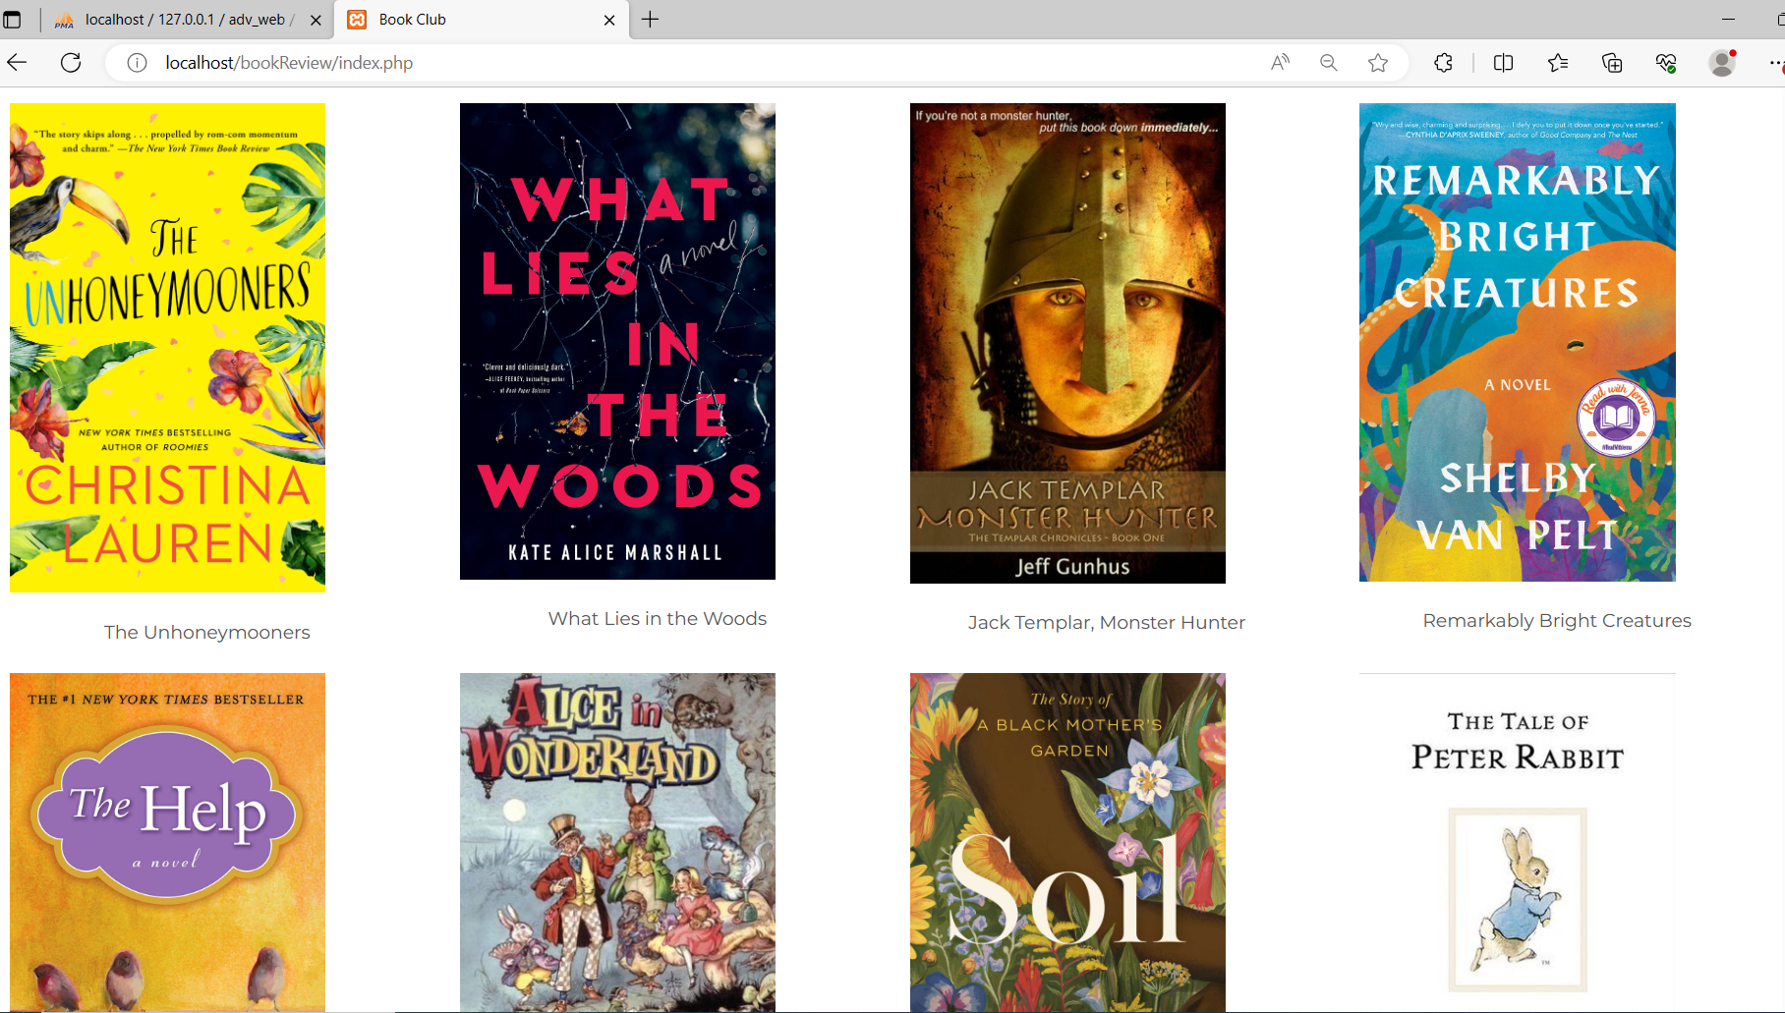

### Login and Sign in Page

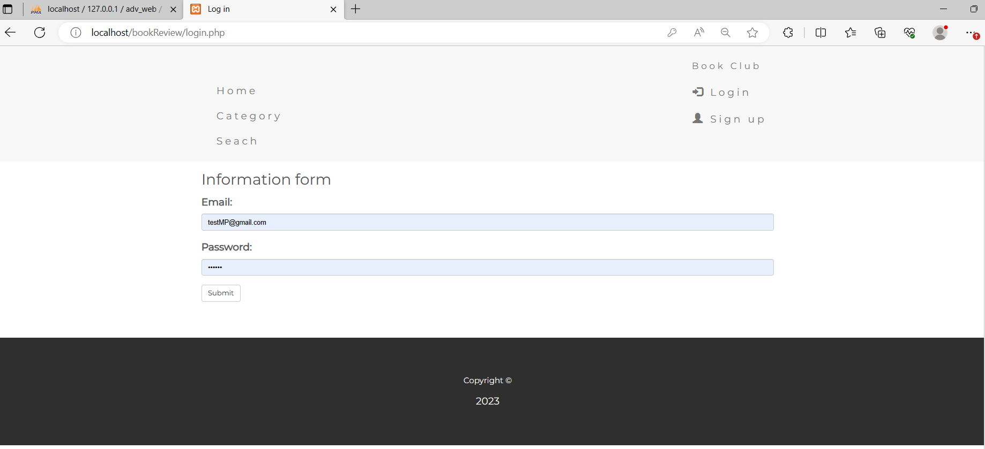

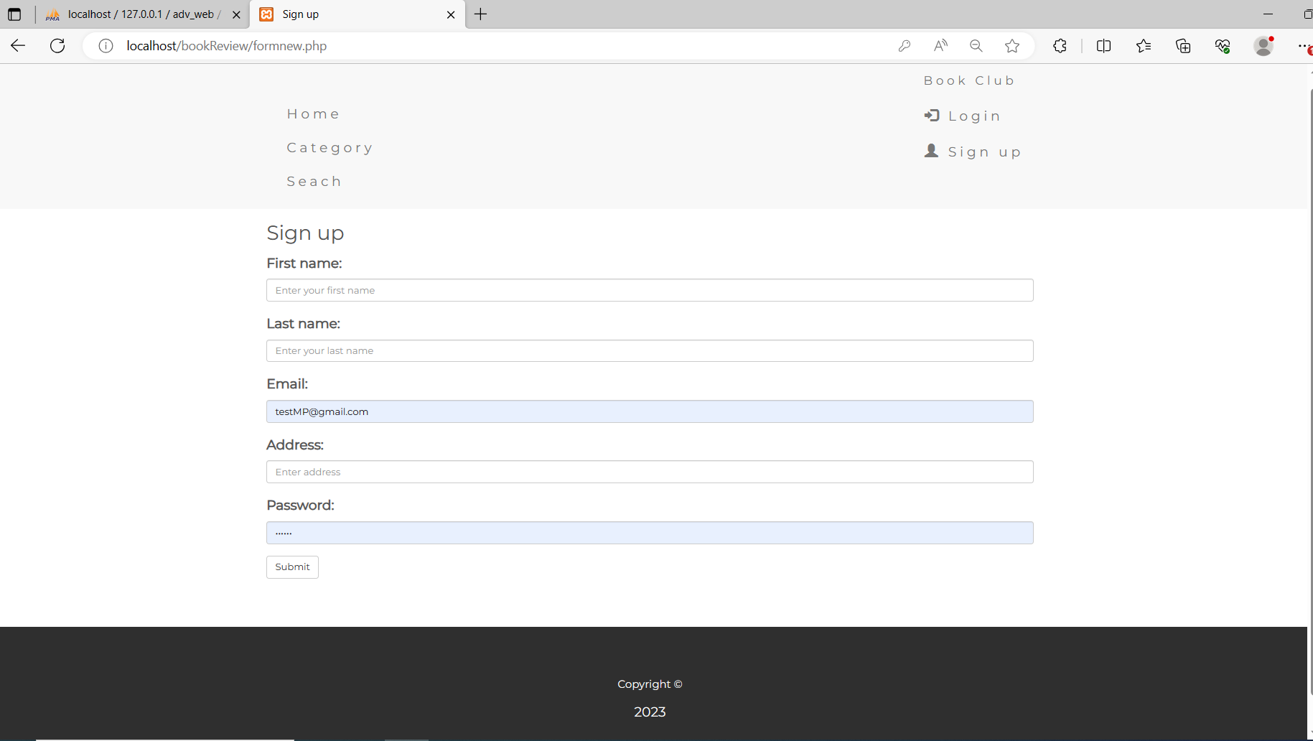

### Book details display

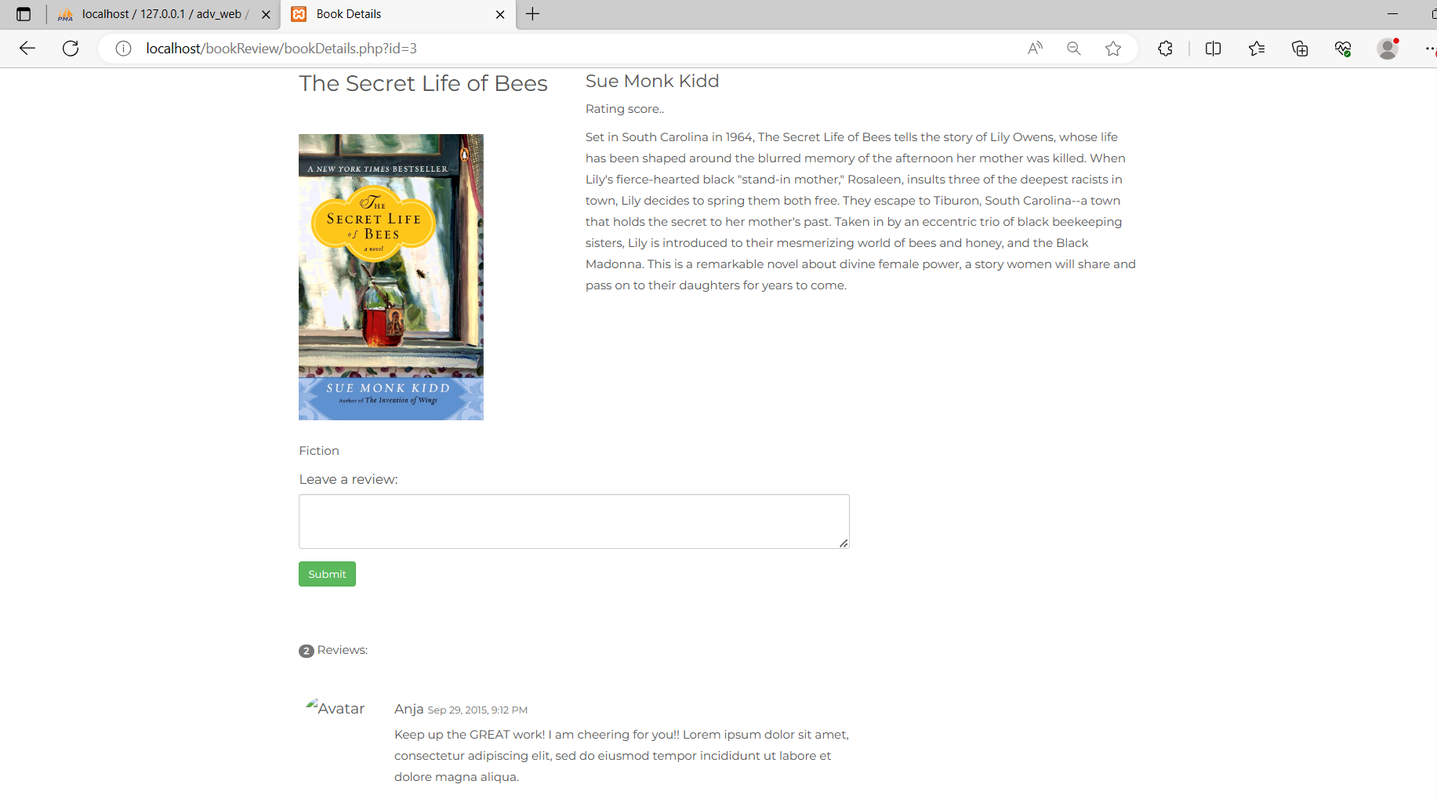

Book details page able to display all the details of the chosen book.

What to deliver next: need to work on review section.

# Completed milestone

| **#** | **Task** | **Week** | **Deliverables** |
| --- | --- | --- | --- |
|  | **Website development** | **5 - 8** | **Demo version** |
|  | Login page and Logout | 5 | Login page |
|  | Register page | 5 | Register page |
|  | Home page(index) | 7-8 | Home page |
|  | Library page | 7-8 | Library page |
|  | Book information page | 8 | Book information page |
|  | Book category | 8 | Book category |

# Next task

| **#** | **Task** | **Week** | **Deliverables** |
| --- | --- | --- | --- |
|  | **Website development** | **8-12** | **Demo version** |
|  | Working display review | 8 | Review section |
|  | Search function | 8-9 | Search function |
|  | User profile display | 9 | User profile |
|  | Fixing bugs | 10 | Fixing bus |
|  | Final project | 12 | Final project |
|  | Presentation | 12 | Project presentation |

Github link:

https://github.com/maiphammm/bookReview.git