Part 1. Grid world
- Description of environment
Environment Overview
Property | Value
Grid Size | 10×10 cells (default)
Cell Size | 60 pixels
Max Steps | 200 per episode
Action Space | 4 discrete actions (UP, DOWN, LEFT, RIGHT)

Entity Types
Entity | Symbol | Behavior
Empty | . | Passable terrain
Rock | R | Impassable obstacle
Fire | F | Instant death on contact
Apple | A | Collectible reward item
Key | K | Required to unlock chests
Chest | C | High-value collectible (requires key)
Monster | M | Stochastic movement, death on contact, 40 percent chance to move.

- Reward design
Reward Breakdown
Event | Reward | Purpose
Apple collection | +1.0 | Primary objective reward
Chest opening | +2.0 | High-value objective (requires planning)
Key pickup | +0.1 | Subgoal shaping reward
Each step | -0.1 | Encourages path efficiency
Death (fire/monster) | -10.0 | Strong aversion to hazards

The current reward design is aimed at achieving the optimal path and obstacle avoidance. The apple and chest create “small wins” in the system, while the key reward (+0.1) is just a signal for the agent. Step penalty (-0.1) avoids the possibility that agent can move back and forth if there is no immediate danger and forcing the agent to find the path to the reward. The death penalty is the most weighted in the system, which teaches the agent to avoid danger.
Intrinsic Reward
The intrinsic reward acts as a curiosity signal that motivates the agent to explore the map independently of its goals, such as collecting apples or chests. This mechanism is extremely effective in sparse environments where there is less danger and exploration often rewards better. The intrinsic formula is as follows:

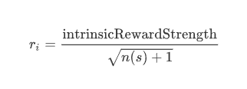
Where:
- n(s) = number of visits to the current state during the episode
- total reward = environment reward + intrinsic reward

- Comparison of algorithms
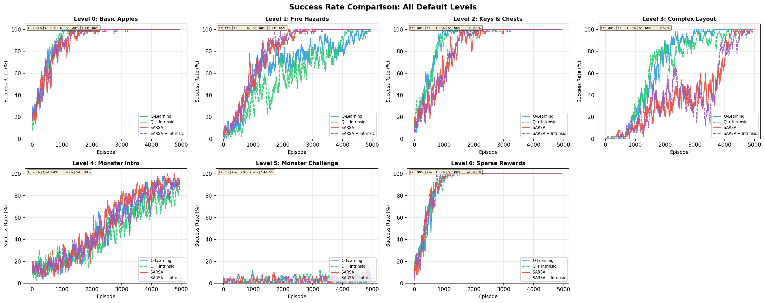
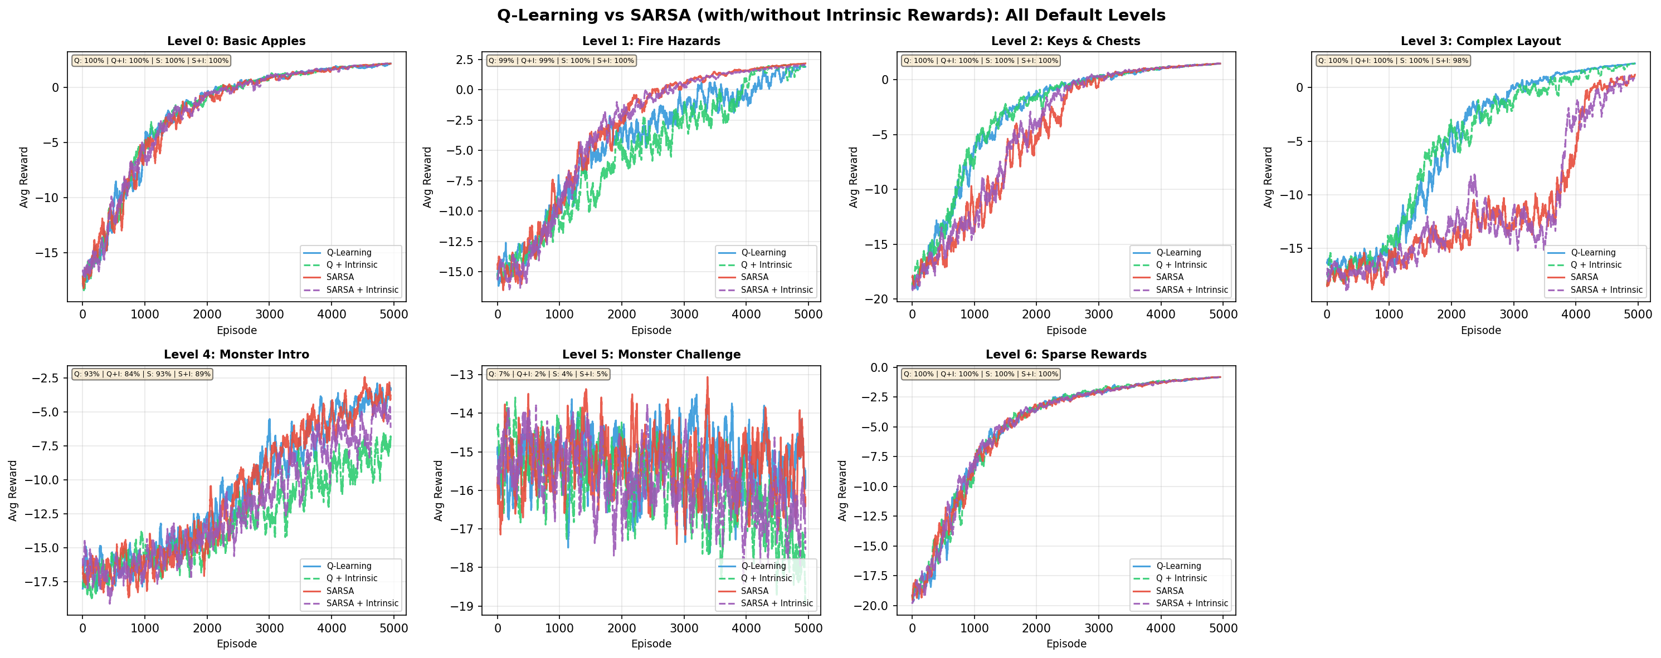
The comparison was performed on 4 algorithms over 5000 episodes. The two algorithms behave differently according to their theoretical definitions:
- Q-Learning (Aggressive): Q-Learning is “off-policy”, generally targets the maximum possible future reward regardless of its current exploratory actions.
- SARSA (Conservative): SARSA is "on-policy," meaning it accounts for the fact that it is still exploring (and might make mistakes). This often results in a smoother, "safer" learning curve.

Observations:
- Simple Levels (0,1, 6): There are no significant differences since both models can handle well. This is expected as the environment is simple enough for even basic epsilon-greedy exploration to succeed, all four algorithms converge to a 100% success rate relatively quickly.
- Complex Levels (2,3): Q-learning outperform SARSA, finding shortcuts which make the performance jump significantly. On the other hand, SARSA is more stable and finding the safe path.
- Monster Levels (4,5): The rewards are significantly lower and noisier. This suggests these levels contain stochasticity, where any exploratory move into a monster's path leads to a massive reward drop. For Level 4 – Simple monster level, shows a steady, linear improvement for all models, suggesting it will reach 100% success rate after 5000 episodes. For Level 5 – Monster Challenge, all algorithms failed, success rate remain near 0% after 5000 episodes, indicating that complexity may create an obstacle that simple reinforcement learning cannot overcome.
- The intrinsic versions slightly outperform the base algorithms in exploration-heavy tasks, they reduce the time the agent spend wandering around. However, they don’t improve in challenges requiring complex analysis.

