Reinforcement Learning for Sequential Decision-Making:
Tabular Methods in Grid Worlds and Deep RL in Continuous Control Environments
Abstract — Reinforcement learning provides a powerful framework for training autonomous agents in dynamic environments. This report investigates reinforcement learning across two fundamentally different problem settings. The first focuses on tabular reinforcement learning in discrete grid world environments, where explicit state-action representations enable analytical comparison of Q-Learning and SARSA learning dynamics. The second examines deep reinforcement learning in a continuous-control arena using Proximal Policy Optimization (PPO), comparing two control schemes—rotation-based and directional movement.
Keywords — Reinforcement Learning, Q-Learning, SARSA, Proximal Policy Optimization (PPO), Deep RL, Game AI, Curriculum Learning, Domain Randomization

1. Introduction
Reinforcement learning (RL) is a fundamental approach for training intelligent agents that can make sequential decisions in complex environments. Unlike supervised learning, RL agents learn through interaction with their environment, receiving rewards or penalties based on their actions. This paradigm is particularly well-suited for game AI, where agents must develop strategies through trial and error.
The progression from tabular methods to deep RL illustrates how the field has evolved to handle increasingly complex state and action spaces. Structuring the report around these two tasks enables clearer analysis of algorithmic strengths, limitations, and generalization behavior. The project is organized into two parts: Classical RL algorithms (Q-Learning, SARSA) with intrinsic reward mechanisms, and Proximal Policy Optimization (PPO) applied to a continuous space shooter game with two distinct control schemes – rotation-based and directional movement.

2. Tabular Reinforcement Learning (Grid World)

2.1 Environment and Entities
The grid world environment is a discrete, episodic domain defined on a fixed 10×10 grid with an action space of 4 discrete actions. The agent begins each episode from a predefined start location and can execute four deterministic actions: up, down, left, and right. The environment includes static obstacles, collectible rewards, hazardous tiles, and stochastic monsters that terminate the episode upon contact.
Details of the GridWorld’s entity types and seven levels test can be found in Appendix A
Seven levels test different aspects of agent learning:

2.2 Reward Design
Event | Reward | Purpose
Apple collection | +1.0 | Primary objective reward
Chest opening | +2.0 | High-value objective (requires planning)
Key pickup | +0.1 | Subgoal shaping reward
Each step | -0.1 | Encourages path efficiency
Death (fire/monster) | -10.0 | Strong aversion to hazards
Table 4. Gridworld reward structure.
The current reward design is aimed at achieving optimal pathfinding while encouraging obstacle avoidance. The apple and chest rewards create "small wins" that guide the agent toward objectives. The key reward (+0.1) serves as a signal that picking up keys is beneficial without being the primary goal. The step penalty (-0.1) prevents the agent from wandering aimlessly when no immediate danger exists, forcing it to find efficient paths to rewards. The death penalty is heavily weighted to teach strong hazard avoidance.

2.3 Intrinsic Motivation
The intrinsic reward acts as a curiosity signal that motivates the agent to explore the map independently of external objectives, such as collecting apples or chests. This mechanism is particularly effective in sparse reward environments where there is less immediate danger, and exploration often leads to better outcomes. The intrinsic formula is:
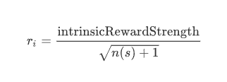
Where:
- n(s) = number of visits to the current state during the episode
- total_reward = environment_reward + intrinsic_reward
This formulation gives high rewards for visiting new states and diminishing rewards for revisiting, naturally encouraging exploration of unvisited regions.

2.4 Algorithms
Q-Learning and SARSA are evaluated to highlight the difference between off-policy and on-policy learning.
Q-Learning [1] is an off-policy algorithm that learns the optimal action-value function Q*(s,a) regardless of the policy being followed:
$$Q(s,a) ← Q(s,a) + α[r + γ·max Q(s',a') - Q(s,a)]$$
SARSA (State-Action-Reward-State-Action) [2] is an on-policy algorithm that updates Q-values based on the actual action taken:
$$Q(s,a) ← Q(s,a) + α[r + γ·Q(s',a') - Q(s,a)]$$
The key distinction is that Q-Learning is optimistic (assumes optimal future behavior), while SARSA is conservative (accounts for exploratory actions). Q-Learning aggressively optimizes expected future return, while SARSA incorporates the agent's current behavior policy, resulting in more conservative learning dynamics.

2.5 Results & Observations
The comparison was performed across all four algorithm variants (Q-Learning, SARSA, Q-Learning+Intrinsic, SARSA+Intrinsic) over 5000 episodes. The two base algorithms behave differently according to their theoretical definitions:
Q-Learning (Aggressive): Q-Learning is "off-policy" and generally targets the maximum possible future reward regardless of its current exploratory actions. This manifests as risk-taking behavior where the agent attempts shortcuts even near hazards.
SARSA (Conservative): SARSA is "on-policy," meaning it accounts for the fact that it is still exploring and might make mistakes. This often results in smoother, safer learning curves and policies that maintain distance from hazards.

Observations by Level Category
Simple Levels (0, 1, 6): No significant differences between algorithms. Both models handle these environments well, as the state spaces are simple enough for basic epsilon-greedy exploration to succeed. All four algorithms converge to approximately 100% success rate relatively quickly.
Complex Levels (2, 3): Q-Learning outperforms SARSA by finding shortcuts that create significant performance jumps. On the other hand, SARSA produces more stable performance but follows safer, sometimes longer paths. The key-chest mechanic in these levels tests the agent's ability to plan multi-step sequences.
Monster Levels (4, 5): Rewards are significantly lower and noisier due to stochasticity. Any exploratory move into a monster's path leads to massive reward drops. For Level 4 (single monster), all models show steady, linear improvement, suggesting convergence would occur with additional training beyond 5000 episodes. For Level 5 (multiple monsters), all algorithms achieve near-0% success rate after 5000 episodes, indicating that the complexity may exceed what simple tabular RL can overcome without additional techniques.
Intrinsic Reward Impact: The intrinsic reward variants slightly outperform base algorithms in exploration-heavy tasks by reducing the time the agent spends wandering around. However, they do not improve performance in challenges requiring complex multi-step analysis, such as the monster levels.

3. Deep Reinforcement Learning (Arena + Curriculum)

3.1 Environment & Action Space
The Deep RL Arena is a space shooter game where the player must destroy enemy spawners across five phases of increasing difficulty. Unlike the discrete gridworld, this environment features continuous movement, real-time physics, and simultaneous multi-entity interactions.
The observation vector is unified across both control schemes, containing 23 normalized features that capture the complete game state. This simplicity proved more effective than scheme-specific observations attempted in later experiments. Details about environmental and action space can be found in Appendix B

3.2 PPO Algorithm
Proximal Policy Optimization (PPO) [3] addresses the challenge of policy gradient methods in continuous spaces. PPO uses a clipped surrogate objective to ensure stable policy updates:
$$L(θ) = E[min(r(θ)·A, clip(r(θ), 1-ε, 1+ε)·A)]$$
where r(θ) is the probability ratio between new and old policies, and A is the advantage estimate. This approach has become a standard algorithm for continuous control tasks due to its stability and sample efficiency. PPO is used with Stable Baselines3 [6] default hyperparameters, which proved optimal after extensive experimentation:
Parameter | Value
Total Timesteps | 4,000,000
Learning Rate | 3e-4
n_steps | 2048
Batch Size | 64
n_epochs | 10
Gamma | 0.99
GAE Lambda | 0.95
Clip Range | 0.2
Network | [64, 64] MLP
Entropy Coefficient | 0.0
Table 8. PPO hyperparameters (SB3 defaults).

3.3 Control Scheme Comparison
Two control schemes are implemented to compare different movement paradigms:
Rotation Scheme: Asteroids-style movement with momentum. Actions are no_action, thrust, rotate_left, rotate_right, and shoot. The player maintains velocity with friction (0.98) and must orient before thrusting. This creates a two-step control problem: first orient toward the target, then act, all while trying to dodge enemies being spawned. The gun fires in the direction the ship faces.
Directional Scheme: Direct 4-way movement where the gun always fires upward. Actions are no_action, up, down, left, right, and shoot. Movement is more direct with higher effective friction (0.8), creating a simpler one-step positioning problem: move to align with target vertically, then shoot while dodging the enemies being spawned. Details on the actions and reward function
Action | Rotation Scheme | Directional Scheme
0 | No Action (drift) | No Action (stop)
1 | Thrust (accelerate forward) | Move Up
2 | Rotate Left | Move Down
3 | Rotate Right | Move Left
4 | Shoot | Move Right
5 | - | Shoot
Table 9. Action definitions for both control schemes.

Reward Structure
Event | Reward | Purpose
Destroy enemy | +10 | Immediate tactical reward
Destroy spawner | +80 | Primary objective
Hit spawner | +5 | Shaping for partial progress
Phase complete | +10,000 (flat) | Major milestone reward
Take damage | -5 | Mild aversion to damage
Death | -200 | Strong failure penalty
Survival tick | +0.01 | Encourages staying alive
Table 10. Deep RL Arena reward structure.

3.4 Results & Analysis

3.4.1 Training Results
Training was conducted on Kaggle CPU instances for approximately 4 hours per scheme (4M timesteps). Results demonstrate significant performance differences between schemes:

Metric | Rotation | Directional
Episodes | 2,916 | 2,230
Mean Reward | 20,760 | 30,625
Std Reward | 12,493 | 13,403
Max Reward | 41,406 | 41,896
Min Reward | -237 | -237
Mean Episode Length | 1,372 | 1,728
Phase 2+ Rate | 82.5% | 83.5%
Phase 3+ Rate | 23.4% | 72.2%
Phase 4+ Rate | 0.7% | 50.2%
Phase 5 Rate | 0.0% | 0.0%
Death Rate | 0.7% | 7.1%
Table 11. Training results (4M timesteps, SB3 default hyperparameters).
The directional scheme significantly outperforms rotation, achieving 50.2% Phase 4+ completion rate compared to rotation's 0.7%. While directional has a higher death rate (7.1% vs 0.7%), this reflects a more aggressive strategy that pays off in higher phase completion.

Learning Progression Analysis
The directional scheme shows dramatic improvement throughout training, while rotation plateaus early:
Quarter | Rotation Phase 4+ | Directional Phase 4+
Q1 (0-25%) | 0.4% | 1.1%
Q2 (25-50%) | 2.3% | 38.8%
Q3 (50-75%) | 0.0% | 78.5%
Q4 (75-100%) | 0.0% | 82.5%
Table 12. Learning progression by training quarter.
The directional scheme demonstrates continuous improvement, reaching 82.5% Phase 4+ rate in the final quarter—a 75× improvement over Q1. In contrast, the rotation scheme shows minimal learning beyond Phase 2 completion. Graphs of learning progression can be found in Appendix F.

3.4.2 Discussion and Analysis
Why Directional Outperforms Rotation
The directional scheme's superior performance stems from its simpler control mapping. The rotation scheme requires the agent to:
- Learn that orientation matters
- Learn how to orient efficiently
- Learn how thrust creates movement in the facing direction
- Learn to coordinate orientation with shooting
This multi-step credit assignment problem is significantly harder than the directional scheme's direct mapping: "move below spawner → shoot up → destroy spawner."
Improve Rotation Scheme
Extra attempts have been made to improve Rotation Scheme, and the result was promising. By adding one extra observation – the angle of our agent regarding the nearest spawner, agent can gain more information about orientation and start coordinating orientation with shooting and movement. However, since we have set up so that both schemes got trained under the same specifications, the result of Directional Scheme in those attempts was not good enough. As a result, this implementation was chosen as it was the best result.
Phase 5 Difficulty Wall
No agents across 5,000+ episodes achieved Phase 5 completion (0% rate). Maximum rewards cluster around ~41,000 (Phase 4 ceiling). Phase 5 presents extreme challenges:
- 5 simultaneous spawners
- 2× spawn rate
- 1.5× enemy speed
The jump from 4 to 5 spawners appears to exceed the agent's learned strategies.

3.5 Curriculum Training (Domain Randomization)

Hypothesis
The experiment tests whether environmental perturbations during training help or hinder agent learning. The initial hypothesis was that randomly repositioning spawners mid-episode would disrupt learning by invalidating the agent's learned spatial strategies.

Curriculum Design
The curriculum condition introduces spawner repositioning with the following parameters:
Parameter | Value
Check Interval | Every 500 steps
Reposition Probability | 30% per check
Min Distance from Player | 200 pixels
Min Distance in Spawners | 150 pixels
Table 14. Curriculum spawner repositioning parameters.
When triggered, active spawners teleport to new random positions that satisfy the minimum distance constraints, preventing exploitation of memorized spawner locations.

Experimental Setup
Four conditions are compared:
- Rotation Control (standard environment)
- Rotation Curriculum (with repositioning)
- Directional Control (standard environment)
- Directional Curriculum (with repositioning)
Each condition uses 500k timesteps to compare early learning dynamics.

3.6 Curriculum Training Results & Analysis

3.6.1 Results
Contrary to the initial hypothesis, the curriculum condition improved performance for the directional scheme:
Metric | Rotation Control | Rotation Curriculum
Episodes | 291 | 273
Mean Reward | 4,594 | 7,449
Max Reward | 20,168 | 20,244
Phase 2+ Rate | 1.2% | 5.1%
Phase 3+ Rate | 0.0% | 0.0%
Positive Reward Rate | 3.7% | 31.5%
Table 15. Rotation: Control vs Curriculum (500k timesteps).
Metric | Directional Control | Directional Curriculum
Episodes | 263 | 272
Mean Reward | 10,745 | 13,192
Max Reward | 30,892 | 31,284
Phase 2+ Rate | 33.7% | 46.7%
Phase 3+ Rate | 6.4% | 11.0%
Positive Reward Rate | 47.4% | 63.8%
Table 16. Directional: Control vs Curriculum (500k timesteps).
Key improvements from curriculum:
- Rotation: +62% mean reward, +28 percentage points positive episode rate
- Directional: +23% mean reward, +13 percentage points Phase 2+ rate

3.6.2 Discussion and Analysis
Curriculum Acts as Domain Randomization
The curriculum condition provides unexpected benefits by acting as domain randomization:
- Prevents overfitting: Agents cannot memorize specific trajectories or spawner positions
- Encourages generalization: Policies must work for any spawner configuration
- Improves robustness: Learned behaviors transfer to novel situations
Why Curriculum Helps Both Schemes
At 500k timesteps both schemes benefit:
- The perturbations prevent early convergence to suboptimal local minima
- Agents learn more general "approach and destroy" behaviors rather than position-specific strategies
- The randomization provides implicit exploration without requiring entropy
Connection to Domain Randomization Literature
These results align with domain randomization research from robotics [5], where training with environmental variations produces policies that generalize better. The spawner repositioning curriculum inadvertently implemented this principle, demonstrating that "harder training makes easier testing."

4. Conclusion
This report demonstrates how reinforcement learning techniques must be adapted to the structure of the problem domain. Tabular methods provide valuable insight into learning dynamics but scale poorly to complex environments, while deep reinforcement learning enables effective control in continuous state spaces.
Key achievements:
- Successful implementation of Q-Learning and SARSA with intrinsic rewards for gridworld navigation, demonstrating the theoretical distinction between off-policy (aggressive) and on-policy (conservative) learning in practice.
- Development of a Deep RL Arena with two control schemes trained using PPO, achieving good results with the directional scheme using SB3 default hyperparameters.
- Discovery that simpler control schemes learn more effectively—the directional scheme's one-step position-to-action mapping dramatically outperforms the rotation scheme's two-step orientation-then-action approach.
- Confirmation that flat reward structures (equal rewards per phase) encourage continuous progression, while scaled rewards inadvertently teach conservative play.
- Validation that environmental perturbations act as domain randomization, improving early learning for both control schemes by preventing overfitting to specific configurations.
- Intrinsic reward mechanisms improve exploration in sparse reward environments by providing curiosity-driven bonuses for visiting novel states.
Limitations:
- Computational constraints limited curriculum experiments to 500k timesteps
- Single random seed results; multiple seeds would provide confidence intervals
- Phase 5 completion remains elusive (0% across all experiments)
- Rotation scheme struggled to exceed Phase 2 performance
- Monster levels in gridworld proved too challenging for tabular methods
Future work could explore:
- Extended training runs targeting Phase 5 completion
- Hierarchical RL approaches for the rotation scheme's multi-step control problem
- Progressive curriculum learning with gradual difficulty increases
- Multi-agent training with cooperative or competitive dynamics
- More sophisticated exploration mechanisms for high-stochasticity environments
The project provides practical insights for applying reinforcement learning to game AI, particularly the finding that control scheme simplicity trumps flexibility—direct action-outcome mappings enable faster and more reliable learning than physics-based controls requiring multi-step coordination.

5. References
[1] Watkins, C. J., & Dayan, P. (1992). Q-learning. Machine learning, 8(3), 279-292.
[2] Rummery, G. A., & Niranjan, M. (1994). On-line Q-learning using connectionist systems. Cambridge University Engineering Department.
[3] Schulman, J., Wolski, F., Dhariwal, P., Radford, A., & Klimov, O. (2017). Proximal policy optimization algorithms. arXiv preprint arXiv:1707.06347.
[4] Pathak, D., Agrawal, P., Efros, A. A., & Darrell, T. (2017). Curiosity-driven exploration by self-supervised prediction. International Conference on Machine Learning (ICML).
[5] Tobin, J., Fong, R., Ray, A., Schneider, J., Zaremba, W., & Abbeel, P. (2017). Domain randomization for transferring deep neural networks from simulation to the real world. IEEE/RSJ International Conference on Intelligent Robots and Systems (IROS).
[6] Raffin, A., Hill, A., Gleave, A., Kanervisto, A., Ernestus, M., & Dormann, N. (2021). Stable-Baselines3: Reliable Reinforcement Learning Implementations. Journal of Machine Learning Research (JMLR).
[7] Sutton, R. S., & Barto, A. G. (2018). Reinforcement learning: An introduction (2nd ed.). MIT Press.
[8] Mnih, V., Kavukcuoglu, K., Silver, D., et al. (2015). Human-level control through deep reinforcement learning. Nature, 518(7540), 529-533.

6. Appendix

A. Environment and entities in GridWorld
Property | Value
Grid Size | 10×10 cells
Cell Size | 60 pixels
Max Steps | 200 per episode
Action Space | 4 discrete actions (UP, DOWN, LEFT, RIGHT)
Training Episodes | 5000
Learning Rate (α) | 0.1
Discount Factor (γ) | 0.99
Epsilon Decay | 1.0 → 0.01 (linear)
Table 1. Gridworld environment parameters.
Entity | Symbol | Behavior
Empty | . | Passable terrain
Rock | R | Impassable obstacle (blocks movement)
Fire | F | Instant death on contact
Apple | A | Collectible reward item
Key | K | Required to unlock chests
Chest | C | High-value collectible (requires key)
Monster | M | Stochastic movement (40% chance per step), death on contact
Table 2. Gridworld entity types and behaviors.
Level | Name | Purpose | Key Challenge
0 | Basic Apples | Q-Learning introduction | Simple pathfinding
1 | Fire Hazards | SARSA demonstration | Navigate around fire
2 | Keys & Chests | Multi-step planning | Collect key before chest
3 | Complex Layout | Multiple objectives | Apples, key, chest with hazards
4 | Monster Intro | Stochastic transitions | Single moving monster
5 | Monster Challenge | High stochasticity | Multiple monsters
6 | Sparse Rewards | Intrinsic motivation | Long path with minimal guidance
Table 3. Gridworld level design and purposes.

B. Observation Vector Summary

Property | Value
Window Size | 960×680 pixels
Max Steps | 3000 per episode
Phases | 5 (1 to 5 spawners)
Action Space (Rotation) | 5 discrete actions
Action Space (Directional) | 6 discrete actions
Observation Space | 23 continuous features (both schemes)
Table 5. Deep RL Arena environment parameters.

Index | Feature | Normalization | Purpose
0-1 | Player position (x, y) | [0, 1] | Spatial awareness
2-3 | Player velocity (vx, vy) | [-1, 1] | Momentum prediction
4-5 | Player angle (cos, sin) | [-1, 1] | Orientation
6-9 | Nearest enemy (dist, cos, sin, speed) | [0, 1] | Threat detection
10-13 | Nearest spawner (dist, cos, sin, facing) | [0, 1] | Target acquisition
14-17 | Health, phase, enemy count, shoot ready | [0, 1] | Game state
18-21 | Wall distances (L, R, T, B) | [0, 1] | Boundary awareness
22 | Active spawner count | [0, 1] | Progress tracking
Table 6. Observation vector design for Deep RL Arena (23 features).

Phase | Spawners | Spawn Rate | Enemy Speed
1 | 1 | 1.0× | 1.0×
2 | 2 | 1.2× | 1.1×
3 | 3 | 1.4× | 1.2×
4 | 4 | 1.6× | 1.3×
5 | 5 | 2.0× | 1.5×
Table 7. Phase progression difficulty scaling.

C. Hyperparameter Experiments Summary
Version | Key Change | Directional Phase 4+
Default | SB3 defaults (ent=0.0) | 50.2% (82.5% Q4)
Ver 5 | Added turn_direction to enhance Rotation | 1.2% (regression), but Rotation increase
Ver 6 | Scheme-specific entropy | 31.0%
Ver 7 | Scheme-specific observations | 20.7%
Table A1. Training version progression showing Default_4k as optimal.
The key finding is that simpler configurations (SB3 defaults, unified observations) outperform more complex scheme-specific tuning. The directional scheme benefits from deterministic policies that can converge cleanly.

D. Training Curves
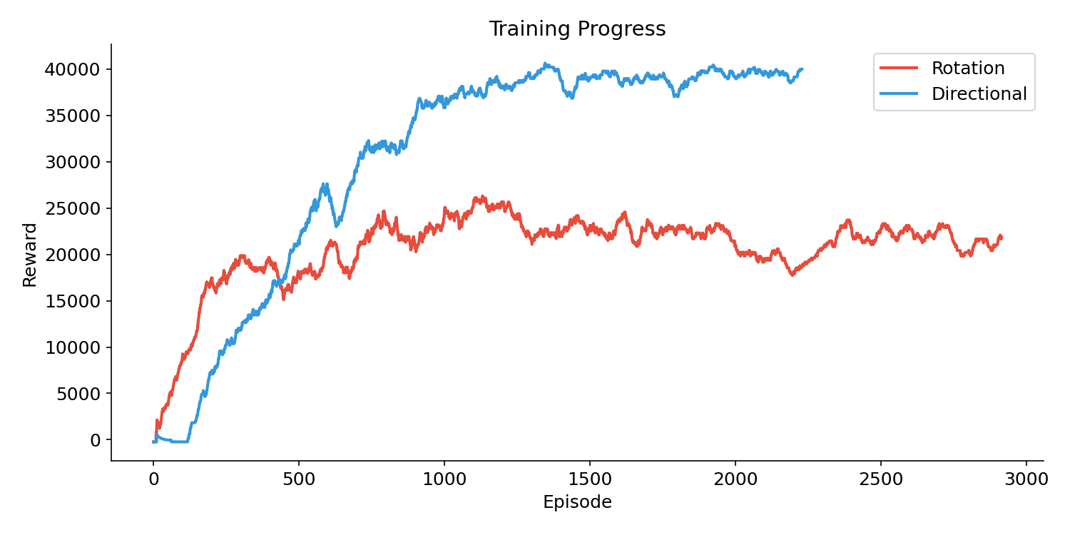Figure A1. Episode reward over training (50-episode moving average).
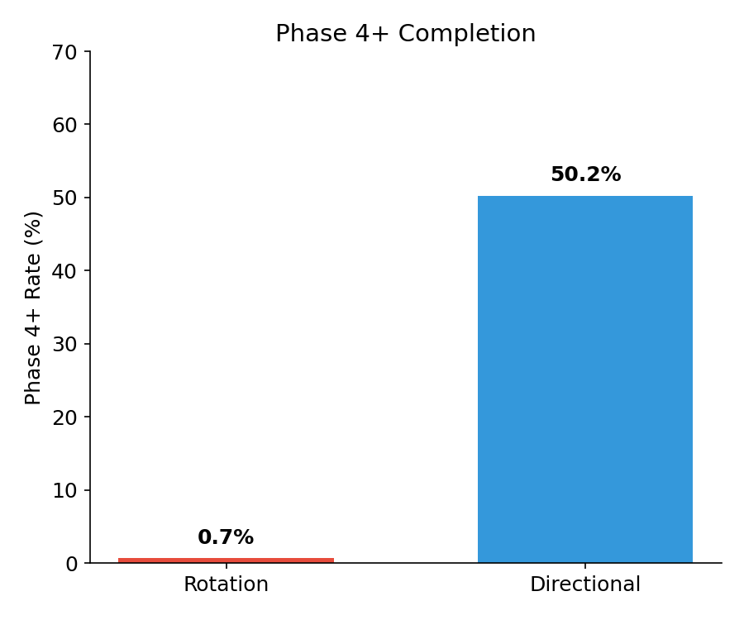Figure A2. Phase 4+ completion rate comparison between schemes.

E. Curriculum Experiment Details
Condition | Phase 2+ | Mean Reward | Change from Control
Rotation Control | 1.2% | 4,594 | -
Rotation Curriculum | 5.1% | 7,449 | +62% reward
Directional Control | 33.7% | 10,745 | -
Directional Curriculum | 46.7% | 13,192 | +23% reward
Table A2. Curriculum experiment results (500k timesteps).

F. Learning Progression

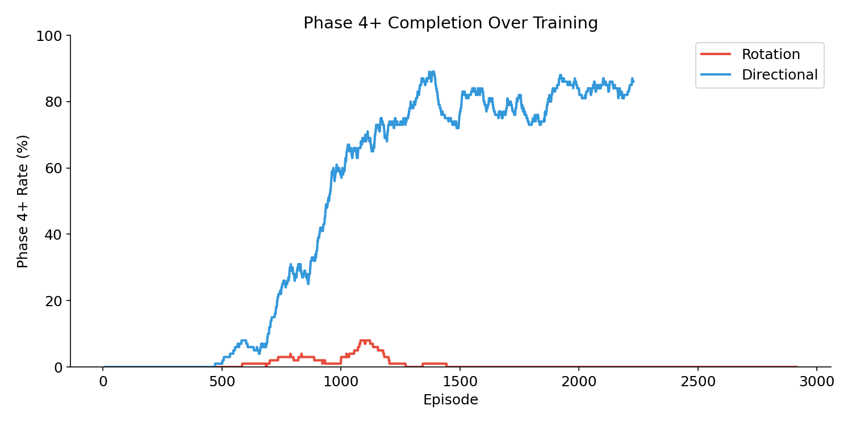
Figure 1. Phase 4+ completion rate over training episodes.
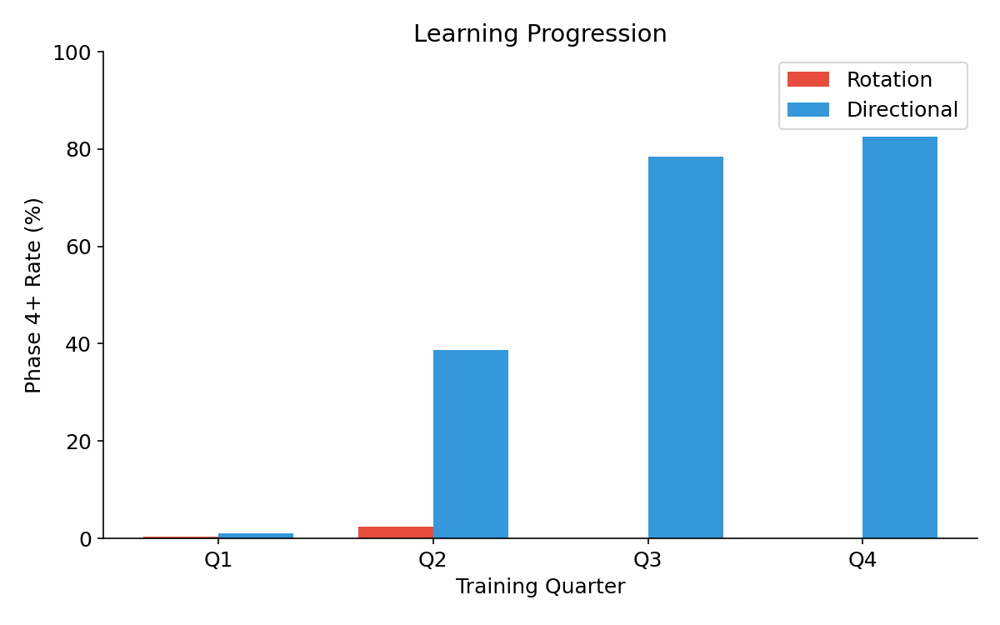
Figure 2. Phase 4+ rate by training quarter.

G. Video demonstration

https://rmiteduau-my.sharepoint.com/personal/s3927049_rmit_edu_vn/_layouts/15/stream.aspx?id=%2Fpersonal%2Fs3927049%5Frmit%5Fedu%5Fvn%2FDocuments%2FAssignment3%5FVideo%2Emp4&nav=eyJyZWZlcnJhbEluZm8iOnsicmVmZXJyYWxBcHAiOiJPbmVEcml2ZUZvckJ1c2luZXNzIiwicmVmZXJyYWxBcHBQbGF0Zm9ybSI6IldlYiIsInJlZmVycmFsTW9kZSI6InZpZXciLCJyZWZlcnJhbFZpZXciOiJNeUZpbGVzTGlua0NvcHkifX0&ga=1&referrer=StreamWebApp%2EWeb&referrerScenario=AddressBarCopied%2Eview%2E55b22d4a%2Db726%2D478f%2D9da1%2D2e415f3f34c5

