RMIT University
Cloud Computing — Assessment 3

PROJECT PROPOSAL
OpenPortfo: A Cloud-Based Crypto and Vietnam Stock Portfolio Tracking System

Student ID: s3927049
Student name: Mai Gia Phu
Table of Contents
1. Problem Statement 3
2. Proposed Solution 3
2.1 Core capabilities 3
2.2 Design principles 3
3. Architecture 4
3.1 High-level architecture 4
Frontend 4
Backend 4
Database and storage 4
Jobs (scheduled) 5
External APIs 5
4. Similar Products 5
5. Limitations and Further Improvement 6
5.1 Current limitations 6
5.2 Further improvement 6
6. Conclusion 7
7. References 7

1. Problem Statement
It is hard for individual investors to manage holdings across different sources—cryptocurrency exchanges or wallets on one side, and Vietnam stock brokers on the other—because each asset class lives in a separate app or spreadsheet, with no single view of total value, allocation, and profit and loss, and no low-cost way to combine on-demand pricing, relevant news, and a simple daily summary under a tight cloud budget.

2. Proposed Solution
OpenPortfo is a cloud-based portfolio tracking application designed for individual investors who hold both cryptocurrencies and Vietnam-listed stocks. The system provides a unified watchlist and holdings model, a portfolio dashboard with charts and filters, on-demand price refresh (not WebSocket real-time streaming), RSS news filtered by keyword relevance, a daily portfolio summary email, user login, and an administrator page for system configuration.

2.1 Core capabilities
- Unified multi-asset tracking. Users can search and add crypto assets (via CoinGecko) and Vietnam stocks (via vnstock) to a personal watchlist and to holdings with quantity and cost basis. The portfolio view computes market value, cost, and profit and loss in a single dashboard.
- On-demand prices with caching. Quotes are refreshed when the user opens the portfolio or presses Refresh, or when a scheduled job updates the cache. There is no continuous real-time stream, which keeps cost and complexity appropriate for a student AWS budget.
- Historical charts and analytics. Price history is cached in S3; Athena supports SQL-style queries over portfolio snapshots for longer-term analysis.
- News and email. A scheduled Lambda pipeline fetches RSS sources configured by an administrator, matches items to user symbols or keywords, stores results in DynamoDB, and can send a daily SES email summary.
- Admin configuration. An admin page manages RSS source URLs, email send time, job enable/disable toggles, and price-cache TTL without redeploying code.

2.2 Design principles
The architecture deliberately separates user-facing request traffic from scheduled background work. The browser loads a statically exported Next.js front end from S3 via CloudFront (client-side rendering only; no server-side rendering). All interactive REST APIs—including authentication, portfolio operations, news read, and admin settings—are served by FastAPI on AWS Elastic Beanstalk. Scheduled tasks (RSS fetch, batch price update, portfolio snapshot, SES email) run only on EventBridge-triggered Lambda functions. Main user traffic does not pass through API Gateway.
External market data is drawn from free or low-cost sources: CoinGecko for crypto markets and vnstock for Vietnam equities. Aggressive caching in DynamoDB and S3 protects free-tier rate limits. The entire design targets an AWS spend of at most USD $50 for the assessment period, using t3.micro-class Beanstalk capacity, on-demand DynamoDB, Lambda free tier, and minimal S3/Athena/CloudFront usage.

3. Architecture

3.1 High-level architecture
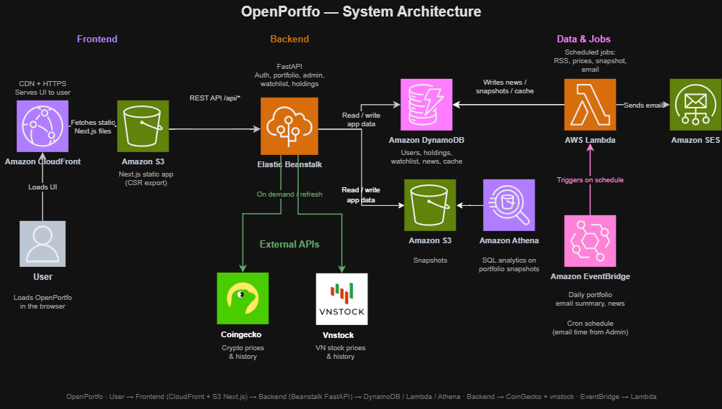
Figure 1. OpenPortfo system architecture.

The architecture is organised into five component groups, each with a clear responsibility.

Frontend
The client is a Next.js application built as a client-side (CSR) static export—no server-side rendering. Static files are stored in Amazon S3 and delivered through Amazon CloudFront with CDN and HTTPS. The user opens the site in a browser; CloudFront serves the UI and fetches Next.js assets from S3. Charts and tables render in the browser after JSON is returned from the backend.

Backend
All interactive application logic runs on AWS Elastic Beanstalk hosting FastAPI (Python). This tier handles authentication, watchlist and holdings CRUD, portfolio valuation, manual price refresh, news read, and the admin page (RSS sources, email time, job toggles). The browser calls REST endpoints under /api/* on Beanstalk. On cache miss or refresh, FastAPI requests live prices from external APIs and writes results back to the database cache.

Database and storage
Amazon DynamoDB is the primary operational database: users, holdings, watchlist, price cache, news items, and system/admin settings. A second Amazon S3 bucket (or prefix) stores price history and daily portfolio snapshots. Amazon Athena runs optional SQL analytics over those snapshot files; it is not used on every portfolio page load. Live dashboard data always comes from DynamoDB (and the price cache) via the backend.

Jobs (scheduled)
Amazon EventBridge runs a cron schedule (email time and job flags come from Admin settings). It triggers AWS Lambda only—Lambda is not a public HTTP API. Lambda jobs include: (1) fetch RSS feeds and keyword-match into DynamoDB News; (2) batch-update prices via CoinGecko and vnstock into the price cache; (3) write portfolio snapshots to DynamoDB and S3; (4) send the daily summary through Amazon SES. This keeps background work separate from user request traffic.

External APIs
CoinGecko supplies cryptocurrency prices and historical data. vnstock supplies Vietnam stock quotes and history. The backend calls both on demand when the user views or refreshes the portfolio. Scheduled Lambda jobs may call the same APIs for batch warm-cache and snapshot work. Free-tier rate limits are managed with caching in DynamoDB and S3.

4. Similar Products
Several commercial and free tools partially address portfolio tracking, but none combine crypto and Vietnam equities in a lightweight, student-deployable cloud application with admin-controlled news and email. Table 2 positions OpenPortfo relative to representative products.

Product | Crypto | VN stocks | Unified portfolio | News | Email | Cloud / self-serve
CoinMarketCap Portfolio | Yes | No | Crypto only | Site news | Limited | SaaS web
Delta / Blockfolio-style apps | Yes | No | Crypto only | Alerts | Push | Mobile SaaS
Yahoo Finance | Limited | Limited VN | Multi-asset (global) | Yes | Alerts | SaaS web/app
CafeF / TCBS investor tools | No | Yes | VN equities focus | Market news | Varies | Local broker portals
Google Sheets trackers | Manual | Manual | If user builds it | No | No | DIY spreadsheet
OpenPortfo (this work) | Yes (CoinGecko) | Yes (vnstock) | Yes (crypto + VN) | RSS + keywords | Daily SES | AWS self-deploy ≤ $50
Table 2. Comparison of related products and OpenPortfo.

CoinMarketCap and Delta-class applications excel at crypto tracking and mobile convenience but do not natively cover Vietnam broker holdings. Yahoo Finance offers broad multi-asset coverage for major global markets, yet Vietnam symbols and free automated portfolio email digests are not its strength for this use case. Domestic tools such as CafeF or TCBS portals are strong for HOSE/HNX data and local news, but they do not unify crypto wallets and international crypto prices. Spreadsheet trackers remain flexible but require manual maintenance and lack integrated news pipelines.
OpenPortfo is positioned as a lightweight multi-asset (crypto + Vietnam stocks) cloud demonstration: not a full brokerage, not a production fintech product, but a complete end-to-end AWS system that solves the fragmented-holdings problem for individual investors under a strict cost cap. Its differentiators for Assessment 3 are the dual external data integrations, the clear split between Beanstalk user APIs and Lambda schedules, admin-managed RSS and email settings, and Athena-ready portfolio snapshots.

5. Limitations and Further Improvement

5.1 Current limitations
The proposed system is intentionally scoped as a demonstration-grade cloud application. The following limitations should be understood by stakeholders and markers.
- Free API rate limits. CoinGecko free or demo tiers impose request-per-minute and monthly call ceilings. Aggressive caching (TTL configurable via admin) is mandatory; bursty multi-user refresh behaviour may still hit limits.
- vnstock / public Vietnam data risk. vnstock relies on unofficial or public broker endpoints. Symbol coverage, field names, or availability may change without notice; the system should fall back to last-known cache prices when live fetch fails.
- No real-time streaming. Prices are on-demand or periodically batch-updated. The product is unsuitable for day-trading or tick-level monitoring.
- SES sandbox constraints. In AWS SES sandbox, email recipients must be verified. Production bulk mailing requires account exit from sandbox and careful bounce handling.
- Single-region deployment. For cost and simplicity, the stack targets one AWS region. Disaster recovery and multi-region latency optimisation are out of scope.
- Simple keyword news relevance. News filtering uses keyword/symbol matching rather than machine learning. Irrelevant items may appear; important nuance may be missed.
- Admin schedule simplicity. Updating email time may be implemented as Lambda hourly checks against admin settings rather than dynamic EventBridge rule rewriting, which is simpler for a student demo but less precise.
- Rough currency conversion. USD and VND display may use approximate FX rates rather than institutional FX feeds.
- Scale for demo, not production. Single small Beanstalk instance, on-demand DynamoDB, and free APIs are appropriate for assessment demos, not for high concurrency or regulated financial advice.

5.2 Further improvement
Beyond the Assessment 3 MVP, the following extensions would increase analytical value and user experience while remaining compatible with the same cloud foundation.
- AI Chatbot helper. A conversational assistant that answers portfolio questions (for example, allocation breakdown, largest positions, PnL over a period) using structured holdings and snapshot data as context.
- RSS RAG Chatbot. Retrieve relevant news chunks from stored RSS articles (vector index or hybrid search) and generate grounded LLM answers with citations to source URLs.
- Analyzer module. Risk and allocation insights (concentration by asset class or symbol), simple anomaly alerts (large day-over-day moves), and optional rebalancing suggestions without executing trades.
- Better NLP relevance. Replace pure keyword filters with embeddings or classifier-based relevance scoring for news.
- Multi-currency FX. Integrate a reliable FX source for accurate USD/VND conversion and multi-currency cost basis.
- Mobile application. A thin mobile client consuming the same FastAPI backend.
- Amazon Cognito. Managed authentication, MFA, and social identity providers instead of a custom auth table.
- More markets. Extend beyond crypto and Vietnam stocks to additional ASEAN equities or traditional commodities where free APIs allow.
These improvements are intentionally deferred so that Assessment 3 can focus on a complete, deployable AWS architecture: static front end, Beanstalk API, DynamoDB data model, S3/Athena analytics path, and EventBridge–Lambda automation under the fifty-dollar budget.

6. Conclusion
OpenPortfo addresses the difficulty of managing holdings across crypto and Vietnam stock sources by unifying watchlist, holdings, on-demand portfolio valuation, keyword-matched news, and optional daily email on AWS: Next.js on S3/CloudFront, FastAPI on Elastic Beanstalk, DynamoDB/S3/Athena for data, EventBridge-triggered Lambda for scheduled jobs, and CoinGecko plus vnstock for market data—feasible under a USD $50 budget and ready for Assessment 3 implementation and demo.

7. References
[1] CoinGecko API documentation. https://www.coingecko.com/en/api/documentation
[2] AWS Elastic Beanstalk Developer Guide. https://docs.aws.amazon.com/elasticbeanstalk/latest/dg/Welcome.html
[3] AWS Lambda Developer Guide. https://docs.aws.amazon.com/lambda/latest/dg/welcome.html
[4] Amazon DynamoDB Developer Guide. https://docs.aws.amazon.com/amazondynamodb/latest/developerguide/Introduction.html

