**Bài 1:**

for (*let* i = 1; i <= 20; i++){

    console.log(i)

}

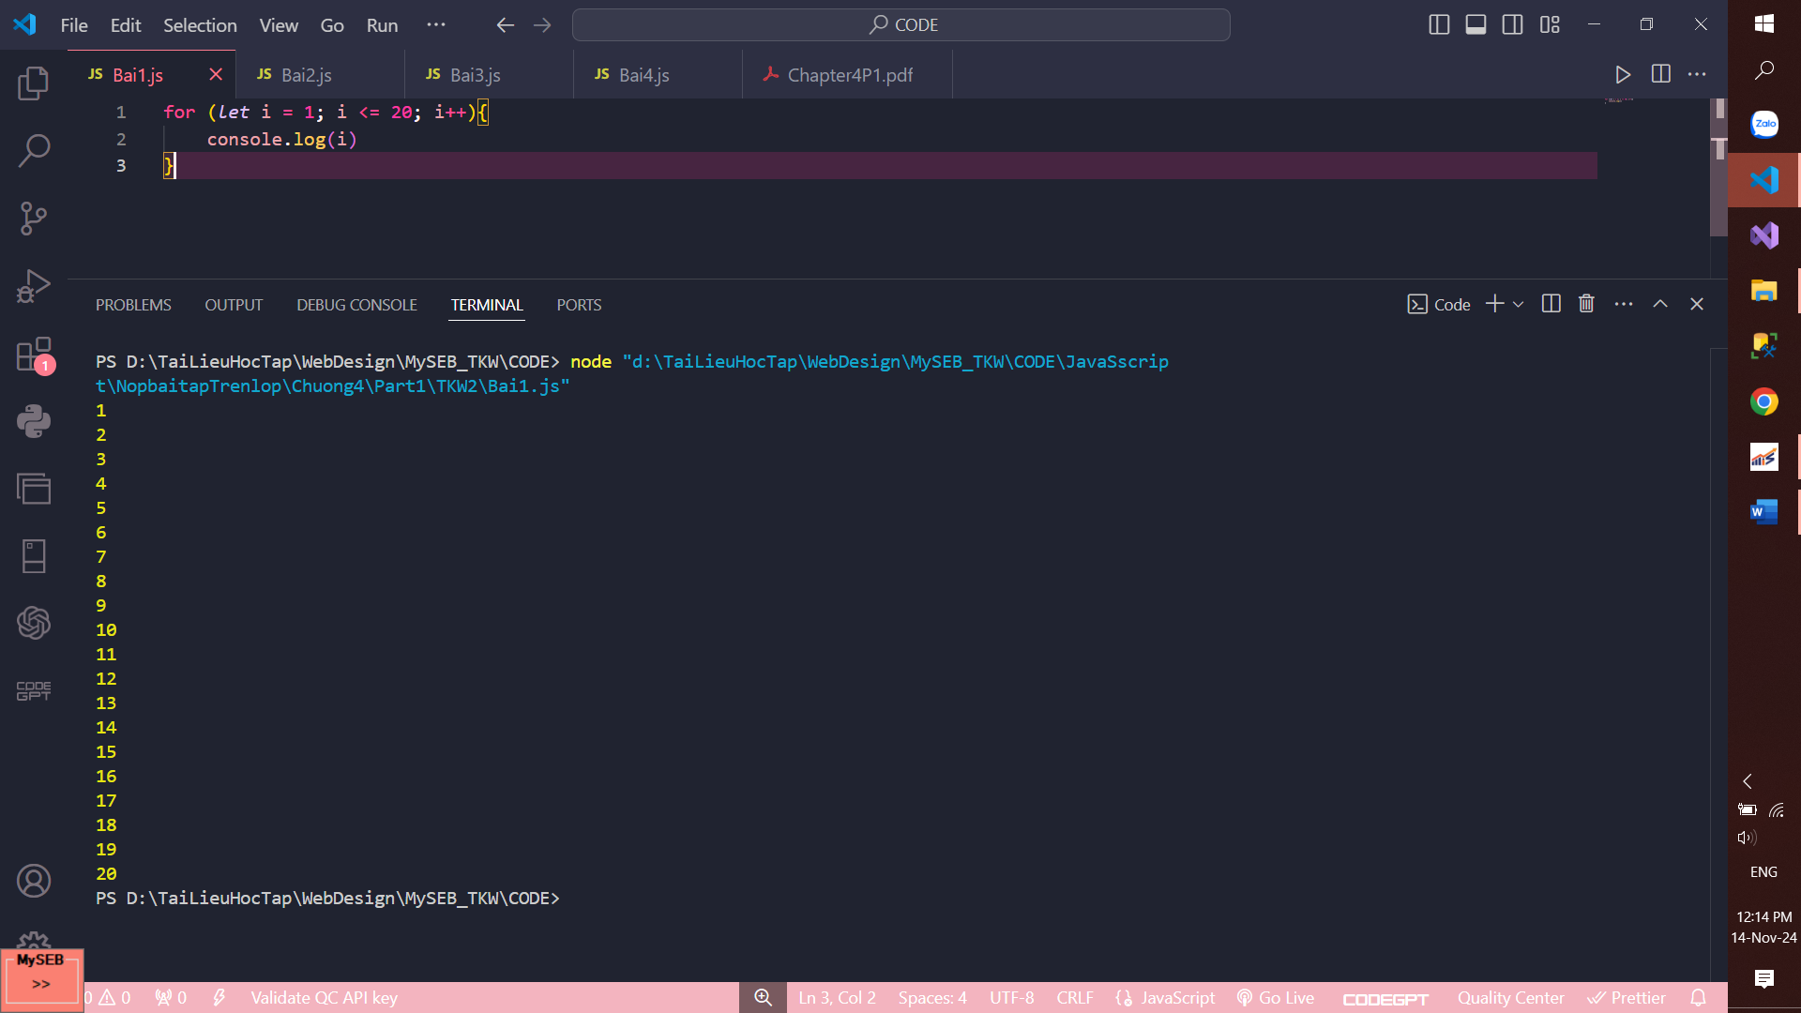

**Bài 2:**

*let* x = 5;

for (*let* i = 1; i <= 10; i++){

    console.log(x + ' X ' + i +  ' = ' + x * i);

}

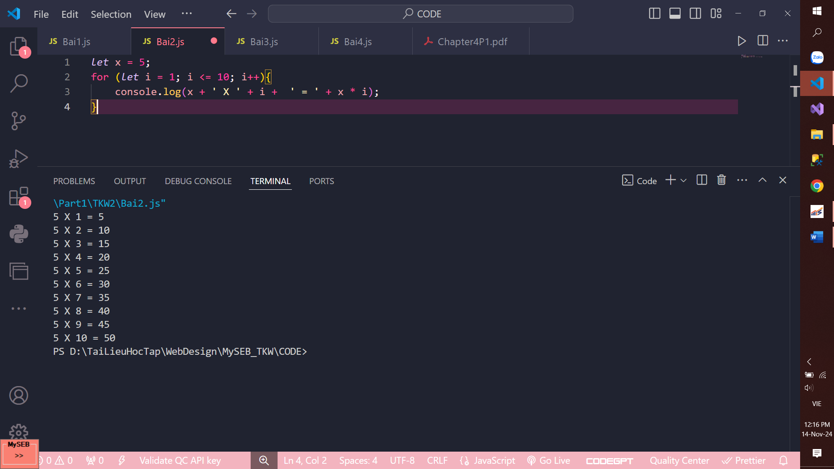

**Bài3:**

*const* fruit = ['apple', 'banana', 'orange', 'mango']

for (i in fruit){

    console.log(fruit[i]);

}

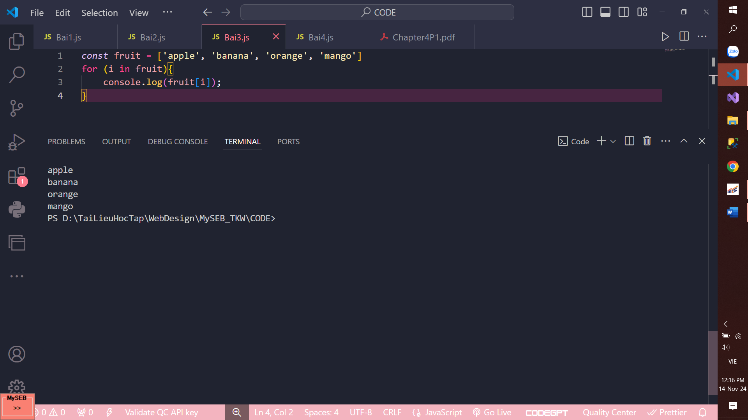

**Bài 4:**

*const* number = [3,5,7,2,8,1,4];

*let* max = 0;

for (i in number){

    if (number[i]> max){

        max = number[i]

    }

}

console.log('so lon nhat la: ' + max);

