**For the submission of your work:**

- Create a folder named **RollNo_Name_DBI202_PaperNo**, e.g. se01245_LongNT_DBI202_01. **Do not** create any subfolder in this folder. All file created will be located in the above folder.

- For each question, you are required to write a database script. Create a file with the name corresponding to the index of the question. For example, **for question 1**, we will create a file named **Q1.sql** and create a file **Q2.sql for question 2**. So, if you do 10 questions, your folder must contain **only** 10 files Q1.sql, Q2.sql, Q3.sql, Q4.sql, Q5.sql, Q6.sql, Q7.sql, Q8.sql, Q9.sql and Q10.sql.

- Do not use any commands having the database name such as create database, alter database, use [database name], *etc*.

- Your response must contain only necessary commands for answering the question. Do not include any other command. For example, if you are required to create a trigger/procedure, then your response should contain only commands for creating the corresponding trigger/procedure; all commands for testing the created trigger/procedure are forbidden.

- On completion, import your work by browsing to the above folder.

**- Note that:**

**+ You could use only SQL Server, SQL Server Management Studio, and paper or offline document in your computer.**

**+ If any of the previous requirements is not respected, your mark will be 0.**

**From the 2nd question**, you should use the database provided in the .sql file which has the following database diagram. Please, run the provided script to create tables and insert data into your database.

Q2:

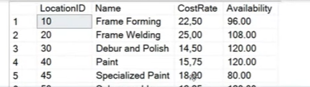

Q3:

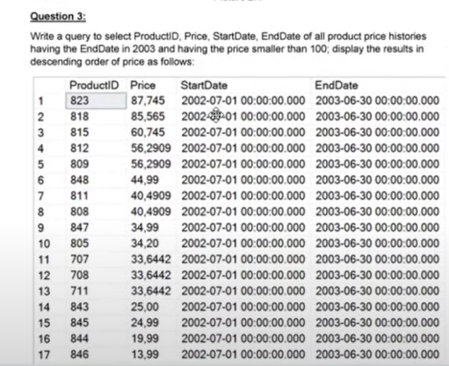

Q4:

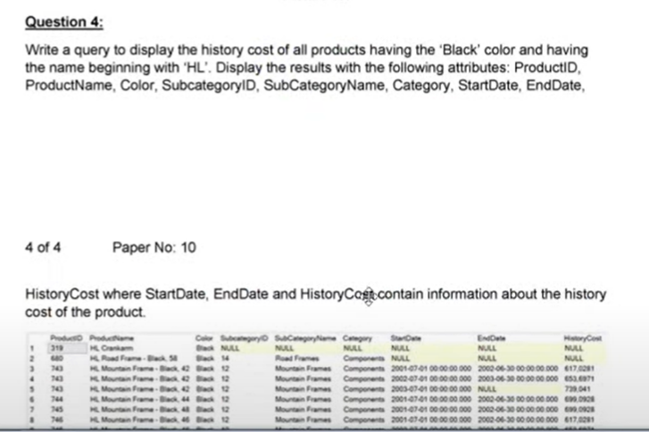

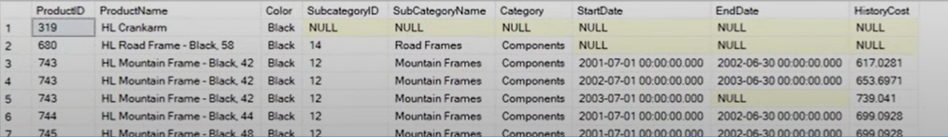

Q5:

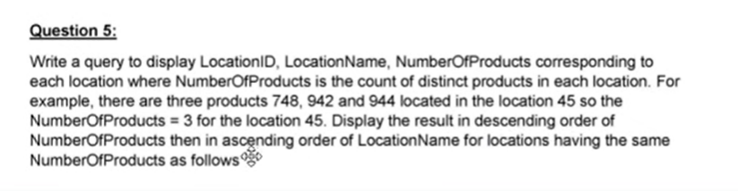

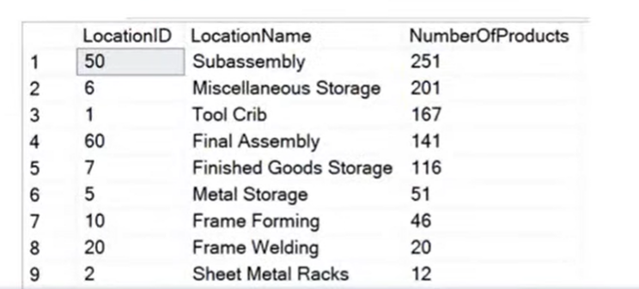

Q7:

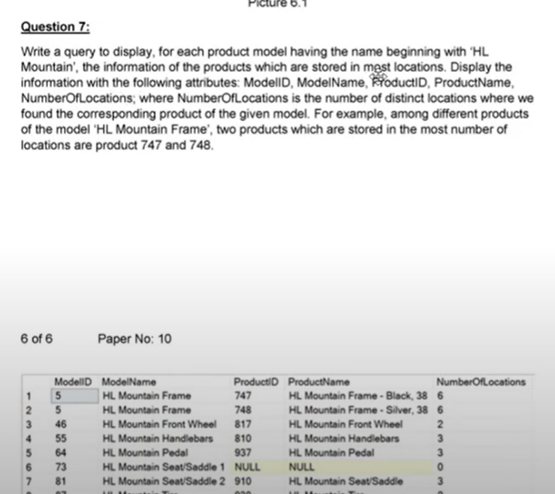

Q8:

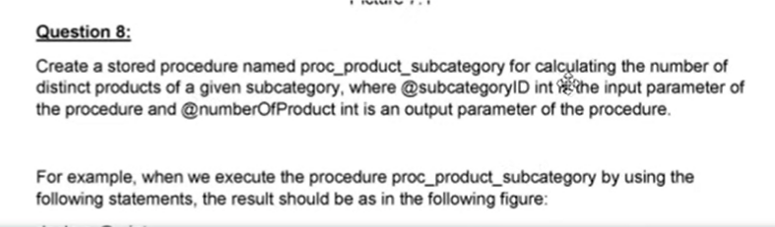

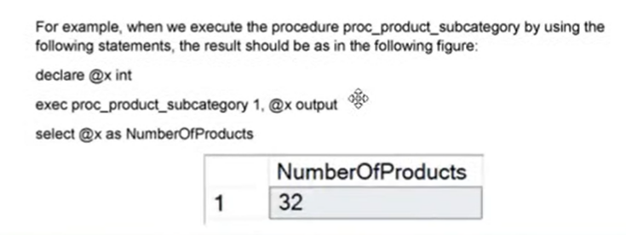

Q9:

