|  |  |
| --- | --- |
| **HOA LAC** | **COMPUTER FUNDAMENTAL DEPARTMENT** |

**PRACTICAL EXAM**

BLOCK 1 – SPRING 2020

**Paper No: 12**

31/03/2020

##### SUBJECT: Database System (DBI202)

**Duration: 85 minutes**

BD14997_

**Student Information**

|  |  |  |  |
| --- | --- | --- | --- |
| Name: |  | Roll number: |  |
| Room No: |  | Class: |  |

BD14997_

**For STAFF only**

|  |  |
| --- | --- |
| **mark** | **marked by**  **(name and signature)** |

**Signature of Proctor**

BD14997_**INSTRUCTIONS**

**Please read the instructions carefully before doing the questions.**

* You can use materials in your computer, notebook and text book.
* While doing the PE exam, you **must disconnect your computer from a network**.
* You are **NOT allowed** to use any device to share data with others.

Beside the above conditions, students must follow the following requirements**:**

1. Down load the compressed file in the **\\fstu\Khao\_Thi\03\_Exam\_Online\PRJ311\_for students.zip** to your computer and decompress it.
2. **THIS PART IS VERY IMPORTANT, PLEASE READ IT CAREFULLY AND FOLLOW THE INSTRUCTIONS.**

* BEFORE starting doing anything. Open your SQL Server creates a database named DBI202\_SPRING18\_SAMPLE\_TEST
* Create a folder named **RollNo\_Name\_DBI202\_PaperNo** (1) **,** e.g.se01245\_LongNT\_DBI202\_01.

All files created are located under above folder.

* For each question asks to write a database script. Create a file with the name corresponding to the index of the question. For example, **for question 1, part a**, we will create a file named **1\_a.sql**, **for question 3**, we will create a file named **3.sql**. This file contains only the required workflow commands that do not include other commands including the database context switch (**not including use [database name]**).
* The questions do not require writing a database script, use the pen to fill in the test paper.

One of the above conditions is not met, your work is considered unsatisfactory in this section

1. On completion, compress the whole folder (1) with the same name in ZIP or RAR format and copy the compressed file to:

**\\fstu\Khao\_Thi\04\_Nop\_Bai\_Thi\PRJ311\_15.10\ROOM <Your room>**

Ex: you’re in Room 510 => copy your compressed file to

[**\\fstu\Khao\_Thi\04\_Nop\_bai\_thi\PRJ311\_15.10\ROOM**](file:///\\fstu\Khao_Thi\04_Nop_bai_thi\CSD201_13.11\ROOM) **510**

1. **Write your name and your roll number and hand in exam papers.**

**If at least one of the above requirements is not followed, the exam will get ZERO.**

**QUESTIONS**

**CÂU 1**

**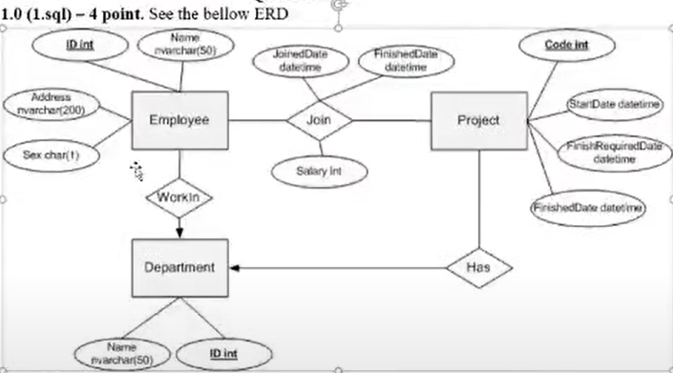**

**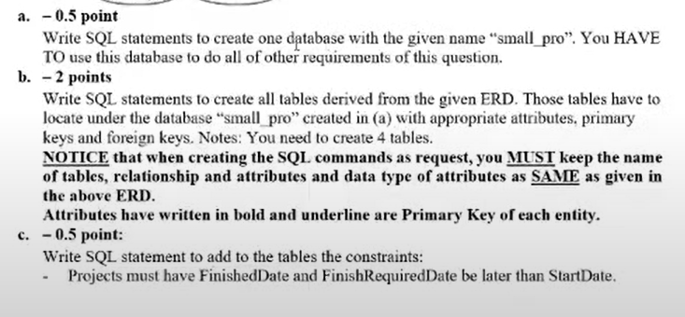**

**CÂU 2**

* 1. **Select all acount which have open\_date in March 2001**



**1.2 Select all acount which have time between last\_activity\_date and open\_date equal 4 years**

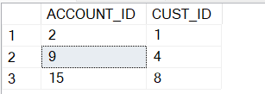

**2.1.Select all are individual customer**

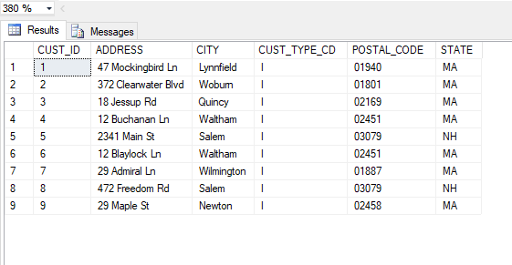

**2.2 Count number of all business customer**

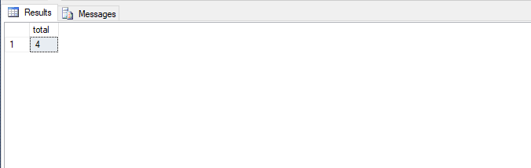

**3. Select all account which have AVAIL\_BALANCE different PENDING\_BALANCE**

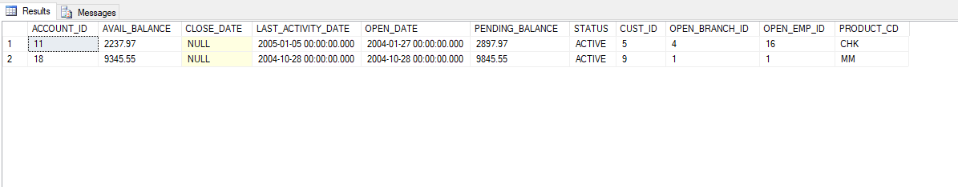

**4. Select all customer**

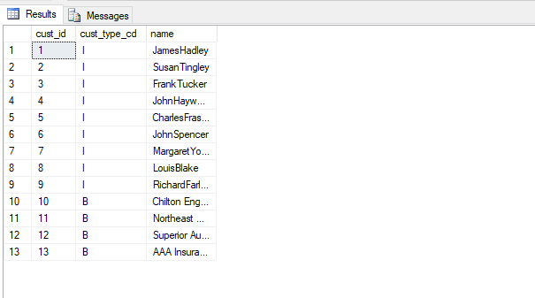

**Yêu cầu #1 : tăng dần theo tên**

**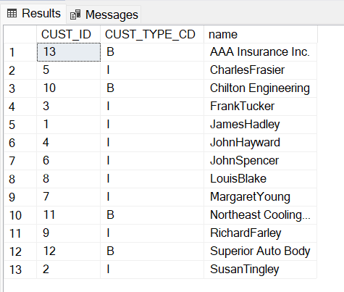**

**Yêu cầu #2: tăng dần theo tên nhưng tăng theo từng loại**

**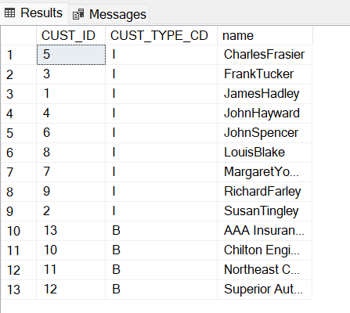**

**5. Count all account of each employee**

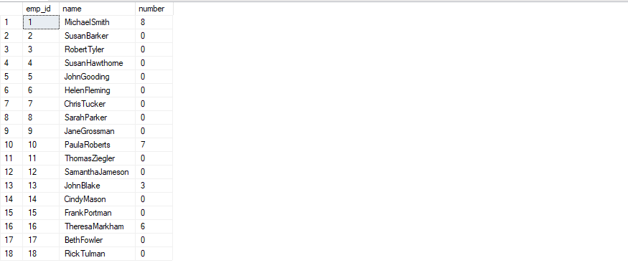

**6. List all account which have one Customer**

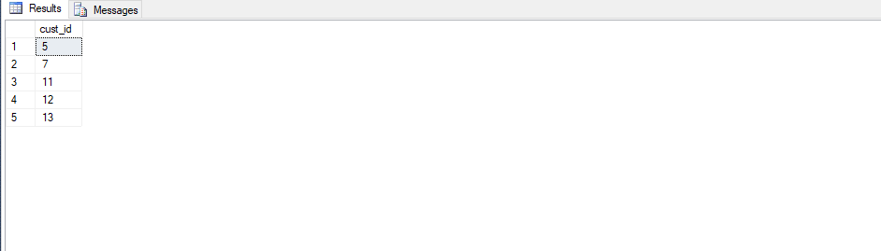

**7. List account which have min or max avail\_balance, but min avai\_balance not equal 0**

