***Hoàng Mai Phương – HE171073 – SE1723***

***Bài làm LAB3 – DBI202***

**Exercise 1**:

300 employees of a company are organized into different departments. For each employee, we have his social security number, name, address, sex, birthdate, phone and email. Each department has a name, a role and a head (who is also an employee). Note that each employee works for only one department at a time but he could change from one department to another department. Each time he works for a department, the company signs a contract specifying his salary, start date and end date. Each department handle a number of projects (each project is handled by only one department). Each project has a name, start date, end date, a project manager and a number of employees who work on it. Note that an employee could work on different projects with a specified number of hour. Each employee may have a number of dependents. For each dependent, we keep track of their name, sex, birthdate and relationship to the employee.

***ERD***

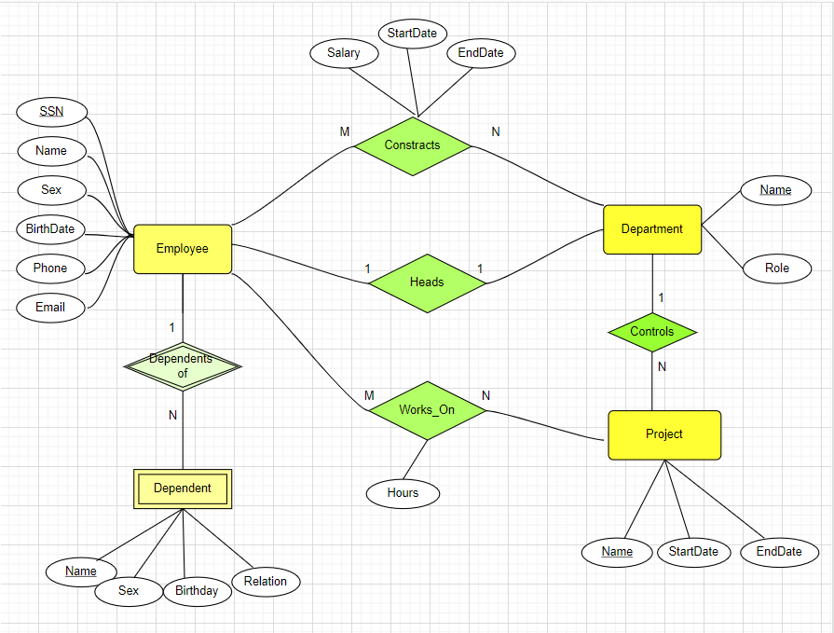

***Relation data model***

**Employees**(SSN, Name, Sex, BirthDate, Address, Phone, Email)

**Dependants**(Name, SSN_Emp, Sex, BirthDate, Relation)

**Departments**(Name, Role, SSN_Header)

**Contracts**(SSN_Emp, Name_Dep, Salary, StartDate, EndDate)

**Projects**(Name, StartDate, EndDate, SSN_Manager)

**Jobs**(SSN_Emp, Name_Project, Hours)

**Exercise 2**:

ABC Consulting is a small-sized consulting firm in the IT industry. ABC’s business is managing several Systems Development projects by assigning staff consultants to these projects as their skills are needed. Each employee is designated to have one primary skill, but there may be other employees with the same primary skill. A consultant may work on one or more projects, or may not yet be assigned to a project. The company charges for each project by billing each consultant's hours worked by the billing rate. The hourly billing rate is dependent on the employee’s primary job skill.

***ERD***

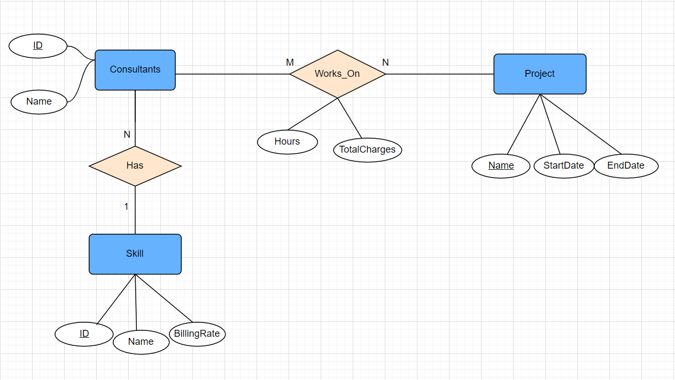

***Relation data model***

**Projects**(Name, StartDate, EndDate)

**Consultants**(ID, Name, ID_Skill)

**Skills**(ID, Name, BillingRate)

**DoJobs** (Name_Project, ID_Consultant, Hours,TotalCharges)

**Exercise 3**:

A company build a website for selling music videos. Each music video has name, id, Production Company, singer, author, release year and price. Assume that each music video could have only one author but could be presented by many singers. Music videos are classified into different categories. A customer could buy many music in an order. Note that the price for music video could be changed by time (only the current price is record for the entity music video). For each music video in an order, there could have a percentage of reduction. When making an order, the customer could decide to be a member (with login and password) for having further promotion and for saving his information for further orders.

***Relation data model***

Videos(ID, CurrentPrice, Year, pComp, ID_Author)

Categories(ID, Name)

Videos_Categories(ID_Video, ID_Category)

Authors(ID, Name)

Singers(Name, Address)

Videos_Singers(ID_Video, Name_Singer)

Members(ID, Login. Password)

Orders(ID, Date, ID_Member)

Videos_Orders(ID_Order, ID_Video, Price, Quantity, Percentage)

***ERD***

