***DATABASE***

***\*\*For Cairo Bank***

***personal information***

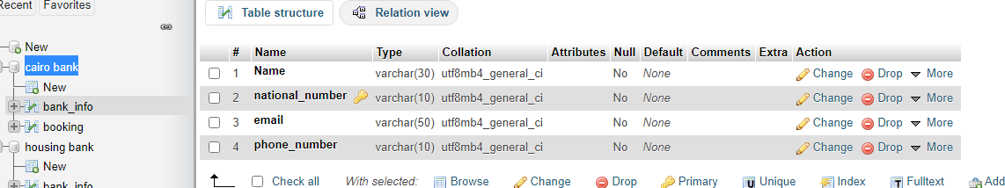

***booking information***

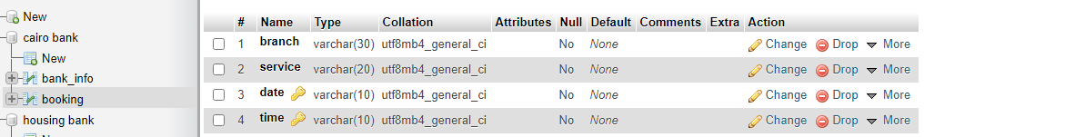

***\*\*For Housing Bank***

***personal information***

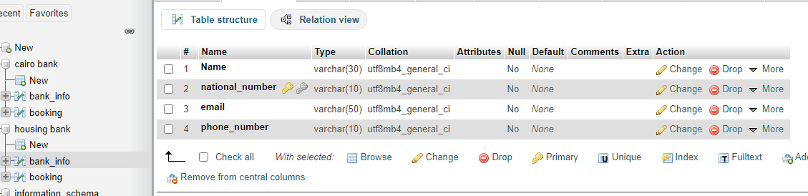

***booking information***

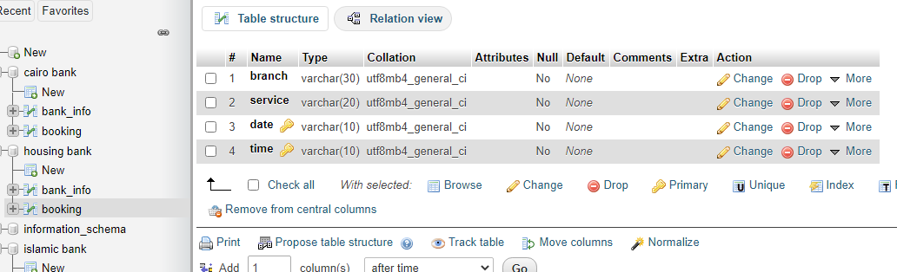

***\*\*For Islamc Bank***

***personal information***

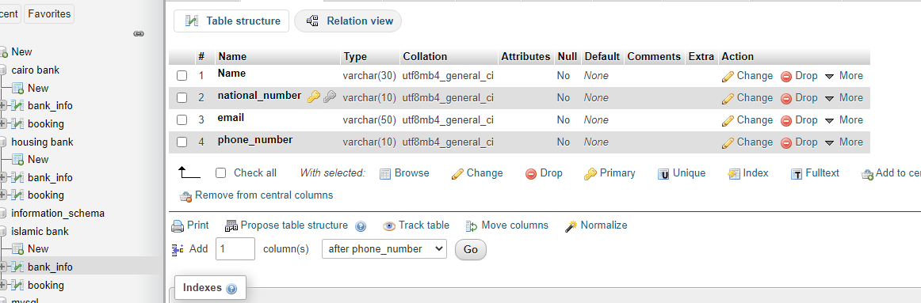

***booking information***

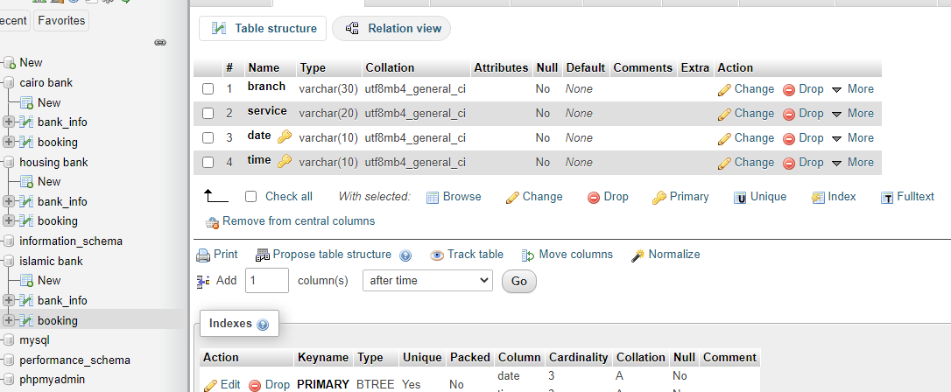

EXAMPLE

