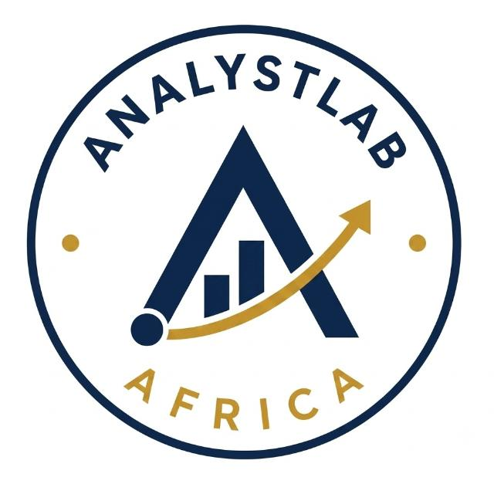
Data Science Internship Programme
Business Understanding Report - Week 1: Employee Attrition Analysis

1. Business Context
ABC Manufacturing Ltd has engaged AnalystLab Africa Consulting to investigate why employees are leaving the company. Employee attrition the rate at which staff voluntarily or involuntarily leave an organisation is one of the most closely watched workforce metrics in modern HR management, because its costs extend well beyond the visible expense of recruitment.
Before ABC Manufacturing Ltd invests in a predictive machine learning model to flag at-risk employees, the HR department first needs a clear, evidence-based understanding of the current attrition situation: how big the problem is, where it concentrates, and which factors appear to be driving it. This report frames that business problem and explains why a data-driven approach is appropriate.

2. Why Employee Attrition Matters to the Business
Attrition carries both direct and indirect costs for an organisation such as ABC Manufacturing Ltd:
- Replacement costs - advertising roles, screening and interviewing candidates, and onboarding new hires typically cost the equivalent of several months of the departing employee's salary.
- Lost productivity - new hires take time to reach full productivity, and teams often operate short-staffed during the gap between departure and replacement.
- Loss of institutional knowledge - experienced employees carry process knowledge, client relationships, and technical expertise that are difficult to transfer or replace quickly.
- Morale and cultural impact - high attrition, especially in specific teams or roles, can unsettle remaining staff and create a self-reinforcing cycle of further departures.
- Disruption to delivery - in manufacturing environments particularly, unplanned staff shortages can directly affect production schedules and quality.
For these reasons, understanding and reducing avoidable attrition is a strategic HR priority, not simply an administrative concern.

3. How Data Science Supports HR Decision-Making
Traditionally, HR decisions about retention have relied heavily on exit interviews, manager judgement, and anecdotal evidence. These sources are valuable but limited: they are collected after an employee has already decided to leave, and they can be biased or incomplete.
Data science allows HR teams to move from a reactive to a proactive stance by:
- Quantifying attrition patterns objectively across departments, roles, tenure, compensation, and demographics, rather than relying on impressions.
- Identifying the strongest statistical drivers of attrition (e.g. overtime, income, job role) using exploratory data analysis and correlation techniques.
- Enabling predictive modelling that can flag employees at elevated risk of leaving before they resign, giving HR a window to intervene.
- Supporting evidence-based policy decisions - for example, whether to revisit overtime practices, compensation bands, or career progression paths in specific departments.
This project follows a structured approach: before any predictive model is built, the team first develops a solid Business Understanding of the problem and performs thorough Data Exploration the two phases covered in this Week 1 assignment. This mirrors the industry-standard CRISP-DM methodology for data science projects (Business Understanding → Data Understanding → Data Preparation → Modelling → Evaluation → Deployment).

4. Objectives of This Analysis
The specific objectives of this Week 1 phase are to:
- Understand the shape and quality of the workforce dataset provided by ABC Manufacturing Ltd.
- Explore attrition patterns across departments, job roles, age, income, and overtime status.
- Translate the HR department's business questions into answerable data questions.
- Surface an initial set of business insights that can inform HR policy discussions and guide the design of a future predictive model.

5. Scope and Limitations
This report is based on the IBM HR Analytics – Employee Attrition & Performance dataset (1,470 employee records, 35 attributes), used as a proxy dataset representative of ABC Manufacturing Ltd's workforce for the purposes of this exercise. As with any dataset, the findings reflect correlation, not proven causation the patterns identified here provide a strong evidence base and starting point for HR discussion, but should be validated against ABC Manufacturing Ltd's own operational context before major policy changes are made.

