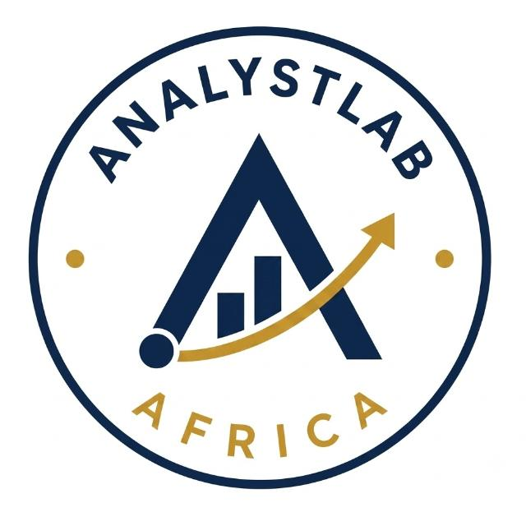
AnalystLab Africa
Reflection Report - Week 1: Business Understanding & Data Exploration

Reflection
[Note to intern: this reflection has been drafted as a starting template. Please personalise it with your own genuine experience, challenges, and thoughts before submission - assessors are specifically looking for authentic reflection, not generic statements.]
Working through Week 1 of the Data Science Internship Programme gave me a much clearer picture of what it actually means to 'understand a business problem' before touching any code. My instinct going in was to jump straight into the dataset and start building charts, but framing the Business Understanding Report first forced me to slow down and think about why ABC Manufacturing Ltd cares about attrition in the first place - the cost of replacing staff, the loss of institutional knowledge, and the knock-on effect on team morale. That context made the exploratory analysis feel purposeful rather than mechanical.
The Data Inspection stage was a useful reminder that even a well-known, 'clean' dataset like the IBM HR Analytics dataset still needs to be verified rather than assumed. Checking for missing values, duplicates, and constant columns (EmployeeCount, StandardHours, Over18) showed me that a dataset can look complete at a glance while still containing columns that add no analytical value and should be dropped before any modelling stage.
The visualisation and insight-generation stage was the most interesting part. Some findings confirmed intuitive expectations for example, that overtime and lower income are associated with higher attrition. Others were more specific than I expected, such as how concentrated attrition is in the Sales Representative role (almost 40%) compared to Managers or Research Directors (under 5%). Translating these patterns into plain-language business insights, rather than just presenting charts, helped me appreciate the difference between doing analysis and communicating analysis a skill that seems central to the Data Scientist role.
One challenge I encountered was resisting the urge to over-interpret correlations as causes. It was tempting to conclude, for instance, that overtime 'causes' attrition, when the data can only show association. I had to be careful in my write-up to frame these as patterns worth investigating further, not proven cause-and-effect relationships.
Going into Week 2, I want to build on this foundation by exploring how these initial insights could be validated with statistical testing, and by thinking more critically about how the class imbalance in the target variable (16% attrition vs 84% retention) will need to be handled once we move toward predictive modelling. Overall, this week strengthened both my technical EDA workflow and my ability to connect data findings back to a real business decision-making context.

