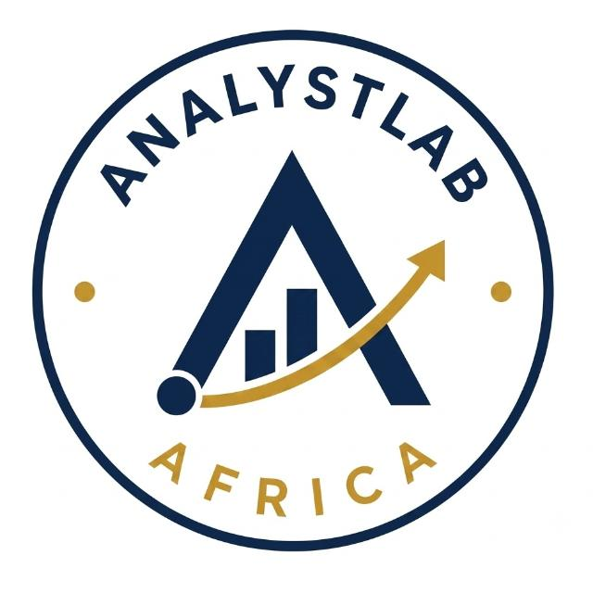
AnalystLab Africa - HealthConnect Experience Lab
Week 7 HC-POD Cross-Track Testing Evidence
This document evidences the mandatory Week 7 HC-POD cross-track testing/validation activity between the Data Science and Data Analytics tracks, structured around the 12 required documentation points, following the cycle: Test → Finding → Action → Retest → Validated Improvement.

1. Track Collaborated With
Data Analytics (continuing the relationship established during the Week 6 integration exchange).

2. Project Dependency
Data Analytics' own Week 6 findings document posed a direct question to the Data Science track: "Do the model's highest-risk predictions align with the high-risk segments identified during the Data Analytics work?" This created a concrete testing dependency between the two tracks' outputs.

3. Component/Output Being Tested
The Week 6 candidate model's risk predictions (top-quartile predicted no-show probability) on the held-out test set.

4. Information/Output Received
Data Analytics' independently-validated high-risk segment definitions, originally shared in their Week 6 findings document: patients with 3 or more previous no-shows, appointments booked 31-60 days in advance, and patients travelling 20km or more to the clinic.

5. Information/Output Provided
The result of the alignment test below (Sections 6-7), plus a newly discovered gender fairness gap in the model, shared back with the Data Analytics track intern (Section 9) for their awareness and potential input.

6. Testing Activity Completed
The candidate model was used to score every appointment in the held-out test set. The top quartile of predicted risk scores was taken as the model's own definition of "high-risk." This was compared against Data Analytics' high-risk criteria (Section 4) to compute an overlap/alignment rate.

7. Issue or Finding Identified
Metric | Value
Model-flagged top-quartile-risk appointments | 237
Also matching a Data Analytics high-risk criterion | 233
Alignment rate | 98.3%

Primary finding: a very high, 98.3% alignment a successful validation, not an issue requiring correction. While testing the model more broadly this same week (patient-level split, threshold tuning, subgroup fairness see the main Week 7 notebook), a second, genuine issue was identified and is reported here as it was shared with Data Analytics as part of this same testing cycle: a gender-based performance gap.
Subgroup | n (test set) | ROC-AUC
Male | 443 | 0.725
Female | 485 | 0.639
Prefer not to say | 20 | 0.845 (small sample, not conclusive)

8. Refinement/Action Taken
For the alignment finding: none needed successful validation. For the gender fairness finding: engineered two interaction features (female × booking lead days, female × distance to clinic), intended to let the model learn gender-specific relationships for its two strongest predictors, and retrained the candidate model with them included.

9. Retest Result
Subgroup | ROC-AUC Before | ROC-AUC After Refinement
Male | 0.725 | 0.723
Female | 0.639 | 0.636

10. What Changed as a Result
For the alignment test: nothing needed to change the model's approach was confirmed sound, giving both tracks confidence to proceed without rework. For the fairness test: the refinement attempt did not close the gap, so the model itself did not change, but the project's readiness assessment did change the model is now presented as suitable only as a prioritisation aid with an explicit, documented fairness caveat, rather than as broadly validated as it was framed at the end of Week 6.

11. Evidence
The quantitative alignment computation and the fairness before/after comparison (both reproduced above), the full test code and outputs in HealthConnect_Model_Testing_Refinement.ipynb (Parts 3, 3b, and 4a), this standalone evidence document, and the message shared with the Data Analytics track intern (Section 12).

12. How This Improved the Overall HealthConnect Solution
This activity moved the relationship between the Data Science and Data Analytics tracks from Week 6's information exchange to genuine mutual validation: the 98.3% alignment result gives the whole HealthConnect project concrete, tested evidence that its analytical and predictive workstreams describe the same at-risk population, rather than two untested parallel efforts. Equally important, testing this integration surfaced a real equity risk (the gender fairness gap) that neither track's Week 6 work had identified in isolation catching this now, before Week 8's final integration and presentation, protects the overall HealthConnect solution from presenting an unvalidated, potentially inequitable tool as finished. Both outcomes the successful validation and the honestly-reported unresolved issue make the eventual HealthConnect solution more trustworthy than either track could establish alone.

13. Message Shared with Data Analytics
"Tested whether our model's top-risk predictions align with your defined high-risk segments (3+ previous no-shows, 31-60 day lead time, 20km+ distance) 98.3% alignment on the held-out test set. Strong cross-validation of both our approaches. Separately, I found a fairness gap in the model: it performs noticeably worse for female patients (ROC-AUC 0.64) than male patients (ROC-AUC 0.73). I tried adding gender-interaction features but it didn't fix the gap wanted to flag in case your segment-level analysis shows anything by gender that could help explain this before Week 8."

14. Summary: Testing Cycle Completed
Stage | Result
Test | Model risk predictions vs. Data Analytics high-risk segments
Finding (validation) | 98.3% alignment successful, no action needed
Finding (new issue) | Gender fairness gap: 0.725 (M) vs 0.639 (F)
Refinement | Gender-interaction features added and retrained
Re-test | Gap unchanged (0.723 vs 0.636) refinement unsuccessful
Outcome | Issue documented as open; readiness assessment revised

