
Name: Maira Rizwan
Registration Number: FA24-B1SE-074
Section: B
GitHub Username: mairairizwan74
Assignment: 01
(Sir Waqas Saleem)

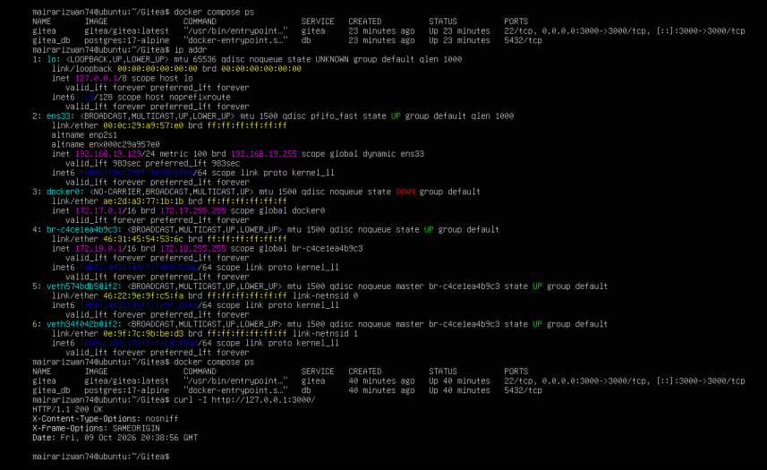
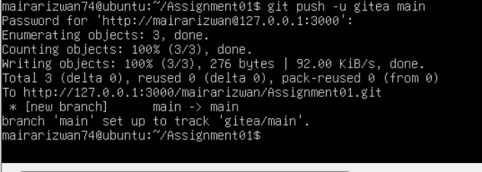
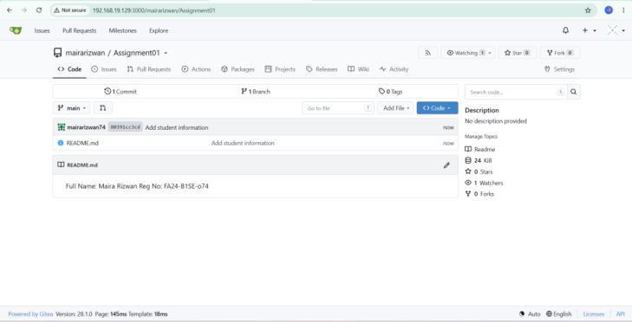
Task 1: Install Gitea and Push a Repository
Task:1.1 (task1_gitea_running)
Task: 1.2 (task1_gitea_push:)
Task: 1.3 (task1_gitea_repository)

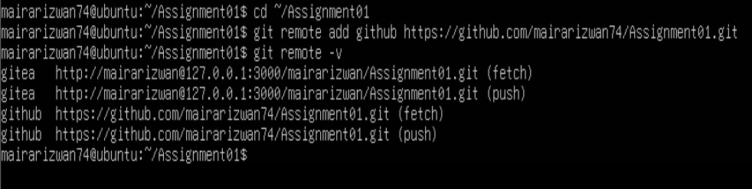
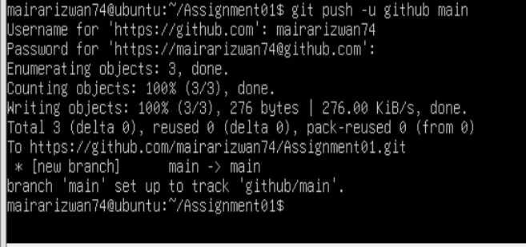
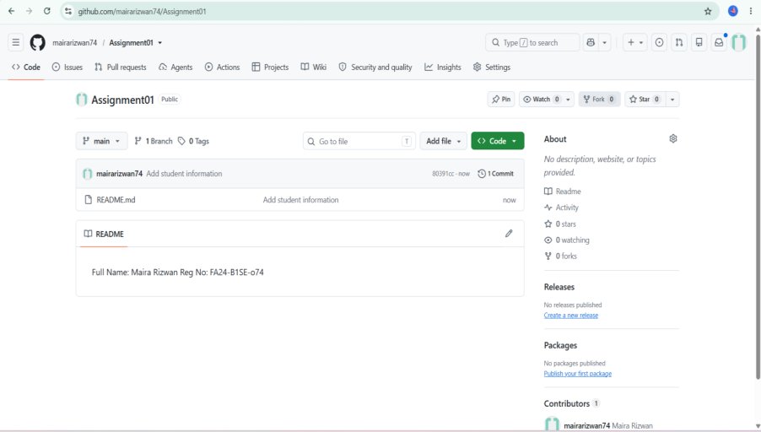
Task 2: Push the Same Repository to GitHub
Task 2.1 (task2_remotes)
Task 2.2 (task2_github_push)
Task 2.3 (task2_github_repository)
Task 3: Track Three Large Files with Git LFS
Task 3.1 (task3_lfs_setup)

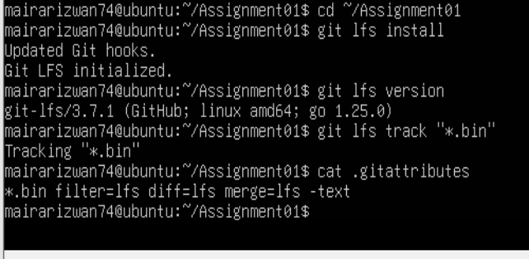
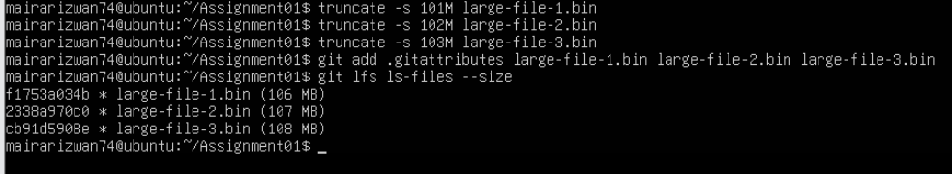
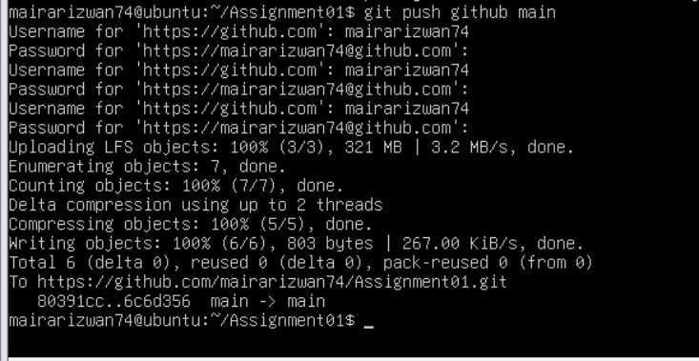
Task 3.2 (task3_lfs_files.png)
Task 3.3 (task3_lfs_push.png)
Task 4: Create a Portfolio or CV with GitHub Pages
Task 4.1 (task4_pages_repository)

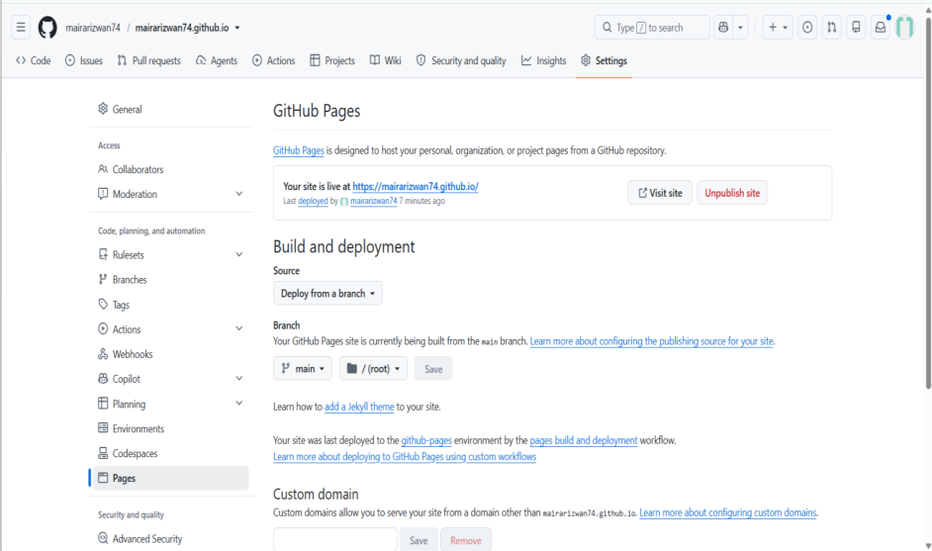
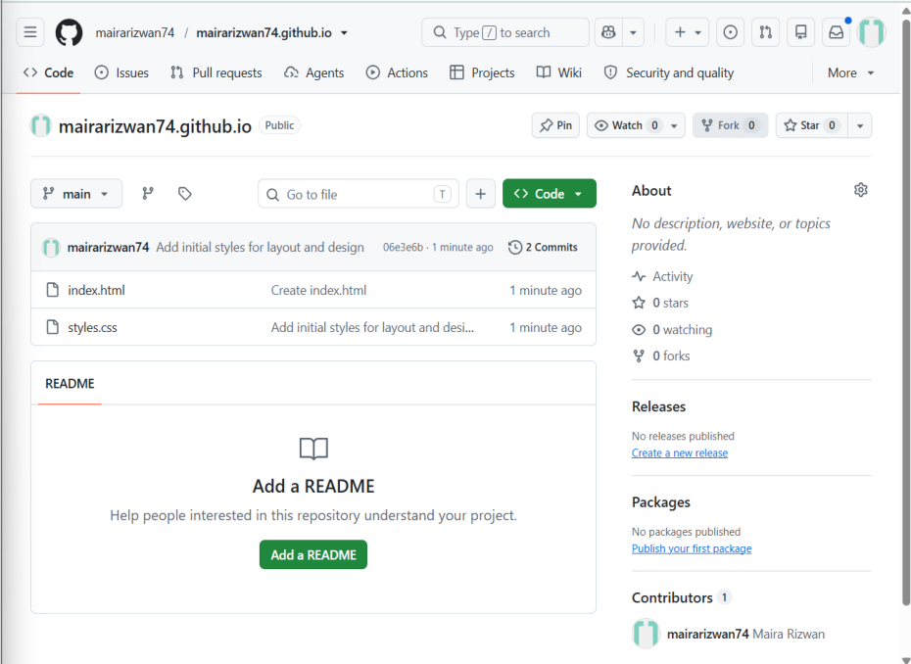
Task 4.2 (task4_pages_deployment)
Task 4.3 (task4_portfolio_live)

