Case Study Script

Eco vs. Economy: The NovaTech Decision

Decision 1: Material Choice
NovaTech Electronics is a mid-sized consumer tech company known for affordable, stylish devices. The leadership wants to expand into the competitive wireless headphones market. To stay profitable, they need to keep costs down, but in a world where consumers and regulators are watching sustainability closely, every material choice carries risk. Today, NovaTech’s engineering team must decide which material to use. Their choice will shape not only the product’s price and launch schedule, but also the company’s long-term reputation.

Amira (Project Lead, calm but firm): “Alright team, we need to lock down the material today. The deadline is coming fast, and leadership wants clarity.”
Luis (Supply Chain Manager, pragmatic): “Material A is the obvious choice. It’s cheap, easy to source, and keeps us on schedule. No supplier headaches.”
Devon (Sustainability Engineer, concerned): “But Material A is non-recyclable. It produces toxic waste. If we choose it, we’re ignoring long-term environmental impact.”
Maya (Marketing Specialist, strategic): “Consumers are watching, Amira. If we launch with Material A, reviewers and social media could slam us. Competitors are already branding themselves as eco-friendly.”
Amira (looking around the table): “So here’s the trade-off:
Material A keeps costs low and launches on time, but carries environmental risks.
Material B costs more, requires supply chain changes, but is sustainable and future-proof.
What should we decide?”
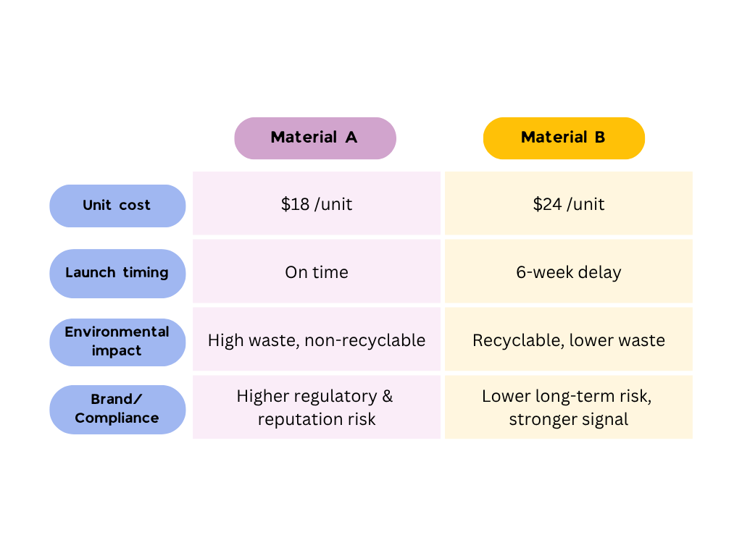

Additional context:
- Leadership wants the product launched before the holiday sales cycle.
- Investors are watching profit margins closely.
- The EU is considering tighter environmental restrictions on electronics materials.

New quick interaction before Decision 1:
Before choosing a material, which factor should NovaTech prioritize most at this stage?
- Immediate cost and speed
- Long-term sustainability and compliance
- Brand reputation and customer trust
- A balance across multiple stakeholders

Decision Point:
Choose your path:
- Material A: Cheaper, faster, but toxic and non-recyclable.
- Material B: Costlier, slower, but sustainable and recyclable.

Feedback after Decision 1:
If Material A is chosen:
- This choice protects cost and schedule in the short term, but it increases long-term environmental, regulatory, and reputational risk.
If Material B is chosen:
- This choice improves sustainability and future compliance, but it increases short-term cost pressure and creates supply-chain uncertainty.

Decision 2A:
Handling Pressure (after choosing Material A)
Six months later, the headphones launch was a financial success. But soon, watchdog reports expose the toxic waste created by Material A. Social media backlash erupts under #NovaTechWaste, and new EU regulations threaten to ban materials like A.

Amira (worried, holding a report): “This is serious. Regulators are circling, and the backlash is growing. We need a response—fast.”
Luis (defensive): “Switching now would be chaos. Contracts, suppliers, production—everything is locked in. We can’t afford a redesign.”
Devon (firm, frustrated): “This is exactly what I warned about. We need to pivot to sustainable materials before regulators force us into a corner.”
Maya (urgent, stressed): “Our reputation is tanking. Reviewers are calling us irresponsible. Competitors are already using this against us. We need to show we care—or risk losing trust completely.”

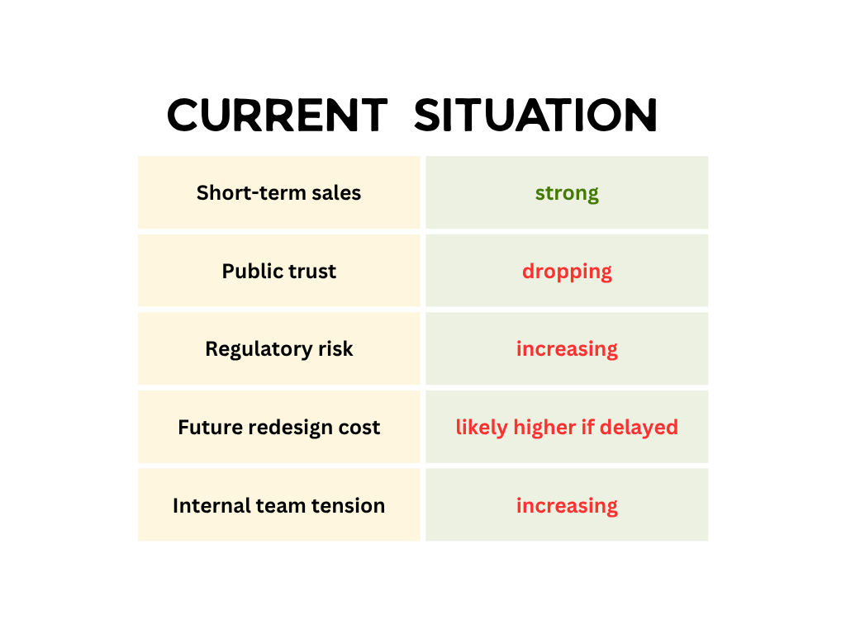

New outcome comparison after Decision 2A options

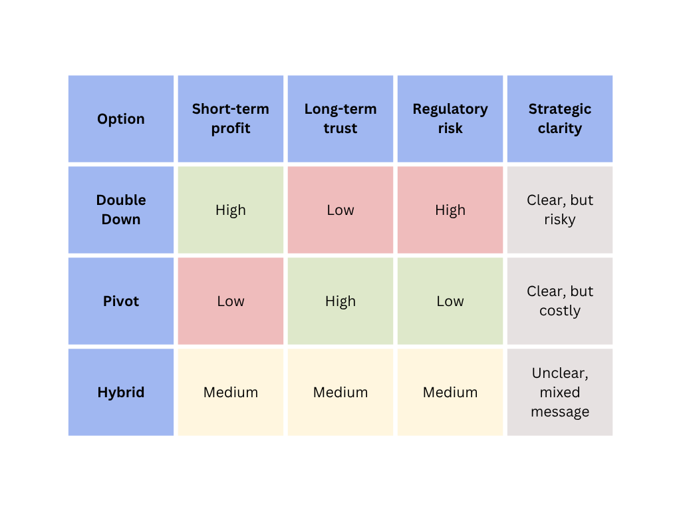
Decision Point
"How should NovaTech respond to the crisis?"
Option 2A: Double Down — Stay with Material A, absorb the criticism, focus on cost savings.
Option 2B: Pivot — Redesign with Material B, take the hit now to rebuild trust.
Option 2C: Hybrid — Launch both a “cheap line” and a “green line” to balance costs and image.

Decision 2B: Handling Pressure (after choosing Material B)
NovaTech launches its sustainable headphones. Media outlets praise the decision, but investors worry about delays and higher costs. Meanwhile, supplier hiccups threaten to stall production further.

Amira (concerned, addressing the team):
“Leadership is pushing back. They’re asking if the delays and higher costs are worth it. We need to justify this decision.”
Luis (pressured, frowning):
“Suppliers are struggling. We’ve had two missed deliveries already. If this keeps up, the timeline slips even further.”
Devon (confident, hopeful):
“Stay the course. This is the right path. Regulations are tightening—when they hit, we’ll already be compliant.”
Maya (measured, persuasive):
“Consumers love the story, but if shelves are empty, loyalty won’t last. Maybe we need a plan B to show flexibility.”

New performance panel
Current situation
- Brand response: positive
- Investor patience: low
- Supply reliability: unstable
- Compliance readiness: strong
- Customer demand risk: rising if delays continue

Decision Point
"How should NovaTech handle investor pressure and supply chain problems?"
Option 2A: Double Down — Stick firmly with Material B, no compromises.
Option 2B: Pivot — Roll back to Material A to cut costs and speed delivery.
Option 2C: Hybrid — Offer both a “green premium” line and a cheaper line for investors.

New feedback after Decision 2B choice
Double Down:
This protects values and long-term positioning, but it requires tolerance for short-term pain.
Pivot:
This relieves short-term pressure, but it undermines credibility and weakens the original sustainability commitment.
Hybrid:
This may look flexible, but it can also create confusion and expose the company to accusations of inconsistency or greenwashing.

Decision 2A — Material A Path Scripts

Option 2A: Double Down: Stay with Material A
NovaTech decides to stay with Material A, hoping to ride out the backlash and focus on cost savings.

Amira (determined, but tense):
“We’ll hold the line. Costs stay low, production continues, and leadership gets their numbers.”
Luis (relieved):
“That’s the right call. Our contracts are solid, and this avoids chaos in the supply chain.”
Devon (frustrated, shaking head):
“This is short-sighted. Regulators will ban this material. We’re ignoring the future.”
Maya (warning, serious):
“And the public won’t forget. Right now we look like we don’t care about sustainability. This could define our brand for years.”

NovaTech has chosen to double down. For now, costs stay low and production runs smoothly. But regulators and the public are closing in. The real question is—how will the team handle these challenges together?

Option 2B: Pivot: Redesign with Material B
NovaTech makes the difficult decision to pivot, redesigning with Material B. The choice comes at a high cost, but positions the company for long-term survival.

Amira (resolute, steady):
“It’ll hurt now, but we need to fix this before it’s too late. Let’s shift to Material B.”
Luis (worried, flipping through notes):
“Redesigning now means delays of several months and a mountain of new contracts. It’s a logistical nightmare.”
Devon (relieved, supportive):
“Finally. This is the right choice. We can still protect the company’s future and align with where regulations are headed.”
Maya (cautious optimism):
“It won’t erase the damage overnight, but at least we’ll have a story: NovaTech listened, corrected, and changed course. That matters.”

NovaTech has chosen to pivot, abandoning Material A for a sustainable redesign. The costs are high, and production slows—but trust begins to rebuild. The decision is made, but now the team must decide: how should they move forward together?

Option 2C: Hybrid: Cheap Line + Green Line
NovaTech tries to balance the backlash with a hybrid approach: one product line with Material A, another with Material B.

Amira (trying to mediate):
“Alright, let’s do both. We’ll keep Material A for the budget market and launch a green line for reputation.”
Luis (satisfied):
“That’s manageable. We keep our supplier contracts and add the new material in slowly.”
Devon (shaking head, disappointed):
“This is a half-measure. We’re still polluting, still ignoring responsibility. Consumers will see right through it.”
Maya (uneasy, skeptical):
“Exactly. Selling both sends a mixed message. Are we sustainable, or not? Competitors will call this out as greenwashing.”

NovaTech has chosen a hybrid path: one line with Material A, another with Material B. It buys time, but creates confusion inside and outside the company. With pressure rising, the real test is not just what NovaTech decides—but how the team makes those decisions together.

Decision 2B: Material B Path Scripts
Option 2A: Double Down (stick firmly with Material B)

NovaTech stands firm. Despite investor pressure and supply chain hiccups, the team commits fully to Material B.

Amira (resolute): “We’ve made our choice. No compromises. NovaTech is staying with sustainable materials.”
Luis (worried): “That means more delays if suppliers can’t deliver. We’ll have to renegotiate contracts.”
Devon (energized): “This is leadership. We’ll be ready for regulations and set the standard in green tech.”
Maya (calm, strategic): “It’ll be tough with investors, but our brand will stand out as consistent and principled.”

NovaTech stands firm. The team refuses to compromise on sustainability, even as investors complain and suppliers struggle. In time, their persistence pays off—but the pressure inside the team is far from over. The real question is: how will they continue to work together under this strain?

Option 2B: Pivot (roll back to Material A)

Under pressure from investors, NovaTech abandons Material B and returns to Material A.

Amira (hesitant, uneasy): “This isn’t ideal, but leadership wants results. We’ll roll back to Material A.”
Luis (relieved): “That stabilizes the supply chain. At least the delays will stop.”
Devon (frustrated, disappointed): “So we threw away progress for short-term comfort? We just destroyed our credibility.”
Maya (grim): “She’s right. Consumers will see this as hypocrisy. Once trust is lost, it’s almost impossible to get it back.”

NovaTech gives in to pressure, abandoning Material B and rolling back to Material A. Investors breathe easier, but trust from consumers and advocates collapses. The team now faces a new challenge: not just what to produce, but how to make decisions when their values collide.

Option 2C: Hybrid (green premium + budget line)

"NovaTech tries to balance competing pressures with a hybrid approach: one sustainable ‘premium’ product line, one cheaper budget line using Material A."

Amira (mediating): “Let’s offer both: a green premium line and a budget line. It’s not perfect, but it might satisfy everyone.”
Luis (practical): “That’s workable. We can keep our old contracts and build new ones slowly.”
Devon (disheartened): “This undermines everything we stood for. Are we committed to sustainability or not?”
Maya (concerned): “Consumers will be confused. Some will see this as innovation, but others will call it greenwashing.”

NovaTech tries to balance both worlds with a dual strategy—eco-friendly for some, cost-friendly for others. The move buys time, but creates confusion inside and outside the company. Now the team must decide: how should they work together to navigate this uncertain path?

Decision 3: Team Communication & Dynamics
The material choice is made, and NovaTech has acted under pressure. But the way the team makes decisions together will shape trust, morale, and NovaTech’s future culture. Will Amira take full control, will the team deliberate together, or will sustainability concerns be sidelined once again?

Amira (serious, under pressure):
“We need a clear path forward. The decision itself matters, but so does how we get there.”
Luis (hesitant):
“I’d rather leadership just make the call. We can’t afford more delays.”
Devon (insistent):
“We can’t keep ignoring different voices. If sustainability gets sidelined again, we’ll keep repeating mistakes.”
Maya (thoughtful):
“The process we use now will set the tone for every future project. Both speed and teamwork matter.”

At this point, NovaTech is not only deciding what to do. It is also deciding what kind of company culture it wants to reinforce.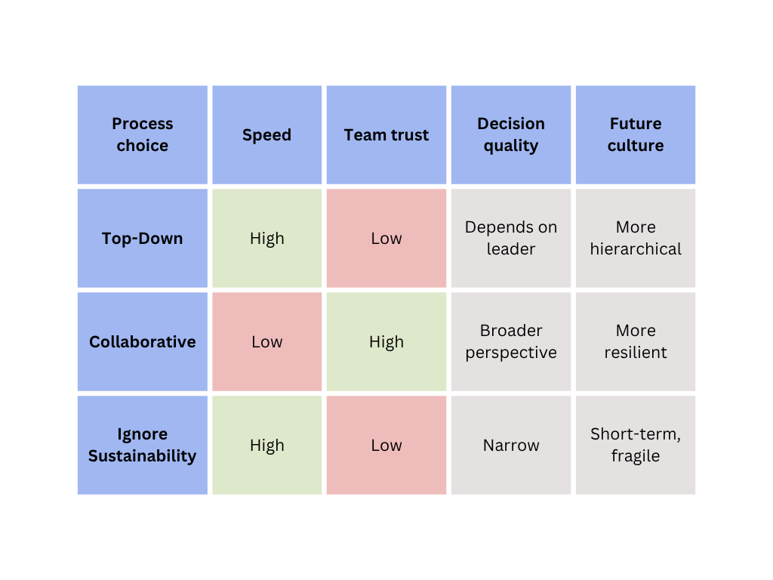

Decision Point
"How should NovaTech make this critical decision?"
Option 3A: Top-Down — Amira decides quickly, prioritizing efficiency.
Option 3B: Collaborative — The team deliberates together, balancing perspectives.
Option 3C: Ignore Sustainability — Devon’s concerns are dismissed, and the focus stays only on cost and delivery."

Option 3A: Top-Down

Amira asserts control, making the decision herself in the interest of speed and clarity.

Amira (decisive): “Enough debate. I’m making the call. This is the path we’ll take.”
Luis (relieved): “Good. Now we can finally move forward without more delays.”
Devon (quietly frustrated): “So much for shared responsibility.”
Maya (measured): “It’s efficient, but people will remember how their voices were treated.”

Decisions move quickly, but morale drops. Some voices feel silenced, and trust erodes over time.

Option 3B: Collaborative
Amira opens the floor. The team deliberates together, weighing cost, ethics, and sustainability.

Amira (open, calm): “Let’s hear everyone out. We need a decision we can all stand behind.”
Luis (uncertain, but engaged): “It’ll take longer, but maybe that’s worth it.”
Devon (encouraged): “This is the only way we’ll avoid the same mistakes.”
Maya (positive): “Collaboration takes time, but it strengthens us as a team.”

The process is slower, but every voice is heard. The team builds trust and resilience, setting a foundation for future challenges.

Option 3C: Ignore Sustainability
Amira and Luis sideline Devon’s concerns, focusing only on cost and delivery.

Amira (firm, impatient): “We don’t have time for another debate on sustainability. We’re moving forward on cost.”
Luis (supportive): “That’s the practical choice. Let’s not overcomplicate this.”
Devon (angry, disheartened): “So my input doesn’t matter? Then don’t be surprised when we face the same fallout again.”
Maya (hesitant): “We might gain speed now, but at what cost to our credibility?”

The project advances, but the culture weakens. Sustainability is ignored, morale falls, and NovaTech repeats the same mistakes.

New final debrief screen
Text: NovaTech’s decisions show that engineering trade-offs are rarely only technical. Cost, schedule, sustainability, regulation, reputation, and team culture can all pull in different directions at the same time.
Key lesson 1:
Key lesson 2:
A sustainable decision may strengthen long-term trust, but it still needs realistic implementation planning.
Key lesson 3:
The way teams make decisions can shape morale, trust, and future organizational behavior.

