Managing Tasks
In (your collaboration platform e.g. MS Teams, Discord, …) > #Everyone
Teamwork requires careful task management, which includes:
  - Writing down everything you need to do in a shared place, so everyone can collaborate on those shared to do items.
  - Assigning ownership to tasks, so everyone is clear who is responsible for completing the task.
  - Assigning deadlines to tasks, so everyone can coordinate their time and responsibilities.
  - Communicating about tasks, so everyone has what they need to get their tasks done.
Tools can help with task management, but they only work if you follow the practices above. Common tools in software engineering include issue trackers (like GitHub issues) and shared task trackers (like Jira, Asana, or other more advanced project management tools).
Your team isn't big enough to need really advanced task management tools. In this class, I'll recommend you use GitHub issues and Github projects to manage your project. Github projects adds more features to Github issues, and is similar to Trello.
Project Managers (PMs): your job is to manage the content of your team's issue tracker. Make sure it reflects the work being done, that everything on it is up to date, and that everyone has tasks.
Let's walk through Facebook's React GitHub issues as an example:
  - The issues tab shows all of the open issues by default
  - Issues describe a feature, problem, or task
  - Issues need descriptive, clear titles and descriptions so that everyone understands them.
  - Issues have an assignee; it's their job to get the work done
  - Issues have labels, which help organize, search, and filter categories of issues.
  - Issues have milestones, which are groups of issues with a shared due date.
  - Issues have comments, which help you discuss the issue.
  - Issues are closed when the work is done, usually culminating in a patch to files in the repository.

With your team, convert Deliverable 0 into issues (20 minutes)
In (your collaboration platform e.g. MS Teams, Discord, …) > your team channel
PMs, lead the conversion of your work into issues. This all takes place in the team repository that Design your Team asked you to make. If you don’t have that yet, use those instructions to make it first.
- Create a milestone on Github for Deliverable 0 with it's deadline
- Create a milestone on Github 48 hours before Deliverable 0 is due, called Deliverable 0 Quality Checking, for when all the work for Deliverable 0 will be completed and ready to be quality checked and integrated together by the team. This is the primary milestone/due date you will set on your tasks.
  - (In the future, you will upgrade your project management to use Github projects so you can set due dates for each task individually)
- As a team, scan Deliverable 0 for work and convert them into small, actionable issues. For each issue:
  - Decide who is doing the work and assign it to them
  - Assign the issue the Deliverable 0 Quality Checking milestone
    - You should have at least 20 issues, e.g. the sections of a document a person will work on, some number of user stories, etc.
    - Here are some examples:
      - Do section X (e.g. prior solution 1) of document Y (e.g. project description), then message the quality checker person for that on your team Discord channel it’s ready to be checked / revised
      - For problem statement 1, address feedback on problem statement 1 with revisions
      - For problem statement 1, reply to the professor’s feedback comments on the Google Document
      - A separate person quality checks problem statement 1 revisions and replies to comments, and the changelog
      - Create the changelog document for changes to problem statements
      - …
    - For the quality checking tasks, Assign the issue the Deliverable 0 milestone
- As you work, you'll identify more tasks; when you do, add them as issues, as you did above.
- It's everyone's job to make sure issues reflect the current status of the work.
  - When you've made progress on an issue, write a comment.
  - When an issue is done, comment on and close the issue, linking to the commit or document that resolved it. (When you make a commit message, if you include in the commit message "Fixed #X", issue #X will be automatically closed and linked to the commit.)
- The project manager's job is to make sure that everyone is getting their assigned issues done. Comment on tasks that are not getting done, @ people in your team channel about that, escalate to the instructor as needed.
- It is also each person’s responsibility to get their assigned issues done.
Example of a screenshare that is helpful. You can open a document on one side and create issues on the other side.
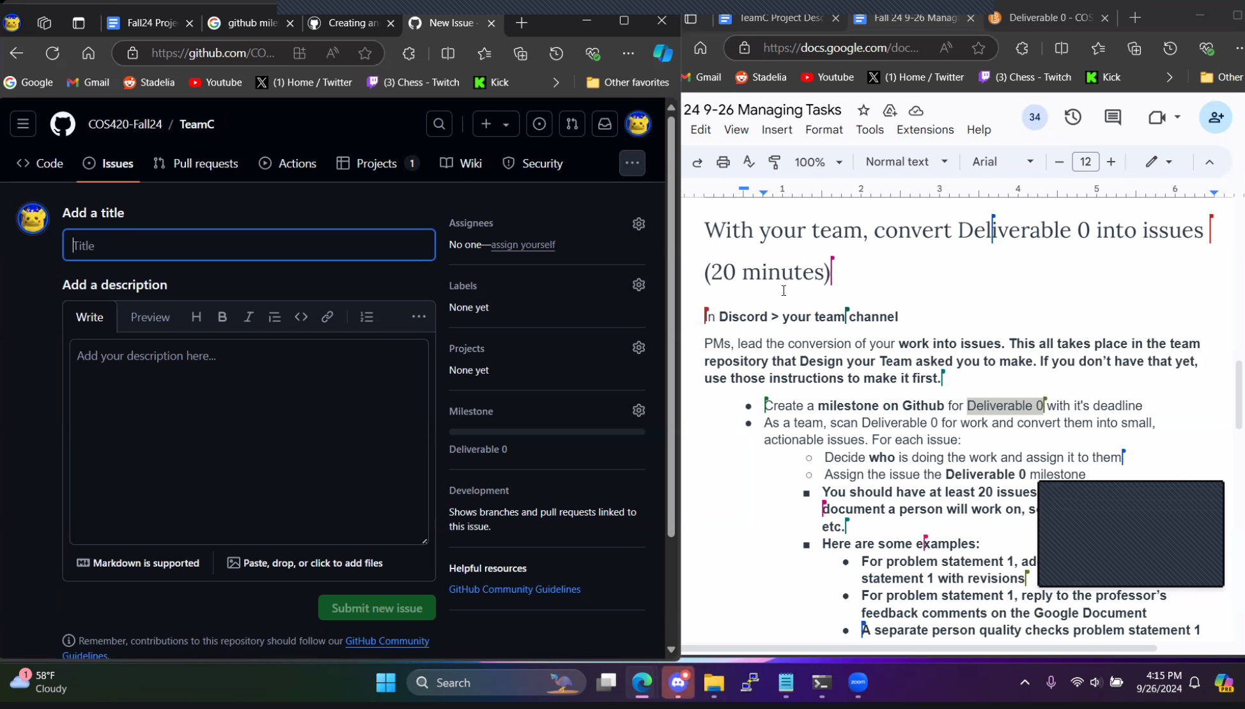
(Note: Adapted and extended by Greg Nelson from materials by Amy J. Ko 🙏 )

