Basic Team Task Management
Creating Tasks During Sprint Planning
Why Quality Checking
How to do Quality Checking
Why having people review other people’s work is important
What should the deadline be for tasks to be ready for quality checking?

Basic Team Task Management
Everyone must attend the sprint planning / kickoff meeting (just like all of your team meetings). Before the meeting
Everyone must read at least one example for each of the deliverable’s parts and the Deliverable rubric (the examples are in the examples listing and linked to in the rubric). I recommend opening them side by side, e.g. the example on the left side of your screen, the rubric on the right.
Review breaking down tasks into small parts and the basics covered in class in the first task management class activity.
By the end of the sprint planning meeting:
- All the tasks for the deliverable have been created and assigned to one person and have due dates.
- Due dates for tasks are at least 2 days before the deliverable is due so your team has time to shift any work from illness, late work, other factors (holidays, etc).
  - In Github projects, the easiest way to set due dates is on the Roadmap view
  - The due date should mean the task is completed and ready for quality checking by another person
- For each task not assigned to one person, there is either:
  - A task to create individually assigned tasks that break the task down into smaller parts. Those “create more tasks” tasks have a due date no later than 2 days after the sprint planning meeting.
  - If the task is actually for 2 or more people to synchronously complete together, a task for the people involved to create a calendar event to set a date and time they will meet and complete the work (your team was tasked with making set aside times for co-working to make this easier, so prefer to use those times). Creating such an event is the standard practice in industry. Everyone involved needs to accept the calendar event and have it on their personal calendar.
- It's everyone's responsibility to make sure issues / the team’s task management system reflect the current status of the work. Your team will follow the standard practices in industry:
  - When you've done any work on an issue, write a brief comment on the issue. That means every day you work on an issue, there should be a brief comment describing what you did.
  - When an issue is done, comment on and move the issue to the “ready for quality checking” status, linking to the commit or document that resolved it. (When you make a commit message, if you include in the commit message "Fixed #X", issue #X will be automatically closed and linked to the commit.)
- If people are not completing their tasks on time, you can create extra columns in the kanban for percent complete e.g. 10-30%, 30-60%, 60-90% (that come before the “ready for quality checking” column).

Creating Tasks During Sprint Planning
Before the meeting, each person needs to have read and understood the example documents for the deliverable. You need to 1) have read and understood at least one, for each part of the deliverable, and 2) have read the rubric. For most people reading the example documents first is easier.
During the meeting, a person (usually the PM) will share their screen and the team will make tasks together.
For each part/section of the rubric:
1) Open at the document / example for that section of the rubric
2) Create tasks for doing the different parts of the document. For larger parts, eg create 15 functional requirements, for example, create 5 tasks for “Create 3 functional requirements”
3) Finish making the tasks
4) Now for each task you made, copy paste the relevant part of the rubric into that task. If the formatting is not correct in the copy paste, open the rubric in Google Docs and go to Tools > Preferences and check “enable markdown”. Now you can do edit > copy as markdown. Then paste that into the description and the formatting and links will be correct.
5) Now assign the tasks to specific people
6) Now go on to the next part of the rubric

Why Quality Checking
Quality checking is why the work of a team becomes better than the skills of any one member of the team. It’s a critical part of software engineering (e.g. code reviews) and team work in general. It’s what takes the work of the team from being correct 80-90% of the time, to 99%+ of the time. And software won’t work without the parts being correct; for example, if there are 10 parts required for some functionality and 80% of them work, the software has a 10.7% chance of working (.8^10).

More generally, the software development process depends on many parts working from requirements to design, implementation, and testing; without a very high quality rate and correction process, errors accumulate very quickly with all the dependencies involved. This is because, as the number of components in a software project increases, the probability that all components work correctly (assuming each has a fixed probability of being correct) decreases exponentially. For example, if each component of a software project has a 90% chance of being correct, the probability that a project with 10 components is entirely correct is .9^10 = ~35%, for 20 components, .9^20=~12%, for 40, 1.5%, for 100, 0.0026%.This is a key root cause of most challenges faced in large-scale software development, where hundreds or thousands of components must interact seamlessly. And for each component, it must have had correct requirements, a correct specification, a correct design, and correct implementation; each piece of the software is the downstream result of all the steps of the software engineering process, each with many potential errors. This is why quality checking is critical. But how do we do it in a team at a larger scale?

How to do Quality Checking
Here is a Review / Quality checking policy you can directly adopt. Your policy needs to ensure 1) individual responsibility for each part of the quality checking, and 2) you can tell what has been quality checked or not by looking at the kanban. See below also for concrete examples.

Review / Quality Check Policy:
All team members shall have their deliverable work reviewed by another team member. This quality checking process should be conducted by another team member familiar with the work (e.g. doing similar work on that part) for efficiency, and distributed across the team. This quality checking should be complete at least 24 hours before any final review of the whole deliverable done by the team (e.g. before a team deliverable review meeting). This includes reviewing code / pull requests.
The person that did the task will assign a reviewer, by:
1) Write a comment on the task @'ing a specific person to do the review e.g. “@name for review:”
2) The comment also has either: a) a couple sentences/bullet points on what was done, or b) “see assigned comments” then add comments on the document on the relevant parts and assign the comments to the reviewer
3) Check the task description in the kanban has the rubric information and/or grading comments that were addressed, so the reviewer knows what to check. If it’s missing, the person doing the task needs to add it.
4) Move the kanban task to the “Waiting for Review” or similarly named lane lane
The reviewer will review / quality check by:
1) Open task in the kanban to view the task guidelines and open relevant examples
2) Open the work and compare to the task description and examples for quality and completeness
3) For revisions, looking at the edit history is very helpful to see what changed
4) Any questions about the reviewed work will be asked of the author in order to clarify any ambiguity or misconceptions, as comments on the kanban task or document
5) Work that does not pass quality check will either be: a) fixed by the reviewer if the work is understandable and fixes are minor, or b) moved back to the In Progress lane and a comment added with what is not done/needs to be fixed (or questions)
6) Work that passes quality checks will be advanced on the kanban; if the reviewer did work they should add a comment on the task with the rough percentage of the task they did/fixed

Be friendly to your team in writing your comments and assume they did they best they could with the knowledge they had at the time. If there is an issue with a person doing work that needs lots of revisions, figure out the root causes via discussion e.g. at the sprint retrospective (root causes might include: knowledge, not seeking clarification, not looking at the examples before doing the work, someone with better knowledge should have been assigned the task or provided mentorship, etc).

Here is an example:
The Kanban
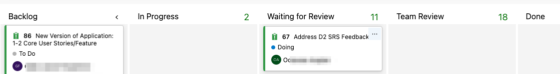

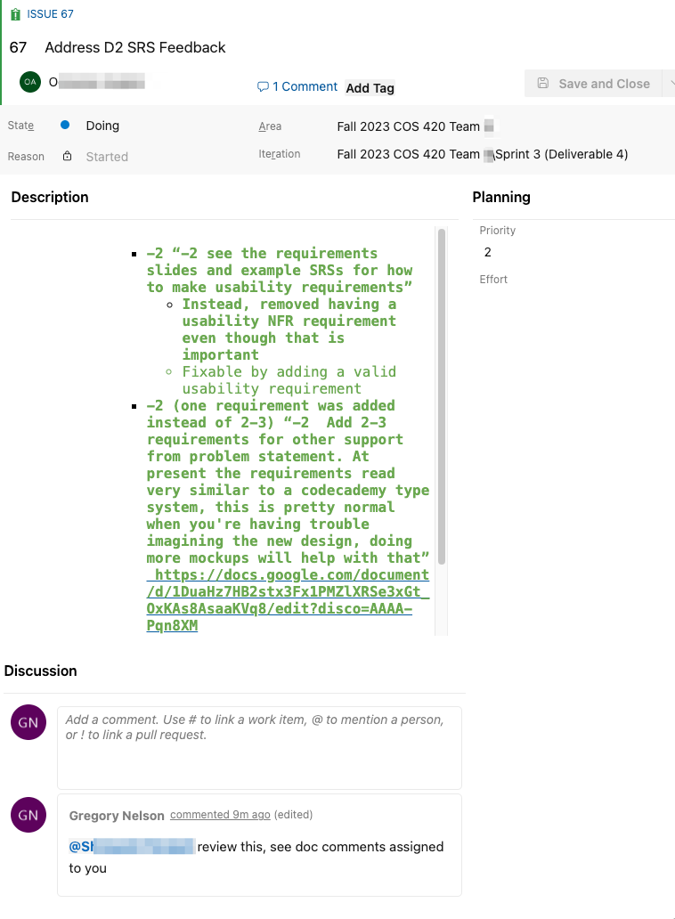
The SRS document:
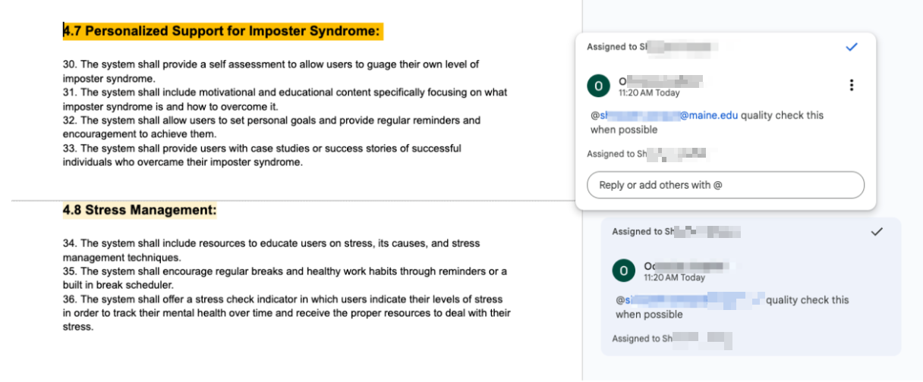

Why having people review other people’s work is important

Fundamentally, quality checking trades some redundancy and loss in efficiency for a lower error rate.

If a person has a 90% chance of doing a task correctly and has no quality checking, there’s a 10% chance the task has an error.

If a person has a 90% chance of doing a task correctly and the quality checker has a 90% chance of catching an error, there’s only a 1% chance of an error getting through, i.e. 10% chance of an error, then 10% chance it gets missed. That’s a huge improvement, a factor of 10x. And that’s in the case when the quality checker has the same skill/chance of doing the task correctly. That’s how the error rate of the team can become lower than that of any one member of the team.

What should the deadline be for tasks to be ready for quality checking?
The team needs a policy for assigning due dates for tasks such that when the inevitable illness or disruption happens, the work is still completed by the deadline without being rushed. The time deadlines below are the latest suggested times e.g. T-72 hours being 72 hours before deliverable deadline for a two week deliverable period. If the task is a dependency for someone else, it should be done earlier and the due date for the task should also be earlier to have similar buffer time.
For example, here is a policy:
1) Each task when created is also assigned a "ready for QC" due date in the Kanban. You can do this nicely on the Gantt chart view that is called Roadmap (see below). You can add fields to your Kanban by going to its settings. If your Kanban doesn’t have those field, you can see what fields to add by looking at the Kanban template or the example.
2) To set that QC due date, the latest due date for work to be ready for QC is T-72 hours from the actual deadline, so people have at least a day to do their QC work and make needed revisions. That then allows all the work to get done, then be QC'd and revised by T-48 hours.
3) Then when there are the inevitable delays, illness, reshuffling of work for unforeseen reasons, you have 2 days of buffer. So hopefully on average everything will actually be ready T-24 hours before the deliverable is due, for any final tweaks.
4) Use that same principle for tasks that are dependencies for other tasks. E.G. if Task B needs Task A before starting, then task A's due date for QC should be 2 days before Task B actually needs to start.
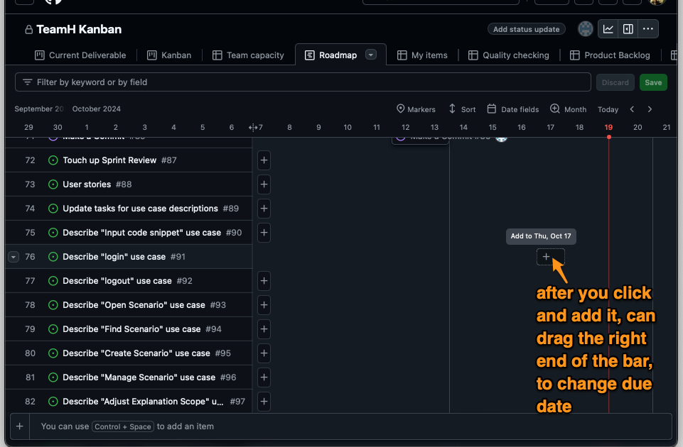

The reasons above are why later deliverables are given two weeks, instead of the original one week periods (they have more internal dependencies).
(Original Version by Greg Nelson)

