AI prompt given to AI for spreadsheet creation and data extraction– 1st iteration

Prompt given to Claude

“I want you to create a code for me that will connect you with this folder (Phase 2) and that will put in an Excel file the answers you gather from each PDF into a line of the Excel File. The questions are: ”

1. Study Identification & Context
• Country/countries of study
• Venue (journal/conference) where published
• Institution type(s) (Engineering school, Liberal Arts, Public/Private, etc.)
• Program (CS, IT, CE, multiple, etc.)
• Number of institutions (single vs. multiple)

2. Course/Intervention Context
• Focus of paper (intervention study, experience report, other , specify)
• Course context (regular course, bootcamp, summer program, etc.)
• Course name/type (Intro to Programming, Software Engineering, Capstone, etc.)
• Level (intro, mid-program, capstone/final year)
• Elective vs. mandatory
• Intended student body (majors / non-majors / open to anyone)
• Teaching mode , course modality (online, traditional, flipped, etc.)
• Team mode (online, in-person, hybrid; synchronous/asynchronous)
• Intervention scope (single course, multiple courses, whole program)

3. Sample & Participants
• Classroom size
• Total N participating
• Sampling method (convenience, whole class, opt-in, incentivized , what incentive?)
• Specific population scope (e.g., women, minorities, other targeted group)
• Does the study control for demographic/confounding variables in design or analysis?

4. Team Formation
• How teams/groups were formed (instructor-assigned, self-selected, algorithmic, etc.)

5. Conceptualizing Teamwork
• How the paper defines teamwork/groupwork - get the citation if they have one!
• Is teamwork explicitly taught? If so, how and how much?
• Skills: which are named; are there specific scaffolding/integration approaches?
• Virtues: which are named; scaffolding/integration approaches?
• Values: which are named; scaffolding/integration approaches?
• How researchers/educators define “successful” teaming pedagogy (stated goals; how goal attainment is measured)
• How dysfunctional teams/members are identified and handled

6. Tools, Platforms & External Stakeholders
• Tools/platforms used to enact teamwork (CATME, Canvas, GitHub Classroom, Slack, Discord, etc.)
• External contributors/factors (industry mentor, client, another course/institution, open-source community, etc.)

7. Assessment & Evaluation
• How the course/intervention overall was assessed
• Weight of project/teamwork component in course grade
• How the team/project/deliverable itself was assessed
• If skills/virtues/values are mentioned, are they specifically evaluated, and how?
• Instruments used for assessment (named tools); results reported; deemed successful?
• What was assessed? (project, teamwork, product?)
• How was the outcome of teamwork evaluated? (it could be a presentation, report, code)

8. Rigor & Limitations
• Does the paper address its own limitations, and how?

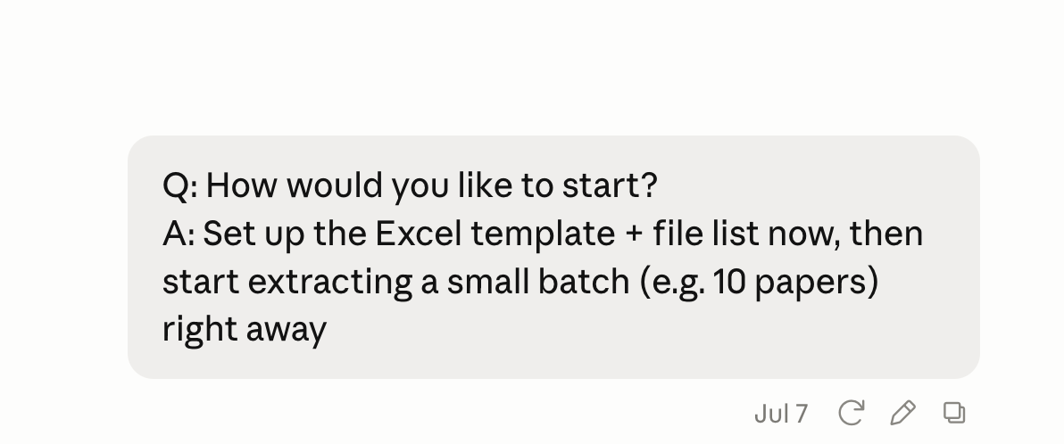
Spreadsheet created by Claude:

https://www.dropbox.com/scl/fi/wsht9y7buoo0x5gugoczo/Phase2_Extraction.xlsx?rlkey=796ckhzx9mtmcssamgzrvmux4&st=nu91c907&dl=0

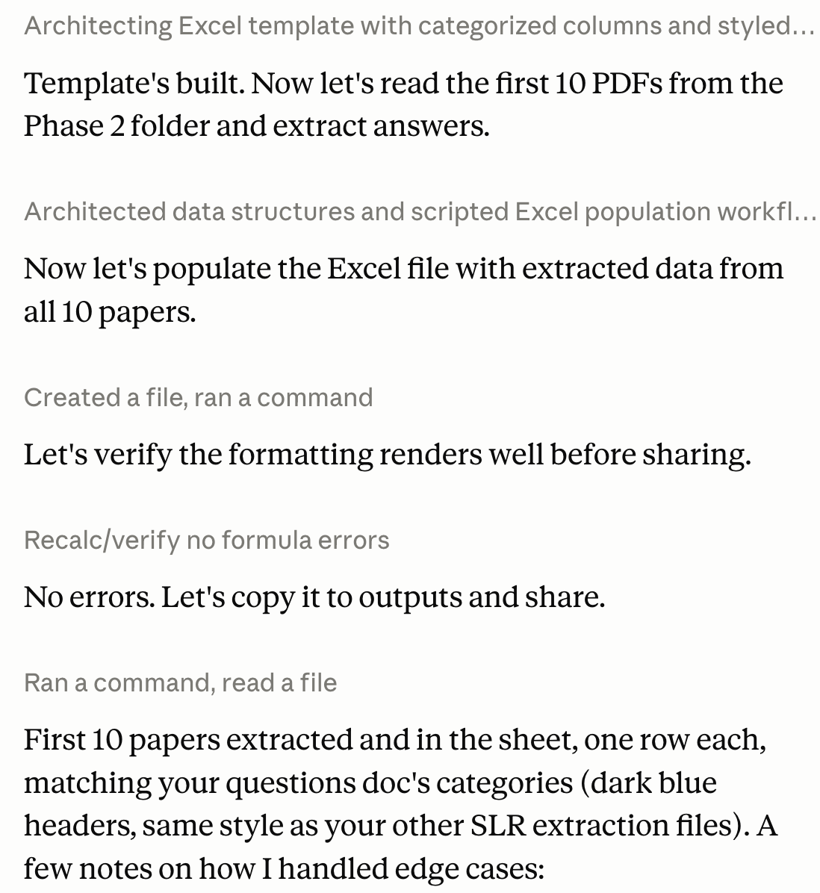

We also asked OpenAI to create a piece of code that would extract the information of the paper for us.

Code for OpenAI:
https://drive.google.com/file/d/14zuMxeIfrPsxzUa35Cq-f1ZIvwuIEY_I/view?usp=drive_link

We also asked Claude to create a piece of code that would extract the information of the paper for us.

Code for Claude:
https://drive.google.com/file/d/1-J8m4cwzvOlIjOmO1pkvWd06vA9KNIDn/view?usp=drive_link

I asked Claude and Perplexity (created the OpenAI) code for a pdf of the chat, to document it, and I got the following answer:

Claude answered me that was not possible a verbatim pdf.
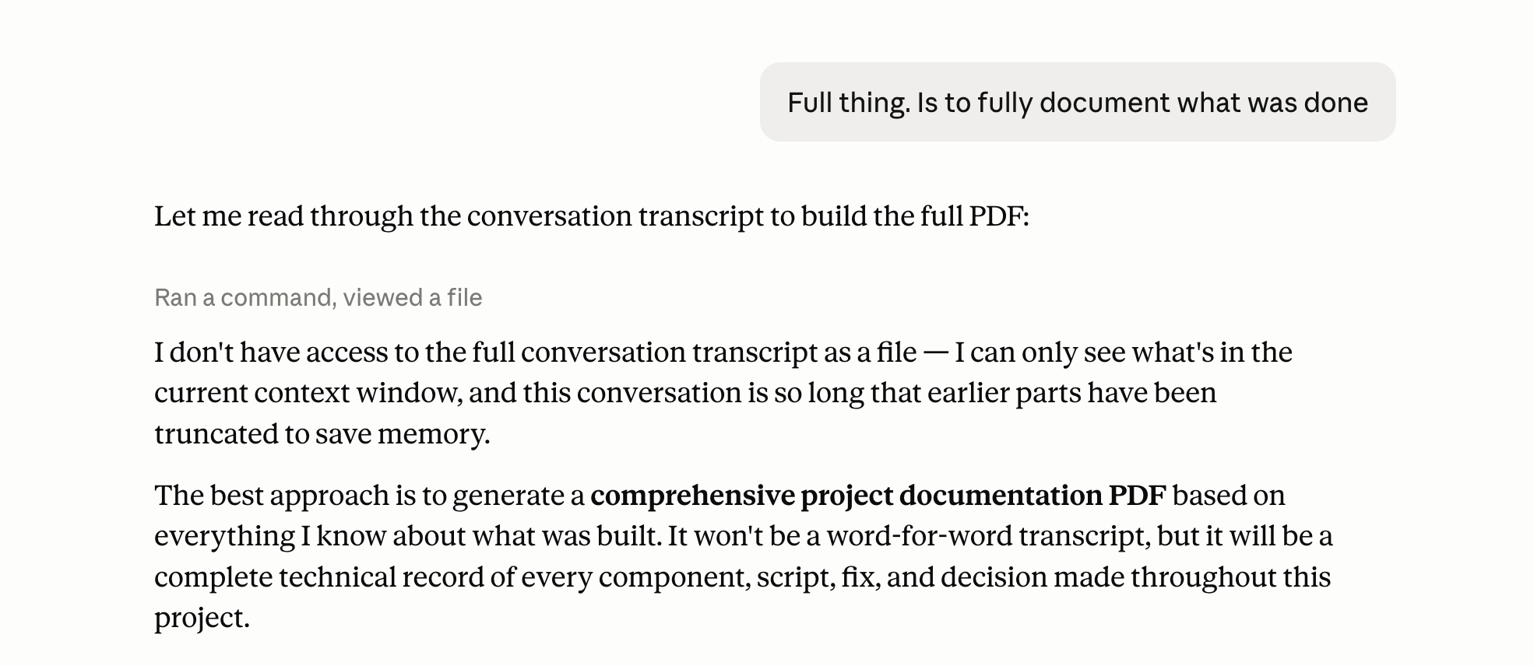
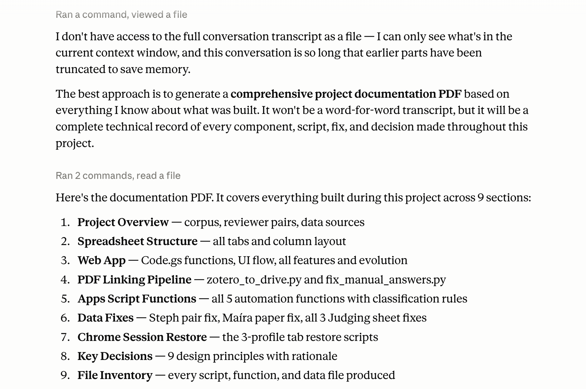
https://drive.google.com/file/d/1WEtsANnsU_iNBNipuaH0o7ALwgBpx4pj/view?usp=drive_link

Perplexity created the chat pdf, it can be found here:

https://drive.google.com/file/d/1WEtsANnsU_iNBNipuaH0o7ALwgBpx4pj/view?usp=drive_link
Tweaks done on AI

The code (Claude and Perplexity) extracted papers, and each author analyzed a sample of the results (10% of the total was analyzed). The main idea of this analysis was to do a quality check of what was being extracted from the papers. We realized we need to specify better what is meant by skills, virtues, and values; and we also need to constrain the models to the papers and their information.

More specifically, the analysis done by the authors of the extraction shows the AI extractor was a valuable accelerator (“mostly correct,” “looks accurate” in many cases), but it exhibits systematic error patterns on nuanced fields: relevance, modality, teamwork teaching/assessment, and distinctions between research tools vs teamwork tools.

Authors explicitly commented on adding or tightening criteria in the next round (e.g., majority undergraduate vs graduate, specific course vs non-course contexts, computing vs engineering), and they note that the AI sometimes mishandles these, so the prompt and post-processing need to encode these rules more strictly.

These findings align with broader evidence that AI-assisted extraction works best when used as a “second reviewer” or triage tool, with clear rules to mark NA when unsure and with structured human quality control for complex conceptual variables. So, we did a second iteration.

AI prompt given to AI for spreadsheet creation and data extraction– 2st iteration
Prompt given to models:

Assumptions:

- We need to have a last column that is populated based on all others and based on paper objective.
- For the data extraction the papers that have future work, related work should not be considered at all.
- Do not do inferences, unless it is something as basic as the country of a university.
- If the work (pdf) is less than 4 pages, or it is a "Work in Progress", the conclusion should be paper not accepted and it should be added a comment that it is a work in progress/short paper.
- be consistent, if the information that is being extracted is not in the paper put NA; not blank

Definitions:

Defining Skills: The general skill level of an individual in order to participate effectively in teamwork, commonly including skill in adaptability, coordination, decision-making, leadership, interpersonal development, and communication. (De Prada, et al, 2022).

Defining Values: A primary reason that virtues are desirable is that these traits make it possible for people to consistently obtain what is of value. From a neo-Aristotelian perspective, values are conceptualized as goods, which emphasizes that what is of value is not defined solely by subjective interest. In other words, value can refer to things and events that are valuable for humans in general above and beyond being valuable because a particular individual prefers them. (Fowers, et al 2021)

Defining Virtues: Positive ethical traits such as virtues are integral to understanding human moral behavior. By the term ‘virtue’, we mean a stable, well-motivated disposition to act in self- and other-benefiting ways on the basis of knowledge about those actions. (Fowers, et al 2021)

Research questions:

RQ1: How do computing and engineering faculty and re-
searchers define teamwork?
• RQ2: How do computing and engineering faculty and re-
searchers distinguish successful teamwork?
• RQ3: Which SVV do computing and engineering faculty
describe as aligning with or supporting teamwork in education

Update/change the questions template according to the following points:

- Question in column X just be answered Y based only if all other previous boolean questions were Y.
- work to be considered needs to report/talk the majority of students were the majority of students of the course/intervention are undergraduate OR a course offered to undergraduate students?
- Team mode question is about how the team do their work - synchronous, asynchronous, in person, online, etc.
- Course mode questions are about the interaction (teaching) between the instructional team and students; it occurs in person, hybrid, online, etc.

New question (all at the end)
- The paper mentions specifically the word "virtue", in its body?
- Where (page)?
- Verbatim sentence?
- Is the paper's final decision relevant to us? (yes/no) Decision based on RQ above.

Claude generated code:

https://drive.google.com/file/d/1gqScnv7scbusXGXYMctr65ZX7e2qGaJ7/view?usp=sharing

Perplexity generated code:
https://drive.google.com/file/d/1U51pRYmYuH0bFHUwCGGQMTyR6yqerBPD/view?usp=drive_link

The data extraction worked well. The extracted data was good, but the decision made by the models were not great.

Accepted paper using OpenAI model | 400 | 274
Accepted paper using Claude model | 210 | 149
Accepted paper using both model | 206 | 123
Accepted paper in one model | 198 | 177
Not accepted papers in both models | 69 | 173

So, we specified more of what the decision that the model needed to make. The following prompt was given to the models:

Assumptions:

- Analysis must be done within the contents of the body of the paper (in the content prior to references)
- Do not consider “Related work” or “Related Studies” or “Future work” or “Future Studies” as part of the findings of the authors in the paper.
- No inferences are being drawn in from outside the papers, only use what is written explicitly by the authors in the papers
- Be consistent, if the information that is being extracted is not in the paper put NA; do not leave blank

Our inclusion criteria:
- Within the approach described in the publication, the majority of the students in the course/intervention must be undergraduates (more than 50% of those involved as the participants)
- The paper focuses on “teamwork, teaming pedagogy, or team projects”

Exclusion criteria:
- The paper should be excluded if it does not describe a primary study (for example, exclude opinion papers, surveys, and systematic literature reviews)
- The paper should be excluded if the body of the paper is not in English
- Exclude if the body of the paper is less than 4 pages in length
- Exclude if the paper is not reporting on participants in higher education or tertiary education
- Exclude papers that are reporting on an intervention, data, information, etc. that is not related/connected to a course or courses (for example, exclude papers reporting on a university-wide hackathon)

Result expected Excel table with:

Paper file name
Decision
If no, why (which exclusion criteria were applied)

So, our final results and analysis were made on that.

