Choosing the Right Graph/Chart Type in Excel

This guide helps you decide which type of Excel chart or graph to use, depending on your data and what you want to show.

Decision Flow

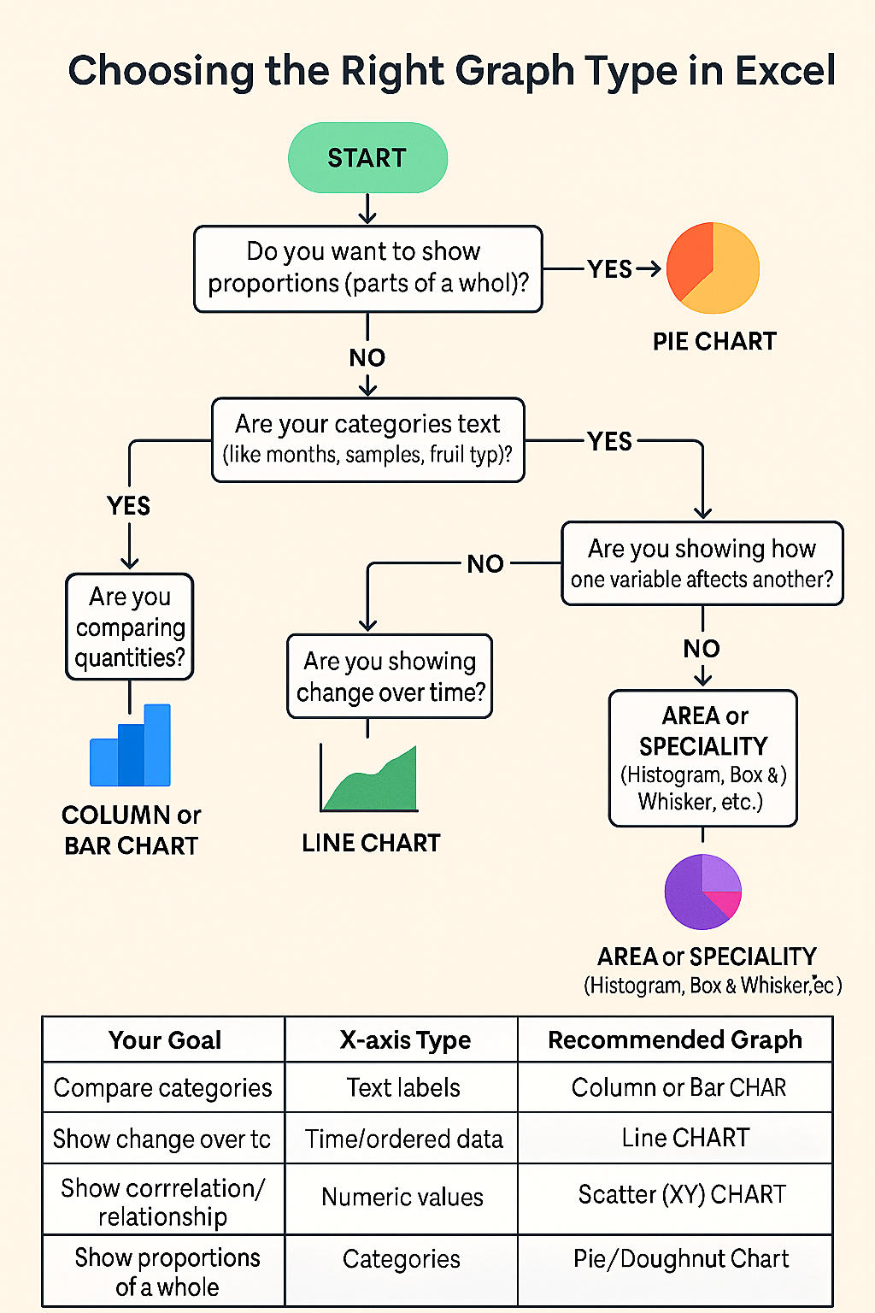

Quick Summary Table
Your Goal | X-axis Type | Recommended Graph
Compare categories | Text labels | Column / Bar
Show change over time | Time / ordered data | Line
Show correlation / relationship | Numeric values | Scatter (XY)
Show proportions of a whole | Categories | Pie / Doughnut
Show distribution or spread | Numeric | Histogram / Box & Whisker

Example Pairings
Situation | Best Chart
Hours studied vs exam score | Scatter
Average temperature per month | Line
Students per major | Column
Budget breakdown | Pie
Distribution of exam scores | Histogram

Note : Scientists use the term ‘Scatter Graph” whereas Excel and other software use the term ‘Scatter Chart’ - they are the same thing.

Reference: These tables, diagrams etc. were created with the use of ChatGPT.

