Exercise 1

Excel Basics

1. Open Microsoft Excel and start a new blank worksheet. Name the sheet ***ExpData***. Save the Excel file ExcelEx1.xlsx.
2. Enter sample data in the following format, make sure to format the sheet as below notice the use of
   * Italics, Bold, Color
   * Cell Merge & Centre

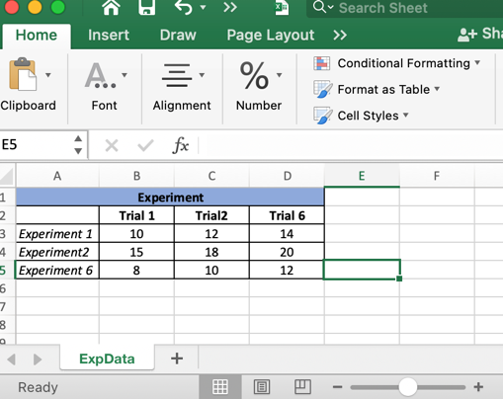

1. Add a border to your data.
2. Modifying Columns and Rows

* Insert 3 new columns between column C and D and use the Fill Handle to name them.
* Insert 3 new rows between rows 3 and 4 and use the Fill Handle to name them.
* Delete Column B and Row 5.

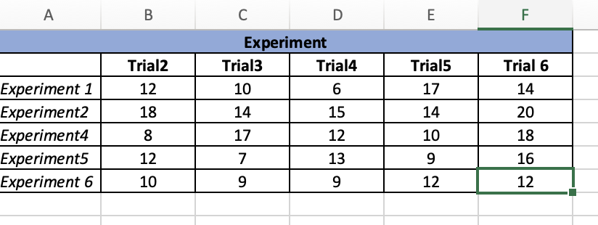

1. Select the data for experiment 6 and format the numbers as Scientific numbers.
2. Select the data for experiment 6 and format the numbers as Percentages.
3. Select the data for experiment 6 and format the numbers as Euros.
4. Undo the last two steps.
5. For all the text cells increase the font to size 16. Make sure all the columns widen to accommodate the new size.
6. For all the number cells increase the font size to 14.
7. Add a Header and Footer to your spreadsheet. Put the date in the Footer and your name and student number in the header.
8. At the bottom of the Excel window, click the "+" icon to add a new worksheet. Rename this worksheet by double-clicking on the sheet name tab. Name this one **EXPResults.**