# Exercises on Loops

# Programming Fundamentals 1 & 2

# Mairead Meagher, Siobhan Roche

1. Write a method (***exer1()*** ) to print numbers from 1 to 10, one number per line.
2. Write a method ***(exer2())*** to print numbers from 15 to 20 inclusive, one number per line.
3. Write a method ***(exer3())*** to print numbers backwards from 10 to 1 inclusive, one number per line.
4. Write a method ***(exer4())*** to print numbers backwards from 20 to 15 inclusive, one number per line.
5. Write a method ***(exer5())*** to sum the numbers from 1 to 10 inclusive. You should print the sum to the console. (sum is 55)
6. Write methods to print the following (name the methods ***exer6_1(),*** etc) : 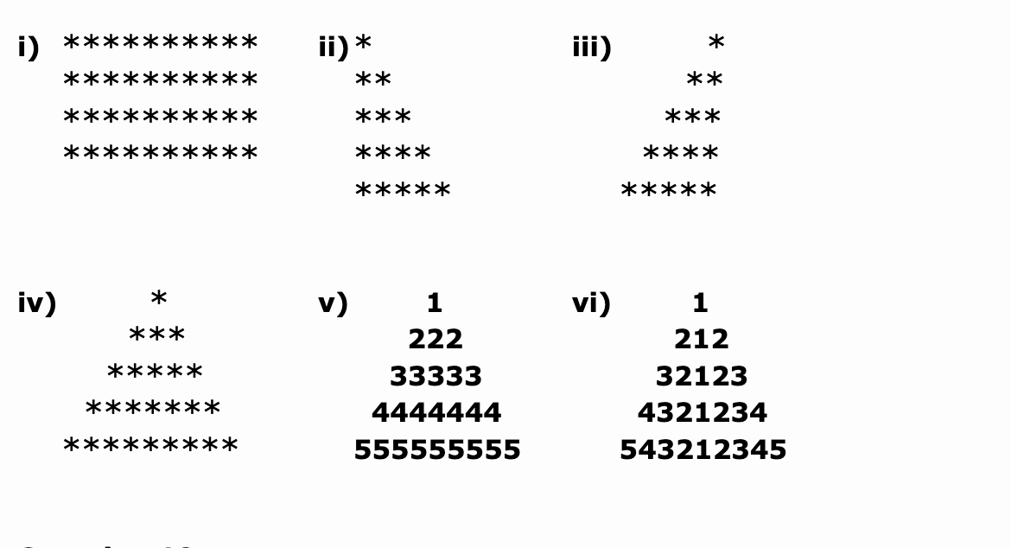
7. Write a method ***exer7(int numRows, int numCols)*** which prints a rectangle of ‘*’s with *numRows* lines and *numCols* asterisks across in each line. So a call of exer7(4, 10) would display the rectangle as in exercise 6.1 above