**SUPPLEMENTAL MATERIALS**

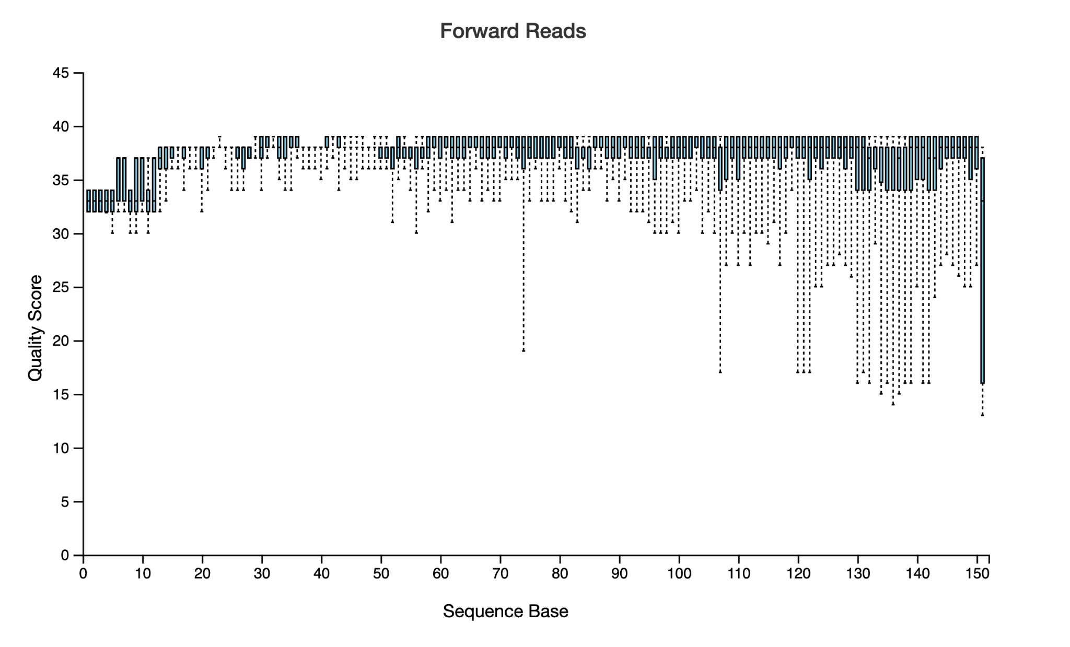

**Figure S1.** **Demultiplexed sequence read quality plot generated for Forward reads only.** From the QIIME2 server, the dorms dataset was imported, demultiplexed and visualized on QIIME2 View. The truncation length was chosen based on the quality of the read. The reads were truncated to 150 nucleotides because there is a drop of the median quality score at position 151.

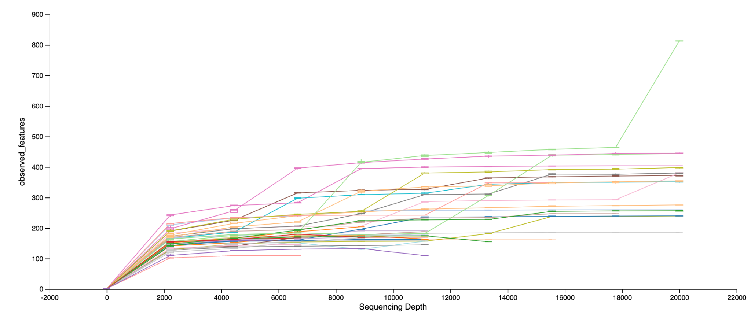

**Figure S2.** **Alpha rarefaction curve generated with filtered skin samples.** The demultiplexed sequences were denoised and clustered using a pre-trained classifier with 515F-806R primer pair. Mitochondria and chloroplast sequences were removed, and we filtered to keep only the skin (hand) samples. Sampling depth is set to 6223 based on the saturation point and plateauing of the alpha rarefaction curve.

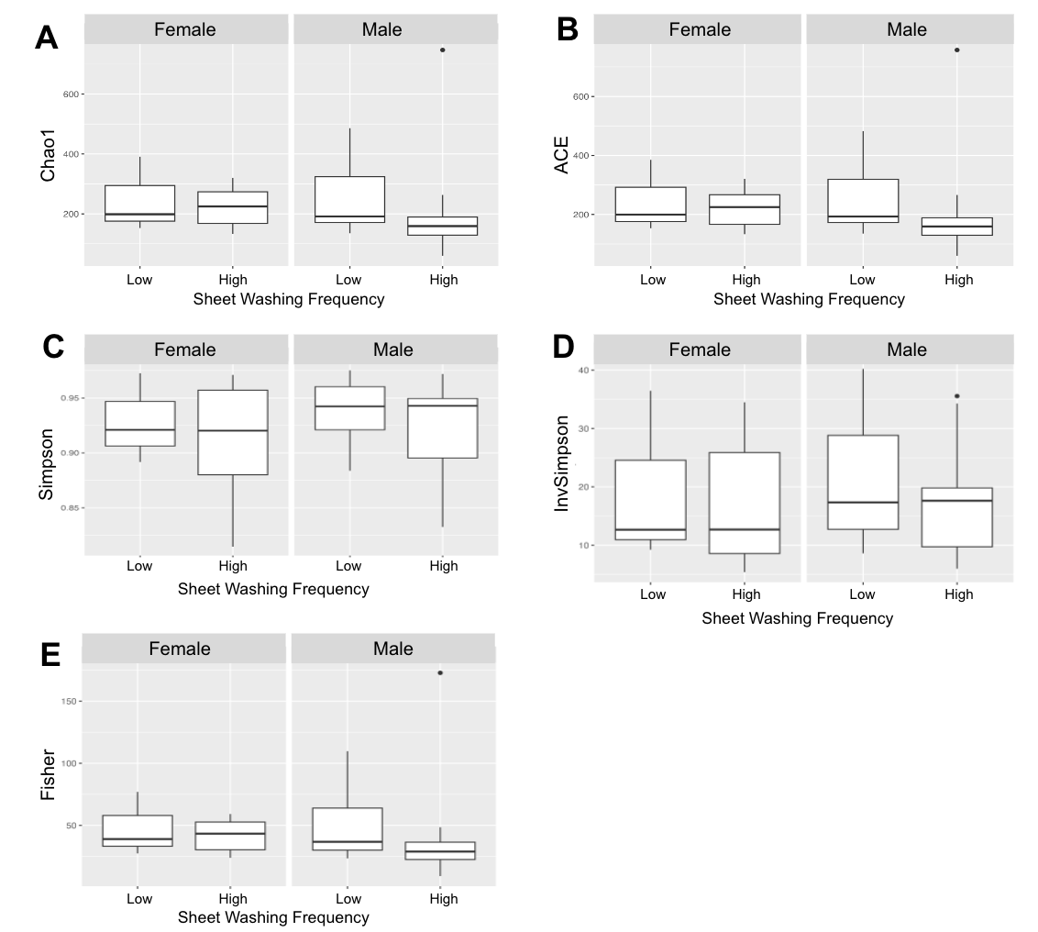

**Figure S3. Sex-specific sheet washing frequency groups do not differ in alpha diversity.** (A) Chao1 Diversity, (B) ACE (Abundance-based Coverage Estimator), (C) Simpson, (D) Inverse Simpson, (E) Fisher’s Diversity alpha diversity analyses were run across sex-specific sheet washing frequency groups.

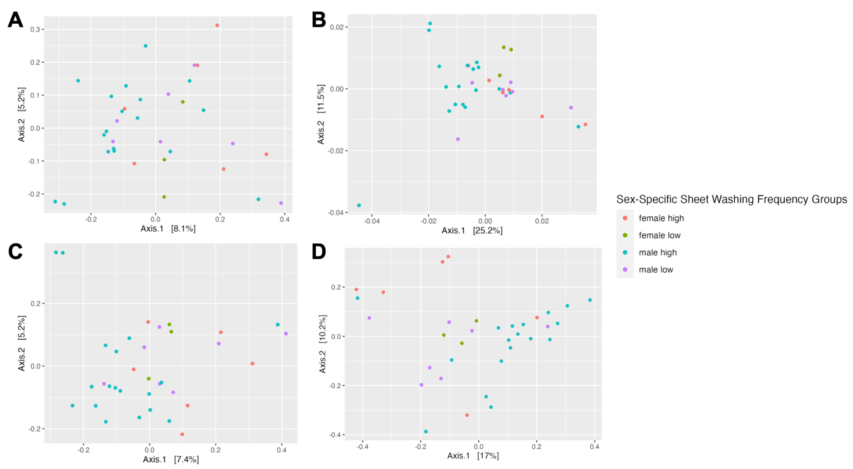

**Figure S4.** **Sex effects hand microbial community beta diversity metrics regardless of sheet washing frequency.** Unweighted UniFrac (A), Weighted UniFrac (B), Jaccard (C), and Bray-Curtis (D) beta diversity analyses were run between groups categorized by sex (female, male) and sheet washing frequency (high, low) and principal coordinate analysis (PCoA) plots were generated. Colouring represents the differing sex-specific sheet washing frequency groups. The axes represent the variables accounted for by each beta diversity analysis. The percentage depicted in brackets to the right of the axes labels demonstrates the percentage of variance represented on each axis.

**Figure S5. Heatmap displaying range of prevalence and relative abundance for core microbiome analysis in male groups with low sheet washing frequency.** The minimum prevalence is set to 0.5 (50%). All the bacteria listed are present in 50% of all individuals, which are shown along the y-axis with genus and family name. The x-axis shows the range of relative abundance values. The shades of colours represent the prevalence of bacteria with darker red indicating a higher value and darker blue indicating a lower value.

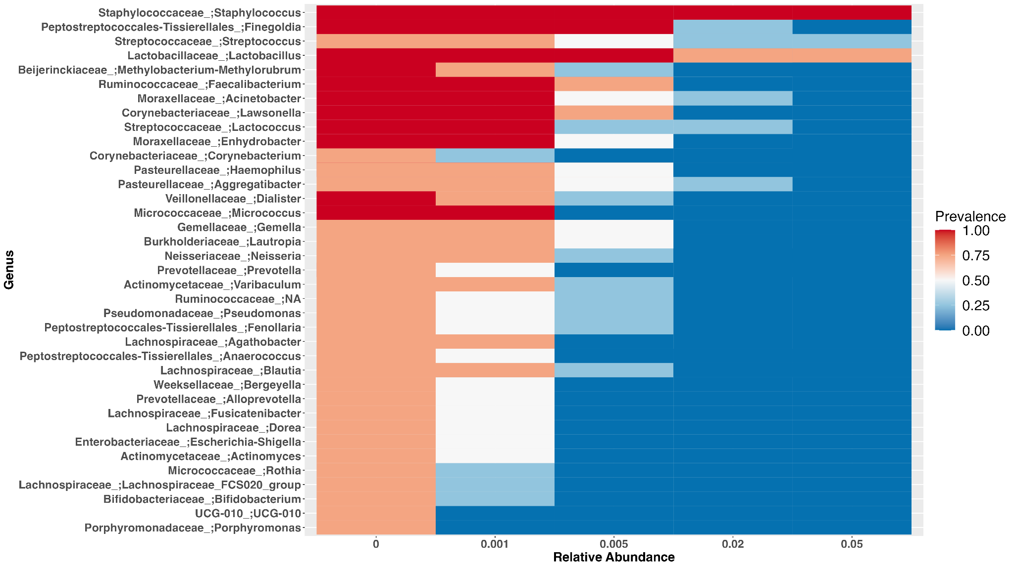

**Figure S6. Heatmap displaying range of prevalence and relative abundance for core microbiome analysis in female groups with low sheet washing frequency.** The minimum prevalence is set to 0.5 (50%). All the bacteria listed are present in 50% of all individuals, which are shown along the y-axis with genus and family name. The x-axis shows the range of relative abundance values. The shades of colors represent the prevalence of bacteria with darker red indicating a higher value and darker blue indicating a lower value.

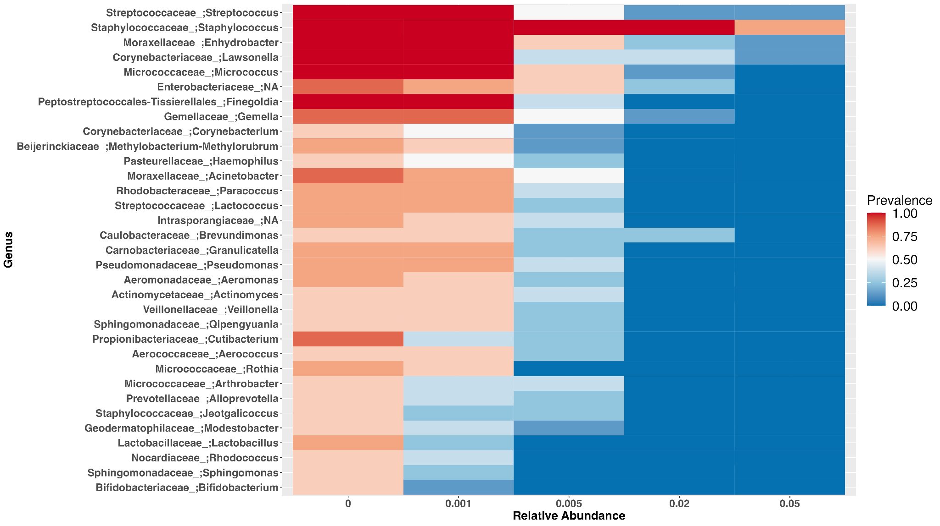

**Figure S7. Heatmap displaying range of prevalence and relative abundance for core microbiome analysis in female groups with high sheet washing frequency.** The minimum prevalence is set to 0.5 (50%). All the bacteria listed are present in 50% of all individuals, which are shown along the y-axis with genus and family name. The x-axis shows the range of relative abundance values. The shades of colours represent the prevalence of bacteria with darker red indicating a higher value and darker blue indicating a lower value.

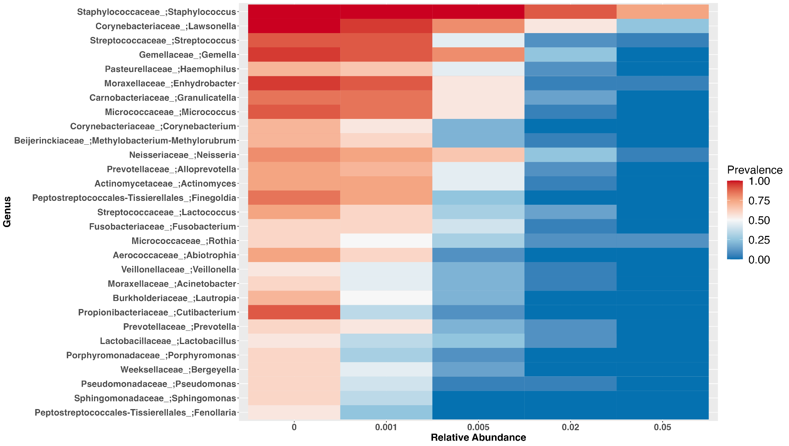

**Figure S8. Heatmap displaying range of prevalence and relative abundance for core microbiome analysis in male groups with high sheet washing frequency.** The minimum prevalence is set to 0.5 (50%). All the bacteria listed are present in 50% of all individuals, which are shown along the y-axis with genus and family name. The x-axis shows the range of relative abundance values. The shades of colors represent the prevalence of bacteria with darker red indicating a higher value and darker blue indicating a lower value.

**Table S1. DESeq2 Table displaying taxonomic resolution and statistical measurements of significant genera in both females and males at high sheet washing frequency.** This table was constructed by filtering all ASVs found in the high sheet washing frequency group for only significant members by using a padj<0.01 & abs(log2FoldChange)>2 & baseMean > 1.

|  |  |  |  |  |  |  |  |  |  |  |  |  |  |
| --- | --- | --- | --- | --- | --- | --- | --- | --- | --- | --- | --- | --- | --- |
|  | **Domain** | **Phylum** | **Class** | **Order** | **Family** | **Genus** | **Species** | **baseMean** | **log2FoldChange** | **lfcSE** | **stat** | **pvalue** | **padj** |
| **1** | d__Bacteria | Bacteroidota | Bacteroidia | Bacteroidales | Prevotellaceae | Prevotella | Prevotella_nanceiensis | 25.178571 | -5.123081 | 1.027012 | -4.988336 | 0.000001 | 0.000099 |
| **2** | d__Bacteria | Proteobacteria | Gammaproteobacteria | Pasteurellales | Pasteurellaceae | Aggregatibacter | Aggregatibacter_aphrophilus | 24.642857 | -5.091694 | 1.106247 | -4.602671 | 0.000004 | 0.000595 |
| **3** | d__Bacteria | Fusobacteriota | Fusobacteriia | Fusobacteriales | Fusobacteriaceae | Fusobacterium | NA | 43.964286 | -4.392911 | 1.040796 | -4.220723 | 0.000024 | 0.001854 |
| **4** | d__Bacteria | Actinobacteriota | Actinobacteria | Micrococcales | Micrococcaceae | Kocuria | NA | 15.000000 | -4.364568 | 1.041529 | -4.190539 | 0.000028 | 0.001986 |
| **5** | d__Bacteria | Actinobacteriota | Actinobacteria | Micrococcales | Micrococcaceae | Rothia | NA | 37.892857 | -4.174098 | 0.987514 | -4.226875 | 0.000024 | 0.001854 |
| **6** | d__Bacteria | Actinobacteriota | Actinobacteria | Propionibacteriales | Nocardioidaceae | Marmoricola | NA | 2.285714 | 2.459430 | 0.647964 | 3.795628 | 0.000147 | 0.006727 |
| **7** | d__Bacteria | Firmicutes | Bacilli | Erysipelotrichales | Erysipelatoclostridiaceae | Catenibacterium | NA | 2.571429 | 2.700438 | 0.669220 | 4.035201 | 0.000055 | 0.003115 |
| **8** | d__Bacteria | Proteobacteria | Alphaproteobacteria | Sphingomonadales | Sphingomonadaceae | Sphingopyxis | NA | 4.107143 | 2.760047 | 0.711669 | 3.878274 | 0.000105 | 0.005006 |
| **9** | d__Bacteria | Proteobacteria | Alphaproteobacteria | Rhodobacterales | Rhodobacteraceae | Paracoccus | NA | 2.678571 | 2.781358 | 0.691760 | 4.020697 | 0.000058 | 0.003156 |
| **10** | d__Bacteria | Actinobacteriota | Actinobacteria | Micrococcales | Micrococcaceae | Arthrobacter | Arthrobacter_agilis | 2.714286 | 2.807353 | 0.718702 | 3.906144 | 0.000094 | 0.004656 |
| **11** | d__Bacteria | Proteobacteria | Alphaproteobacteria | Rhizobiales | Rhizobiaceae | Allorhizobium-Neorhizobium-Pararhizobium-Rhizobium | NA | 3.785714 | 2.870819 | 0.709159 | 4.048202 | 0.000052 | 0.003102 |
| **12** | d__Bacteria | Proteobacteria | Alphaproteobacteria | Rhizobiales | Beijerinckiaceae | Methylobacterium-Methylorubrum | NA | 4.964286 | 2.893082 | 0.671387 | 4.309115 | 0.000016 | 0.001737 |
| **13** | d__Bacteria | Actinobacteriota | Actinobacteria | Frankiales | Geodermatophilaceae | Modestobacter | NA | 6.785714 | 2.968288 | 0.727314 | 4.081164 | 0.000045 | 0.002843 |
| **14** | d__Bacteria | Actinobacteriota | Actinobacteria | Micrococcales | Micrococcaceae | Rothia | NA | 6.892857 | 3.124478 | 0.791601 | 3.947038 | 0.000079 | 0.004107 |
| **15** | d__Bacteria | Firmicutes | Bacilli | Staphylococcales | Staphylococcaceae | Staphylococcus | Staphylococcus_equorum | 3.321429 | 3.189822 | 0.752424 | 4.239396 | 0.000022 | 0.001854 |
| **16** | d__Bacteria | Actinobacteriota | Actinobacteria | Propionibacteriales | Nocardioidaceae | Nocardioides | NA | 3.357143 | 3.209451 | 0.712370 | 4.505312 | 0.000007 | 0.000841 |
| **17** | d__Bacteria | Proteobacteria | Alphaproteobacteria | Caulobacterales | Caulobacteraceae | uncultured | uncultured_bacterium | 3.392857 | 3.228816 | 0.755729 | 4.272453 | 0.000019 | 0.001840 |
| **18** | d__Bacteria | Proteobacteria | Alphaproteobacteria | Rhodobacterales | Rhodobacteraceae | Paracoccus | NA | 3.464286 | 3.266784 | 0.758906 | 4.304598 | 0.000017 | 0.001737 |
| **19** | d__Bacteria | Proteobacteria | Alphaproteobacteria | Rhodobacterales | Rhodobacteraceae | Paracoccus | NA | 45.785714 | 4.194684 | 1.009214 | 4.156388 | 0.000032 | 0.002172 |
| **20** | d__Bacteria | Proteobacteria | Alphaproteobacteria | Rhodobacterales | Rhodobacteraceae | Paracoccus | NA | 7.928571 | 4.658206 | 0.863249 | 5.396133 | 0.000000 | 0.000013 |
| **21** | d__Bacteria | Proteobacteria | Alphaproteobacteria | Caulobacterales | Caulobacteraceae | Brevundimonas | NA | 9.428571 | 4.930731 | 0.881620 | 5.592806 | 0.000000 | 0.000005 |
| **22** | d__Bacteria | Actinobacteriota | Actinobacteria | Corynebacteriales | Mycobacteriaceae | Mycobacterium | NA | 10.214286 | 5.055277 | 0.805302 | 6.277493 | 0.000000 | 0.000000 |
| **23** | d__Bacteria | Actinobacteriota | Actinobacteria | Corynebacteriales | Nocardiaceae | Williamsia | NA | 12.142857 | 5.321921 | 0.882404 | 6.031165 | 0.000000 | 0.000000 |
| **24** | d__Bacteria | Proteobacteria | Alphaproteobacteria | Sphingomonadales | Sphingomonadaceae | Qipengyuania | NA | 35.357143 | 5.854633 | 0.866665 | 6.755359 | 0.000000 | 0.000000 |
| **25** | d__Bacteria | Actinobacteriota | Actinobacteria | Corynebacteriales | Corynebacteriaceae | Corynebacterium | Corynebacterium_suicordis | 58.642857 | 7.663545 | 1.016151 | 7.541738 | 0.000000 | 0.000000 |

**Table S2. DESeq2 Table displaying taxonomic resolution and statistical measurements of significant genera in both females and males at low sheet washing frequency.**  This table was constructed by filtering all ASVs found in the low sheet washing frequency group for only significant members by using a padj<0.01 & abs(log2FoldChange)>2 & baseMean > 1.

|  |  |  |  |  |  |  |  |  |  |  |  |  |  |
| --- | --- | --- | --- | --- | --- | --- | --- | --- | --- | --- | --- | --- | --- |
|  | **Domain** | **Phylum** | **Class** | **Order** | **Family** | **Genus** | **Species** | **baseMean** | **log2FoldChange** | **lfcSE** | **stat** | **pvalue** | **padj** |
| **1** | d__Bacteria | Bacteroidota | Bacteroidia | Bacteroidales | Prevotellaceae | Prevotella | Prevotella_timonensis | 81.909091 | -7.001586 | 1.840063 | -3.805079 | 0.000142 | 0.004645 |
| **2** | d__Bacteria | Proteobacteria | Gammaproteobacteria | Pseudomonadales | Moraxellaceae | Acinetobacter | Acinetobacter_baumannii | 73.909091 | -6.852622 | 1.642711 | -4.171532 | 0.000030 | 0.001488 |
| **3** | d__Bacteria | Actinobacteriota | Actinobacteria | Micrococcales | Micrococcaceae | Kocuria | NA | 54.727273 | -6.416630 | 1.631676 | -3.932539 | 0.000084 | 0.003248 |
| **4** | d__Bacteria | Proteobacteria | Gammaproteobacteria | Pseudomonadales | Pseudomonadaceae | Pseudomonas | NA | 26.363636 | -5.352508 | 1.265465 | -4.229677 | 0.000023 | 0.001266 |
| **5** | d__Bacteria | Actinobacteriota | Actinobacteria | Micrococcales | Intrasporangiaceae | NA | NA | 24.181818 | -5.226058 | 1.369652 | -3.815610 | 0.000136 | 0.004645 |
| **6** | d__Bacteria | Actinobacteriota | Actinobacteria | Micrococcales | Dermabacteraceae | Brachybacterium | NA | 27.818182 | -4.609286 | 1.213660 | -3.797840 | 0.000146 | 0.004645 |
| **7** | d__Bacteria | Proteobacteria | Alphaproteobacteria | Rhodobacterales | Rhodobacteraceae | Paracoccus | NA | 24.818182 | -4.242489 | 1.134349 | -3.740023 | 0.000184 | 0.005530 |
| **8** | d__Bacteria | Firmicutes | Clostridia | Lachnospirales | Lachnospiraceae | Roseburia | gut_metagenome | 9.181818 | 4.554578 | 1.248108 | 3.649187 | 0.000263 | 0.006777 |
| **9** | d__Bacteria | Firmicutes | Clostridia | Oscillospirales | Ruminococcaceae | Faecalibacterium | metagenome | 9.363636 | 4.584951 | 1.270196 | 3.609640 | 0.000307 | 0.007540 |
| **10** | d__Bacteria | Firmicutes | Bacilli | Staphylococcales | Staphylococcaceae | Staphylococcus | Staphylococcus_pettenkoferi | 9.454545 | 4.599902 | 1.243121 | 3.700286 | 0.000215 | 0.006132 |
| **11** | d__Bacteria | Deinococcota | Deinococci | Thermales | Thermaceae | Thermus | Thermus_thermophilus | 9.818182 | 4.658200 | 1.269665 | 3.668843 | 0.000244 | 0.006591 |
| **12** | d__Bacteria | Firmicutes | Bacilli | Lactobacillales | Lactobacillaceae | Lactobacillus | NA | 13.090909 | 5.098021 | 1.203709 | 4.235260 | 0.000023 | 0.001266 |
| **13** | d__Bacteria | Firmicutes | Clostridia | Lachnospirales | Lachnospiraceae | Coprococcus | unidentified | 15.636364 | 5.366308 | 1.335107 | 4.019383 | 0.000058 | 0.002428 |
| **14** | d__Bacteria | Bacteroidota | Bacteroidia | Bacteroidales | Bacteroidaceae | Bacteroides | Bacteroides_uniformis | 16.181818 | 5.417837 | 1.345213 | 4.027494 | 0.000056 | 0.002428 |
| **15** | d__Bacteria | Firmicutes | Clostridia | Oscillospirales | Ruminococcaceae | Faecalibacterium | NA | 34.818182 | 5.638284 | 1.166733 | 4.832541 | 0.000001 | 0.000182 |
| **16** | d__Bacteria | Firmicutes | Clostridia | Oscillospirales | Ruminococcaceae | Subdoligranulum | uncultured_bacterium | 20.818182 | 5.794400 | 1.355569 | 4.274513 | 0.000019 | 0.001266 |
| **17** | d__Bacteria | Firmicutes | Clostridia | Oscillospirales | Ruminococcaceae | Faecalibacterium | NA | 21.636364 | 5.851733 | 1.353850 | 4.322289 | 0.000015 | 0.001193 |
| **18** | d__Bacteria | Firmicutes | Clostridia | Lachnospirales | Lachnospiraceae | Blautia | NA | 22.363636 | 5.900852 | 1.285600 | 4.589959 | 0.000004 | 0.000400 |
| **19** | d__Bacteria | Firmicutes | Bacilli | Lactobacillales | Lactobacillaceae | Lactobacillus | NA | 325.727273 | 6.118987 | 1.034016 | 5.917688 | 0.000000 | 0.000002 |
| **20** | d__Bacteria | Firmicutes | Clostridia | Peptostreptococcales-Tissierellales | Peptostreptococcales-Tissierellales | Anaerococcus | NA | 27.818182 | 6.223986 | 1.281696 | 4.856053 | 0.000001 | 0.000182 |
| **21** | d__Bacteria | Firmicutes | Clostridia | Oscillospirales | Ruminococcaceae | NA | NA | 28.818182 | 6.276108 | 1.325935 | 4.733345 | 0.000002 | 0.000239 |
| **22** | d__Bacteria | Actinobacteriota | Actinobacteria | Corynebacteriales | Corynebacteriaceae | Corynebacterium | NA | 40.363636 | 6.771473 | 1.268037 | 5.340121 | 0.000000 | 0.000025 |