**FISH 505 Exercise 9 – Mairin Deith, April 30, 2018**

Management strategy evaluation (MSE) with DLMTool for Stone’s Sheep in WMU7-42

Summary:

This report summarizes a management strategy evaluation for the trophy hunt of Stone’s sheep in the Peace Region of British Columbia, Canada (WMU 7-42). The harvest is currently managed with two alternative controls: only hunters who obtain prescribed licenses can capture rams, and when they do hunt they can only harvest males who are fully mature (as indicated by ‘full-curl’ horns that have grown long enough to encircle the ram’s eye). In this analysis, seven alternative management procedures are simulated. First, the performance of these management options is compared under a base-case scenario built from observed historical data. Then, to assess whether the management options are robust to alternative scenarios, they are then simulated under six stress-test scenarios that represent plausible alternatives.

Questions:

1. *State a minimum of one fishery objective and one conservation objective for your case study fishery and use the three-point guidelines for management objective specification from the seminar slides presented in the first FISH 505 session on MSE.*

Performance of the Stone’s sheep harvest can be summarized in a set of two harvest objectives and two conservation objectives (Table 1).

Table 1. Management objectives for the Stone’s sheep harvest in WMU7-42, the timeframe in which they should be met, and the probability of meeting each objective. Harvest objectives are catered towards maximizing the number and value of harvestable males, while conservation objectives seek to avoid recruitment overharvest. Note that one of the ideal objectives, maximizing the length of horns that are harvested, could not be implemented as custom performance metrics are still under development in the current version of DLMtool (see Chapter 25, *Custom Performance Metrics* in the DLMtool user guide; Carruthers and Hordyk, 2018).

|  |  |  |
| --- | --- | --- |
| Objective and performance metric (PM) | Time frame to meet objective | Probability of meeting the objective |
| *Harvest/conservation*  Keep the male population size, B, at or below BMSY  *PM:* P100 | *Long-term*  Harvest should reduce the population to below BMSY at any point in the simulation (2016-2066). | *Probability:* 80%  The population should not drop below BMSY in more than 20% of simulations |
| *Conservation*  Maintain the mature male population above 5% of the total female population (this should avoid recruitment overharvest; Ontario Sheep, no date; Milner-Gulland *et al.*, 2003)*⁠*  *PM:* P10 | *Long-term*  The male population should not drop below 5% of the female population at any point in the 50- year simulation | *Probability*: 95%  Recruitment overharvest can have serious consequences on the overall population, even leading to collapse. Therefore a 95% probability of success is vital for this metric. |
| *Harvest*  Minimize variation in number of harvested rams to ensure continued employment for guides; inter-annual variation should be less than 20%  *PM:* AAVY | *Long-term*  Inter-annual variation should be minimal over the entire 50-year simulation to safeguard the guide industry | *Probability:* 50%  Tolerance for variability is likely high (as guides are paid regardless of whether the harvest is successful, assuming the demand for guides is constant), probability of low variability can be lower than conservation metrics |
| *Not currently implementable:* |  |  |
| *Harvest*  *Maximize/maintain the length of horns being harvested* | *Long-term*  *Average harvested horns should be >90cm after 2036* | *Probability: 90%*  *Over 90% of simulations should ensure that the average harvested horn length is greater than 90cm* |

1. *Identify and list the types of information available from which you can formulate an operating model for your case study fishery.*

The most important source of information that can be used to construct the operating models (OMs) comes from harvest records collected by the province of British Columbia from 1975-2016. Data collected by the provincial government includes:

* **Hunter effort** – measured as the total number of days that hunters spent hunting for rams in the open season in each year
* **Number of harvested rams** – the total number of rams hunted in each year, assuming that all hunters turn in harvested horns to conservation officers for compulsory inspection
* **Length and age composition of harvested rams** – data are collected from the horns that are submitted for compulsory inspection, including total length of the horns (in cm) and the expected age of the ram (measured according to growth annuli)

Additional data sources from unharvested populations of Stone’s sheep elsewhere in British Columbia and the Yukon were also used to populate key parameters in the operating model:

* **Horn length at age** – although horn length at age could be generated exclusively from the length and age composition of harvested rams, Loehr et al. (2007)⁠ provided a dataset of horn length at age that includes younger age classes that are below the legal limit for hunters, and are therefore not represented in harvest data. I therefore calculated the relationship between horn length and age using data from both harvest records and published materials.
* **Natural mortality at age** – the demographics of an unharvested population of thinhorn sheep, including natural sex ratios and mortality at age, were collected from Hoefs & Bayer, 1983.

These data were used to populate key harvest parameters in the OM. Horn length and age data collected from compulsory horn inspections and from Loehr et al. (2007) were used to calculate hunters’ selectivity at horn size and to parameterize a model of horn length at age, following the von Bertalanffy equation. Natural mortality and catch at age data were used previously in a stock reduction analysis (SRA). Parameters estimated with the maximum likelihood approach were then included in the base case operating model (i.e. recruitment at unharvested biomass, *R0*, current estimated depletion, *D*, and steepness of the Beverton-Holt stock-recruit relationship, *h*, were all taken from SRA estimates).

1. *Make a copy of the Example_Chile_Hake Excel file in the Excel directory of the Exercise subdirectory and rename your new file to your case study fishery name. Provide a print-out of the tabs of your updated Excel file and list brief justifications for your entries into each of the tabs of this file.*

Ram removals are numbers-based, and the biomass-based OM provided in the Hake example was inappropriate for this analysis. Rather than copying the Chilean hake example and modifying the Stone’s sheep operating model from this template, I generated blank OMs using the OMinit() command in DLMtool, and populated all parameters in Excel. Parameter ranges and values were input from either the sources listed above (where the data were available), or default values were copied from another numerical harvest model that has previously been analyzed with DLMtool: Grey seals (whose documentation can be found at

<http://www.datalimitedtoolkit.org/Case_Studies_Table/Grey_Seal_5ZJM_DFO/Grey_Seal_5ZJM_DFO.html>).

Printouts of the different tabs for the OMs (i.e. Stock, Fleet, Obs, Imp, and OM parameters) and brief justifications for parameter inputs can be found in Figure 1. More detailed documentation for each of the operating models can be found in the supplementary materials in the following files:

* **Base case OM1**: file WMU42_StonesSheep_baseCase.html
* **Stress case OM2**: file WMU42_StonesSheep_periodicRecruitment.html
* **Stress case OM3**: file WMU42_StonesSheep_selective_om3.html
* **Stress case OM4a**: file WMU42_StonesSheep_selectYoung_om4a.html
* **Stress case OM4b**: file WMU42_StonesSheep_selectOld_om4b.html
* **Stress case OM5a**: file WMU42_StonesSheep_highSteep_om5a.html
* **Stress case OM5b**: file WMU42_StonesSheep_lowSteep_om5b.html

Figure 1. Screen captures of the data input tabs used to populate the Stone’s sheep base-case operating model, OM1. Data tabs include operating model specifications (a), stock parameters (b), fleet parameters (c), observation specifications (d), and implementation specifications (e). Panels b-e are continued on the following pages. Full documentation for these operating models can be found in the .html files included as supplementary materials.

1. 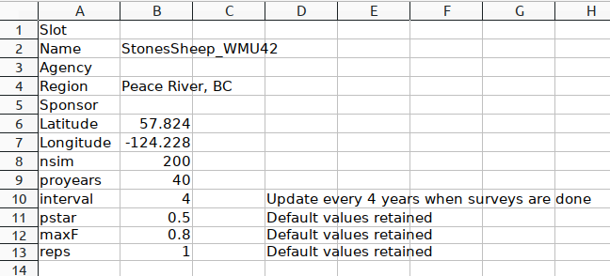OM specifications
2. 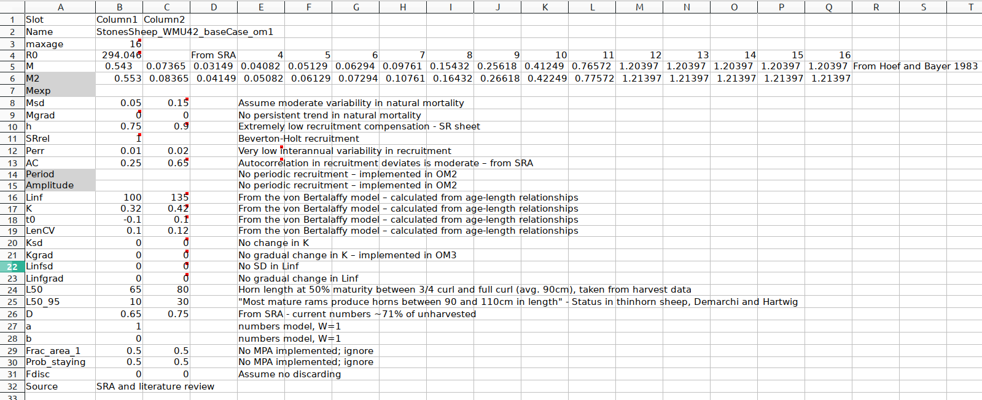Stock parameters
3. Fleet parameters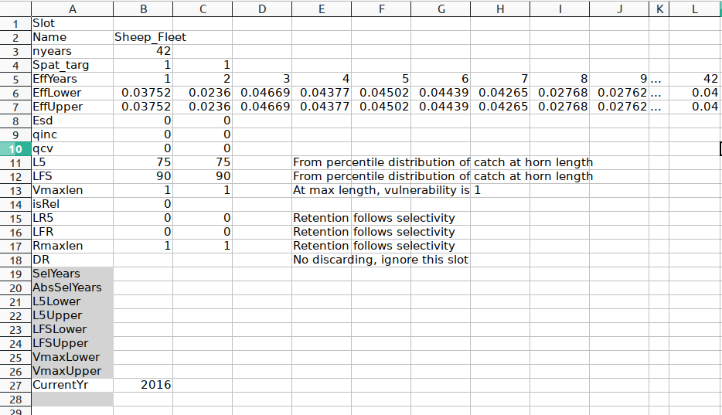
4. Observation parameters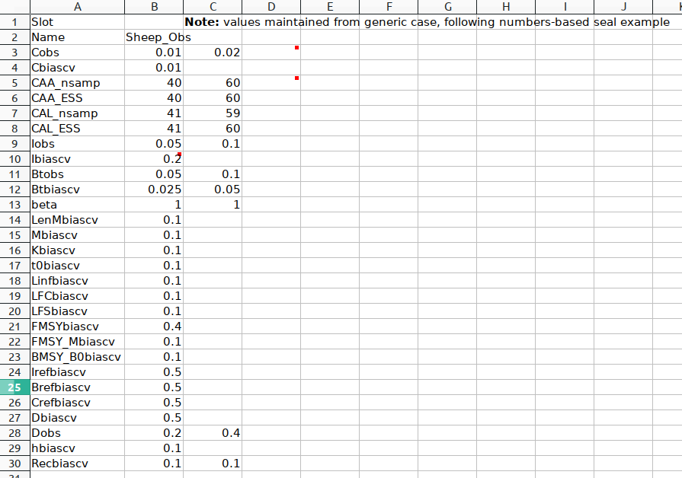 (largely retained from default values)
5. Implementation specifications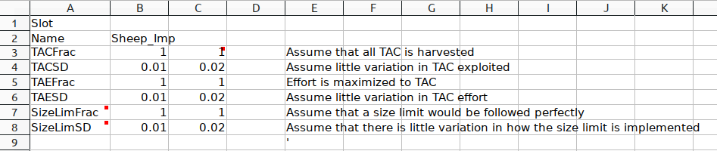
6. *Identify which alternative management procedures in the DLM tool software would be appropriate and of interest to evaluate for your case study fishery.*

Two forms of management procedures are considered in this analysis: input controls and controls that react to changes in the average harvested horn length by modifying TAC. Output controls are generally less useful than input controls and reference-based management procedures because once hunters obtain a permit to hunt a ram, it is unlikely that they will not capture a ram in that year. Output controls may not be reactive enough to prevent hunters from hunting once they have access to a permit.

The management procedures (MPs) investigated with this MSE are:

1. **AvC** (average catch): maintain the status quo by allocating the same number of hunting permits and allowing for constant capture of rams according to historic catches.
2. **matlenlim** (retention is set according to the maturity curve): selectivity at length is designated according to maturity at age. Because maturity at age is relatively well known for this Sheep population, and horn length selectivity can be relatively well-implemented in this highly selective harvest, this MP could be implemented with presumably little implementation error.
3. **CompSRA** (age-composition-based estimate of current stock depletion given constant Z linked to an FMSY estimate to provide OFL): Stone’s sheep harvests include compulsory inspections that provide presumably perfect age-composition of harvests. This MP fits with current management procedures that could be implemented with minimal additional effort and cost to the province.
4. **Fdem** (demographic FMSY calculated from r/2): Stone’s sheep populations are relatively well studied, and estimates of r could be generated with high confidence compared to what is possible with fish populations.
5. **Ltarget4** (incrementally adjusts TAC to reach a target mean length in catches): this is a precautionary MP that could be easily implemented with the current system of compulsory inspections. This way, the number of allocated permits could be modified in response to observed horn length during inspections.
6. **slotlim** (sets a slot limit): this MP is an input control where selectivity-at-horn length is set within a slot limit. This limit is arbitrarily set at the 75% between the new minimum legal length and the asymptotic length
7. **Nfref** (no harvest scenario): a zero-harvest case to simulate the natural, unhunted dynamics of the population. This MP is not included in MP rankings, and is included here only as a base case for comparison.
8. *Apply the plotting features in DLM tool to plot out the various attributes of your operating model and make appropriate adjustments to make sure that your operating model shows intuitively correct attributes.*

Figure 2 demonstrates some of the plots generated with DLMtool for the base-case operating model, OM1. Plots of all attributes of all operating models can be found in the supplementary materials as documentation .html files.

Figure 2 (this and following pages). Summary plots describing the input parameters used in the base-case operating model, OM1. Outputs include summary characteristics of the operating model (a), natural mortality at age (b), recruitment (c), horn length at age (d), maturity at age (e), and selectivity at age (f).

1. 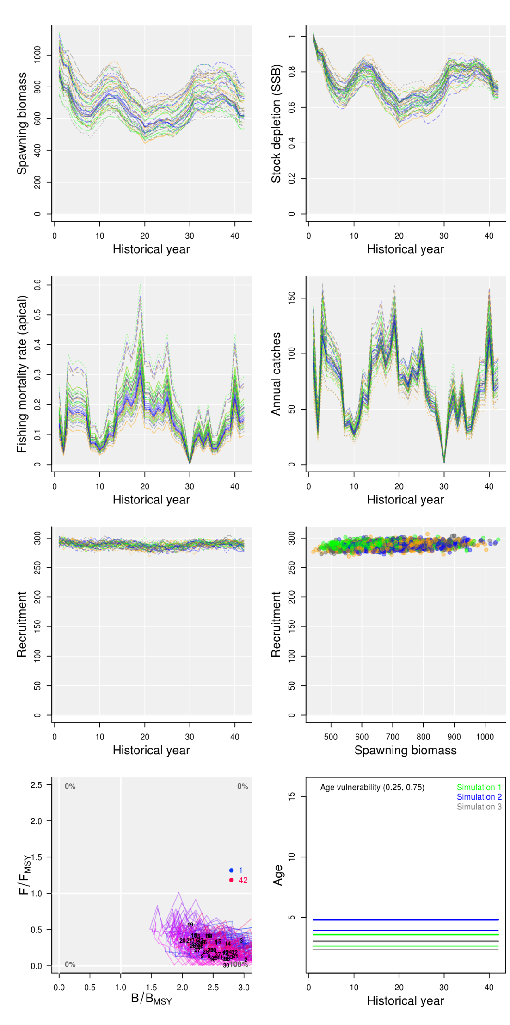OM summary plots; continued on the following page



1. Natural mortality at age

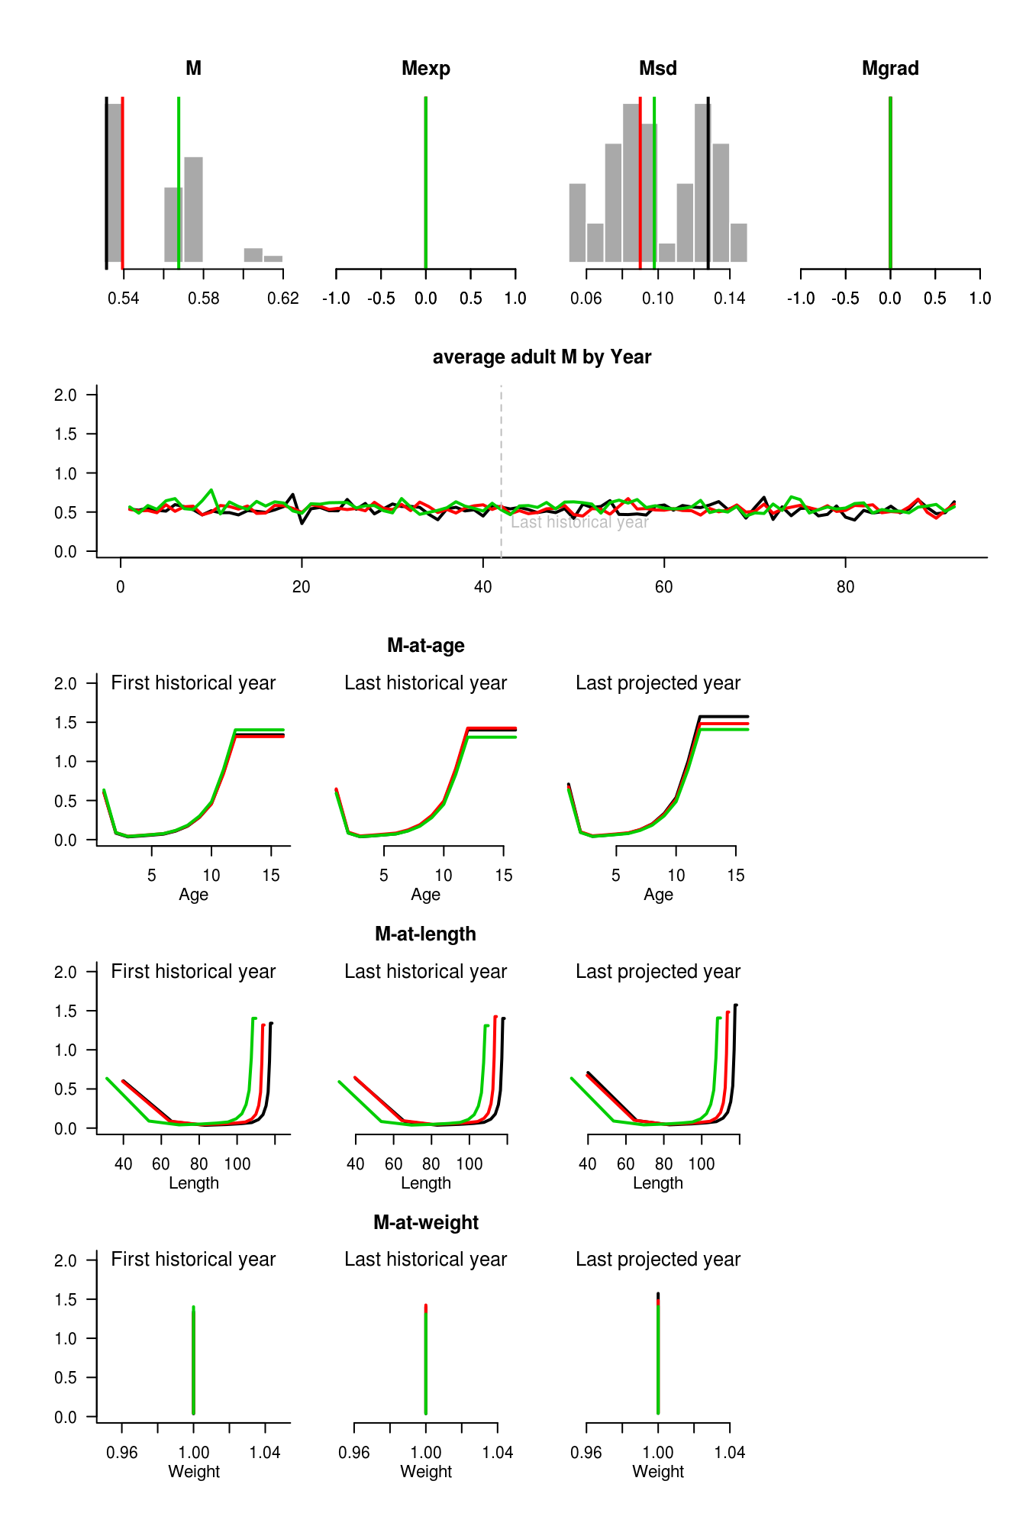

1. Recruitment

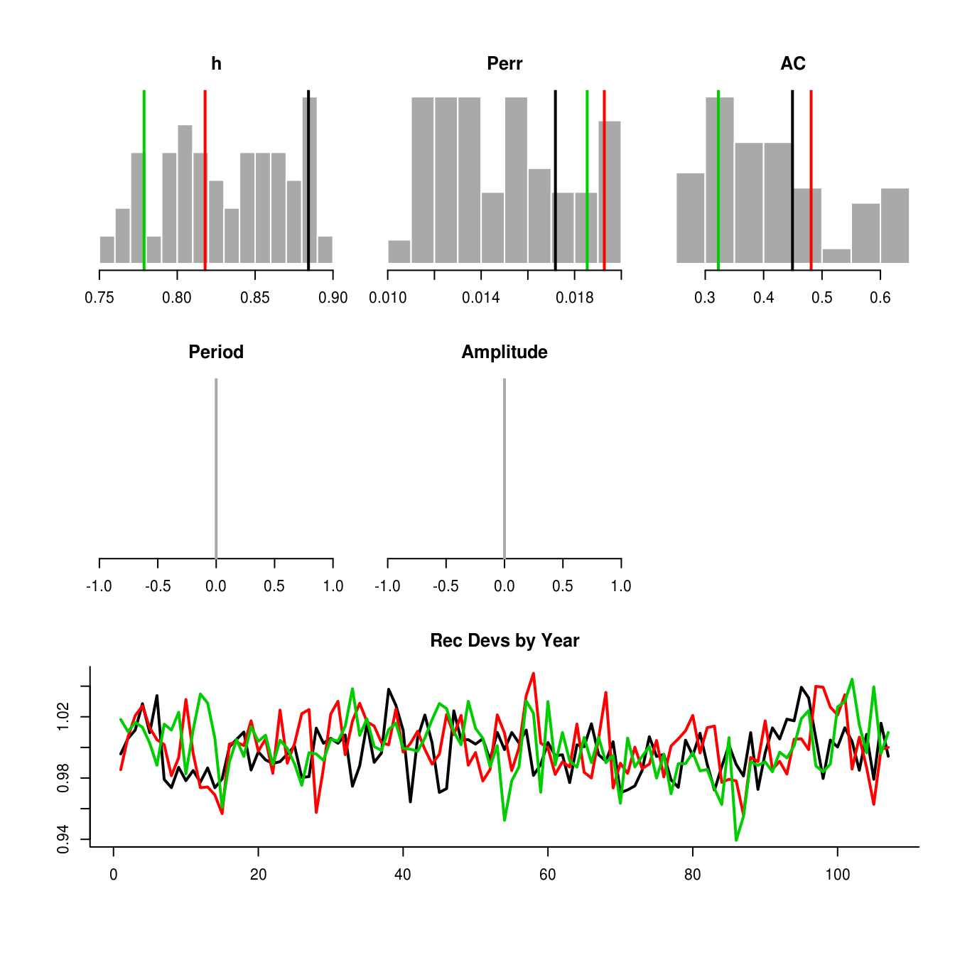

1. Horn length (cm) at age

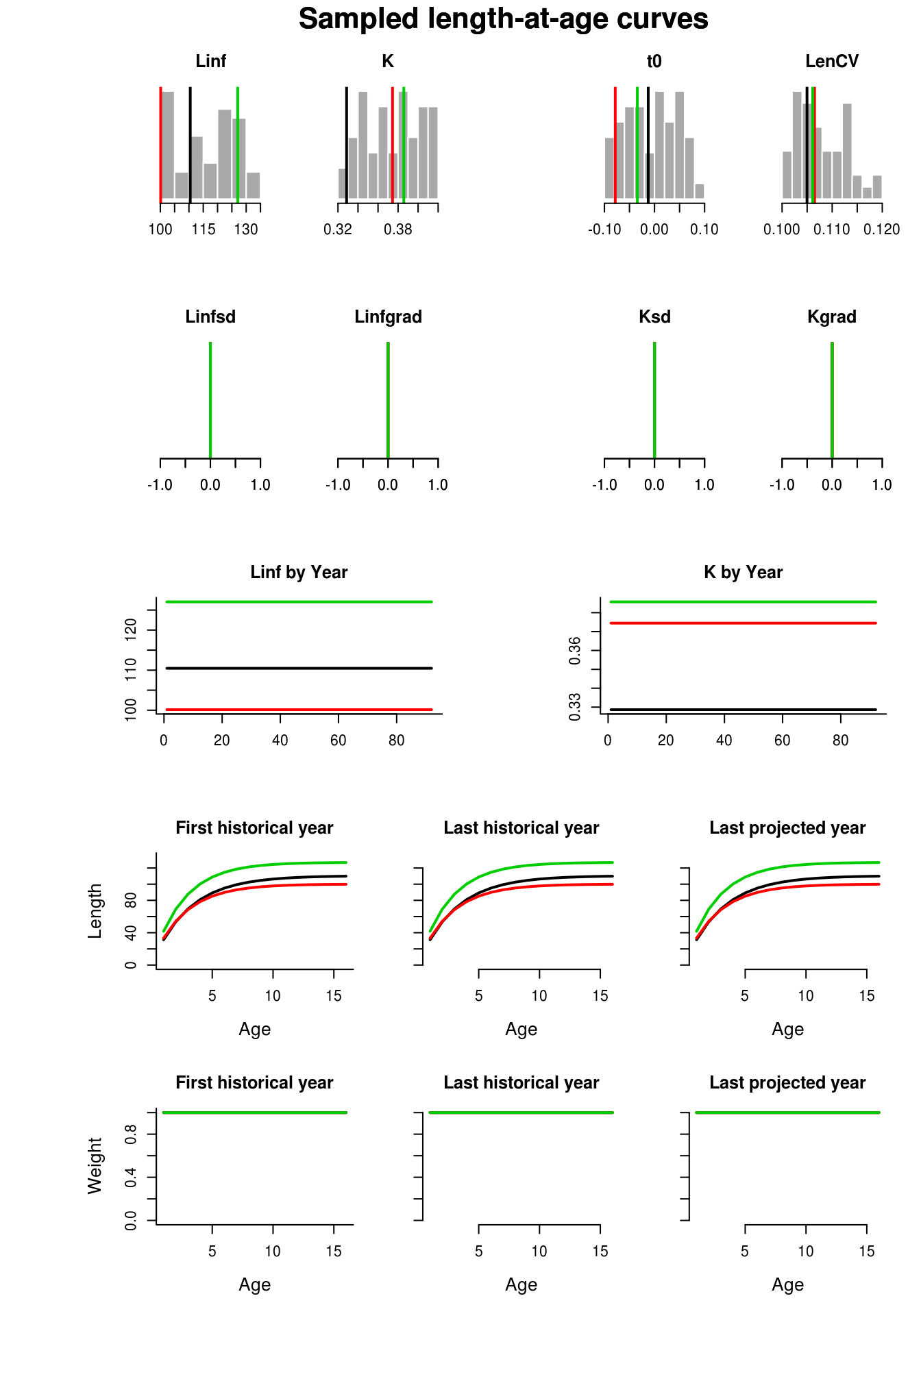

1. 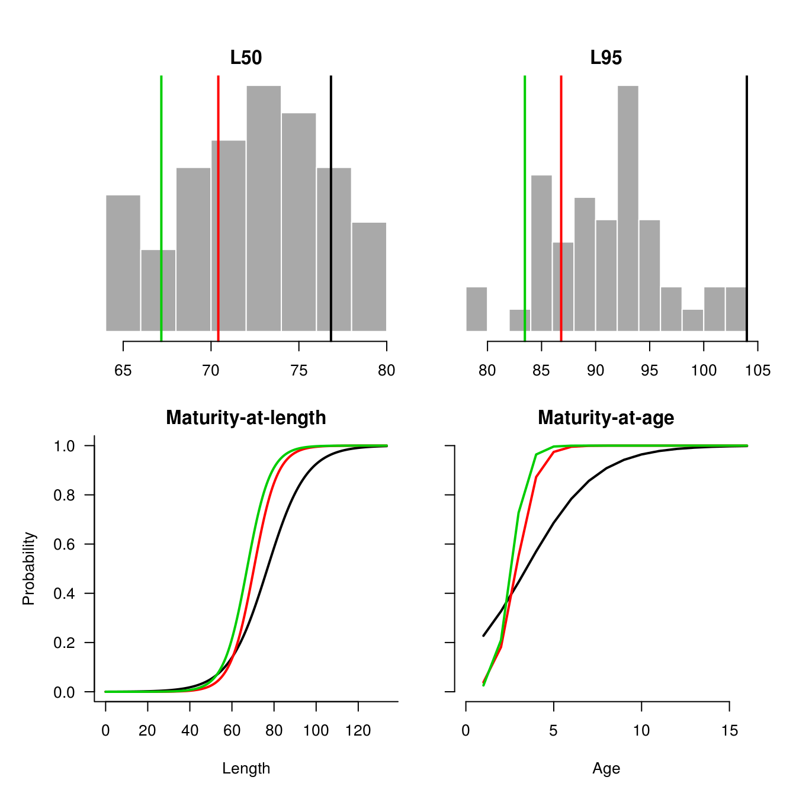Maturity at age/length
2. 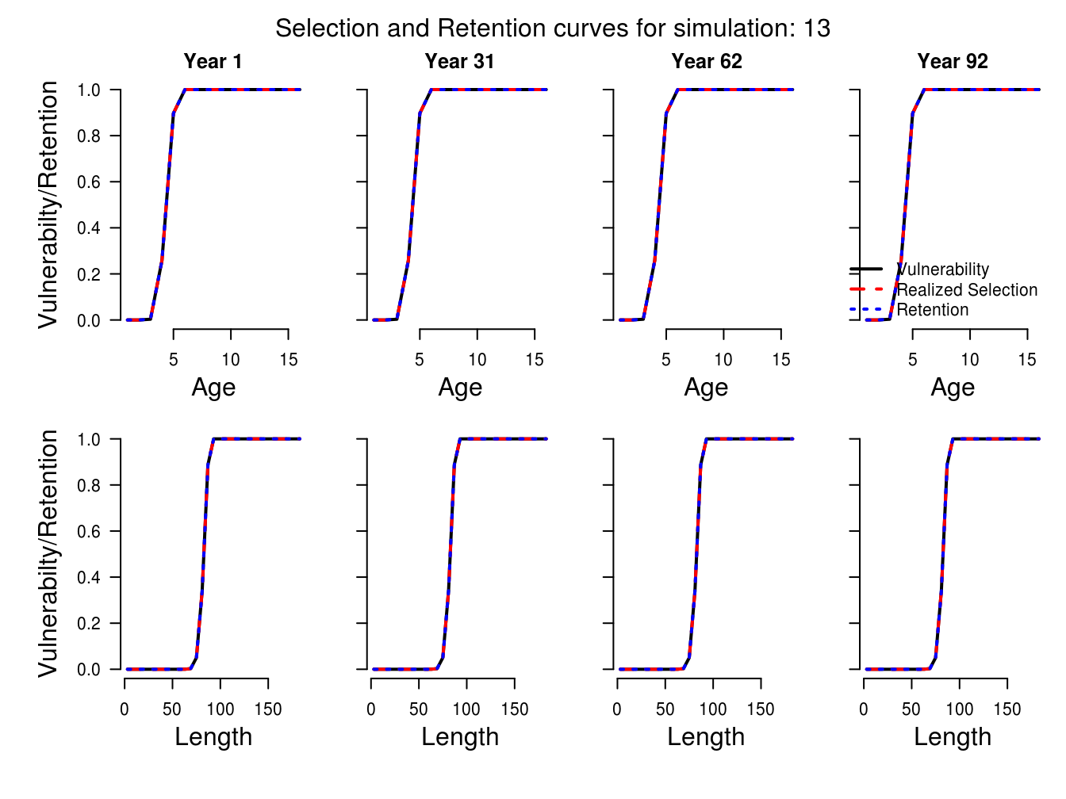Selectivity at length/age
3. 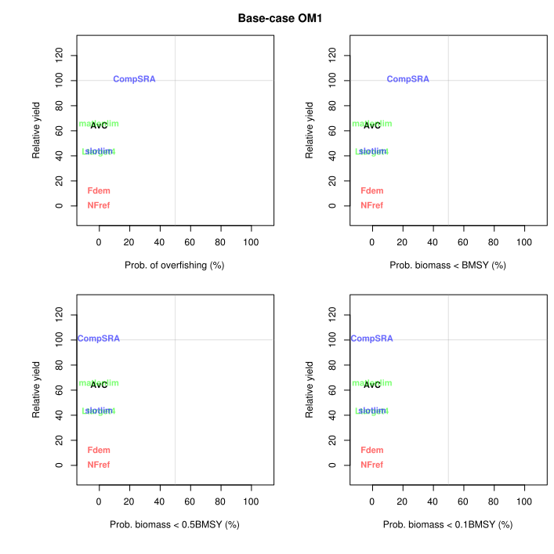*Evaluate the performance of the candidate management procedures (MPs). Show the plots of trade-offs in performance metrics for the different candidate MPs. Provide also a summary table of key performance metrics for each of the candidate MPs under the base case OM.*

Figure 3. Trade-off plots showing the performance of the seven candidate MPs considered with this MSE (AvC, CompSRA, matlenlim, slotlim, Ltarget4, Fdem, and NFref) under the base-case operating model, OM1.

Table 2. Available performance metrics (PM) for the base-case operating model (OM1) for Stone’s sheep harvest in the Peace Region of BC under a series of alternative management procedures. Definitions for the alternative management procedures can be found under Question 4. The performance metrics here include short-term yield relative to reference yield (STY), long-term yield relative to reference yield (LTY), yield relative to reference yield (Yield), the probability that biomass falls below 10% of BMSY (P10), probability that biomass falls below BMSY (P100), and the probability that the average annual variation in yield is less than 20% (AAVY).

|  |  |  |  |  |  |  |  |
| --- | --- | --- | --- | --- | --- | --- | --- |
|  | Management Procedure (MP) | | | | | | |
| *PM* | AvC | NFref | matlenlim | CompSRA | Fdem | Ltarget4 | slotlim |
| *STY* | 0.807 | 0.000 | 0.955 | 1.000 | 0.000 | 0.075 | 0.337 |
| *LTY* | 0.814 | 0.000 | 0.970 | 1.000 | 0.000 | 0.110 | 0.378 |
| *Yield* | 0.643 | 0.000 | 0.653 | 1.057 | 0.115 | 0.395 | 0.433 |
| *P10* | 1.000 | 1.000 | 1.000 | 1.000 | 1.000 | 1.000 | 1.000 |
| *P100* | 1.000 | 1.000 | 1.000 | 0.762 | 1.000 | 1.000 | 0.997 |
| *AAVY* | 1.000 | 1.000 | 1.000 | 1.000 | 1.000 | 1.000 | 0.990 |

Under the base case operating model, the only significant trade-off that emerged was between maximization of yield and the probability of keeping the ram population above BMSY. Yield is highest in simulations that implemented the CompSRA management procedure, which uses age-composition data to calculate an overfishing limit. This MP provided the greatest yields when considering both short- and long-term time frames (Table 2). However, this MP was also the only procedure with a non-negligible risk of pushing the population below BMSY (Figure 3, Table 2), although the probability of the ram population falling below MSY is relatively low and was realized in only ~25% of simulations of the CompSRA MP.

The matlenlim and AvC procedures also offered relatively high expected yields. While the expected yield under these MPs was less than the expected yields under CompSRA, harvests managed with the matlenlim or average catch MPs were less likely to push ram populations below the BMSY threshold (Table 2).

1. *Formulate at least three other credible operating models for your case study fishery which represent different types of uncertainty in your operating model settings. Using each of these “stress test” operating models, compute the performance metrics for the candidate MPs and plot the trade-offs for the candidate MPs under each of these alternative OMs.*

To assess the robustness of these alternative management procedures, I also simulated the outcomes of the alternative MPs under alternative stock and fleet dynamics that differed from the base case. See Table 3 for descriptions of these alternative, stress-test operating models.

Table 3. Summary of the alternative operating models (OM) explored in this MSE analysis. These operating models are designed to stress-test the candidate management procedures being considered for this analysis.

|  |  |  |  |
| --- | --- | --- | --- |
| OM | Documentation file | Description | Key parameters |
| OM2 | *WMU42_StonesSheep_ periodicRecruitment_om2.html* | Rather than constant recruitment (as in the base case, OM1), recruitment follows a 10-year periodic boom-bust system following sunspot activity. | *Period* and *Amplitude* in the *Stock* object |
| OM3 | *WMU42_StonesSheep_ selective_om3.html* | It has been suggested that trophy hunting can cause artificial selective pressure against males with large horns, and that horn growth rates are declining over time in response (Douhard *et al.*, 2016)⁠. This OM simulates a 3-5% annual decrease in mean horn growth rate. | *Kgrad* in the *Stock* object |
| OM4 | *WMU42_StonesSheep_ selectYoung_om4a.html*  and  *WMU42_StonesSheep_ selectOld_om4b.html* | This OM assumes that true hunter selectivity for horn length is biased either towards younger males with smaller horns (OM4a) or towards older males with larger horns (OM4b) than was seen in historical catches. | *L5* and *L95* in the *Fleet* object |
| OM5 | *WMU42_StonesSheep_ highSteep_om5a.html*  and  *WMU42_StonesSheep_ lowSteep_om5b.html* | This OM assumes different values for Beverton-Holt steepness. The SRA used to calculate steepness returned a wide range of values for *h*, and the actual relationship between male population size and overall fecundity is unclear. These OMs therefore simulate the case where steepness is increased by 75% (OM5a) or decreased by 75% (OM5b) | *h* in the *Stock* object |

Table 4. Available performance metrics for each of the alternative operating models considered in this MSE. Definitions for the PM and MP acronyms can be found in the description of Table 3 and the answer to Question 4, respectively.

a)OM2 – Periodic oscillations in recruitment.

|  |  |  |  |  |  |  |  |
| --- | --- | --- | --- | --- | --- | --- | --- |
|  | Management Procedure (MP) | | | | | | |
| *PM* | AvC | NFref | matlenlim | CompSRA | Fdem | Ltarget4 | slotlim |
| *STY* | 0.675 | 0.000 | 0.749 | 0.974 | 0.000 | 0.270 | 0.369 |
| *LTY* | 0.691 | 0.000 | 0.879 | 0.956 | 0.000 | 0.260 | 0.538 |
| *Yield* | 0.656 | 0.000 | 0.768 | 1.099 | 0.125 | 0.413 | 0.507 |
| *P10* | 1.000 | 1.000 | 1.000 | 1.000 | 1.000 | 1.000 | 1.000 |
| *P100* | 0.997 | 1.000 | 0.991 | 0.647 | 1.000 | 1.000 | 0.993 |
| *AAVY* | 1.000 | 1.000 | 0.995 | 0.825 | 1.000 | 1.000 | 0.720 |

b)OM3 – Selective trophy hunting causes gradual reductions in average horn length.

|  |  |  |  |  |  |  |  |
| --- | --- | --- | --- | --- | --- | --- | --- |
|  | Management Procedure (MP) | | | | | | |
| *PM* | AvC | NFref | matlenlim | CompSRA | Fdem | Ltarget4 | slotlim |
| *STY* | 0.806 | 0.000 | 0.947 | 1.000 | 0.000 | 0.042 | 0.380 |
| *LTY* | 0.808 | 0.000 | 0.950 | 1.000 | 0.000 | 0.145 | 0.413 |
| *Yield* | 0.641 | 0.000 | 0.648 | 1.061 | 0.117 | 0.397 | 0.440 |
| *P10* | 1.000 | 1.000 | 1.000 | 1.000 | 1.000 | 1.000 | 1.000 |
| *P100* | 1.000 | 1.000 | 1.000 | 0.781 | 1.000 | 1.000 | 0.997 |
| *AAVY* | 1.000 | 1.000 | 1.000 | 1.000 | 1.000 | 1.000 | 0.980 |

c)OM4a – Hunter selectivity is biased towards younger/short-horned males compared to OM1.

|  |  |  |  |  |  |  |  |
| --- | --- | --- | --- | --- | --- | --- | --- |
|  | Management Procedure (MP) | | | | | | |
| *PM* | AvC | NFref | matlenlim | CompSRA | Fdem | Ltarget4 | slotlim |
| *STY* | 0.869 | 0.000 | 0.991 | 1.000 | 0.000 | 0.224 | 0.399 |
| *LTY* | 0.864 | 0.000 | 0.999 | 1.000 | 0.000 | 0.286 | 0.420 |
| *Yield* | 0.698 | 0.000 | 0.727 | 1.040 | 0.101 | 0.437 | 0.436 |
| *P10* | 1.000 | 1.000 | 1.000 | 1.000 | 1.000 | 1.000 | 1.000 |
| *P100* | 1.000 | 1.000 | 1.000 | 0.715 | 1.000 | 1.000 | 0.981 |
| *AAVY* | 1.000 | 1.000 | 1.000 | 1.000 | 1.000 | 1.000 | 0.925 |

d)OM4b – Hunter selectivity is biased towards older/long-horned males compared to OM1.

|  |  |  |  |  |  |  |  |
| --- | --- | --- | --- | --- | --- | --- | --- |
|  | Management Procedure (MP) | | | | | | |
| *PM* | AvC | NFref | matlenlim | CompSRA | Fdem | Ltarget4 | slotlim |
| *STY* | 0.869 | 0.000 | 0.991 | 1.000 | 0.000 | 0.224 | 0.399 |
| *LTY* | 0.864 | 0.000 | 0.999 | 1.000 | 0.000 | 0.286 | 0.420 |
| *Yield* | 0.698 | 0.000 | 0.727 | 1.040 | 0.101 | 0.437 | 0.436 |
| *P10* | 1.000 | 1.000 | 1.000 | 1.000 | 1.000 | 1.000 | 1.000 |
| *P100* | 1.000 | 1.000 | 1.000 | 0.715 | 1.000 | 1.000 | 0.981 |
| *AAVY* | 1.000 | 1.000 | 1.000 | 1.000 | 1.000 | 1.000 | 0.925 |

e)OM5a – Steepness of stock-recruitment function 75% higher than OM1.

|  |  |  |  |  |  |  |  |
| --- | --- | --- | --- | --- | --- | --- | --- |
|  | Management Procedure (MP) | | | | | | |
| *PM* | AvC | NFref | matlenlim | CompSRA | Fdem | Ltarget4 | slotlim |
| *STY* | 0.761 | 0.000 | 0.943 | 1.000 | 0.000 | 0.042 | 0.326 |
| *LTY* | 0.795 | 0.000 | 0.962 | 1.000 | 0.000 | 0.097 | 0.354 |
| *Yield* | 0.619 | 0.000 | 0.635 | 1.048 | 0.133 | 0.389 | 0.422 |
| *P10* | 1.000 | 1.000 | 1.000 | 1.000 | 1.000 | 1.000 | 1.000 |
| *P100* | 1.000 | 1.000 | 1.000 | 0.968 | 1.000 | 1.000 | 0.998 |
| *AAVY* | 1.000 | 1.000 | 1.000 | 1.000 | 1.000 | 1.000 | 0.995 |

f)OM5b – Steepness of stock-recruitment function 75% lower than OM1.

|  |  |  |  |  |  |  |  |
| --- | --- | --- | --- | --- | --- | --- | --- |
|  | Management Procedure (MP) | | | | | | |
| *PM* | AvC | NFref | matlenlim | CompSRA | Fdem | Ltarget4 | slotlim |
| *STY* | 0.930 | 0.000 | 0.989 | 1.000 | 0.000 | 0.216 | 0.446 |
| *LTY* | 0.937 | 0.000 | 0.997 | 1.000 | 0.000 | 0.285 | 0.453 |
| *Yield* | 0.725 | 0.000 | 0.724 | 1.046 | 0.084 | 0.440 | 0.478 |
| *P10* | 1.000 | 1.000 | 1.000 | 1.000 | 1.000 | 1.000 | 1.000 |
| *P100* | 0.996 | 1.000 | 1.000 | 0.171 | 1.000 | 1.000 | 0.997 |
| *AAVY* | 1.000 | 1.000 | 1.000 | 1.000 | 1.000 | 1.000 | 0.990 |

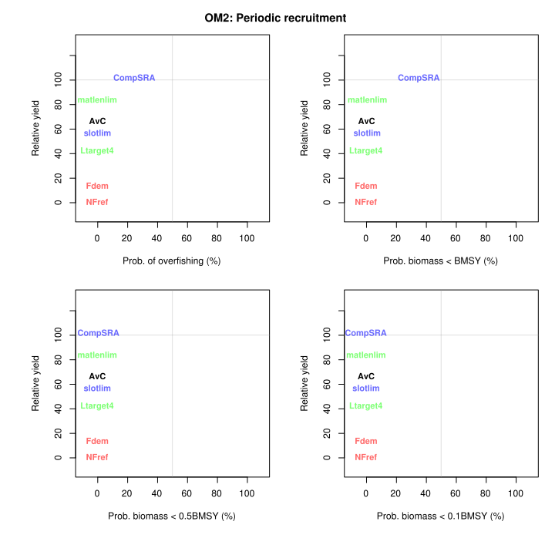

Figure 4a. Trade-off plots (Tplot() in DLMtool) for OM2, the stress-test operating model that considers periodically oscillating recruitment in the Stone’s sheep population.

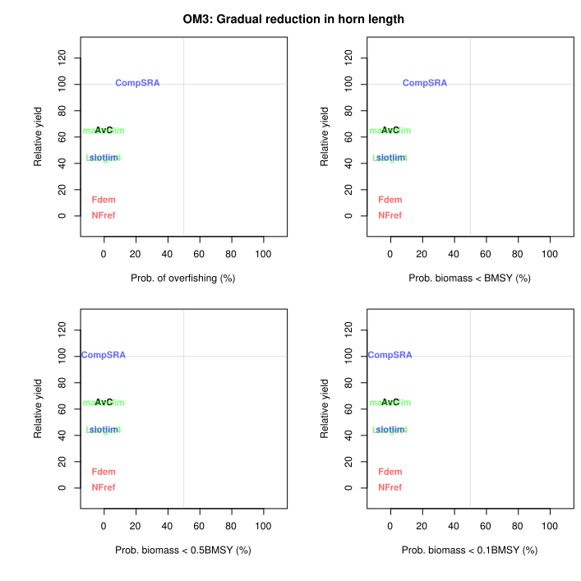

Figure 4b. Trade-off plots (Tplot() in DLMtool) for OM3, the stress-test operating model that considers a scenario where selective hunting pressure reduces the growth rate of horns in early life.

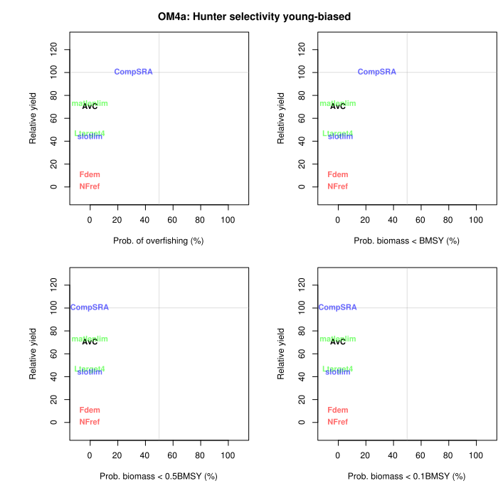Figure 4c. Trade-off plots (Tplot() in DLMtool) for OM4a, the stress-test operating model that considers a scenario where true hunter selectivity at horn length is biased more towards younger males with smaller horns than what is seen in historical catch records.

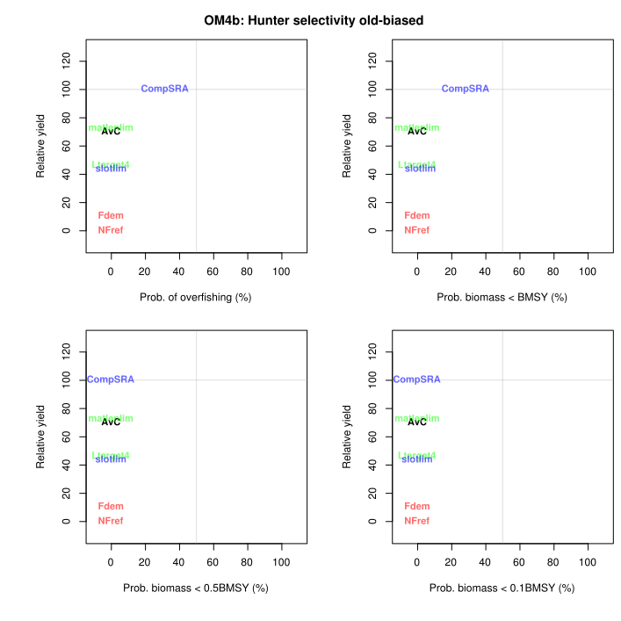Figure 4d. Trade-off plots (Tplot() in DLMtool) for OM4b, the stress-test operating model that considers a scenario where true hunter selectivity at horn length is biased more towards older males with larger horns than what is seen in historical catch records.

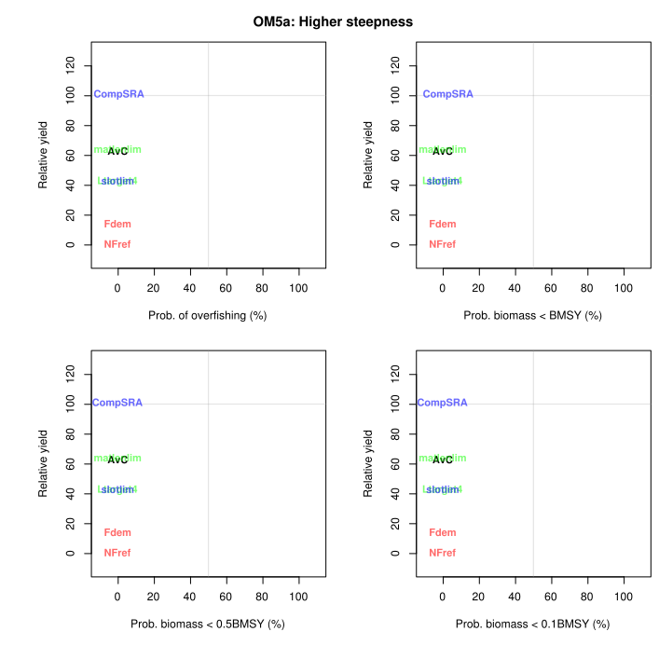Figure 4e. Trade-off plots (Tplot() in DLMtool) for OM5a, the stress-test operating model that considers a scenario where steepness of the Beverton-Holt recruitment curve is 75% higher than what was calculated with stock reduction analysis.

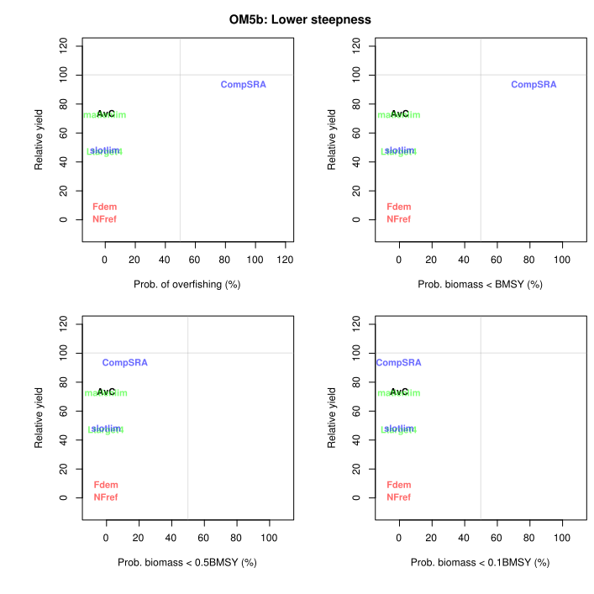Figure 4f. Trade-off plots (Tplot() in DLMtool) for OM5b, the stress-test operating model that considers a scenario where steepness of the Beverton-Holt recruitment curve is 75% lower than what was calculated with stock reduction analysis.

1. *Identify which MPs are most robust to uncertainty.*

All the management procedures performed well regardless of operating model with one exception: CompSRA. Although this MP offers the highest expected yield in both short- and long-term time frames, it also bears the highest risk of overharvest of the ram population. For example, under OM5b, the stress-test that simulates low recruitment compensation, managing harvests with CompSRA caused the ram population to fall below BMSY in 83% of simulations.

By comparison, all other MPs other than CompSRA were resilient to alternative stock and fleet scenarios, and MP ranking was generally unchanged between alternative OMs. Ranking was somewhat sensitive to hypotheses about recruitment however, as the stress-test operating models OM2 and OM5b influenced which of AvC or matlenlim provided the highest expected yield. The performance of all MPs other than CompSRA was consistent in all OMs.

1. *Based on your analyses, rank the performance of the candidate MPs and justify your approach for ranking the performance of the candidate management procedures.*

Considering the trade-offs apparent in Tables 2 and 4 and Figures 3 and 4, the ranking that I would give to the candidate management procedures is as follows:

1. matlenlim
2. AvC
3. slotLim
4. Ltarget4
5. Fdem
6. CompSRA

*Note that NFref is excluded from this ranking as it was included simply as a non-harvest reference and is not a realistic management procedure.*

The above ranking is based on a key principle: yields should be maximized, insofar as ram populations do not run a serious risk of overexploitation (see Table 1). Therefore MPs are ranked first by whether they meet conservation targets, and then by the expected yield when considering all OMs simultaneously. Matlenlim was the most resilient MP, and typically offered the second-highest expected yields following CompSRA. Only under OM5b did matlenlim’s ranking fall below AvC (thus this MP is ranked second overall). The lowest ranked MPs, Fdem and CompSRA, offered either small yields that are unlikely to satisfy hunters’ needs (as was the case for Fdem), or were unable to meet conservation standards across all OMs (as was the case for CompSRA).

The ranking therefore reflects the trade-offs that were seen between high yields and probability of depleting the ram population. The highest ranked MP, matlenlim, does not maximize yield in any of the OMs, but it has a near-zero probability of failing conservation metrics across all simulations. Meanwhile, despite its promise of high yield, CompSRA fails conservation targets if recruitment compensation is lower than SRA predictions or if lamb recruitment follows strong periodic oscillations (as simulated in OM5a and OM2 respectively). While it is unlikely that this exploitation would lead to recruitment overharvest (indicated by near-zero probability of ram numbers falling below 10% of BMSY, demonstrated in theP10 performance metric), the reduction in biomass could have unintended consequences on population by influencing female or juvenile ram behaviour and reproductive timing (Mysterud, Coulson and Stenseth, 2002). Ultimately, the easiest and most cost-efficient management procedure for this population may be average catch (AvC).

1. *Provide a brief summary of the key strengths and potential weaknesses of your analysis.*

The primary strength of this analysis lies in its ability to compare the outcomes of alternative management procedures under a variety of recruitment scenarios. Ungulate recruitment dynamics, particularly regarding the role of males in overall reproduction, is understudied and poorly understood in many sex-specific trophy harvests. It is commonly believed that no amount of mature male removal could lead to reproductive overharvest, as younger males are capable of fertilizing all females in a given population (Ian Hatter, personal communication; Mysterud, Coulson and Stenseth, 2002). However, rampant male-only harvest can still lead to catastrophic declines in hunted populations (Milner-Gulland *et al.*, 2003). Therefore trophy hunting management often assumes that mature male harvest is effectively unlimited.

Interestingly, this analysis reflected this resilience, as most of management procedures had a near-zero probability of causing ram density to decline beyond BMSY (Tables 3 and 4). However, alternative assumptions about recruitment dynamics implemented in OMs 2, 5a, and 5b had a strong influence over the conservation and yield outcomes of the alternative MPs, particularly CompSRA. Therefore including the male influence on recruitment dynamics may be vital to effective management of sex-specific harvests.

However, the recruitment dynamics modelled in this analysis are still unrealistic. Ideally, a two-sex model could be implemented in DLMtool, such that recruitment could be based primarily on female population dynamics rather than male density. In this way, ram density could influence, for example, female fertility rates and the size and survivorship of lambs (Mysterud, Coulson and Stenseth, 2002). Unfortunately, DLMtool will be unable to implement sex-specific dynamics until later this year (Adrian Hordyk, personal communication).

Another weakness of this analysis, albeit minor compared to recruitment dynamics, is a lack of size-based performance metrics. Trophy hunters are primarily interested in capturing large-horned males, and the number of rams captured may be less important to hunters than their desire to capture large males. Ideally, future analysis could include custom performance metrics like average horn length in the population, proportion of legal males to non-legal males, and the average and standard deviation of horn lengths captured by hunters. At this time, however, custom performance metrics are still under development (Carruthers and Hordyk, 2018), and such metrics may only be available in future analyses.

Supplementary materials:

The following supplementary materials are included in a compressed zip folder entitled “MDeith_SheepDLMTool_OMDocumentation.zip”.

1. Documentation and justification for parameters in all operating models:
   1. **Base case OM1**: WMU42_StonesSheep_baseCase.html
   2. **Stress case OM2**: WMU42_StonesSheep_periodicRecruitment.html
   3. **Stress case OM3**: WMU42_StonesSheep_selective_om3.html
   4. **Stress case OM4a**: WMU42_StonesSheep_selectYoung_om4a.html
   5. **Stress case OM4b**: WMU42_StonesSheep_selectOld_om4b.html
   6. **Stress case OM5a**: WMU42_StonesSheep_highSteep_om5a.html
   7. **Stress case OM5b**: WMU42_StonesSheep_lowSteep_om5b.html
2. CSV files for each tab of each operating model can be found in subfolders “baseCase_om1”, “periodicRecruitment_om2”, “graduallyShorterHorns_om3”, “selectivityOlder_om4a”, “selectivityYounger_om4b”, “steepnessHigher_om5a”, and “steepnessLower_om5b”

Literature cited

Carruthers, T. and Hordyk, A. (2018) ‘Data-Limited Methods Toolkit (DLMtool)’, (November), pp. 1–40. doi: 10.1016/j.fishres.2013.12.014>.

Loehr, J. *et al.* (2007) ‘Horn growth rate and longevity: Implications for natural and artificial selection in thinhorn sheep (Ovis dalli)’, *Journal of Evolutionary Biology*, 20(2), pp. 818–828. doi: 10.1111/j.1420-9101.2006.01272.x.

Milner-Gulland, E. J. *et al.* (2003) ‘Reproductive collapse in saiga antelope harems’, *Nature*, 422(6928), p. 135. doi: 10.1038/422135a.

Mysterud, A., Coulson, T. and Stenseth, N. C. (2002) ‘The role of males in the dynamics of ungulate populations’, *Journal of Animal Ecology*, 71(6), pp. 907–915. doi: 10.1046/j.1365-2656.2002.00655.x.