FISH 505 Exercise 9
Management Strategy Evaluation for Stone’s Sheep in WMU742
Steps and Questions
- State a minimum of one fishery objective and one conservation objective for your case study fishery and use the three-point guidelines for management objective specification from the seminar slides presented in the first FISH 505 session on MSE.
Table 1. Management objectives for the Stone’s sheep harvest in WMU7-42. Harvest objectives are catered towards maximizing the number and value of harvestable males, while conservation objectives seek to avoid recruitment overharvest.
Objective | Time frame to meet objective | Probability of obtaining the objective
Harvest/conservation  Keep the male population size, B, at or below B_{MSY} | Long-term  Harvest should reduce the population to below B_{MSY} at any point in the simulation (2016-2056). | Probability: 80%  The population should not drop below B_{MSY} in more than 20% of simulations
Harvest  Maximize the length of horns available for harvest | Long-term  Average harvested horns should be be >90cm after 2036 | Probability: 50%  Over 90% of simulations should ensure that the average harvested horn length is greater than 90cm
Conservation  Maintain the mature male population above 5% of the total female population (this should avoid recruitment overharvest; Ontario Sheep, no date; Milner-Gulland et al., 2003)⁠ | Long-term  The male population should not drop below 5% of the female population at any point in the 40 year simulation | Probability: 90%  The mature male population must remain above 5% of the female population size in at least 90% of simulations
Harvest  Minimze variation in number of harvested rams; interannual variation should be less than 15% | Long-term  Many guides depend on consistent harvest of mature males for income, so interannual variation over the entire 40 year time span should not exceed 15% | Probability: 50%  Tolerance for variability is likely high (as guides are paid regardless of whether the harvest is successful, assuming that demand for guides is constant)
- Identify and list the types of information available from which you can formulate an operating model for your case study fishery.

The most important source of information that can be used to construct the operating models comes from harvest records collected by the province of British Columbia from 1975-2016. Data collected by the provincial government includes:

- Hunter effort – measured as the total number of days that hunters spent hunting during the open season in each year
- Number of harvested rams – the total number of rams hunted in each year, assuming that all hunters turn in harvested horns to conservation officers for compulsory inspection
- Length and age composition of harvested rams – data are collected from the horns that are submitted for compulsory inspection, including total length of the horns (in cm) and the expected age of the ram (measured according to growth annuli)

These data were used to populate the operating model with data for horn-length selectivity by hunters and to generate an age-length relationship to model how horn length changes as the rams age. These data were also used in a stock reduction analysis to quantify recruitment at unharvested biomass, R₀, current estimated depletion, D, and steepness of the Beverton-Holt stock-recruit relationship, h.

Additional data sources from unharvested populations of Stone’s sheep elsewhere in British Columbia and the Yukon were also used to populate key parameters in the operating model:
- Horn length at age – although horn length at age could be generated exclusively from the length and age composition of harvested rams, Loehr et al. (2007)⁠ generated a dataset of horn length at age that includes younger age classes that are below the legal limit for hunters, and are therefore not represented in harvest data. I therefore calculated the relationship between horn length and age using data from both harvest records and published materials.
- Natural mortality at age – the demographics of an unharvested population of thinhorn sheep, including natural sex ratios and mortality at age, were collected from Hoefs & Bayer, 1983.

- Make a copy of the Example_Chile_Hake Excel file in the Excel directory of the Exercise subdirectory and rename your new file to your case study fishery name. Provide a print-out of the tabs of your updated Excel file and list brief justifications for your entries into each of the tabs of this file.

Because ram removals are numbers-based rather than biomass based, I generated a numerical model. Rather than copying the Chilean hake example and modifying the operating model from this template, I generated OMs from scratch using the Ominit() command in DLMtool. Parameters were input from the sources listed above, or were taken from another example provided with DLMtool: Grey seals. The operating model parameters for the Grey Seal OM can be found at: http://www.datalimitedtoolkit.org/Case_Studies_Table/Grey_Seal_5ZJM_DFO/Grey_Seal_5ZJM_DFO.html.

Similarly, parameter values and their justifications for the base-case operating model (as well as the three alternative OMs considered in this MSE) can be found in the attached supplementary materials:
- Base case OM1: file WMU42_StonesSheep_baseCase.html
- Stress case OM2: file WMU42_StonesSheep_periodicRecruitment.html
- Stress case OM3: file WMU42_StonesSheep_selective_om3.html
- Stress case OM4a: file WMU42_StonesSheep_selectivityYounger_om4a.html
- Stress case OM4b: file WMU42_StonesSheep_selectivityOlder_om4b.html

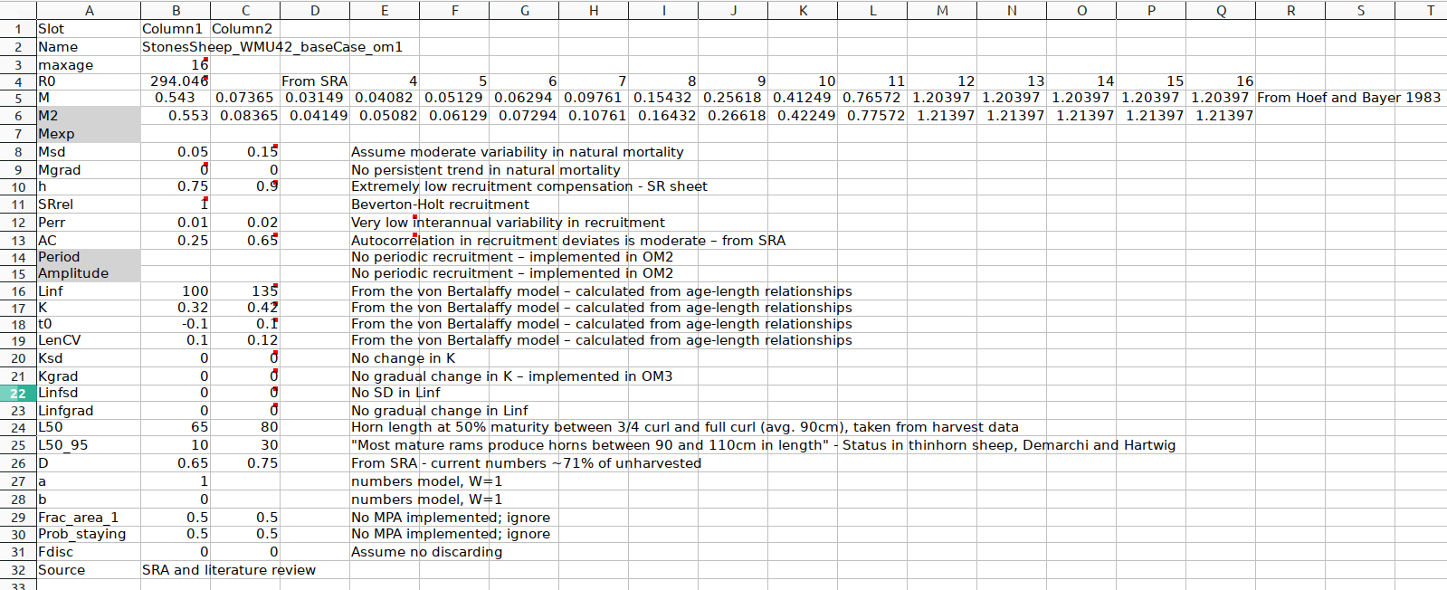
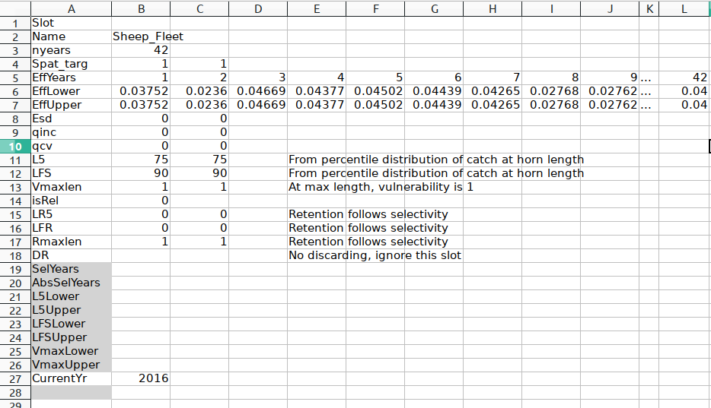

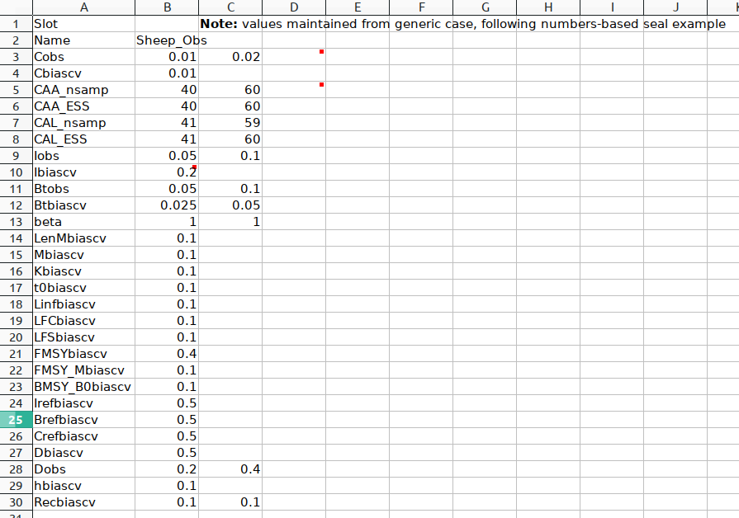
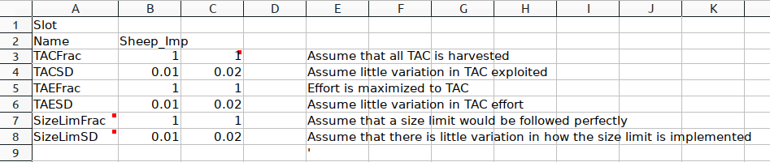
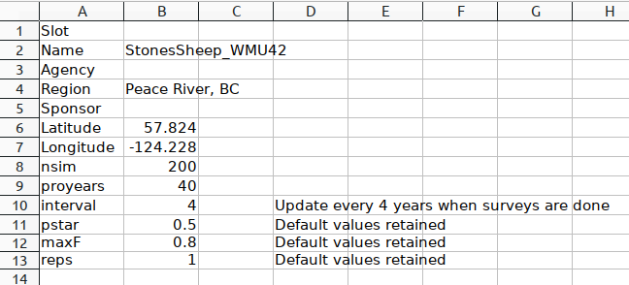
Figure 1. Screen captures of each of the tabs included in the Stone’s sheep base-case operating model.

- Identify which alternative management procedures in the DLM tool software would be appropriate and of interest to evaluate for your case study fishery.
Two types of management procedures are considered in this analysis: input controls and length-based changes to TAC. Output controls are less useful in this case because hunters, once they obtain a hunting permit, will hunt until they capture a ram and output controls may therefore be ineffective. The management procedures investigated with this MSE are:
- AvC (average catch): maintain the status quo and allow the same number of hunting permits and hunters to continue activity
- Nfref (no harvest scenario): a zero-harvest case to simulate the natural, unhunted dynamics of the population; included for a baseline comparison
- matlenlim (retention is set according to the maturity curve): selectivity at length is designed according to maturity at age. Because maturity at age is relatively well known, and length-based selectivity can be relatively well-controlled in this harvest, this MP could be effectively implemented with presumably little implementation error
- CompSRA (age-composition-based estimate of current stock depletion given constant Z linked to an F_{MSY} estimate to provide OFL): Stone’s sheep harvests include compulsory inspections that provide presumably perfect age-composition of harvests. This MP fits with current management procedures that could be implemented with minimal additional effort and cost to the province.
- Fdem (demographic F_{MSY} calculated from r/2): Stone’s sheep populations are relatively well studied, and estimates of r could be generated with high confidence compared to what is possible with fish populations.
- Ltarget4 (incrementally adjusts TAC to reach a target mean length in catches): this is a precautionary MP that could be easily implemented with the current system of compulsory inspections. This way, the number of allocated permits could be modified in response to observed horn length during inspections.
.slotlim (sets a slot limit): this MP is an input control where selectivity-at-horn length is set within a slot limit. This limit is arbitrarily set at the 75% between the new minimum legal length and the asymptotic length

- Apply the plotting features in DLM tool to plot out the various attributes of your operating model and make appropriate adjustments to make sure that your operating model shows intuitively correct attributes.

Plots of the attributes of the operating model can be found in the following documentation files:
- Base case OM1: file WMU42_StonesSheep_baseCase.html
- Stress case OM2: file WMU42_StonesSheep_periodicRecruitment.html
- Stress case OM3: file WMU42_StonesSheep_selective_om3.html
- Stress case OM4a: file WMU42_StonesSheep_selectivityYounger_om4a.html
- Stress case OM4b: file WMU42_StonesSheep_selectivityOlder_om4b.html

- Evaluate the performance of the candidate management procedures (MPs). Show the plots of trade-offs in performance metrics for the different candidate MPs. Provide also a summary table of key performance metrics for each of the candidate MPs under the base case OM.
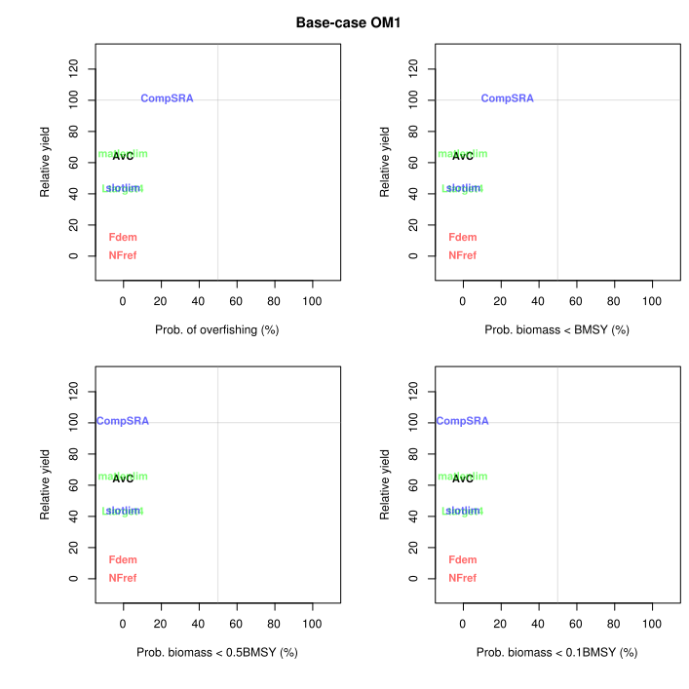
Table 2. Available performance metrics (PM) for the base-case operating model (OM1) for Stone’s sheep harvest in the Peace Region of BC under a series of alternative management procedures. Definitions for the alternative management procedures can be found under Question 4. The performance metrics here include short-term yield relative to reference yield (STY), long-term yield relative to reference yield (LTY), yield relative to reference yield (Yield), the probability that biomass falls below 10% of B_{MSY} (P10), probability that biomass falls below B_{MSY} (P100), and the probability that the average annual variation in yield is less than 20% (AAVY).
 | Management Procedure (MP)
PM | AvC | NFref | matlenlim | CompSRA | Fdem | Ltarget4 | slotlim
STY | 0.807 | 0.000 | 0.955 | 1.000 | 0.000 | 0.075 | 0.337
LTY | 0.814 | 0.000 | 0.970 | 1.000 | 0.000 | 0.110 | 0.378
Yield | 0.643 | 0.000 | 0.653 | 1.057 | 0.115 | 0.395 | 0.433
P10 | 1.000 | 1.000 | 1.000 | 1.000 | 1.000 | 1.000 | 1.000
P100 | 1.000 | 1.000 | 1.000 | 0.762 | 1.000 | 1.000 | 0.997
AAVY | 1.000 | 1.000 | 1.000 | 1.000 | 1.000 | 1.000 | 0.990

Under the base case operating model, only a minor tradeoff emerged between maximization of yield and the probability of keeping the ram population above B_{MSY}. Yield is highest in simulations that implemented the CompSRA management procedure, which uses age-composition data to calculate an overfishing limit. This MP provided the greatest yields when considering both short- and long-term time frames (Table 2). However, this MP was also the only procedure with a non-negligible risk of pushing the population below B_{MSY} (Figure 2, Table 2), although the probability of the ram population falling below MSY is relatively low and was realized in only ~25% of simulations of the CompSRA MP.

The matlenlim and AvC approaches also offered relatively high yields. While the expected yield under these MPs was less than the expected yields under CompSRA, harvests managed with the matlenlim or average catch methods were less likely to push ram populations below the B_{MSY} threshold (Table 2).

- Formulate at least three other credible operating models for your case study fishery which represent different types of uncertainty in your operating model settings. Using each of these “stress test” operating models, compute the performance metrics for the candidate MPs and plot the trade-offs for the candidate MPs under each of these alternative OMs.
To assess the robustness of these alternative management procedures, I also simulated harvests if stock and fleet dynamics are different than the base case. See Table 3 for descriptions of these alternative, stress-test operating models.
Table 3. Summary of the alternative operating models (OM) explored in this MSE analysis. These operating models are designed to stress-test the candidate management procedures being considered for this analysis.
OM | Documentation file | Description | Key parameters
OM2 | WMU42_StonesSheep_ periodicRecruitment_om2.html | Rather than constant recruitment (as in the base case, OM1), recruitment follows a 10-year periodic boom-bust system following sunspot activity. | Period and Amplitude in the Stock object
OM3 | WMU42_StonesSheep_ selective_om3.html | It has been suggested that trophy hunting can cause artificial selective pressure against males with large horns, and that horn growth rates are declining over time in response (Douhard et al., 2016)⁠. This OM simulates a 3-5% annual decrease in mean horn growth rate. | Kgrad in the Stock object
OM4 | WMU42_StonesSheep_ selectYoung_om4a.html  and  WMU42_StonesSheep_ selectOld_om4b.html | This OM assumes that true hunter selectivity for horn length is biased either towards younger males with smaller horns (OM4a) or towards older males with larger horns (OM4b) than was seen in historical catches. | L5 and L95 in the Fleet object
OM5 | WMU42_StonesSheep_ highSteep_om5a.html  and  WMU42_StonesSheep_ lowSteep_om5b.html | This OM assumes different values for Beverton-Holt steepness. The SRA used to calculate steepness returned a wide range of values for h, and the actual relationship between male populuation size and overall fecundity is unclear. These OMs therefore simulate the case where BH steepness is increased by 75% (OM5a) or decreased by 75% (OM5b) | h in the Stock object

Table 4. Available performance metrics for each of the alternative operating models considered in this MSE. Definitions for the PM and MP acroynms can be found in the description of Table 3 and the answer to Question 4, respectively.
a) OM2 – Periodic oscillations in recruitment.
 | Management Procedure (MP)
PM | AvC | NFref | matlenlim | CompSRA | Fdem | Ltarget4 | slotlim
STY | 0.675 | 0.000 | 0.749 | 0.974 | 0.000 | 0.270 | 0.369
LTY | 0.691 | 0.000 | 0.879 | 0.956 | 0.000 | 0.260 | 0.538
Yield | 0.656 | 0.000 | 0.768 | 1.099 | 0.125 | 0.413 | 0.507
P10 | 1.000 | 1.000 | 1.000 | 1.000 | 1.000 | 1.000 | 1.000
P100 | 0.997 | 1.000 | 0.991 | 0.647 | 1.000 | 1.000 | 0.993
AAVY | 1.000 | 1.000 | 0.995 | 0.825 | 1.000 | 1.000 | 0.720

b) OM3 – Selective trophy hunting causes gradual reductions in average horn length.
 | Management Procedure (MP)
PM | AvC | NFref | matlenlim | CompSRA | Fdem | Ltarget4 | slotlim
STY | 0.806 | 0.000 | 0.947 | 1.000 | 0.000 | 0.042 | 0.380
LTY | 0.808 | 0.000 | 0.950 | 1.000 | 0.000 | 0.145 | 0.413
Yield | 0.641 | 0.000 | 0.648 | 1.061 | 0.117 | 0.397 | 0.440
P10 | 1.000 | 1.000 | 1.000 | 1.000 | 1.000 | 1.000 | 1.000
P100 | 1.000 | 1.000 | 1.000 | 0.781 | 1.000 | 1.000 | 0.997
AAVY | 1.000 | 1.000 | 1.000 | 1.000 | 1.000 | 1.000 | 0.980

c) OM4a – Hunter selectivity is biased towards younger/short-horned males compared to OM1.
 | Management Procedure (MP)
PM | AvC | NFref | matlenlim | CompSRA | Fdem | Ltarget4 | slotlim
STY | 0.869 | 0.000 | 0.991 | 1.000 | 0.000 | 0.224 | 0.399
LTY | 0.864 | 0.000 | 0.999 | 1.000 | 0.000 | 0.286 | 0.420
Yield | 0.698 | 0.000 | 0.727 | 1.040 | 0.101 | 0.437 | 0.436
P10 | 1.000 | 1.000 | 1.000 | 1.000 | 1.000 | 1.000 | 1.000
P100 | 1.000 | 1.000 | 1.000 | 0.715 | 1.000 | 1.000 | 0.981
AAVY | 1.000 | 1.000 | 1.000 | 1.000 | 1.000 | 1.000 | 0.925

d) OM4b – Hunter selectivity is biased towards older/long-horned males compared to OM1.
 | Management Procedure (MP)
PM | AvC | NFref | matlenlim | CompSRA | Fdem | Ltarget4 | slotlim
STY | 0.869 | 0.000 | 0.991 | 1.000 | 0.000 | 0.224 | 0.399
LTY | 0.864 | 0.000 | 0.999 | 1.000 | 0.000 | 0.286 | 0.420
Yield | 0.698 | 0.000 | 0.727 | 1.040 | 0.101 | 0.437 | 0.436
P10 | 1.000 | 1.000 | 1.000 | 1.000 | 1.000 | 1.000 | 1.000
P100 | 1.000 | 1.000 | 1.000 | 0.715 | 1.000 | 1.000 | 0.981
AAVY | 1.000 | 1.000 | 1.000 | 1.000 | 1.000 | 1.000 | 0.925

e) OM5a – Steepness of stock-recruitment function 75% higher than OM1.
 | Management Procedure (MP)
PM | AvC | NFref | matlenlim | CompSRA | Fdem | Ltarget4 | slotlim
STY | 0.761 | 0.000 | 0.943 | 1.000 | 0.000 | 0.042 | 0.326
LTY | 0.795 | 0.000 | 0.962 | 1.000 | 0.000 | 0.097 | 0.354
Yield | 0.619 | 0.000 | 0.635 | 1.048 | 0.133 | 0.389 | 0.422
P10 | 1.000 | 1.000 | 1.000 | 1.000 | 1.000 | 1.000 | 1.000
P100 | 1.000 | 1.000 | 1.000 | 0.968 | 1.000 | 1.000 | 0.998
AAVY | 1.000 | 1.000 | 1.000 | 1.000 | 1.000 | 1.000 | 0.995

f) OM5b – Steepness of stock-recruitment function 75% lower than OM1.
 | Management Procedure (MP)
PM | AvC | NFref | matlenlim | CompSRA | Fdem | Ltarget4 | slotlim
STY | 0.930 | 0.000 | 0.989 | 1.000 | 0.000 | 0.216 | 0.446
LTY | 0.937 | 0.000 | 0.997 | 1.000 | 0.000 | 0.285 | 0.453
Yield | 0.725 | 0.000 | 0.724 | 1.046 | 0.084 | 0.440 | 0.478
P10 | 1.000 | 1.000 | 1.000 | 1.000 | 1.000 | 1.000 | 1.000
P100 | 0.996 | 1.000 | 1.000 | 0.171 | 1.000 | 1.000 | 0.997
AAVY | 1.000 | 1.000 | 1.000 | 1.000 | 1.000 | 1.000 | 0.990

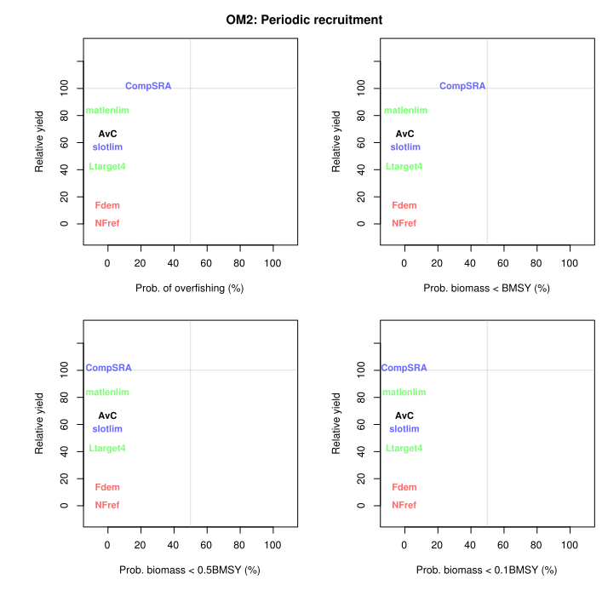
Figure 3a. Tradeoff plots (Tplot() in DLMtool) for OM2, the stress-test operating model that considers periodically oscillating recruitment in the Stone’s sheep population.

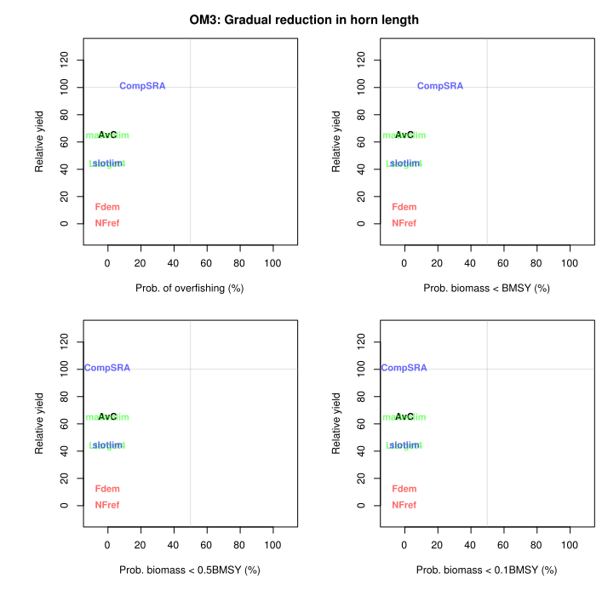
Figure 3b. Tradeoff plots (Tplot() in DLMtool) for OM3, the stress-test operating model that considers a scenario where selective hunting pressure reduces the growth rate of horns in early life.

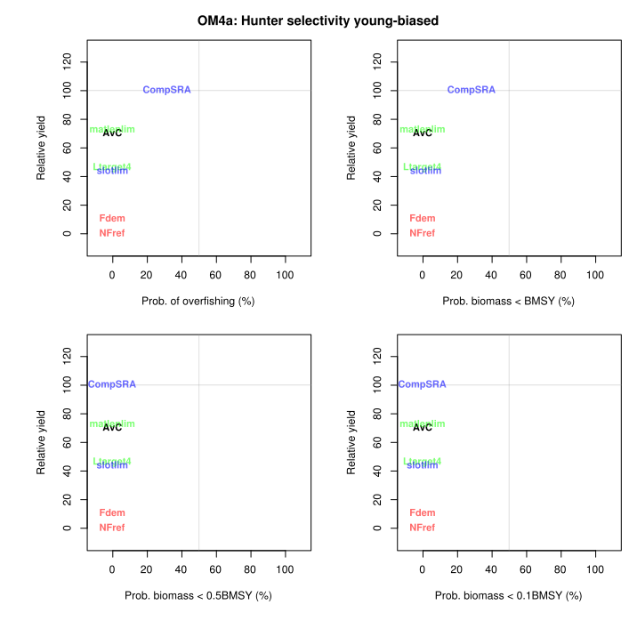
Figure 3c. Tradeoff plots (Tplot() in DLMtool) for OM4a, the stress-test operating model that considers a scenario where true hunter selectivity at horn length is biased more towards younger males with smaller horns than what is seen in historical catch records.
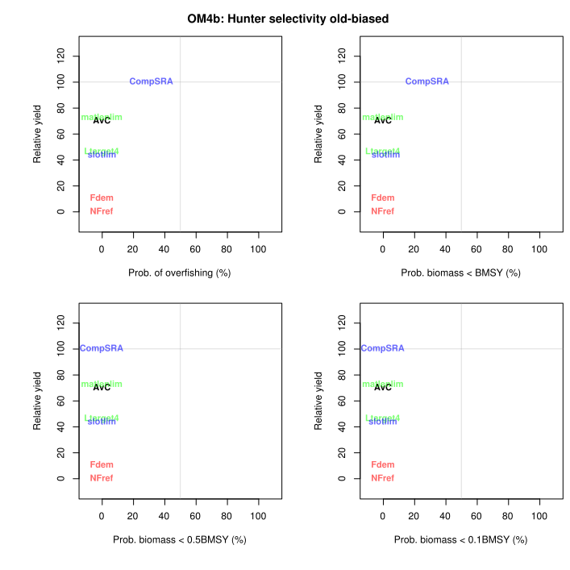
Figure 3d. Tradeoff plots (Tplot() in DLMtool) for OM4b, the stress-test operating model that considers a scenario where true hunter selectivity at horn length is biased more towards older males with larger horns than what is seen in historical catch records.

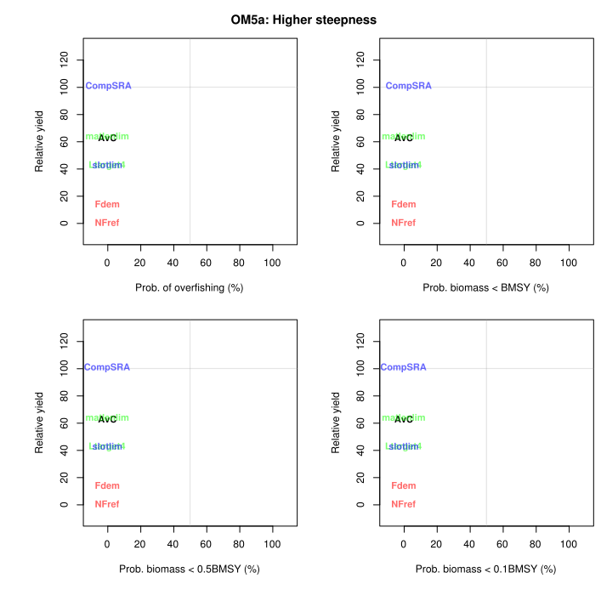
Figure 3e. Tradeoff plots (Tplot() in DLMtool) for OM5a, the stress-test operating model that considers a scenario where steepness of the Beverton-Holt recruitment curve is 75% higher than what was calculated with stock reduction analysis.
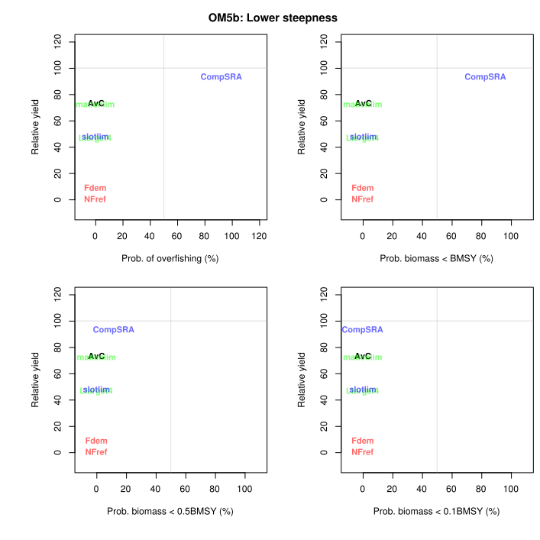
Figure 3f. Tradeoff plots (Tplot() in DLMtool) for OM5b, the stress-test operating model that considers a scenario where steepness of the Beverton-Holt recruitment curve is 75% lower than what was calculated with stock reduction analysis.

- Identify which MPs are most robust to uncertainty.

All of the management procedures performed well under all operating models except for CompSRA. Although this management procedure offers the highest expected yield in both short- and long-term time frames, it also bears the highest risk for ram populations. For example, under OM5b, the stress-test that simulates low recruitment compensation, managing harvests with CompSRA caused the ram population to fall below B_{MSY} in 83% of simulations.

- Based on your analyses, rank the performance of the candidate MPs and justify your approach for ranking the performance of the candidate management procedures.

In accordance with the tradeoffs demonstrated in Table 4 and Figure 3, the ranking that I would give to the candidate management procedures is as follows:

- matlenlim
- AvC
- slotLim
- Ltarget4
- Fdem
- CompSRA

Note that NFref is excluded from this ranking as it was included simply as a non-harvest reference.

This ranking takes into account the tradeoffs between high yields and probability of depleting the ram population.

- Provide a brief summary of the key strengths and potential weaknesses of your analysis.

Strengths: robust to which uncertainties?
Weaknesses: sensitivities to certain parameters, no sex-specific processes, assumes perfect implementation
--> NO CUSTOM PERFORMANCE METRICS!!!

11. Along with your report, please e-mail also, the csv files that you used to form your base case operating model.

