School of Information Technologies and Engineering, ADA University
CSCI4734 – Machine Learning
Fall 2025
Course Project Report

Team 8

 | Full Name | Student ID
Member 1 | Maisa Babayeva | 18079
Member 2 | Shabnam Shirinova | 16236
Member 3 | Vasif Maharramli | 18061

Project

Problem formulation
This project addresses a supervised binary classification problem, where the goal is to predict whether a video game will become a "Hit" or "Not Hit". We defined a video game as a hit if its global sales exceed one million units. We use a publicly available Kaggle dataset that includes release year, platform, genre, publisher, critic and user scores, and review counts. Based on these numeric and categorical features, the model estimates that a game will achieve high global sales.

Discussion of related works (optional)
Previous studies have explored video game sales prediction and the factors affecting their commercial success. Classical statistical methods and machine learning algorithms have been applied such as linear and logistic regressions, support vector machines, k-nearest neighbors, random forests, and gradient boosting to forecast sales or classify titles. The features such as platform popularity, genre trends, publisher reputation, and game quality indicators such as critic and user scores were considered.

EDA and data preprocessing
EDA was performed to understand the characteristics of the dataset before applying machine learning models. The original dataset consists of 16928 rows and 17 columns. In first step, we identified which features are numerical and which are categorical. We also observed that some columns contain missing values such as User_Count, Critic_Score and Critic_Count. We checked for duplicate rows in the dataset as well and confirmed that there are no duplicate entries. Additionally, the number of unique values for each column is checked to understand feature cardinality.
Our next step was to define target variable which was based on Global_Sales column. We decided that we will define video games whose global sales is over 1 million as Hit and the remaining games as Not Hit. During EDA, we observed that User_Score column is stored as object type although it should be numeric type. Therefore, we converted User_Score column to numeric type.
In next step, we analyzed missing values separately for Hit and Not Hit games and this showed that hit games are more likely to receive user and critic attention. We then examined the distribution of key numerical features with the help of histograms and KDE curves.

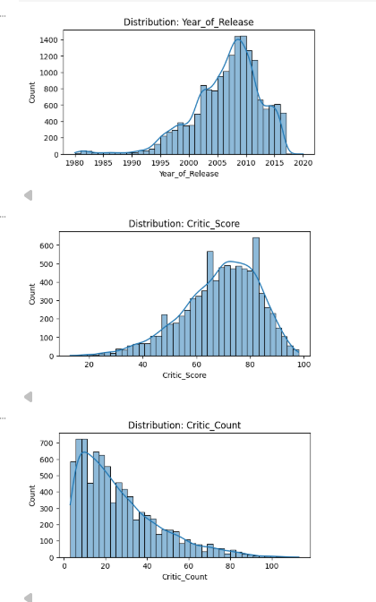 | 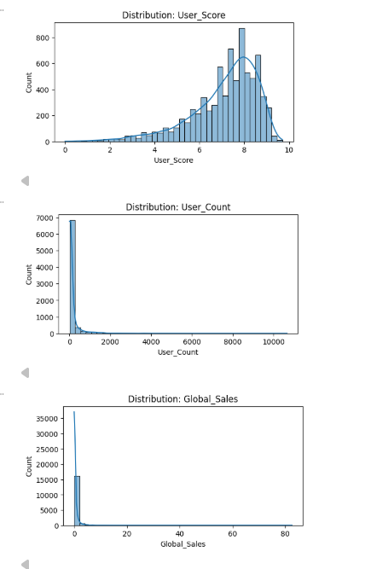

We also examined the relationships between numerical features by using a correlation heatmap. The heatmap shows a moderate positive correlation between Critic_Score and User_Score, as well as between review scores and their corresponding review counts. No extremely strong correlations were observed, therefore no numerical features were removed based on correlation analysis.
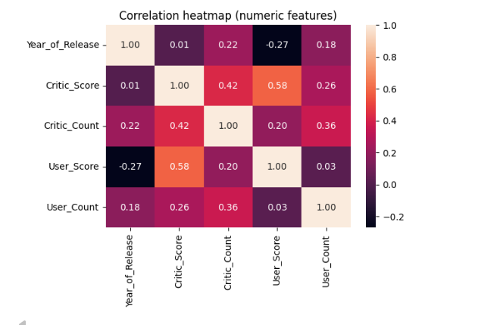
We also dropped columns such as NA_Sales, EU_Sales and other sales related features since they are closely related to our target and can cause data leakage. We analyzed hit rates across categorical columns such as Platform, Genre, Rating, and Publisher.
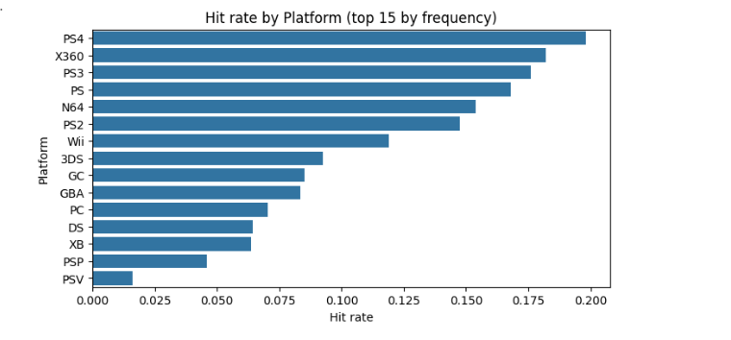
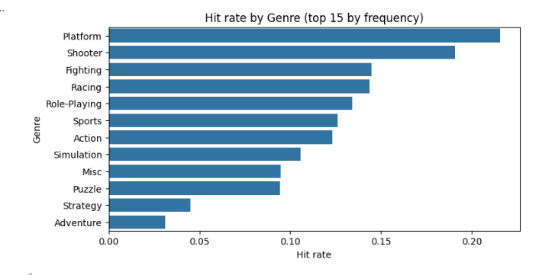
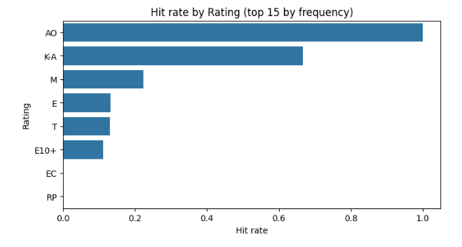
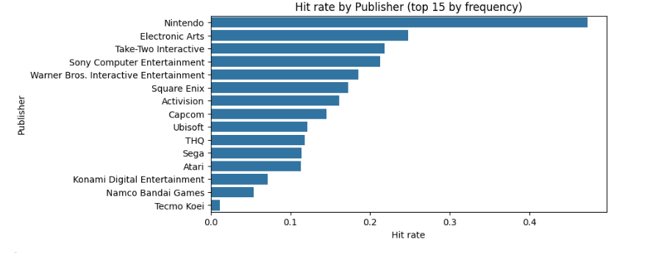

Finally, we used boxplots to compare numerical features between Hit and Not Hit games. We observed that Hit games have higher critic and user scores and larger critic and user counts.
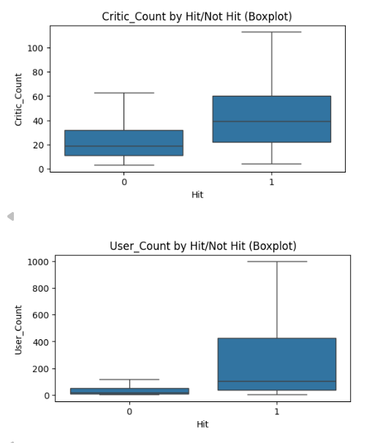 | 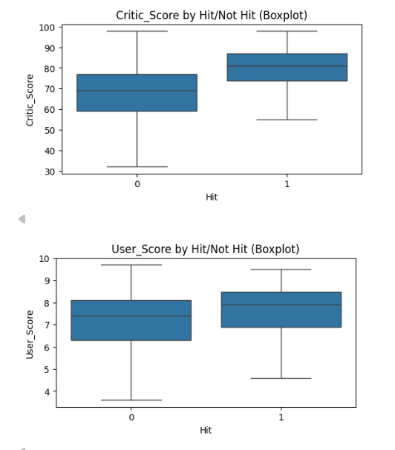

Modeling
In the modeling stage, we selected features available before or shortly after a game’s release, including platform, release year, genre, publisher, critic and user scores and counts, and age rating. The target variable Hit is a binary label indicating whether a game is a hit. The dataset was split into training and testing sets using an 80/20 stratified split with a fixed random state to preserve class distribution and ensure reproducibility. Features were divided into numerical and categorical groups. Numerical features were imputed using the median and standardized with StandardScaler, while categorical features were imputed with the most frequent value and one-hot encoded, with unseen categories ignored.
Logistic Regression was used as a baseline model due to its simplicity and interpretability. To address class imbalance, class_weight="balanced" was applied and max_iter=1000 ensured convergence. The model was evaluated using accuracy, precision, recall, F1 score, and a classification report. The results show an accuracy of around 0.80. Although recall for the Hit class was high, precision was low, indicating many false positives. This suggests the model favors identifying potential hit games. The confusion matrix was analyzed to further examine the model’s predictions.
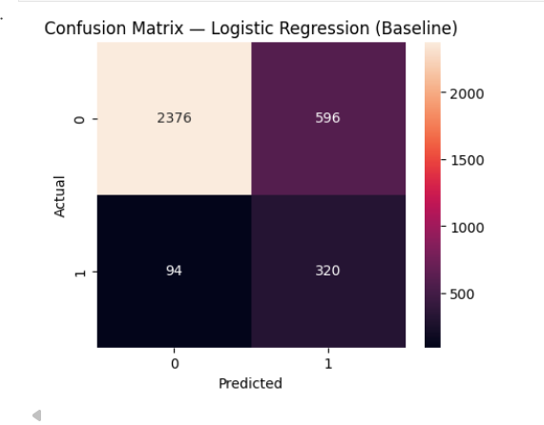
Next, we trained a Decision Tree Classifier using the same preprocessing pipeline. Decision Trees were selected because they can capture non-linear relationships and feature interactions that Logistic Regression cannot. Class imbalance was again handled using class_weight="balanced". The Decision Tree achieved higher accuracy (around 88%) than Logistic Regression, with improved precision and F1-score for the Hit class. This indicates more accurate Hit predictions and fewer false positives, as shown in the confusion matrix. However, some Hit games are still misclassified, meaning the model is not perfect.
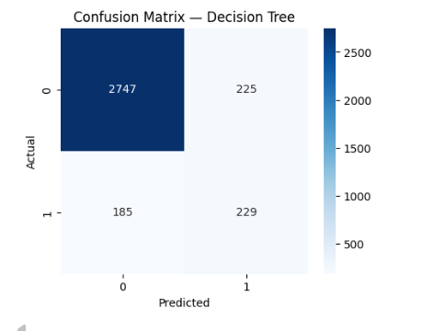
After the Decision Tree, we applied a Random Forest classifier to improve performance and reduce overfitting. Random Forest was chosen as an ensemble method that combines multiple decision trees and provides better generalization. The same preprocessing pipeline was used, and the model was trained with 300 trees, class_weight="balanced", random_state=42, and n_jobs=-1. The Random Forest achieved the highest accuracy (around 0.91), outperforming both Logistic Regression and Decision Tree. Precision for the Hit class was high, while recall was lower, indicating that the model is conservative and misses some actual hit games.
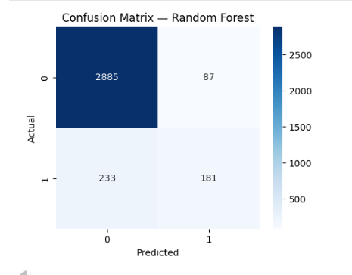
We also used LinearSVC to compare with Logistic Regression. To address class imbalance, class_weight="balanced" was applied and a high max_iter ensured convergence. The model achieved an accuracy of around 0.79. Similar to Logistic Regression, it showed high recall but low precision for the Hit class, indicating many detected hit games along with a significant number of false positives.
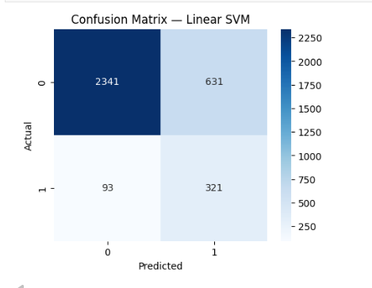
Finally, we adjusted the classification threshold for the Random Forest to balance precision and recall. Instead of always using 0.5, we tested alternative thresholds and picked the one that improves Hit detection. Compared to the original Random Forest, recall and F1-score for the Hit class improved, indicating better detection of hit games. Although false positives slightly increased, this trade-off was acceptable given the goal of identifying hits more effectively.
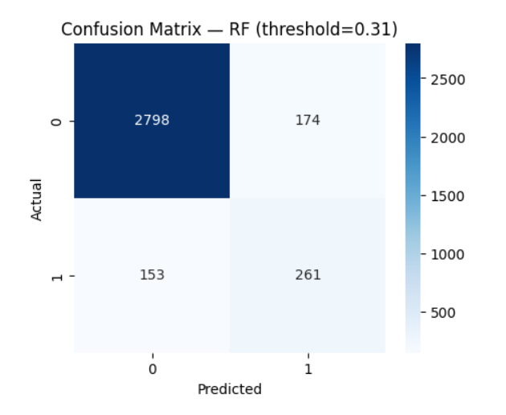

Experiments
We ran supervised classification experiments to predict whether a game is a Hit or Not Hit. We compared Logistic Regression, Decision Tree, Random Forest, and SVM using the same preprocessing pipeline, so the comparison was fair. For evaluation, we reported accuracy, precision, recall, and F1-score, and we used confusion matrices to understand the main error types.
For the MLOps part of the project, we used MLflow for experiment tracking. MLflow stored our runs in one place and allowed us to compare models and settings in a clear way through the tracking UI.
In each MLflow run, we logged the information needed to reproduce the experiment: the model type (baseline or threshold-tuned), fixed model parameters, and (when used) the decision threshold. We also logged evaluation metrics such as accuracy, precision, recall, and F1-score. In addition, we saved artifacts like confusion matrix figures and the final trained pipeline so results are not lost between runs.
We used MLflow during Random Forest threshold tuning. This allowed us to quickly compare runs side by side in the UI, select the best configuration, and keep a clear history of what we tried and why we chose the final model.
Overall, MLflow improved our workflow. It made comparisons clearer because all runs are stored in one place, and it increased reproducibility because parameters and metrics are recorded automatically. It also improved organization when we tested multiple models, and it supported reporting because the tracking UI provides visual evidence of the experiments.
However, we also noticed limitations. There is extra setup and a learning curve at the beginning. If tracking is stored only locally, collaboration can be harder unless the tracking server is shared. Good results also require discipline (consistent run names and logging). Finally, MLflow mainly supports experiment tracking; it does not automatically deploy the model by itself.

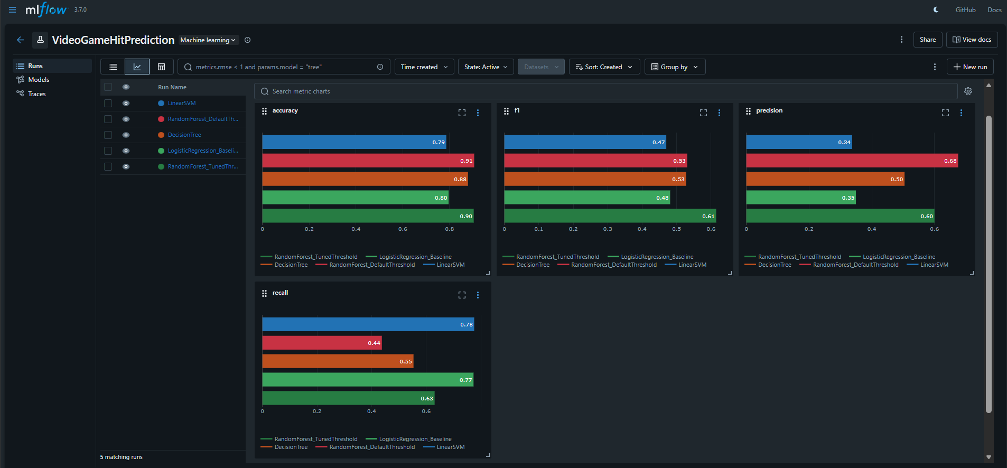

Discussion of results
From the results, the Random Forest with the tuned threshold achieved the best balance between precision and recall, so it produced the highest F1-score among the tested models. Using the default threshold (0.5) increased accuracy, but it missed more true “Hit” games (lower recall), which reduced F1. Linear SVM and Logistic Regression had higher recall, meaning they found more hit games, but their precision was lower, so they produced more false positives. This shows an important trade-off: if the goal is to catch as many potential hits as possible, a higher-recall model can be useful, but if we want fewer false alarms, we need higher precision. Because the classes are imbalanced, F1-score is a more informative metric than accuracy alone. In future work, we can try stronger hyperparameter tuning, add feature selection, and use feature importance to better understand which factors drive the predictions.

