BALANSAG, Ma. Isabelle November 16, 2019

2 – ECE – E

**EXPERIMENT 6: HANGAROO GAME**

1. *isWordGuessed* function

To test if the function works, input a was set to “test” and input b was set to “k” and “t” to check if the function can correctly identify if either letter can be found in the inputted secretWord. It is expected to return a Boolean.

1. *getGuessedWord* function

The function is expected to return a string consisting of the letters that have already been guessed by the player, with unguessed letters to show up as blanks. To run a trial, the secretWord is set to “test”. The list of letters is first converted to a string to be able to compare if the elements in the list can be found in the secretWord string.

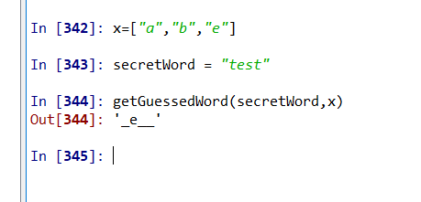

1. *getAvailableLetters* function

The function is expected to remove the letters that have already been guessed by the player from the list containing all the letters in the alphabet.

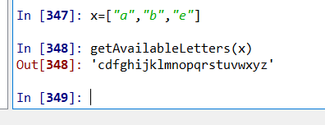

1. *Hangaroo* function

Since this is an interactive gameplay, there are two situations that occur: 1.) if the player responds that they want to play the game, and 2.) if they say don’t wish to do so. The secretWord is decided at random from a list of words.

1. The player says “yes”

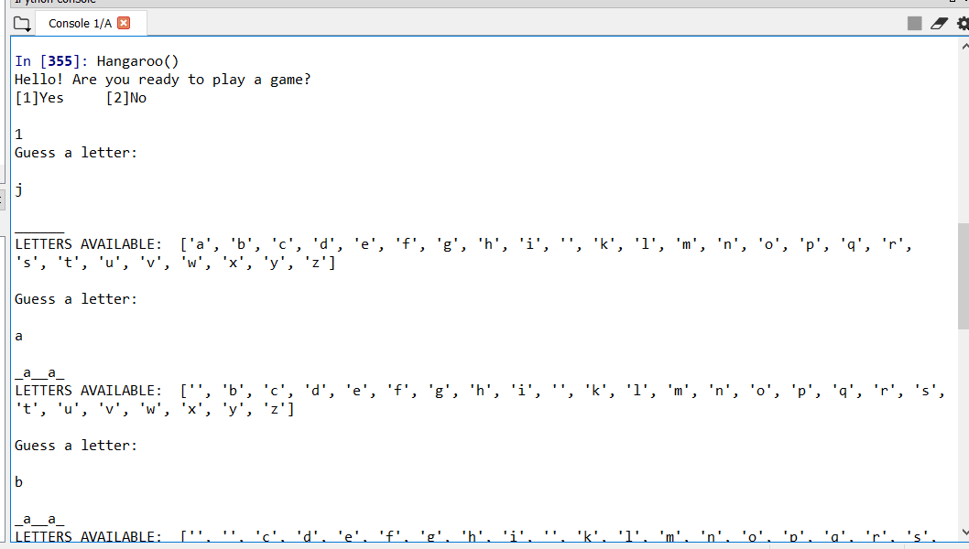

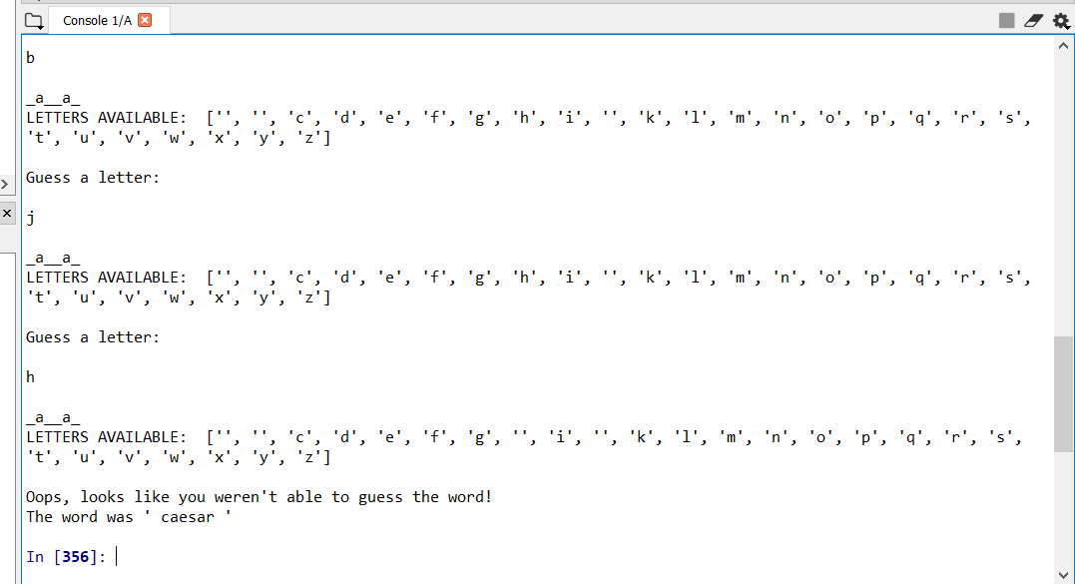

1. The player says “no”

