BUSINESS INTELLIGENCE & MACHINE LEARNING PROJECT
Electricity Demand Forecasting
and Energy Consumption Pattern Analysis
Project Documentation

Item | Details
Primary objective | Analyze electricity demand patterns and build a reliable demand forecasting model.
Data sources | Hourly energy, generation, price and weather data for Spain.
Main tools | Python / Google Colab, Microsoft Excel, Tableau.
Supervised models | Ridge Regression and XGBoost Regression.
Unsupervised model | K-Means clustering with 4 clusters.
BI output | Interactive Tableau dashboards using the enriched final dataset.

Prepared from the project notebook, analytical outputs, and Tableau workbook.

Table of Contents
- 1. Project Overview
- 2. Data Acquiring and Initial Understanding
- 3. Data Preprocessing
- 4. Exploratory Data Analysis (EDA)
- 5. Advanced Time-Series Analysis
- 6. Feature Engineering and Feature Selection
- 7. Supervised Machine Learning Models
- 8. Model Testing and Final Model Selection
- 9. Electricity Demand Clustering
- 10. Tableau Business Intelligence and Dashboards
- 11. Key Findings and Business Interpretation
- 12. Tools and Workflow Integration
- 13. Final Deliverables and Reproducibility
- 14. References

1. Project Overview
The project develops a Business Intelligence and machine-learning workflow for electricity demand forecasting and energy consumption pattern analysis. The workflow starts with acquiring and inspecting hourly electricity and weather data, continues through cleaning and feature engineering, and then applies exploratory analysis, time-series analysis, supervised forecasting models, and unsupervised clustering. The final analytical results are prepared for interactive presentation in Tableau.
Overall analytical workflow
Data acquisition → data inspection → cleaning and integration → temporal feature engineering → EDA and time-series analysis → feature selection/reduction → Ridge and XGBoost modeling → model testing and comparison → K-Means clustering → cluster labeling → Tableau dataset and dashboards.

2. Data Acquiring and Initial Understanding

2.1 Data sources
The project uses the publicly available Hourly Energy Demand Generation and Weather dataset. The energy data contain hourly electricity demand, electricity generation by source, electricity prices, and forecast variables. The weather data contain observations collected for five major Spanish cities.
- Energy Dataset: 35,064 hourly observations and 29 variables.
- Weather Dataset: 178,396 observations and 17 variables.
- The two datasets are aligned using their common hourly timestamp.
- The integrated dataset contains 35,064 observations and 39 columns before later modeling transformations.
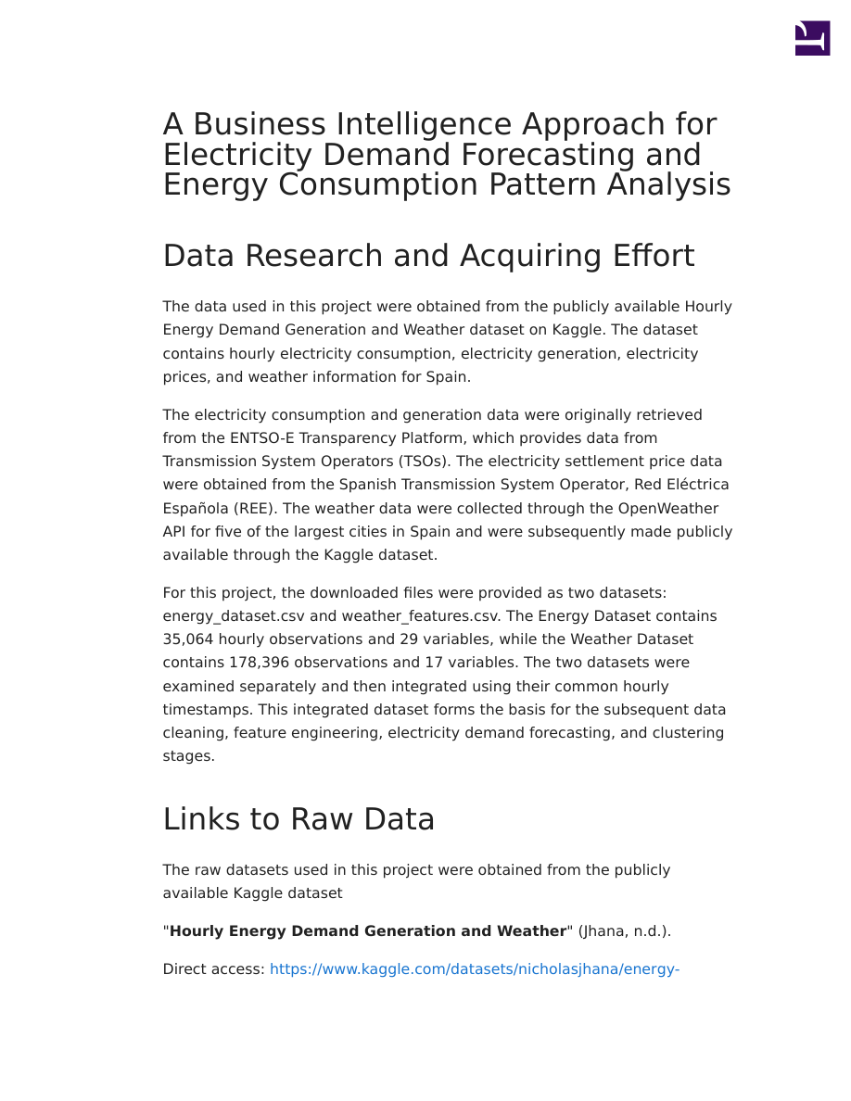
Figure 1. Project report page showing the data-acquisition stage and the initial energy-data context.
The target variable for forecasting is total load actual, representing actual electricity demand. Generation variables represent electricity produced from different sources, while weather variables describe meteorological conditions.
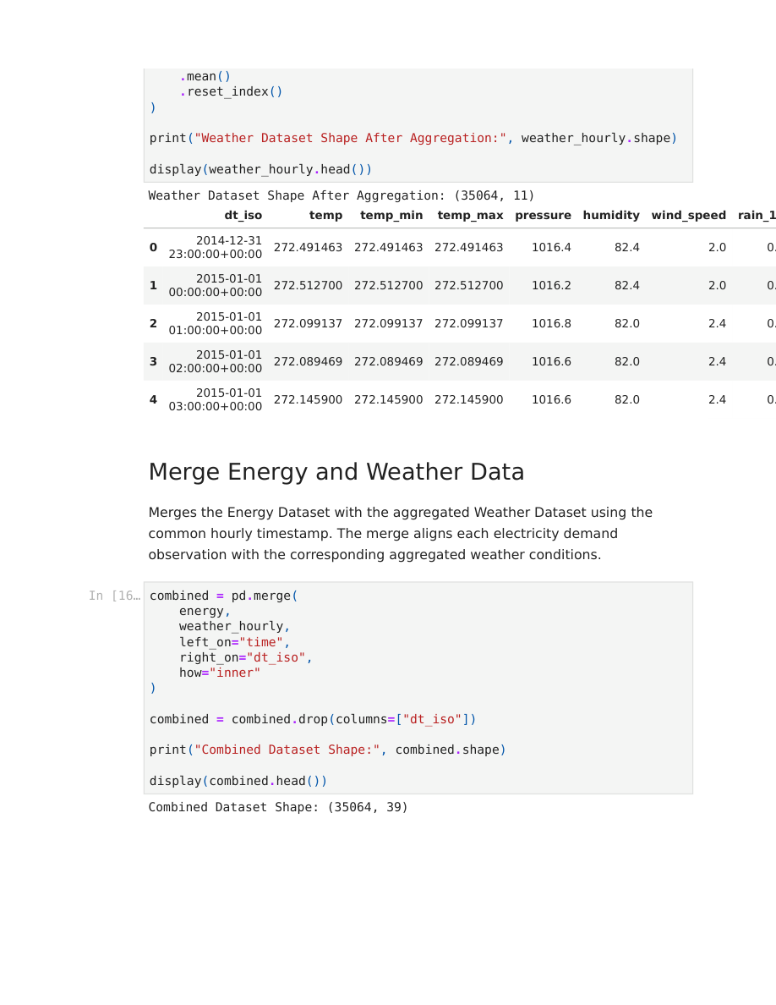
Figure 2. Hourly weather aggregation after combining observations from the five cities.

2.2 Initial data inspection
- Loaded both datasets with Pandas and inspected structure, data types, dimensions, and sample records.
- Checked chronological ordering of the two datasets.
- Reviewed variable definitions and identified the target and explanatory variables.
- Checked missing values and duplicate records before integration.
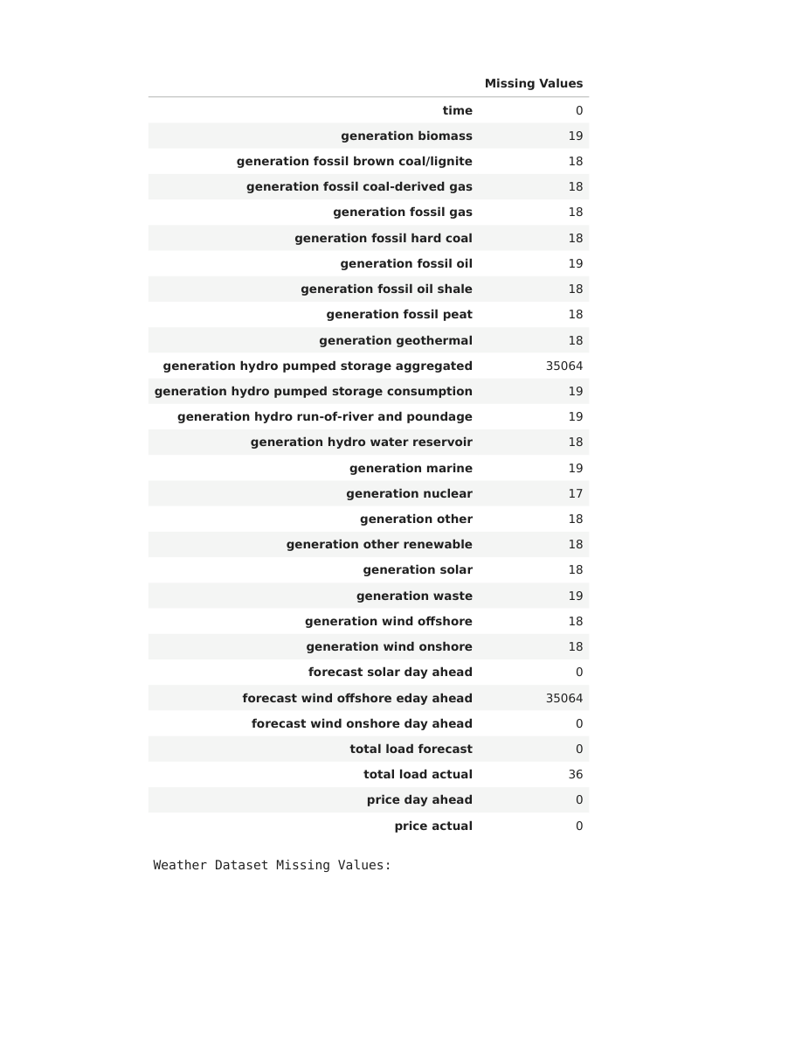
Figure 3. Initial missing-value assessment in the energy dataset.

3. Data Preprocessing

3.1 Chronological ordering and weather aggregation
The Energy Dataset was already chronologically ordered, while the Weather Dataset was not. The weather records were therefore sorted by timestamp and city. Continuous weather variables were aggregated across the five cities for each timestamp using their mean values. Weather ID and wind direction were excluded from simple averaging because they are categorical/circular variables.
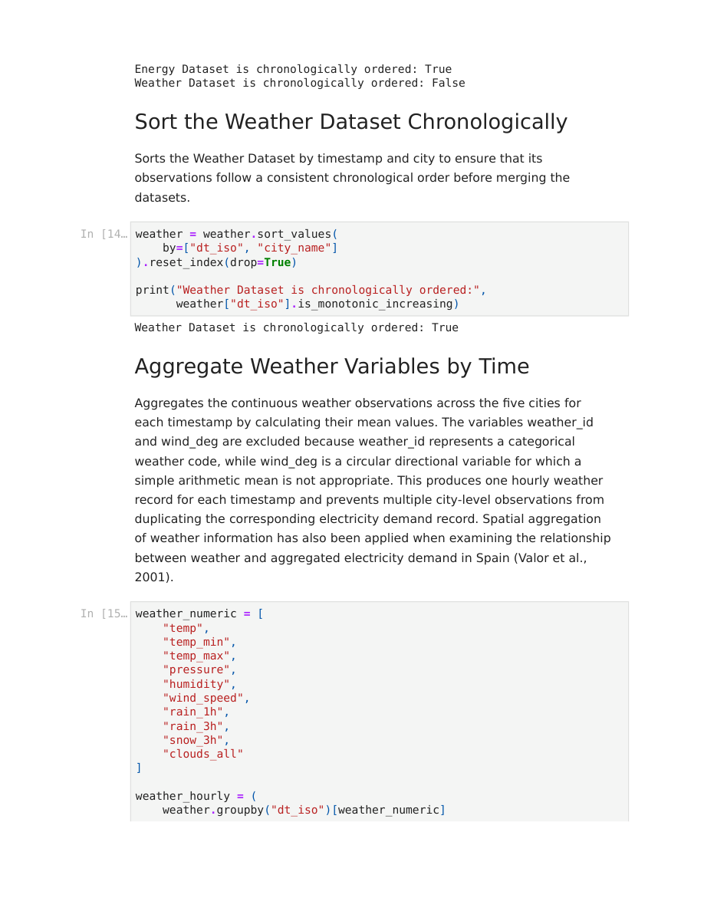
Figure 4. Chronological ordering of the weather dataset before aggregation.

3.2 Dataset integration
The aggregated hourly weather data were merged with the energy data using the common hourly timestamp. This prevents multiple city-level weather records from duplicating an electricity observation.
- Combined dataset shape after integration: 35,064 rows × 39 columns.
- The datetime field was standardized for the integrated dataset.
- The redundant dt_iso field was removed after merging.

3.3 Missing-value treatment
Missing values were examined before cleaning. The project contains 36 missing values in the target variable total load actual. Several generation fields contain small numbers of missing values, while some variables are completely missing in the original dataset. The preprocessing stage removes unusable records and handles missing values generated later by lag and rolling calculations.
- Target missing values identified: 36.
- Weather observations were checked for completeness before aggregation.
- After the energy-data cleaning stage, the remaining missing energy values were reduced to zero.
- After feature engineering, the initial rows created by unavailable lag/rolling history were removed.
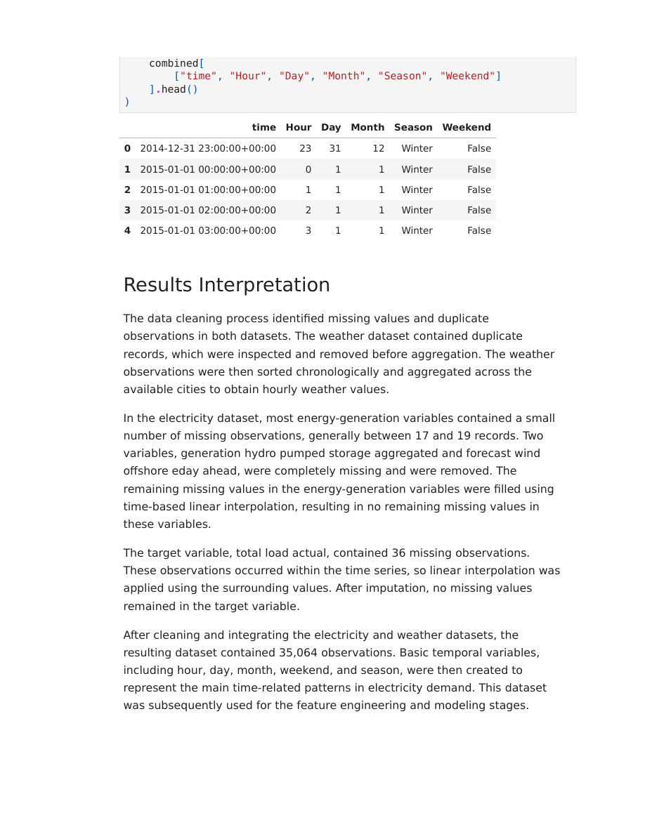
Figure 5. Chronological data with basic time-based features used for later analysis.

3.4 Duplicate checking
The weather dataset contained duplicate records during the inspection stage. These were reviewed before aggregation. After merging and cleaning, the combined dataset was checked again and the final duplicate count was zero.

3.5 Basic temporal features
- Hour: hour of the day.
- Day: day of the month.
- Month: month number.
- Season: Winter, Spring, Summer, or Autumn.
- Weekend: binary indicator for weekend observations.

4. Exploratory Data Analysis (EDA)
EDA was used to understand the distributions, variability, relationships, and unusual observations in electricity demand, generation, prices, and weather variables. The analysis supports both the feature-selection decisions and the interpretation of the forecasting problem.

4.1 Descriptive statistics
Variable | Mean | Minimum | Maximum
Total load actual | 28,698.28 MW | 18,041 MW | 41,015 MW
Total load forecast | 28,712.13 MW | 18,105 MW | 41,390 MW
Price day ahead | 49.87 | 2.06 | 101.99
Price actual | 57.88 | 9.33 | 116.80

Electricity demand has a broad distribution, while several weather and generation variables are strongly skewed. The demand range extends from 18,041 MW to 41,015 MW.
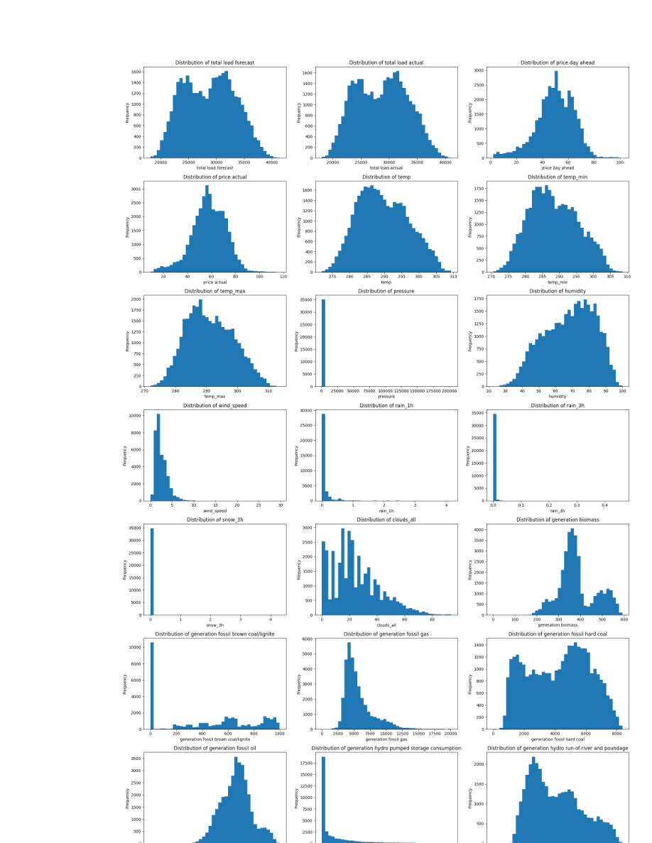
Figure 6. Distribution plots for major demand, price, weather, and generation variables.

4.2 Outlier analysis
Potential outliers were identified using the Interquartile Range (IQR) method and box plots. The project intentionally retained these observations because extreme values can represent genuine operating, weather, generation, or market conditions rather than data-entry errors.
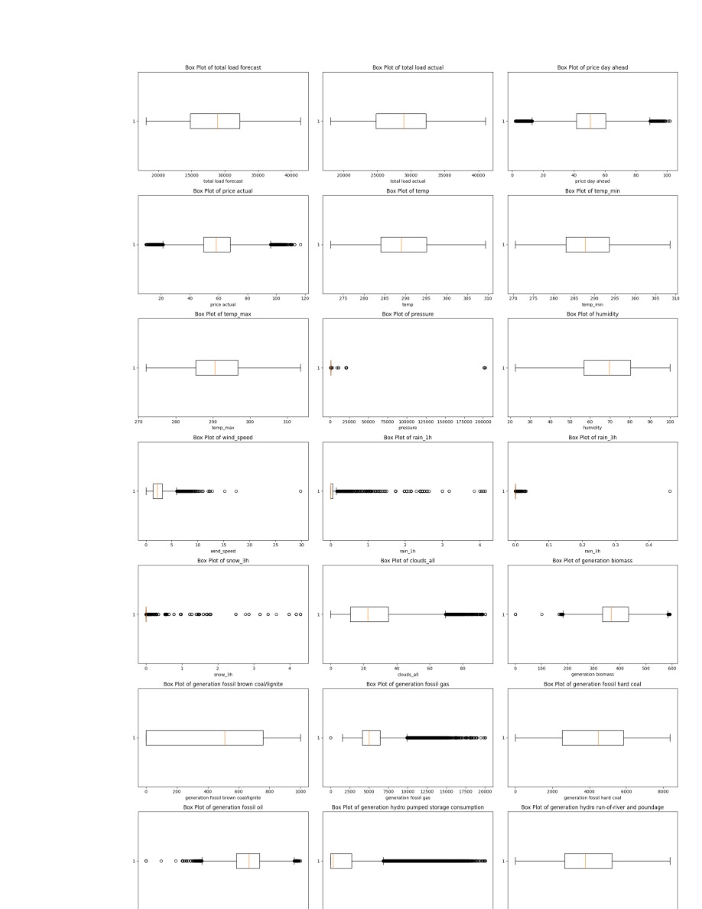
Figure 7. Box-plot based outlier inspection across selected numerical variables.
Important preprocessing decision
Outliers were not automatically deleted. Retaining genuine extreme observations protects the time-series structure and avoids removing potentially meaningful electricity-system events.

4.3 Correlation analysis
Pearson correlation was used to examine linear relationships between numerical variables. The strongest positive relationship with actual demand was the day-ahead load forecast (r = 0.995). Other relatively strong positive relationships included fossil gas generation, fossil oil generation, hydro water-reservoir generation, and day-ahead price. Pumped-storage consumption showed a relatively strong negative relationship.
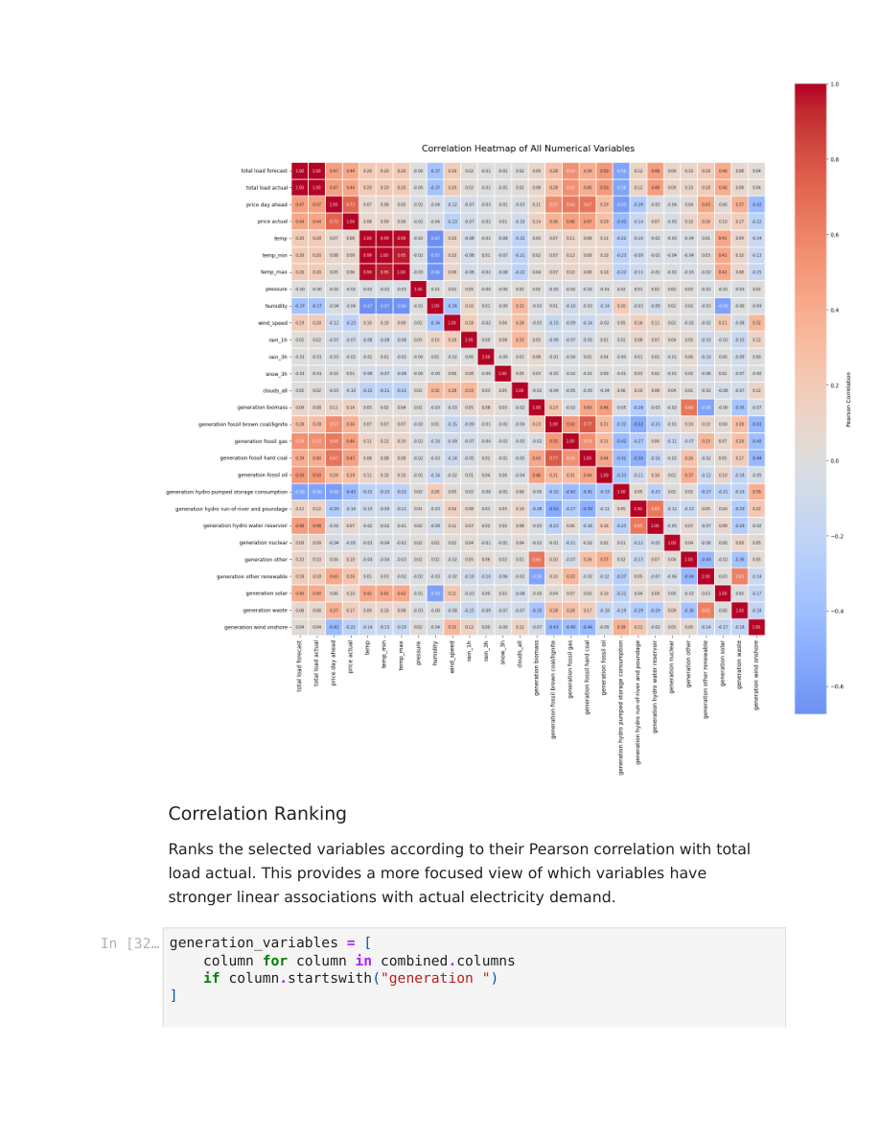
Figure 8. Correlation heatmap used to inspect relationships among numerical variables.

5. Advanced Time-Series Analysis
Before building the forecasting models, the temporal structure of actual electricity demand was examined through time-series decomposition, autocorrelation, partial autocorrelation, and stationarity testing.

5.1 Time-series decomposition
An additive decomposition with a 168-hour period was used to separate the observed demand into trend, seasonal, and residual components. The results show clear seasonal behavior and short-term variation around the underlying pattern.
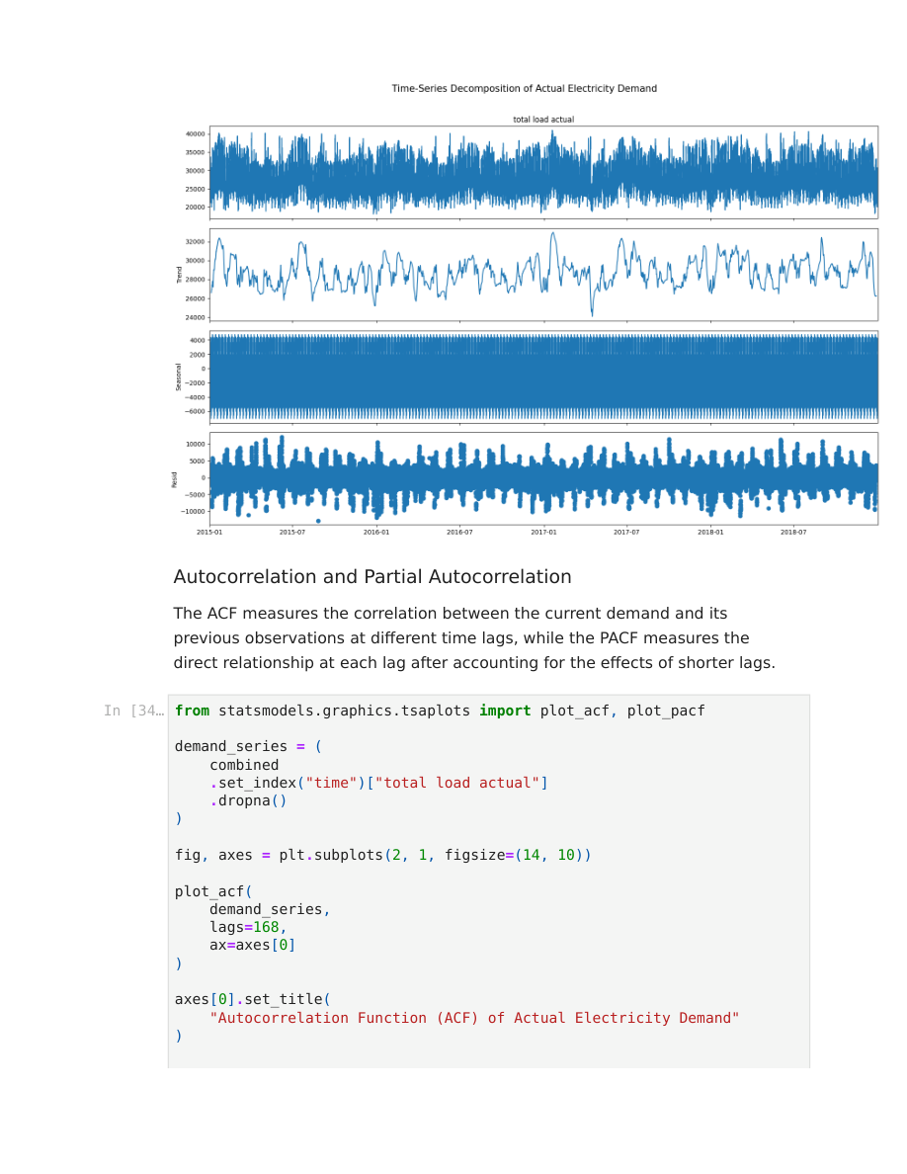
Figure 9. Time-series decomposition of actual electricity demand using a weekly (168-hour) period.

5.2 ACF and PACF
The ACF and PACF were calculated up to 168 lags. The ACF shows recurring peaks at approximately 24-hour intervals, indicating a strong daily pattern. Repeated peaks at longer lags are consistent with weekly seasonality. The PACF shows a strong first-lag relationship and additional effects around the daily seasonal lag.
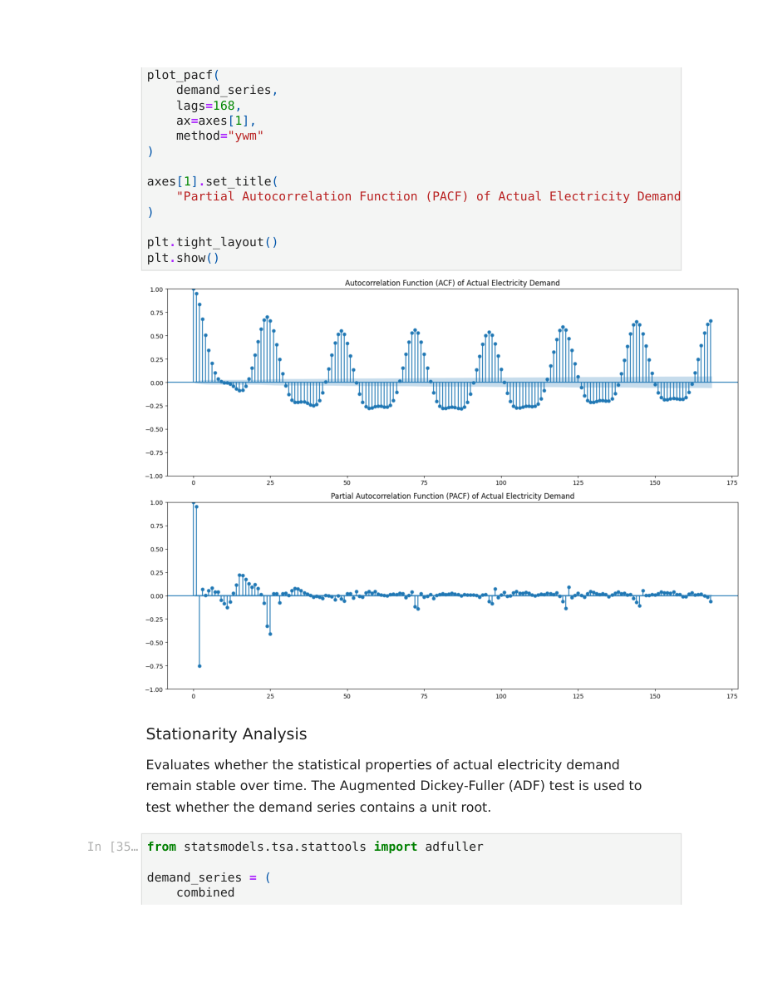
Figure 10. Autocorrelation Function (ACF) and Partial Autocorrelation Function (PACF).

5.3 Stationarity
ADF metric | Value
ADF statistic | -21.420316
p-value | < 0.001
Used lags | 52
Observations | 35,011

The Augmented Dickey-Fuller test rejected the unit-root null hypothesis. Therefore, the demand series is considered stationary according to the ADF test, and differencing is not required solely to achieve stationarity.

Figure 11. Stationarity-analysis output associated with the ADF testing stage.

6. Feature Engineering and Feature Selection

6.1 Cyclical time features
Hour and Month were represented using sine/cosine transformations so that the beginning and end of a cycle remain close in the feature space.
- hour_sin = sin(2π × Hour / 24)
- hour_cos = cos(2π × Hour / 24)
- month_sin = sin(2π × Month / 12)
- month_cos = cos(2π × Month / 12)

6.2 Lag features
Lagged demand variables were created to capture short-term, daily, and weekly dependence.
- 1, 2, 3 hours
- 24, 48, 72 hours
- 168 hours (one week)

6.3 Rolling statistics
- 24-hour rolling mean
- 24-hour rolling standard deviation
- 168-hour rolling mean
Rolling calculations use only previous observations so that future information is not introduced into the predictors.

6.4 Chronological Train–Validation–Test split
Dataset | Start | End | Observations
Training | 2015-01-07 23:00 | 2017-10-21 17:00 | 24,427
Validation | 2017-10-21 18:00 | 2018-05-27 19:00 | 5,234
Testing | 2018-05-27 20:00 | 2018-12-31 22:00 | 5,235

The split is chronological rather than random, preserving the temporal order required for forecasting and ensuring that the test period remains unseen during model development.
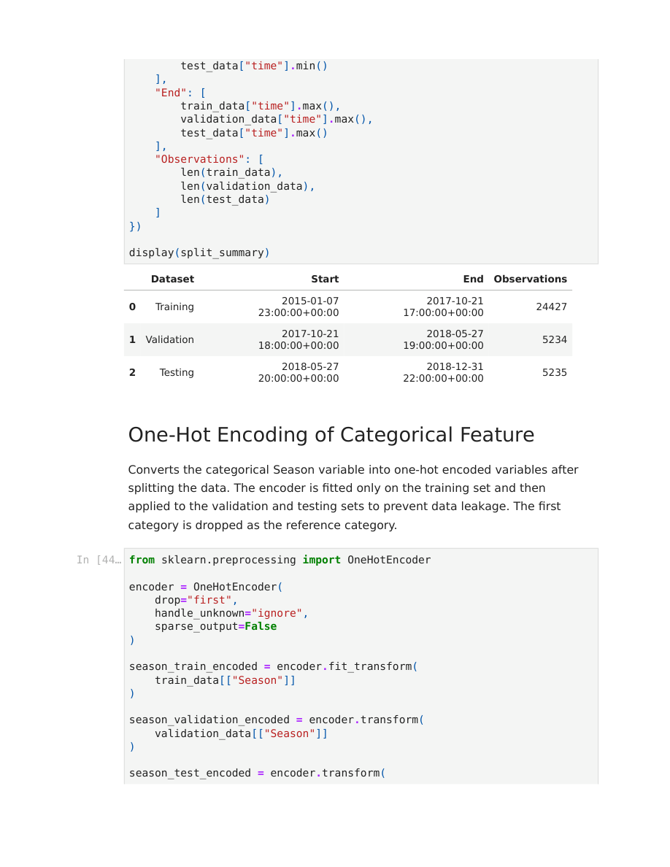
Figure 12. Chronological train, validation, and test split.

6.5 Categorical and binary encoding
- Season was one-hot encoded after the chronological split; the encoder was fitted only on training data and then applied to validation and test data.
- The first season category was dropped as the reference category.
- Weekend was converted from Boolean to a numerical 0/1 feature.

6.6 Feature selection and multicollinearity
Correlation with the target was examined using training data only. Variance Inflation Factor (VIF) was also calculated to assess multicollinearity. The feature-reduction stage reduced the predictor set from 51 features to 34.

Figure 13. Feature-reduction output showing the final 34 predictors used for modeling.

7. Supervised Machine Learning Models
Two supervised regression models were developed: Ridge Regression and XGBoost Regression. The models were evaluated using the same chronological validation and testing periods.

7.1 Ridge Regression
Ridge Regression was selected as a regularized linear baseline because the dataset contains highly correlated predictors. StandardScaler was fitted only on the training set and then applied to validation and test data.
Regularization strengths tested:
- α = 0.001, 0.01, 0.1, 1, 10, 100, 1000
The best validation configuration was α = 0.001. The test results were MAE 701.56, RMSE 907.44, MAPE 2.45%, and R² 0.9608.

7.2 XGBoost Regression
XGBoost was used to capture nonlinear relationships and interactions among the engineered predictors. Hyperparameter tuning was performed on the validation set while keeping the test set completely unseen.
Parameter | Selected value
n_estimators | 700
learning_rate | 0.03
max_depth | 8
min_child_weight | 1
subsample | 0.8
colsample_bytree | 0.8

The tuning grid varied the number of estimators, learning rate, tree depth, minimum child weight, and sampling ratios. Validation RMSE was used as the primary tuning criterion because it penalizes larger errors more strongly.
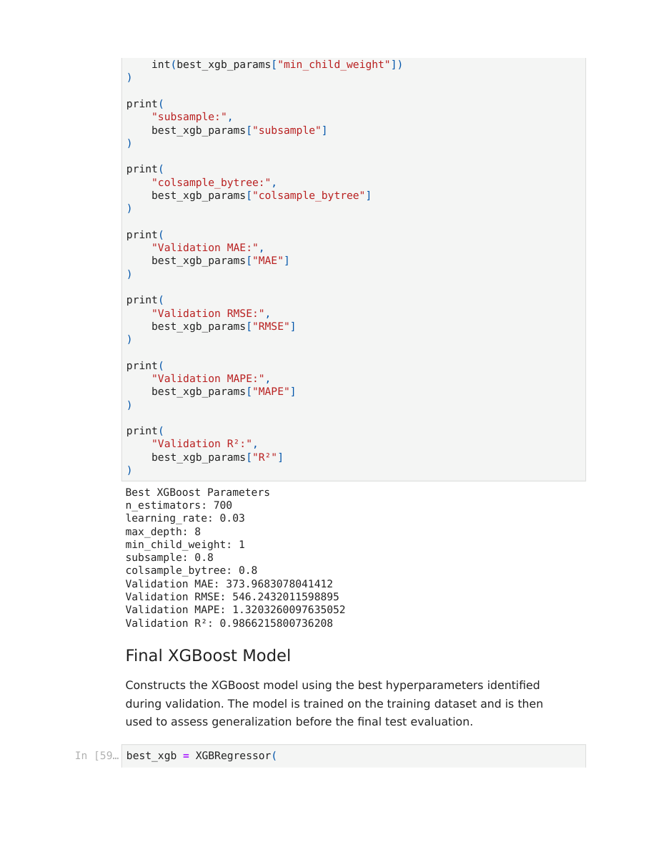
Figure 14. Selected XGBoost configuration and validation results.

8. Model Testing and Final Model Selection

8.1 Evaluation metrics
- MAE: Mean Absolute Error.
- RMSE: Root Mean Squared Error.
- MAPE: Mean Absolute Percentage Error.
- R²: Coefficient of determination.
The same independent chronological test period was used for both models so that their performance could be compared fairly.

8.2 Final test results
Model | MAE | RMSE | MAPE | R²
XGBoost | 397.26 | 560.96 | 1.42% | 0.9850
Ridge | 701.56 | 907.44 | 2.45% | 0.9608

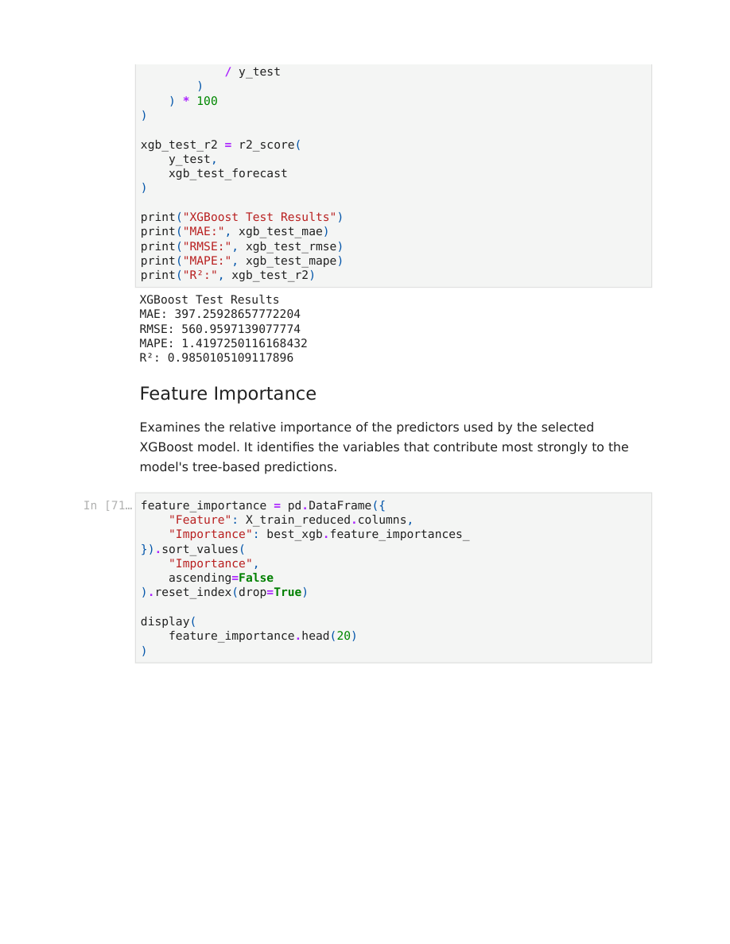
Figure 15. XGBoost independent test results.
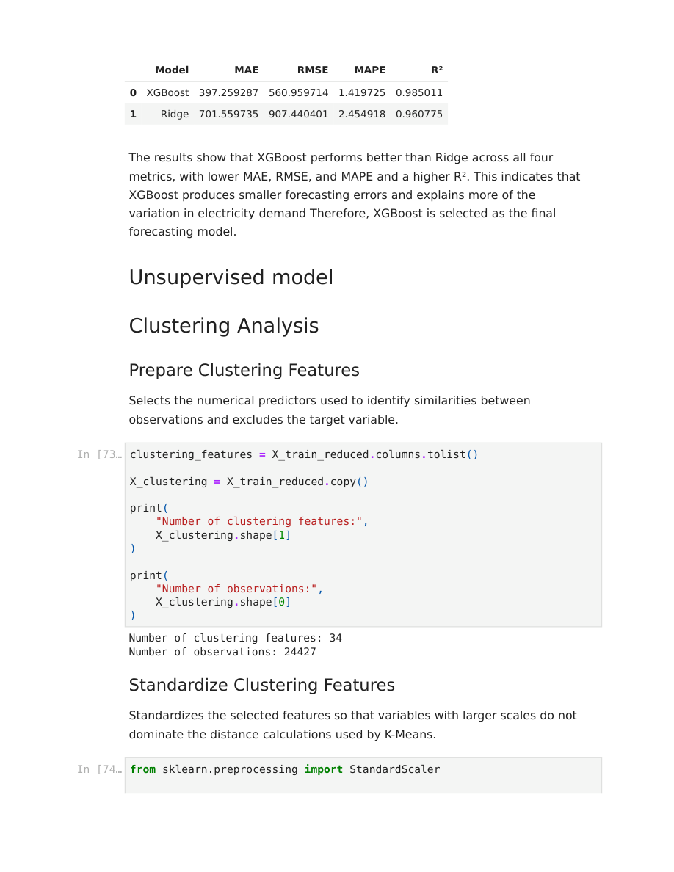
Figure 16. Final comparison of XGBoost and Ridge on the test set.
Final model decision
XGBoost was selected as the final forecasting model because it achieved lower MAE, RMSE, and MAPE and a higher R² than Ridge on the same independent test period.

8.3 Feature importance
Rank | Feature | Importance
1 | load_lag_1 | 49.59%
2 | generation hydro pumped storage consumption | 11.74%
3 | Hour | 11.31%
4 | hour_cos | 7.36%
5 | load_rolling_mean_24 | 4.44%
6 | load_lag_24 | 3.44%

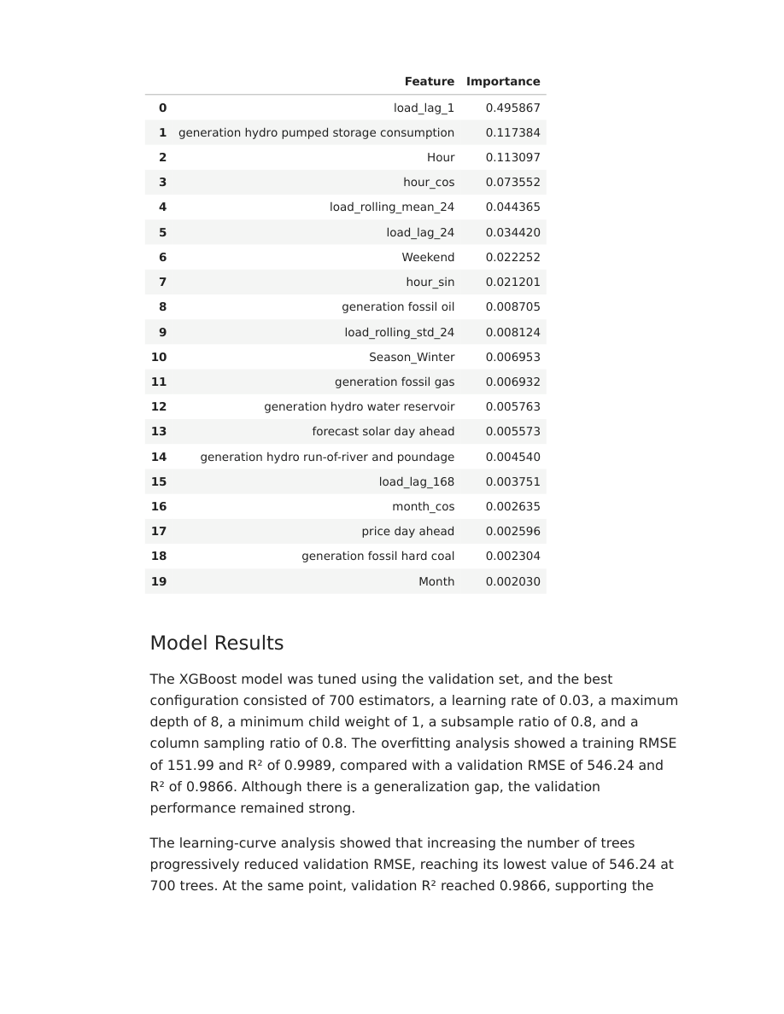
Figure 17. Top feature-importance results from the selected XGBoost model.
The importance profile shows that recent demand and temporal structure are the strongest contributors to the model's predictions, with load_lag_1 clearly dominating the feature-importance ranking.

9. Electricity Demand Clustering
K-Means clustering was applied as an unsupervised analysis to identify groups of observations with similar operating characteristics. The target variable total load actual was excluded from the clustering predictors.

9.1 Clustering preparation
- 34 selected numerical predictors were used.
- 24,427 training observations were clustered.
- Predictors were standardized before distance-based clustering.
- The number of clusters was examined using the Elbow Method and Silhouette Score.
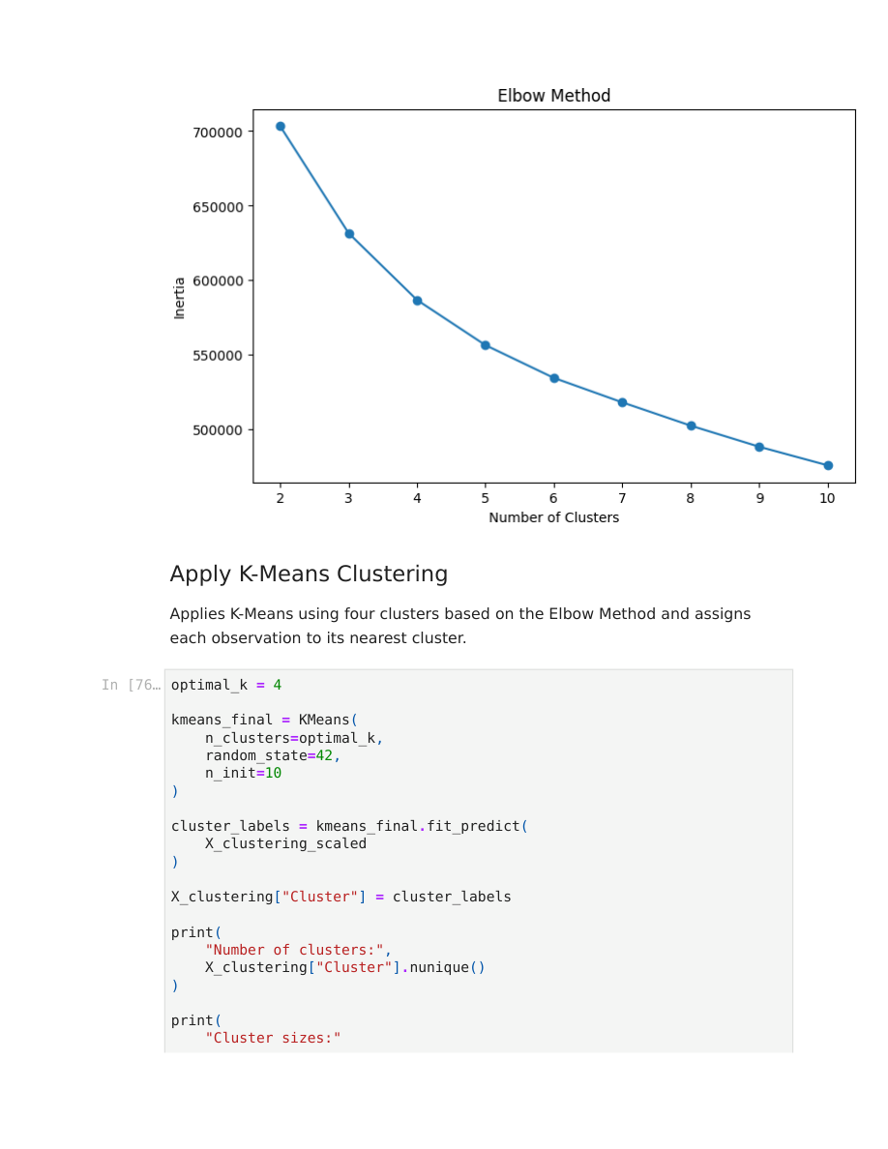
Figure 18. Elbow Method used to assess the appropriate number of clusters.

9.2 Final K-Means solution
Cluster | Count | Mean demand (MW) | Assigned BI label
0 | 4,897 | 31,865.57 | High Demand
1 | 7,244 | 30,759.60 | Relatively High Demand
2 | 4,963 | 29,202.09 | Medium Demand
3 | 7,323 | 23,750.44 | Low Demand

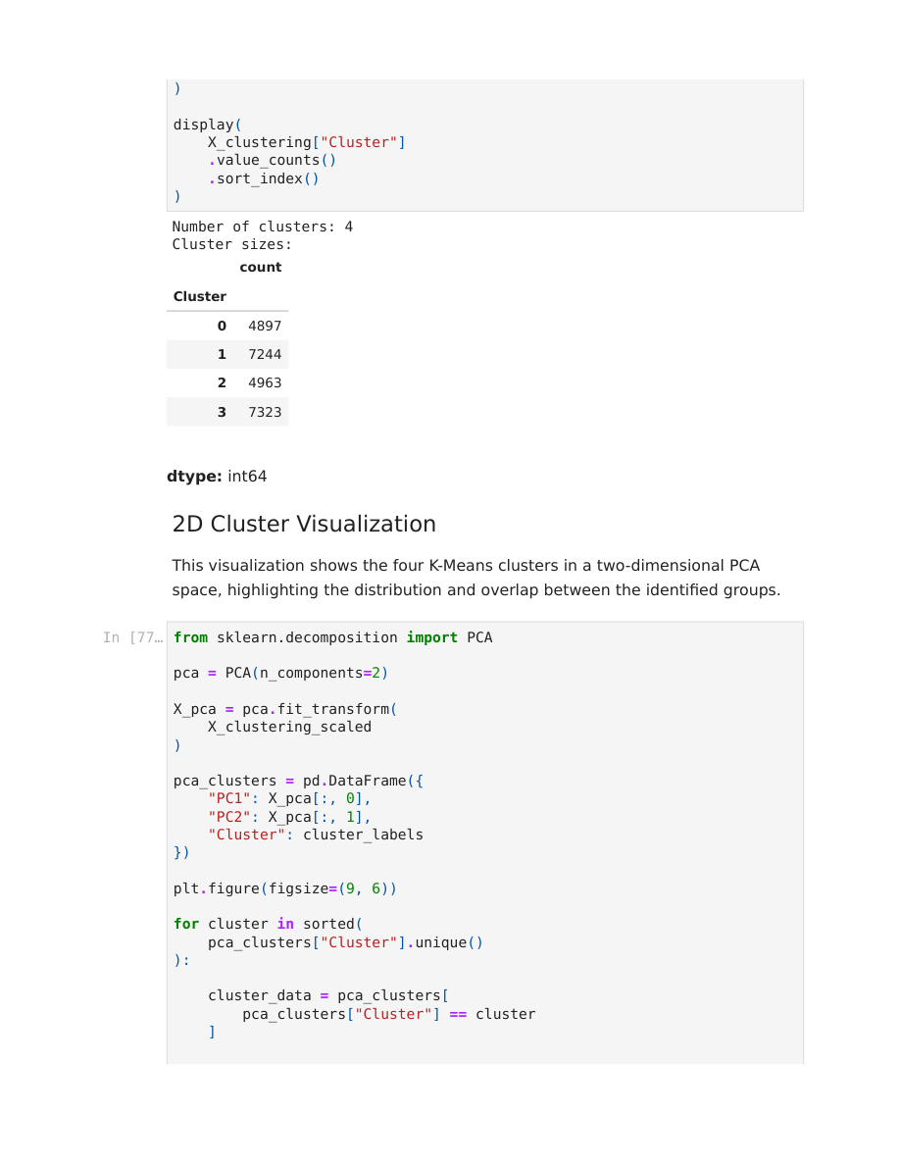
Figure 19. Cluster counts after applying the final four-cluster K-Means solution.
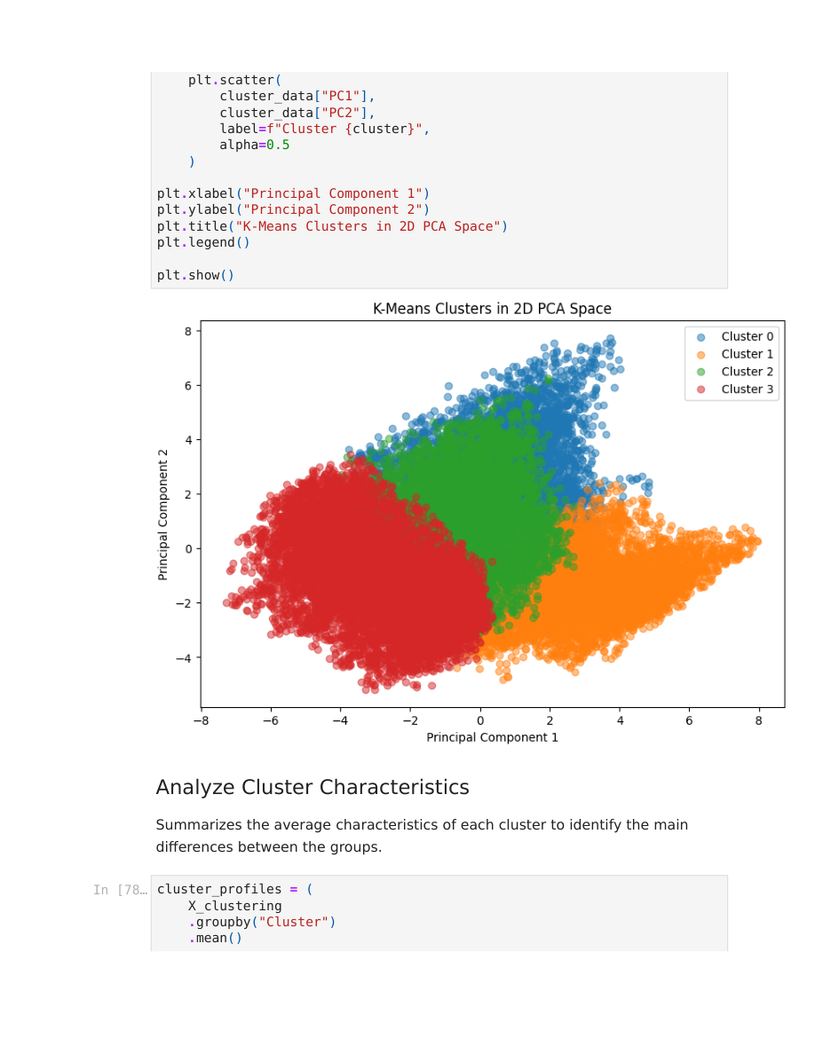
Figure 20. Two-dimensional PCA visualization of the four K-Means clusters.

9.3 Cluster interpretation
Cluster | Interpretation
0 – High Demand | High electricity demand with relatively high fossil-fuel and hydro generation; represents particularly high-demand operating periods.
1 – Relatively High Demand | High demand associated with warmer temperatures and predominantly summer conditions.
2 – Medium Demand | Moderate demand with a stronger contribution from hydroelectric generation.
3 – Low Demand | Low demand, mainly associated with off-peak periods and relatively higher pumped-storage consumption.


Figure 21. Cluster-profile analysis used to interpret differences between the four groups.

9.4 Cluster labels for BI
The numerical cluster assignments were converted into descriptive names so that the results could be understood easily in Tableau. The cluster number and descriptive Cluster_Name were then merged back into the main analytical dataset.

10. Tableau Business Intelligence and Dashboards
Tableau was used as the final Business Intelligence layer. The enriched dataset was exported as final_electricity_demand_tableau.xlsx and connected to the Tableau workbook. The dashboard stage transforms the analytical outputs into interactive views for decision-oriented communication.

10.1 Dashboard 1 – Electricity Demand Overview
- KPI – Average Demand
- KPI – Demand Maximum
- KPI – Demand Minimum
- KPI – Total Observations
- Demand Over Time
- Demand by Hour
- Demand by Month
- Weekday vs Weekend
- Cluster Distribution
- Cluster Name filter
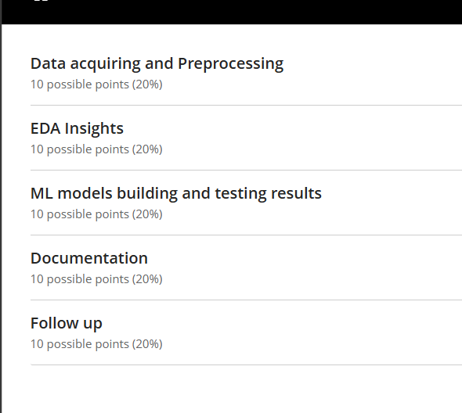
Figure 22. Current Tableau dashboard view for the electricity-demand analysis.

10.2 Dashboard 2 – Energy Generation & Trends
- KPI – Average Generation
- KPI – Maximum Generation
- KPI – Minimum Generation
- KPI – Total Generation
- Average Generation by Source
- Energy Generation Trend
- Renewable vs Fossil
- Selected Energy Generation
- Energy Generation by Month
- Energy Source parameter/filter
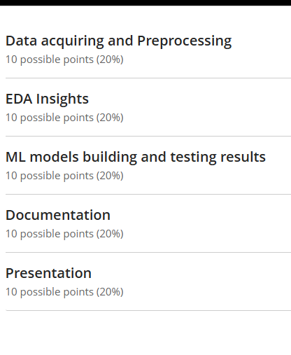
Figure 23. Current Tableau dashboard view for the energy-generation analysis.

10.3 Interactive parameters and calculations
An Energy Source parameter was created to let the user select a generation source such as biomass, fossil gas, hard coal, oil, hydro, nuclear, solar, wind, or waste. A calculated field maps the selected parameter value to the corresponding generation measure, allowing the selected source to drive KPI and trend views.
The Cluster Distribution view uses Cluster Name to divide the pie chart and displays the percentage of observations represented by each cluster. The legend provides the mapping between cluster colors and cluster names.

10.4 Dashboard design principles
- KPIs are placed at the top for quick summary.
- Time-series and comparison charts occupy the central area.
- Detailed monthly/hourly views are placed below the main trend views.
- Filters and parameters are positioned where they remain visible and easy to use.
- The two-dashboard structure separates electricity-demand analysis from energy-generation analysis.

11. Key Findings and Business Interpretation

11.1 Demand behavior
- Actual electricity demand ranges from 18,041 MW to 41,015 MW.
- Demand has strong daily and weekly temporal dependence.
- The day-ahead load forecast has an extremely strong positive correlation with actual demand (r = 0.995).
- The ADF test indicates stationarity under the selected test specification.

11.2 Forecasting performance
- XGBoost is the final forecasting model.
- Test MAPE is approximately 1.42%, indicating a low average percentage error on the independent test period.
- Test R² is 0.9850, showing that the model explains most of the observed variation in demand.
- Recent demand history, especially load_lag_1, is the most important predictive information.

11.3 Energy and cluster patterns
- Generation variables have different distributions and scales, motivating careful preprocessing and feature reduction.
- Four demand-related operating clusters were identified.
- The clusters range from a high-demand regime to a low-demand/off-peak regime, with distinct generation and weather characteristics.
- The descriptive cluster labels make the unsupervised results easier to communicate through Tableau.

12. Tools and Workflow Integration
Tool | Role in the project
Python | Data preprocessing, feature engineering, EDA, time-series analysis, modeling, tuning, evaluation, clustering.
Google Colab | Main notebook/development environment for executing the Python workflow.
Microsoft Excel | Initial data inspection, verification, organization, and manual review.
Tableau | Interactive BI dashboards, filtering, parameters, KPI presentation, and business communication.
Pandas / NumPy | Data manipulation and numerical computation.
Matplotlib | Analytical visualizations.
Scikit-learn | Scaling, encoding, Ridge, metrics, K-Means, and PCA.
Statsmodels | Time-series decomposition and stationarity/ACF/PACF analysis.
XGBoost | Nonlinear regression and demand forecasting.


Figure 24. Project report section describing the role of Python, Excel, Tableau, and the integrated workflow.

13. Final Deliverables and Reproducibility
The project produces the following main deliverables:
- Electricity_Demand_Forecasting.ipynb – main analytical notebook.
- final_electricity_demand_tableau.xlsx – enriched dataset prepared for Tableau.
- Book1.twbx – Tableau workbook containing the BI analysis and dashboards.
- Project Documentation – this document, describing the complete analytical workflow.
The analytical workflow is reproducible from the notebook because the major preprocessing, feature-engineering, modeling, tuning, evaluation, and clustering steps are explicitly documented. The Tableau workbook consumes the final enriched dataset produced at the end of the Python workflow.

13.1 Recommended presentation sequence
- Introduce the business problem and objective.
- Explain the two raw datasets and why they were integrated.
- Show the main preprocessing decisions and missing-value handling.
- Present the strongest EDA and time-series insights.
- Explain the engineered temporal and lag features.
- Compare Ridge and XGBoost using the independent test results.
- Explain why XGBoost was selected.
- Present the four K-Means clusters and their business interpretation.
- Demonstrate the two Tableau dashboards and their interactive filters/parameters.
- Finish with the key findings and practical interpretation.

14. References
- Rubio-León, J., Rubio-Cienfuegos, J., Vidal-Silva, C., Cárdenas-Cobo, J., & Duarte, V. (2023). Applying fuzzy time series for developing forecasting electricity demand models. Mathematics, 11(17), 3667.
- Valor, E., Meneu, V., & Caselles, V. (2001). Daily air temperature and electricity load in Spain. Journal of Applied Meteorology, 40(8), 1413–1421.
- Hoerl, A. E., & Kennard, R. W. (1970). Ridge regression: Biased estimation for nonorthogonal problems. Technometrics, 12(1), 55–67.
- Chen, T., & Guestrin, C. (2016). XGBoost: A scalable tree boosting system. Proceedings of the 22nd ACM SIGKDD International Conference on Knowledge Discovery and Data Mining, 785–794.
- MacQueen, J. (1967). Some methods for classification and analysis of multivariate observations. Proceedings of the Fifth Berkeley Symposium on Mathematical Statistics and Probability.
Documentation note
This document is based on the submitted project notebook/report and the Tableau workbook state available during preparation. Where a result was not explicitly present in the source material, it has not been invented.

