

Computer Network Lab ENCS4130

# Practice

**Student Name: Student ID:**

**Question 1:** Given the IPv4 address 130.240.12.4

1. What is the IP class?
2. How many bits are for the network?

**Question 2:** Given the subnet mask: 255.255.255.128

1. How many bits are for the network?
2. How many different networks we could have?
3. How many bits are for the host?
4. Find the total number of IPs.
5. Find the of number usable IPs.
6. Write the given subnet mask in the slash notation.

**Question 3:** Given the topology shown in Figure 1.

* 1. How many different networks we have?
  2. Divide the range 192.168.8.0 /24 on the available networks using the minimum number of IPs. Illustrate the subnet mask, start and end address for each network.

**Note**: host means PCs, Laptop, etc. and it includes router interfaces.

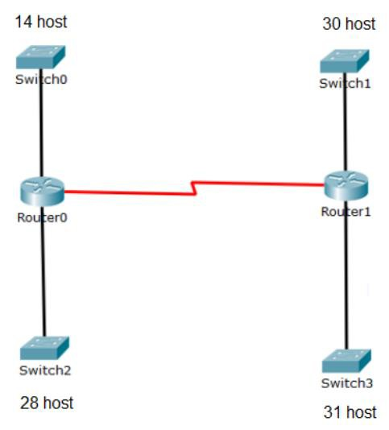

**Figure 1: Question 3 Topology.**

|  |  |  |  |  |
| --- | --- | --- | --- | --- |
| **Network Symbol** | **Start IP (Network IP)** | **Valid Hosts Range** | **End IP (Broadcast IP)** | **Subnet Mask** |

**Question 4:** Given the topology shown in Figure 2.

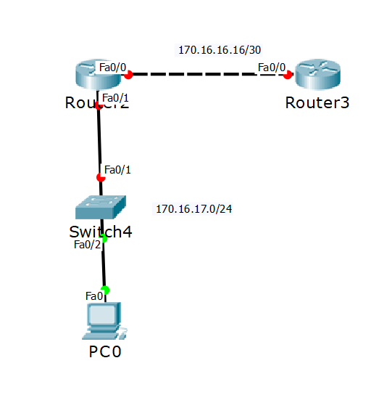

**Figure 2: Question 4 Topology.**

1. Assign IP address for PC0 and router interfaces.
2. What is the gateway for PC0?
3. Can we set an IP address for switch 0?
4. Consider we want also to connect a new PC called (PC1) to Switch 0, what is a suitable IP address to give it to this PC, and what is the Gateway for PC1?