

**Faculty of Engineering & Technology**

**Electrical & Computer Engineering Department**

**ENCS4380**

**INTERFACING TECHNIQUES**

**Homework #2**

**Prepared by**: Maisam alaa

**ID**: 1200650

**Instructor's Name**: Dr. Wasel Ghanem

**Section**: 2

**Date**: 17/12/2023

# Question 1

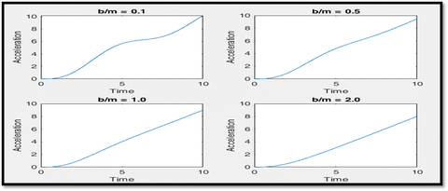

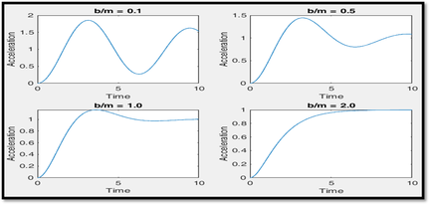

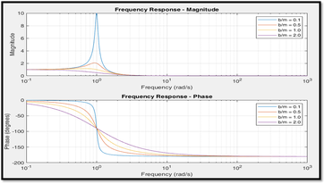

* Unit Step Response: Damping ratio (B/M) affects overshoot and settling time. Higher damping reduces overshoot and speeds up settling time.
* Ramp Response: Damping influences the system's speed of response to input changes. Higher damping leads to a quicker response to ramp input.
* Frequency Response: Describes system behavior at different frequencies. Higher B/M causes a faster roll-off in frequency response, effectively attenuating higher frequencies. Increasing B/M (damping) accelerates oscillation decay and reduces amplitude faster at higher frequencies in the system's response.

# Question 2

Accelerometers:

Smartphone accelerometers work by noticing how things move using a concept called inertia. They're made using MEMS tech and can measure how fast or slow something moves (that's the static part) and also how quickly it changes speed (that's the dynamic part). People who make apps can use special tools in the phone's system, like the SensorManager in Android, to get information from these sensors. This helps apps do cool stuff like counting steps or making sure the screen shows up the right way when you turn the phone.

Gyroscopes:

The gyroscopes in smartphones work by noticing how things spin or move in circles. They use special MEMS technology to measure how fast something is spinning or turning (that's the static part). They can also tell how quickly that spinning speed changes over time (that's the dynamic part). People who make apps can use tools provided by the phone, like the smartphone's APIs, to get this spinning information. This helps apps in gaming, virtual reality, and navigation to make things feel more real by keeping track of how the phone moves and turns.

# Question 3

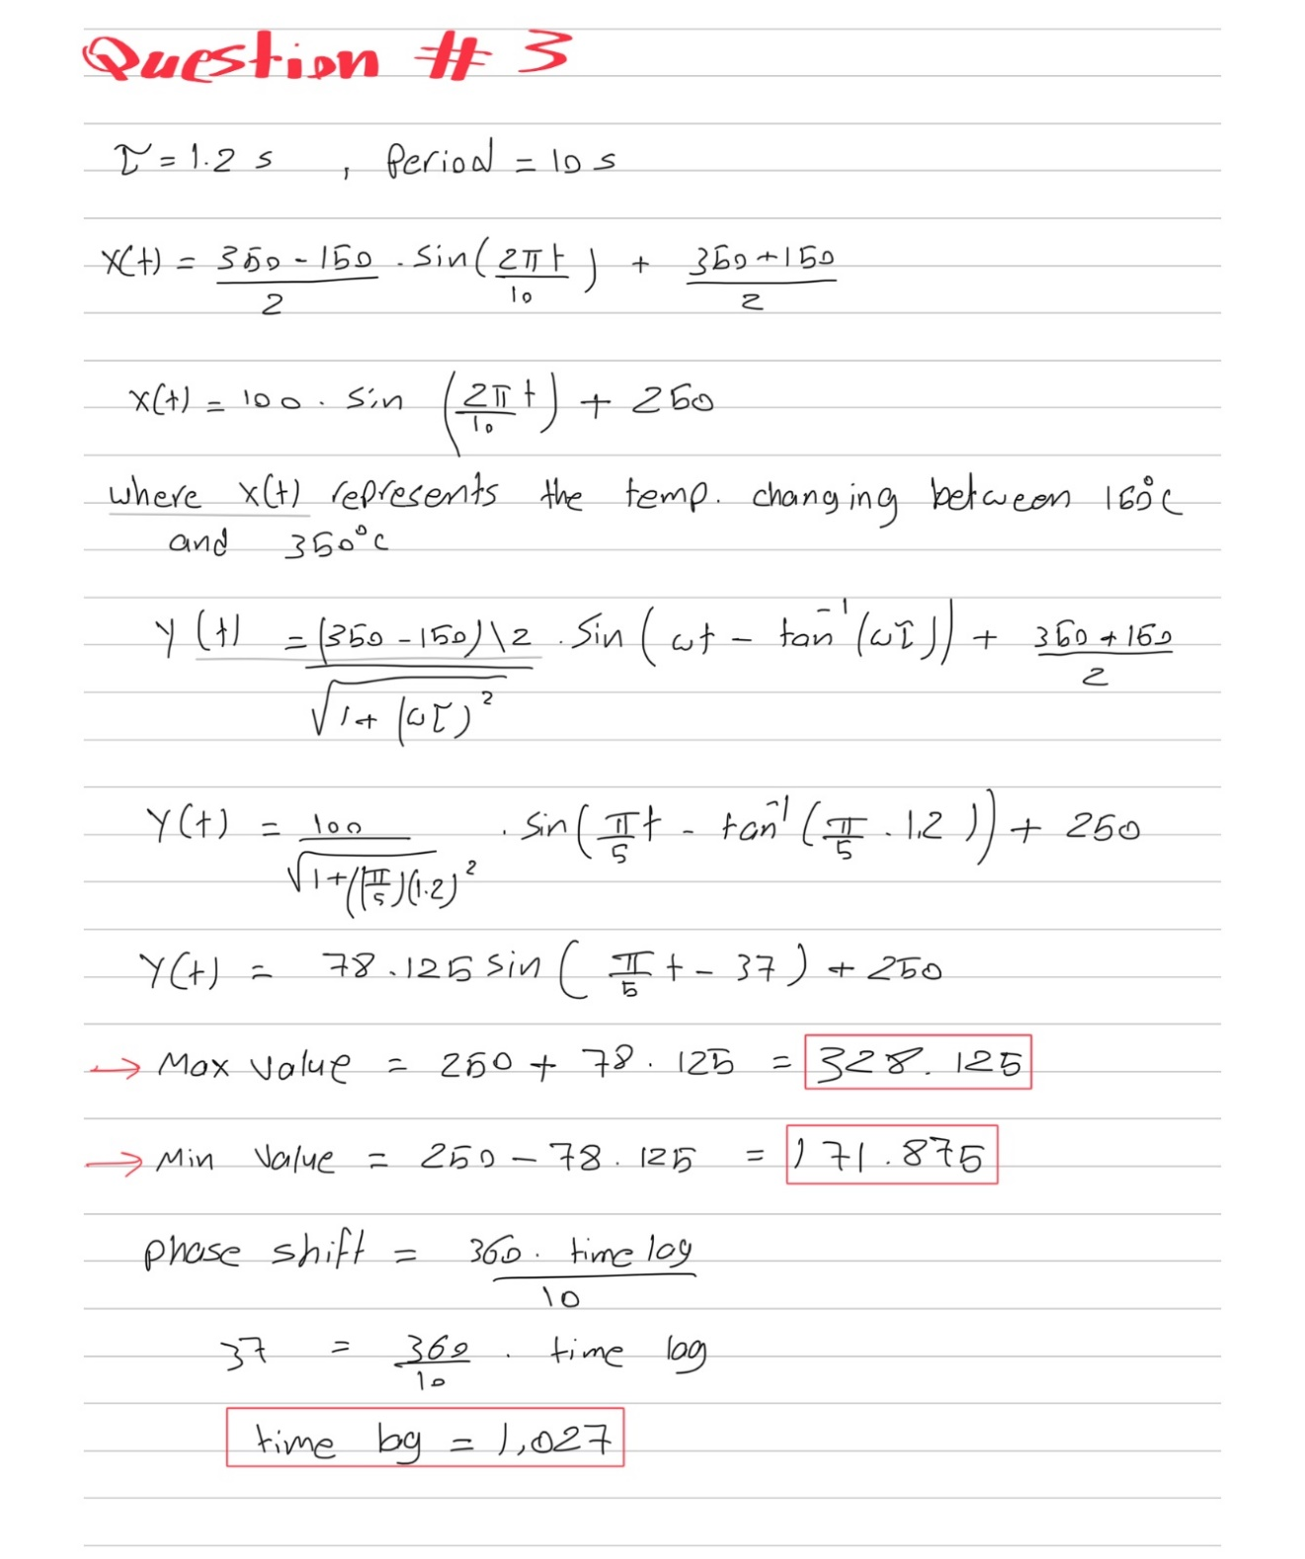

# Question 4

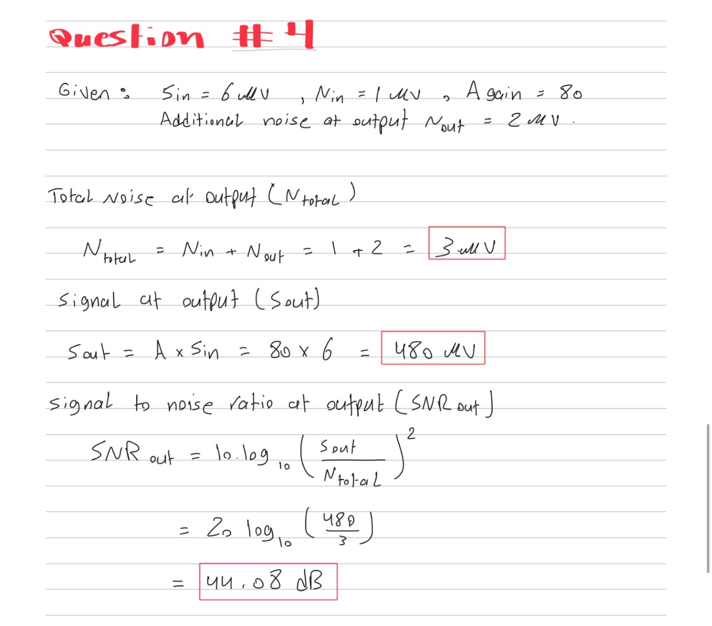

# Question 5

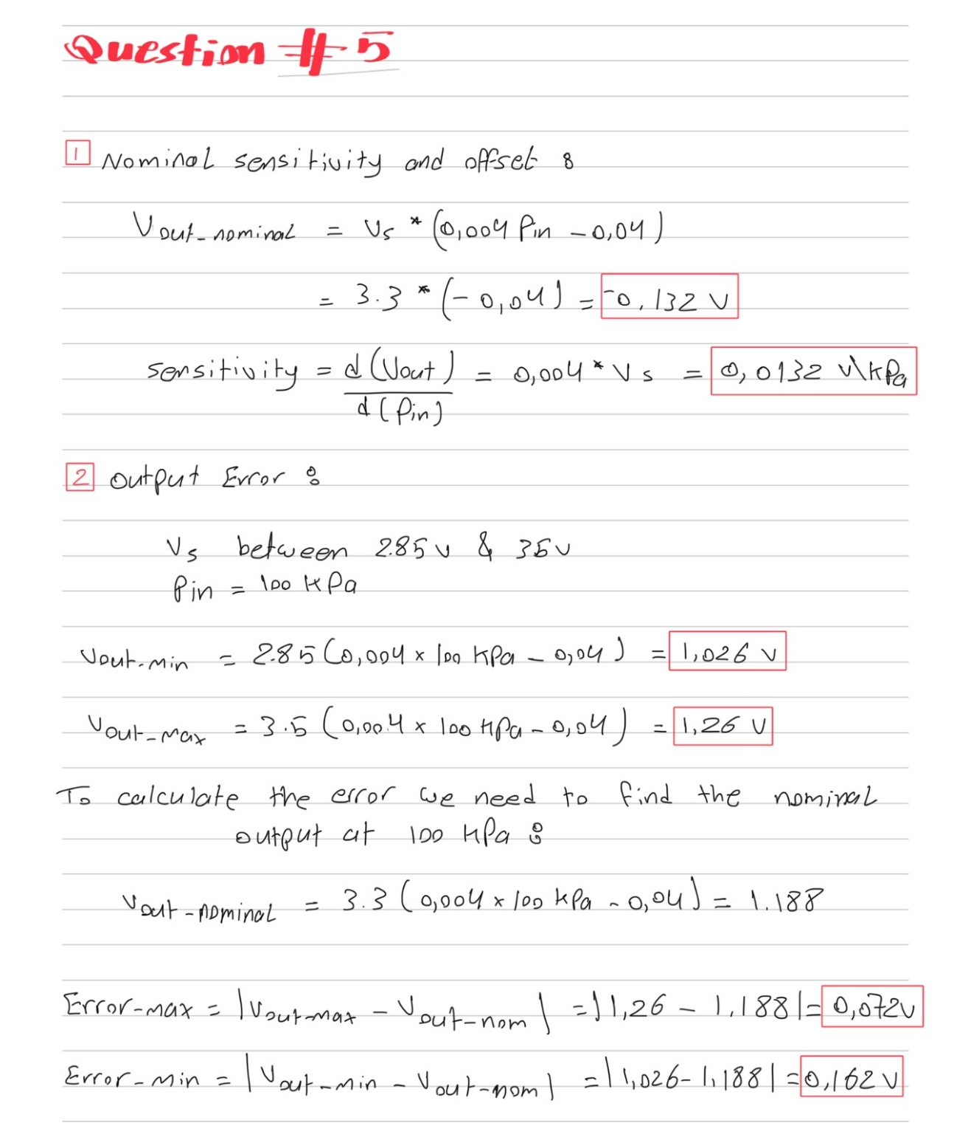

# Question 6

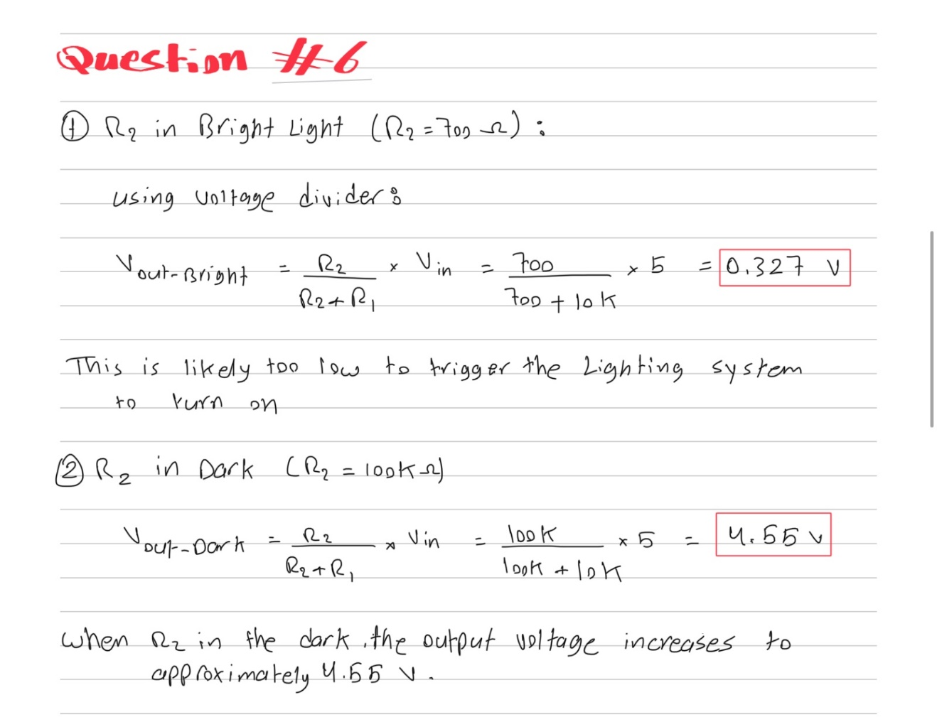

The circuit effectively acts as a dark sensor. R2's resistance changes drastically depending on the light conditions, causing a significant change in the output voltage. This voltage change can be used to control the lighting system, turning it on only when it's dark.

# Question 7

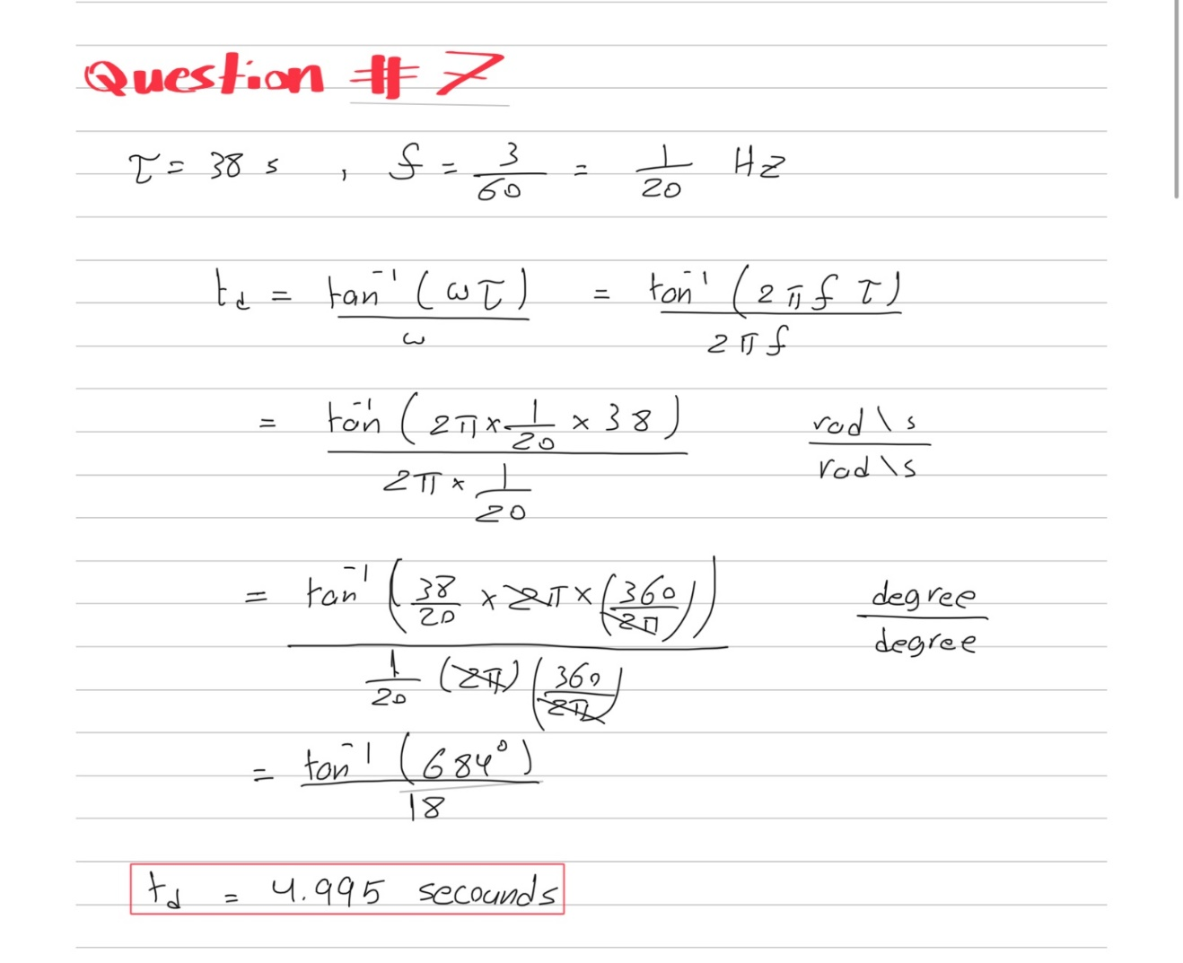

# Question 8

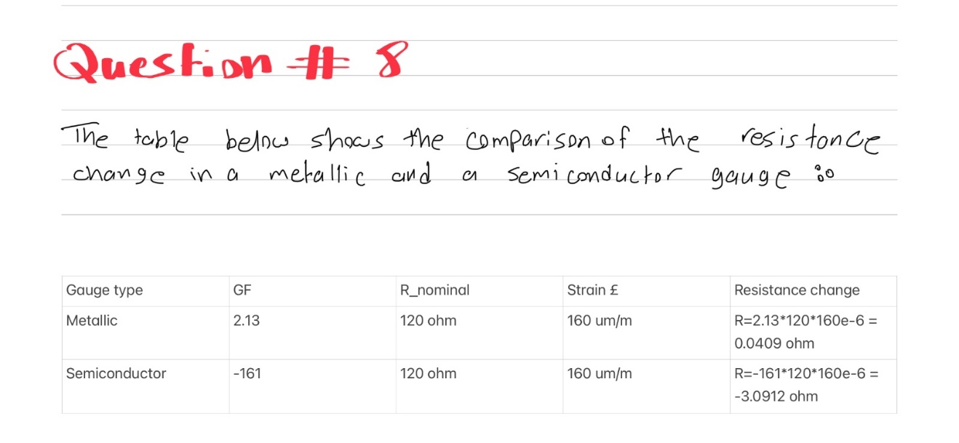

The semiconductor gauge has a much bigger change in resistance compared to the metallic one because its gauge factor is higher and negative. While the metallic gauge gets more resistant when pushed (positive gauge factor), the semiconductor one gets less resistant when pushed (negative gauge factor). This makes the semiconductor gauge super sensitive, detecting even tiny pushes and giving a stronger signal. But this sensitivity means it needs more careful handling and might need extra stuff to work well. The metallic gauge is simpler and steadier but not as good at noticing small changes. Picking one depends on what you need: the semiconductor is super sensitive and can notice a lot, but it's a bit more complicated to use, while the metallic one is easier but not as sensitive.

# Question 9



# Question 10

The natural frequency wn in rad/s.

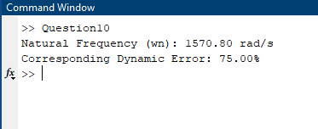

The step response of second order system figure.

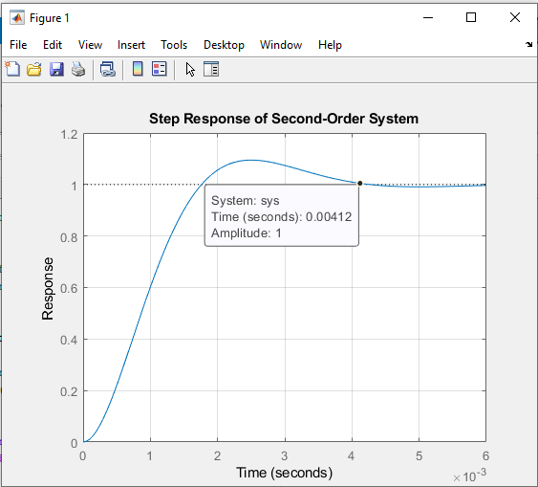

# Question 11

This is the final circuit shown below for the required scale.

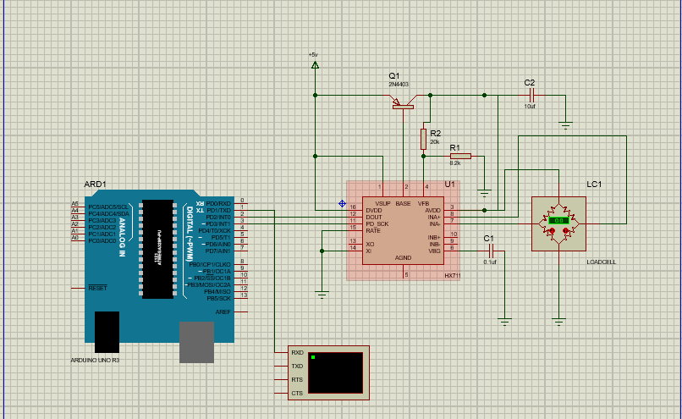

This is he readings and some test cases when changing the load cell values.

