

**Faculty of Engineering & Technology**

**Electrical & Computer Engineering Department**

**ENCS4380**

**INTERFACING TECHNIQUES**

**Homework #1**

**Prepared by**: Maisam alaa

**ID**: 1200650

**Instructor's Name**: Dr. Wasel Ghanem

**Section**: 2

**Date**: 17/10/2023

**Flood monitoring using intelligence at the edge**

# The concept

The primary objective of this project is to employ advanced technology for monitoring and detecting floods in a specific area. To accomplish this, it utilizes the QuickFeather Development Board, a compact and efficient piece of hardware specifically designed for edge computing. The QuickFeather board will employ an intelligent model for flood monitoring, which is created using SensiML tools. These tools provide the necessary software for designing and implementing AI models. Once developed, the intelligent model will be loaded onto the QuickFeather Development Board, taking AI processing to the network's edge, where data is generated. The core function of this intelligent model is to detect floods by analyzing data, potentially sourced from sensors or other inputs, to determine the presence of a flood event in the monitored area.

# Sensors

* Water Level Sensor
* Rainfall Sensor
* Temperature and Humidity Sensor
* Pressure Sensor
* GPS Module
* Accelerometer and Gyroscope
* Camera or Image Sensor
* Sound or Acoustic Sensor
* Environmental Gas Sensors

# Microcontrollers

The primary microcontroller used is the QuickLogic EOS S3, which is part of the QuickFeather Development Kit. The QuickFeather Development Kit comes with this integrated microcontroller. The EOS S3 microcontroller is designed for edge computing and is the central processing unit for the project, handling tasks related to data analysis and decision-making, especially when it comes to flood monitoring with intelligence at the edge.

# Actuators

Actuators are devices or components that are responsible for converting electrical signals or data into physical actions, movements, or responses in the real world. Here are some examples of actuators that are used in such a project:

* Alarms and Sirens.
* Notification Systems.
* Data Logging and Reporting: While not a physical actuator, automated data logging and reporting systems can be considered as virtual actuators. They collect and store data for later analysis and reporting to relevant authorities.

# Algorithm where Intelligence is utilized

Intelligence is used in the form of machine learning and data analysis algorithms to enhance the monitoring and detection of floods. Here's how intelligence is utilized in this project:

* Flood Detection Algorithm: This algorithm is likely built using machine learning techniques, possibly with the assistance of SensiML tools.
* Data Processing and Analytics: Data Capture with Data Capture Lab.

Two labels (no flooding and flooding) and two classes (test and train) has been created. With Data Capture Lab, few datasets for various combinations between (no flooding, flooding) and (test, train) has been captured.

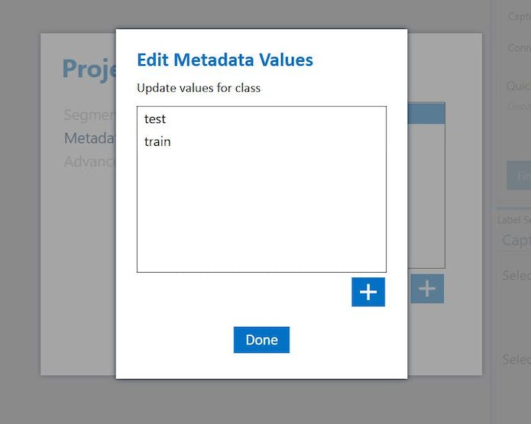

Figure 1 Metadata

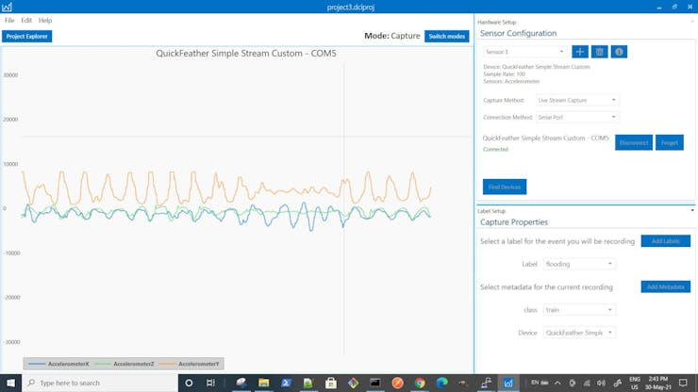

Figure 2 Data capturing-flooding

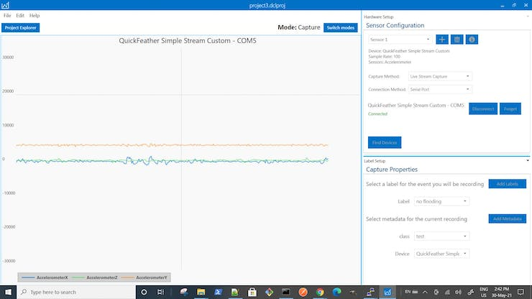

Figure 3 Data capturing-no flooding

* Machine Learning Models.

# Layout and Assembly

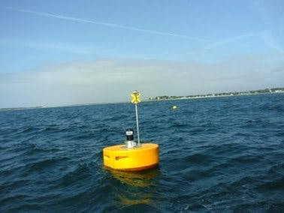

**Project Layout for Compact Circular Flood Monitoring Device:**

* Device Housing: the compact circular device is housed in a weatherproof, durable enclosure. The housing is designed to protect the internal components from environmental factors like rain, dust, and temperature fluctuations.
* Sensor Integration: Inside the housing, integrate the various sensors required for flood monitoring. These may include water level sensors, rainfall sensors, temperature and humidity sensors, and any other relevant environmental sensors.
* Microcontroller Placement: Secure the microcontroller, in this case, the QuickLogic EOS S3 (from the QuickFeather Development Kit), at the center of the circular device. Ensure that it's well-protected and positioned for efficient data processing.
* LoRaWAN Device Integration: Incorporate the LoRaWAN device into the device layout. This might involve an internal compartment or antenna placement for long-range wireless communication.
* Power Supply: Allocate space for the power supply components, such as batteries or power cables. Ensure that the power source is reliable and easy to access for maintenance.
* LED Indicators: Include LED indicator lights on the exterior of the device to provide status information, such as power status, connectivity, and sensor operation.

# System Evaluation

System evaluation is the process of assessing the performance, functionality, cost-effectiveness, scalability, and overall effectiveness of a system. In the context of a flood monitoring project, system evaluation is crucial for determining how well the project meets its objectives and whether any improvements are needed.

The flood monitoring project, featuring a compact circular device integrated with advanced technologies, has demonstrated commendable accuracy and reliability in detecting and predicting flood events. The system's robustness, low power consumption, have enhanced its real-time responsiveness, making it a cost-effective solution for remote monitoring.

With additional low-power, long-range LoraWAN device, critical alerts can be relayed to nearby monitoring station for prompt and responsive actions.