

**Faculty of Engineering & Technology**

**Electrical & Computer Engineering Department**

**ENCS4380**

**INTERFACING TECHNIQUES**

**Homework #3**

**Prepared by**: Maisam alaa

**ID**: 1200650

**Instructor's Name**: Dr. Wasel Ghanem

**Section**: 2

**Date**: 1\1\2024

# Example 4:

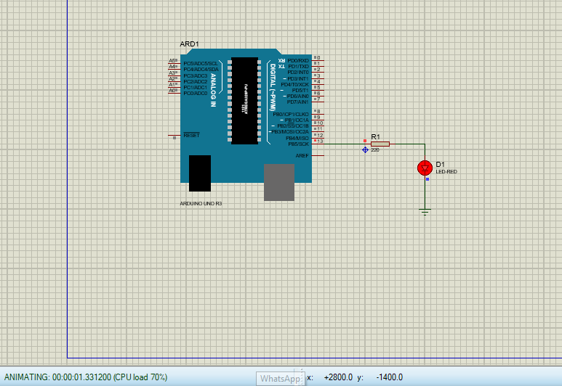

# Example 5:

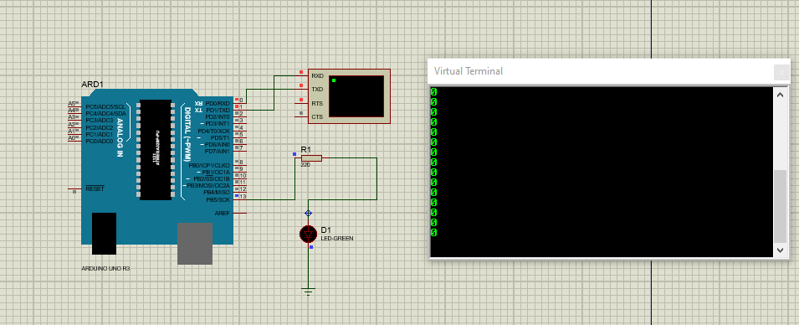

# Example 6:

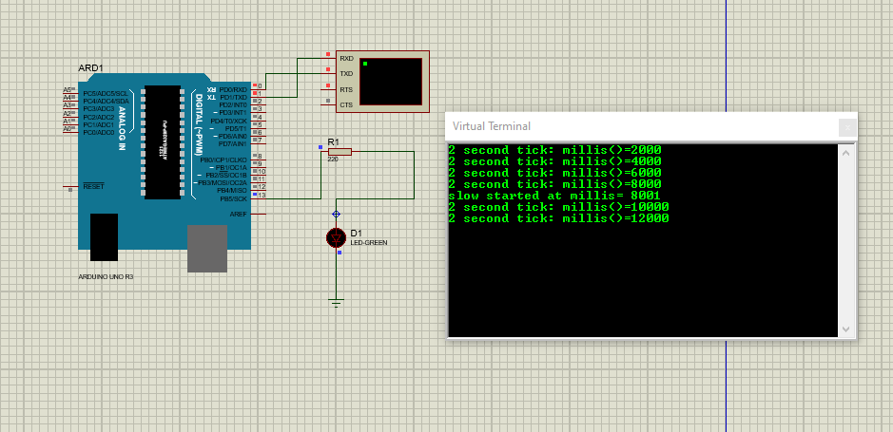

# Question 2:

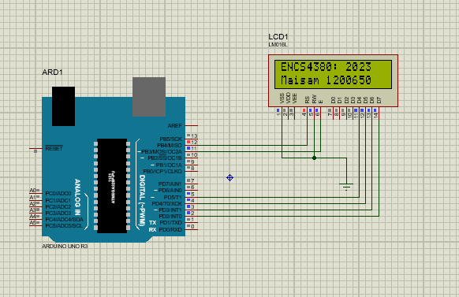

The massage after it moves a little:

