Exercises

I. Write a shell script that prompt user for name, address and age. Lastly display all 3

info in sequence. Script shall be written base on condition below in separate

filename:

1. Condition A – All three-read statement must be in separated lines

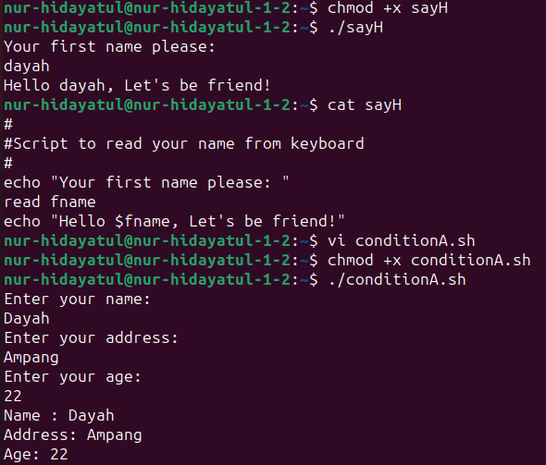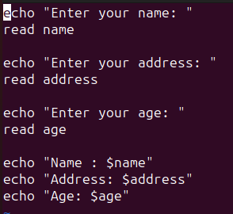

1. Condition B – All three-read statement must be in one line

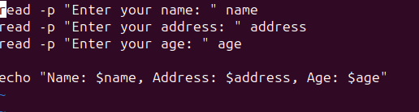

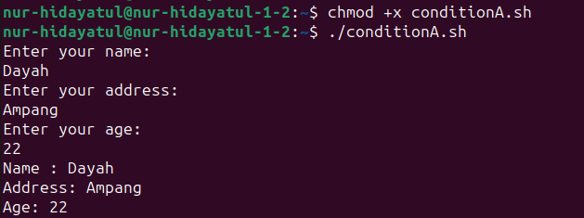

II. Observe the output and note down your findings