**NAME: NUR HIDAYATUL FADHILAH BINTI RAHMAD**

**MATRIC NO.: CB22053**

**SECTION: 01B**

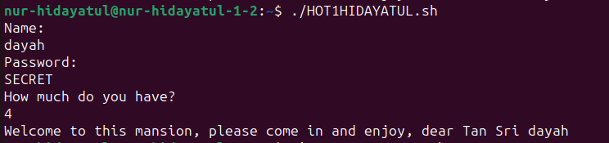QUESTION 1  
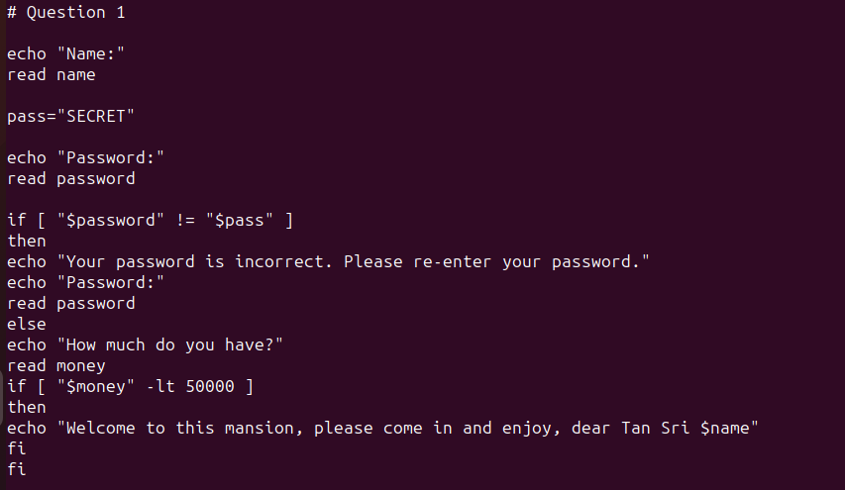

QUESTION 2

