PROJECT REPORT
HEALTH DATA ANALYTICS:\nHEART DISEASE PREDICTION\nUSING MACHINE LEARNING
A comparative study of Logistic Regression,\nK-Nearest Neighbour and Random Forest
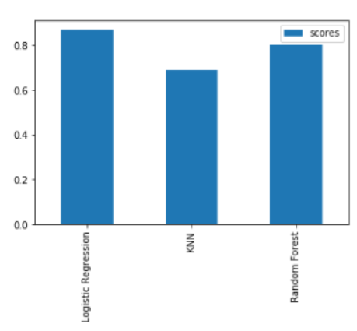
Comparative model accuracy as reported in the source notebook
\n
Submitted by | Maisha Mahi Muqtadir
Programme / Department | BBA- IBM 3rd sem/ FOCM
Institution | United University
Academic Year | 2026–2027
\nPrepared from the supplied research notebook

CERTIFICATE
This is to certify that the project report entitled “Health Data Analytics: Heart Disease Prediction Using Machine Learning” is a structured presentation of the work and research material contained in the supplied Jupyter Notebook. The report discusses the dataset, preprocessing approach, exploratory analysis, classification algorithms and findings described in that source.
The report has been prepared for academic project documentation. Student, supervisor, department and institutional details are intentionally left as editable placeholders and should be completed and verified before formal submission.
\n\n
\n\n _Mr. Ferhan Project Guide / Supervisor
\n\n Dr. Anand _Kumar Gupta Head of Department

DECLARATION
I declare that the final submitted version of this report will be reviewed and approved by me, and that all sources used in the project will be appropriately acknowledged. Any code, dataset version, experimental configuration or additional result included during final submission will be checked against the actual project files.
The supplied notebook is primarily a research-style document and does not contain executable model-training code or a complete reproducibility record. Accordingly, this report does not claim independent execution or validation of the reported experiment.
\n
Student Signature: ___Maisha____________________ Date: __9/11/26____________

ACKNOWLEDGEMENT
I would like to express my sincere gratitude to the faculty members, project guide and department for their academic support and encouragement during the preparation of this project report. Their guidance has been valuable in organizing the research material and understanding the application of machine learning to a healthcare-related classification problem.
I also acknowledge the University of California, Irvine (UCI) Machine Learning Repository as the dataset source identified in the supplied notebook, and the researchers whose studies are discussed in its literature review. Their work provides the background for comparing classification techniques in the context of heart disease prediction using health data.

ABSTRACT
Cardiovascular disease is a major global health concern, and early identification of possible risk can support timely clinical assessment. This project presents a machine-learning approach to heart disease prediction using health data using clinical attributes from the UCI Heart Disease dataset. The source notebook describes a dataset containing 303 instances and 75 attributes, from which 14 clinically relevant attributes are selected during preprocessing. The workflow includes data preprocessing, cleaning, normalization, exploratory visualization, train–test splitting, model training and comparative evaluation.
Three supervised classification algorithms are considered: Logistic Regression, K-Nearest Neighbour (KNN) and Random Forest. The notebook reports that Logistic Regression achieves the highest stated accuracy of approximately 87.78% at a test proportion of 0.2 (the narrative rounds this to 87%). At the same proportion, KNN is reported at 68.85% and Random Forest at 80.32%. These values are reproduced from the notebook’s embedded comparison table; they have not been independently re-run in this report.
The findings suggest that model performance depends on both the algorithm and the train–test proportion. The project is a research prototype for decision support and is not a medical diagnostic system. Further work should use larger and more representative datasets, document validation procedures, assess clinically relevant metrics and obtain appropriate clinical review.
Keywords: Heart disease, cardiovascular disease, machine learning, Logistic Regression, KNN, Random Forest, UCI dataset, classification.

TABLE OF CONTENTS
1. Introduction
2. Problem Statement, Aim and Objectives
3. Literature Review
4. Dataset and Clinical Features
5. Research Methodology
6. Data Preprocessing and Cleaning
7. Exploratory Data Analysis and Visualization
8. Machine Learning Algorithms
9. Training, Testing and Evaluation
10. Results and Comparative Analysis
11. Discussion
12. Conclusion and Future Scope
13. Limitations and Ethical Considerations
14. References

LIST OF FIGURES
- Figure 1. Correlation heatmap of selected clinical attributes
- Figure 2. Overall model workflow
- Figure 3. Clinical features and descriptions
- Figure 4. Exploratory pairplot based on age
- Figure 5. Accuracy by train–test proportion
- Figure 6. Comparative model accuracy

LIST OF TABLES
- Table 1. Dataset overview
- Table 2. Clinical features listed in the notebook
- Table 3. Accuracy across test proportions
- Table 4. Algorithms compared
- Table 5. Summary of reported findings
Note: Page numbers may be refreshed in Microsoft Word after editing placeholders or formatting.

1. INTRODUCTION
Cardiovascular diseases (CVDs) affect the heart and blood vessels and represent an important public-health challenge. The supplied notebook frames heart disease prediction using health data as a classification problem in which patient-related clinical measurements are used to estimate whether the record belongs to a heart-disease category. An early risk indication may encourage further clinical examination and timely preventive action.
Conventional medical assessment depends on clinical expertise, patient history, physical examination and diagnostic tests. Machine learning can complement this process by identifying patterns in historical data and producing a consistent classification output. It does not replace the judgment of a qualified healthcare professional.

1.1 Background
The notebook identifies attributes such as age, cholesterol, resting blood pressure, maximum heart rate and exercise-related indicators as relevant variables for analysis. Relationships among these variables can be explored using statistical summaries and visualizations such as a correlation heatmap and pairplots. Classification algorithms can then learn patterns from labelled examples.

1.2 Motivation
The motivation for this project is to compare different supervised learning approaches on a commonly used heart-disease dataset. Logistic Regression offers a probability-oriented linear classification approach; KNN classifies observations based on neighbouring examples; and Random Forest combines multiple decision trees. Comparing these models provides an introductory view of how algorithm choice and data splitting can influence predictive performance.

1.3 Project Overview
The workflow described in the notebook begins with the UCI dataset, proceeds through preprocessing and visualization, and then trains and tests the three classifiers. The reported results are compared across several test proportions. The source identifies Logistic Regression at a 0.2 test proportion as the strongest reported configuration.

2. PROBLEM STATEMENT, AIM AND OBJECTIVES

2.1 Problem Statement
Heart-disease datasets contain multiple clinical attributes whose combined patterns may be difficult to interpret through a simple inspection of tabular records. The project addresses the problem of classifying heart-disease outcomes from selected clinical features and comparing the predictive performance of three supervised machine-learning algorithms.

2.2 Aim
To study and compare Logistic Regression, K-Nearest Neighbour and Random Forest for heart-disease prediction using health data using the UCI Heart Disease dataset described in the supplied notebook.

2.3 Objectives
- Identify the dataset and clinical variables used in the research workflow.
- Describe the preprocessing, data-cleaning and normalization stages.
- Explore relationships and patterns in the clinical attributes through visual analysis.
- Train and evaluate Logistic Regression, KNN and Random Forest as described in the source material.
- Compare reported accuracy values across different test proportions.
- Identify the best-performing configuration reported in the notebook.
- Discuss limitations and practical steps required before any clinical application.

2.4 Scope of the Project
The scope is limited to a comparative classification study based on the UCI Heart Disease dataset referenced by the notebook. It covers 303 instances and the stated selection of 14 attributes from an original set of 75. The report documents the three algorithms and the accuracy values explicitly visible in the source. It does not introduce a new dataset, deploy a clinical application or claim prospective clinical validation.

2.5 Expected Outcome
The expected outcome is a clear comparison of the three classifiers under the train–test proportions documented in the notebook, together with an explanation of the workflow and its limitations. The notebook reports Logistic Regression as the best-performing model at a 0.2 test proportion.

3. LITERATURE REVIEW
The supplied notebook summarizes earlier work on data mining and machine-learning methods for heart-disease prediction using health data. The studies use different datasets and algorithms, so their reported performance should be interpreted in the context of their individual experimental settings.
Study / Year | Approach described in the notebook | Key point noted in the source
Pandey et al. (2013) | Decision Tree and other statistical / ML approaches | Explored classification approaches; the source notes challenges with decision-tree performance.
Mythili et al. (2013) | SVM, Decision Tree and Logistic Regression (SDL) | Combined classifiers on a heart-disease dataset; outcomes depended on the method.
Bashir et al. (2019) | Feature-selection approach | Focused on improving prediction through feature selection.
Mohan et al. (2019) | Hybrid Random Forest and Linear Model (HRFLM) | Compared algorithms and proposed a hybrid approach.
Gavhane et al. (2018) | Machine-learning prediction using MLP | The notebook describes improved efficiency, with possible limitations in model behaviour.
Soni et al. (2011) | Predictive data mining and weighted associative classifiers | Discussed the influence of dataset and algorithm choice.
Taneja (2013) | Data-mining techniques on Chandigarh data | Reported that data-mining methods can support heart-disease prediction.
Ishtake et al. (2013) | Intelligent prediction system | Presented a prototype intended to support healthcare learning and prediction.
Ziasabounchi et al. (2014) | Adaptive neuro-fuzzy inference system | Combined neural-network and fuzzy-logic ideas.
Masethe et al. (2014) | J48, REPTREE and Simple CART | Applied classification techniques to a South African patient dataset.

3.1 Research Gap and Rationale
The literature summary indicates that prediction performance varies with the dataset, selected features and algorithm. The current project therefore compares three widely used supervised classifiers on the UCI dataset rather than assuming that one method is universally superior. Direct numerical comparisons with earlier studies require caution because dataset composition, preprocessing and evaluation design may differ.

4. DATASET AND CLINICAL FEATURES
The source notebook identifies the UCI Heart Disease dataset as the data source. It describes the dataset as multivariate, with 303 instances and 75 attributes in its broader form. During preprocessing, 14 attributes are stated to be selected for the prediction task. The notebook does not include a complete data dictionary or a version identifier for the downloaded file; therefore, the feature descriptions below follow the embedded clinical-feature table.
Feature | Description in the notebook
Num | Diagnosis of heart disease
Exang | Exercise-induced angina
Age | Patient age in years
Thal | 3 = normal; 6 = fixed defect; 7 = reversible defect
Restecg | Resting electrocardiographic results
Cp | Chest pain type
Ca | Number of major vessels (0–3) coloured by fluoroscopy
FBS | Fasting blood sugar
Sex | Instance gender
Slope | Slope of the peak exercise ST segment
Thalach | Maximum heart rate achieved
Trestbps | Resting blood pressure
Oldpeak | ST depression induced by exercise relative to rest
Chol | Serum cholesterol

4.1 Dataset Summary
Item | Description
Source | UCI Machine Learning Repository, as stated in the notebook
Instances | 303
Attributes in broader dataset | 75
Attributes selected for analysis | 14
Task | Supervised classification
Target description | Heart-disease diagnosis / outcome

The source notebook uses a mixture of numerical and categorical clinical variables. The exact encoding, units and class distribution should be confirmed from the actual dataset file before reproducing the experiment. The report does not infer missing values or class counts that are not documented in the notebook.

5. RESEARCH METHODOLOGY
The methodology described in the source follows a conventional supervised machine-learning pipeline. Raw data is obtained from the UCI repository, prepared for analysis, visualized and divided into training and testing subsets. Three classifiers are trained and their results are compared.
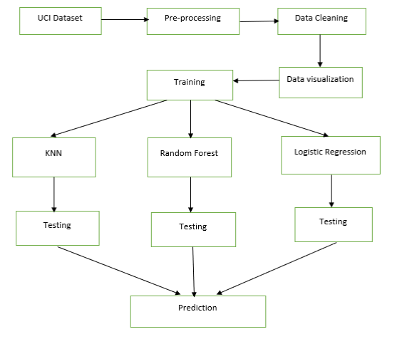
Figure 2. Model workflow reproduced from the supplied notebook

5.1 Workflow Stages
- Dataset acquisition: obtain the UCI Heart Disease dataset identified in the source.
- Feature selection: retain the 14 clinical attributes described in the notebook.
- Preprocessing: convert values into a usable numerical representation and normalize attributes as required by the stated workflow.
- Data cleaning: address null or missing values and remove irrelevant attributes.
- Exploratory analysis: inspect relationships through a heatmap and graphical plots.
- Train–test split: evaluate multiple proportions of training and testing data.
- Model training: fit Logistic Regression, KNN and Random Forest using the training subset.
- Testing and comparison: assess the trained models on the test subset and compare accuracy.

5.2 Workflow Interpretation
The workflow is designed to compare alternative classifiers using the same general data source and preprocessing concept. The test proportion is treated as an experimental setting because the embedded accuracy table reports results for proportions from 0.1 through 0.9. A reproducible experiment should additionally fix the random seed, stratification strategy and preprocessing fit procedure; these details are not specified in the notebook.

6. DATA PREPROCESSING AND CLEANING
Preprocessing is an important stage because model performance depends on the quality and representation of input data. The notebook states that the original UCI dataset contains 75 attributes and that 14 attributes are extracted for the analysis. It also describes conversion into numerical form and normalization.

6.1 Feature Selection
Feature selection reduces the analysis to a smaller group of variables considered relevant to the clinical prediction task. The 14 features listed in the notebook include demographic information, symptoms, blood pressure, cholesterol, electrocardiographic observations and exercise-related measurements. The source does not document a formal feature-selection algorithm or ranking procedure.

6.2 Missing-Value Handling
The notebook describes removing null (NaN) values to improve dataset quality. It does not report the number of missing values before cleaning, the number of records removed or whether imputation was considered. These values should be added from the executed preprocessing code if the project is reproduced.

6.3 Numerical Conversion and Normalization
The source states that attribute values are converted into numerical form and normalized. Numerical encoding is necessary for algorithms that operate on numeric feature representations. Normalization is particularly relevant to distance-based KNN, where variables with larger numeric scales can otherwise dominate distance calculations.

6.4 Recommended Reproducibility Controls
- Fit scaling and other learned preprocessing steps on the training data only, then apply the fitted transformation to the test data.
- Document how categorical variables are encoded and how missing values are handled.
- Record the final feature list and the exact target encoding.
- Use a fixed random state and, where appropriate, stratified splitting.
- Retain a clear record of the number of rows before and after cleaning.
These controls are recommendations for a reproducible implementation; they are not confirmed operations in the supplied notebook.

7. EXPLORATORY DATA ANALYSIS AND VISUALIZATION
The notebook emphasizes visualization as a way to understand relationships that may be difficult to identify in a tabular dataset. It includes a correlation heatmap and an exploratory pairplot. The source text highlights age, chest-pain type, slope, maximum heart rate and exercise-induced angina among attributes discussed in relation to heart-disease patterns.
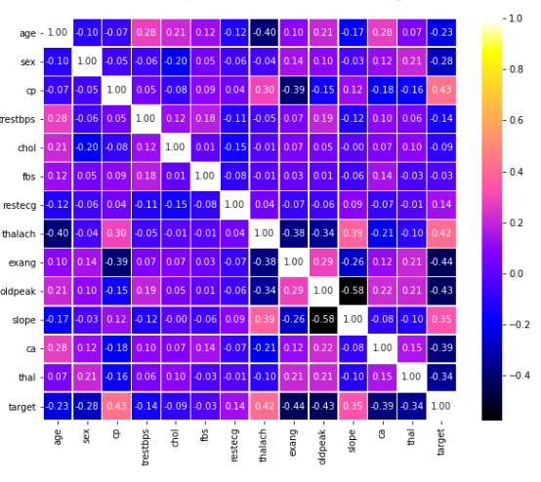
Figure 1. Correlation heatmap of clinical attributes supplied in the notebook
A heatmap uses colour intensity to represent the strength and direction of pairwise relationships. It can help identify correlated variables and potential redundancy. Correlation does not establish causation, and the heatmap alone cannot demonstrate that a feature causes cardiovascular disease.
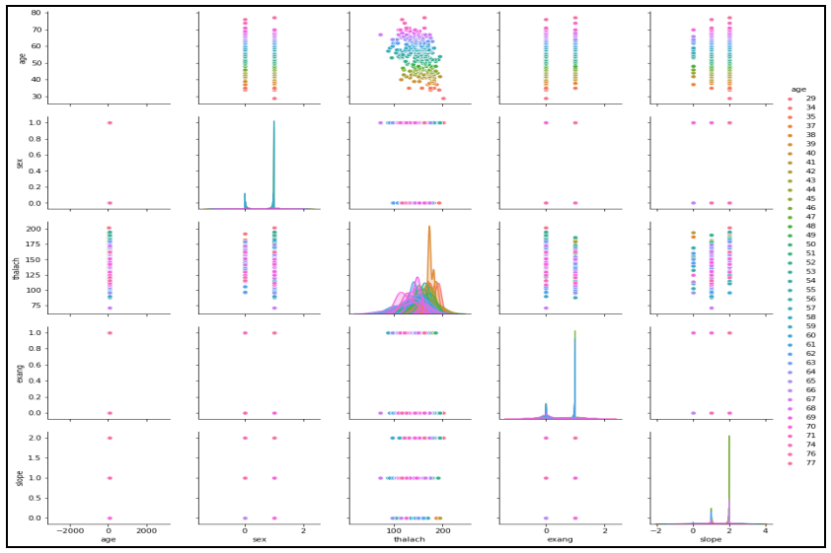
Figure 4. Exploratory pairplot based on age, supplied in the notebook

7.1 Interpretation
The pairplot presents distributions and pairwise relationships among selected attributes, with the source describing the analysis in relation to patient age. Such plots can reveal clusters, skewed distributions and possible associations that may inform subsequent modelling. The notebook does not provide a detailed written interpretation for every plotted relationship, so no additional clinical conclusions are inferred here.

7.2 Role in the Project
Exploratory visualization supports data familiarization, helps identify unusual patterns and communicates the structure of the dataset. It should be treated as an exploratory stage rather than a substitute for formal statistical testing or clinical interpretation.

8. MACHINE LEARNING ALGORITHMS

8.1 Logistic Regression
Logistic Regression is a supervised classification algorithm used when the target represents categorical outcomes. The notebook describes a binary target and models the probability of an outcome using a weighted combination of input variables. A logistic transformation maps the linear score to a probability between zero and one. The predicted class is then determined using a decision threshold.
The source presents Logistic Regression as the strongest model in its reported comparison at a test proportion of 0.2. Its accuracy in the embedded table is 0.87788, approximately 87.79%.

8.2 K-Nearest Neighbour (KNN)
KNN is an instance-based classification method. For a new observation, it calculates distances to observations in the training set and uses the labels of the nearest neighbours to determine the predicted class. The notebook refers to Euclidean distance and majority voting. Since KNN is distance-based, feature scaling is important.
At a test proportion of 0.2, the embedded table reports KNN accuracy of 0.6885, or 68.85%.

8.3 Random Forest
Random Forest is an ensemble learning method that constructs multiple decision trees using sampled training data and feature subsets. The individual tree predictions are combined to produce the final classification. The notebook describes bootstrap aggregation (bagging) and the use of multiple trees to improve prediction stability.
At a test proportion of 0.2, the embedded table reports Random Forest accuracy of 0.8032, or 80.32%.
Algorithm | Core idea | Important consideration
Logistic Regression | Estimate class probability from a weighted feature combination | Check class balance, threshold and feature relationships
KNN | Classify from the labels of nearest training observations | Sensitive to scaling, distance metric and choice of k
Random Forest | Combine predictions from multiple decision trees | Performance depends on tree and ensemble settings

9. TRAINING, TESTING AND EVALUATION
The notebook describes splitting the heart-disease dataset into training and testing subsets. The training subset is used to fit each classifier, while the test subset is used to assess predictions on data not used for fitting. Several test proportions are compared, from 0.1 to 0.9.

9.1 Accuracy Across Test Proportions
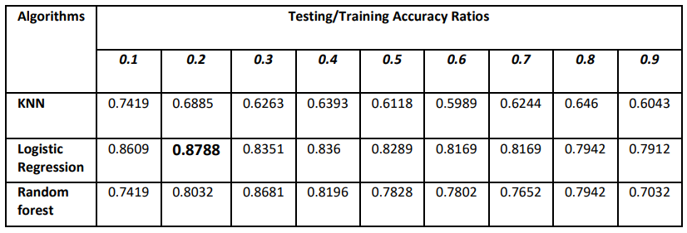
Figure 5. Accuracy values across the test proportions shown in the source notebook
Test proportion | KNN | Logistic Regression | Random Forest
0.1 | 0.7419 | 0.8609 | 0.7419
0.2 | 0.6885 | 0.87788 | 0.8032
0.3 | 0.6263 | 0.8351 | 0.8681
0.4 | 0.6393 | 0.8360 | 0.8196
0.5 | 0.6118 | 0.8289 | 0.7828
0.6 | 0.5989 | 0.8169 | 0.7802
0.7 | 0.6244 | 0.8169 | 0.7652
0.8 | 0.6460 | 0.7942 | 0.7942
0.9 | 0.6043 | 0.7912 | 0.7032

9.2 Evaluation Measure
The principal quantitative measure presented in the notebook is accuracy, calculated as the proportion of correctly classified observations among all test observations. The source also refers to error rates in its literature comparison tables. It does not provide a confusion matrix, precision, recall, F1-score, ROC-AUC, confidence intervals or cross-validation results for the current experiment.
For a healthcare-related classifier, accuracy alone is insufficient. False negatives and false positives can have different implications, so future evaluation should include sensitivity (recall), specificity, precision, F1-score and ROC-AUC, together with class-wise confusion matrices.

10. RESULTS AND COMPARATIVE ANALYSIS
The notebook reports that the highest Logistic Regression accuracy occurs at a test proportion of 0.2. The embedded table gives 0.87788 (approximately 87.79%), while the narrative text rounds this to 87%. The table also shows that Random Forest reaches 0.8681 (86.81%) at a test proportion of 0.3.
Figure 6. Visual comparison of the reported model scores
Model / setting | Reported accuracy | Interpretation
Logistic Regression, test proportion 0.2 | 87.788% (table: 0.87788) | Highest value in the Logistic Regression row and highest value in the table.
Random Forest, test proportion 0.3 | 86.81% (0.8681) | Strong result; highest value in the Random Forest row.
KNN, test proportion 0.1 | 74.19% (0.7419) | Highest value in the KNN row.

10.1 Key Observations
- Logistic Regression is the best-performing model at the 0.2 test proportion in the supplied accuracy table.
- Random Forest performs best at a 0.3 test proportion and is close to the best Logistic Regression result.
- KNN records lower accuracy than the other two models across the listed proportions.
- The reported accuracy changes with the selected test proportion.

10.2 Interpretation Caution
The table does not explain whether each split uses the same random seed, whether the test proportion is defined consistently, or whether repeated trials were averaged. The values should therefore be treated as the results reported by the notebook, not as a statistically validated ranking across repeated experiments. The table’s 0.2 Logistic Regression value is 0.87788, while the accompanying prose rounds the result to 87%; this report retains the more precise table value and notes the rounded narrative.

11. DISCUSSION, CONCLUSION AND FUTURE SCOPE

11.1 Discussion
The reported comparison indicates that Logistic Regression provides the strongest accuracy at a 0.2 test proportion, while Random Forest also achieves a competitive result at 0.3. KNN performs less strongly in the displayed comparison. These outcomes illustrate that algorithm selection and data partitioning can affect measured performance. They do not establish that Logistic Regression will be superior on other datasets or in clinical settings.

11.2 Conclusion
This project documents a machine-learning workflow for heart-disease prediction using health data using the UCI dataset described in the supplied notebook. The workflow includes feature selection, cleaning, normalization, exploratory visualization, train–test splitting and comparison of Logistic Regression, KNN and Random Forest. The highest reported accuracy is 0.87788 for Logistic Regression at a test proportion of 0.2. Random Forest reaches 0.8681 at 0.3. Based on the reported table, Logistic Regression is the best configuration in this experiment.
The model should be viewed as an academic prediction prototype. It is not a clinically validated diagnostic tool and must not be used to make patient-care decisions without rigorous validation, clinical oversight and regulatory consideration.

11.3 Future Scope
- Increase dataset size and evaluate additional, diverse and locally relevant patient data.
- Compare further algorithms, including Support Vector Machines and other suitable classifiers.
- Use robust validation such as stratified cross-validation and repeated experiments.
- Report confusion matrices, sensitivity, specificity, precision, F1-score and ROC-AUC.
- Document feature engineering, hyperparameter settings, random seeds and preprocessing steps.
- Evaluate fairness, calibration, interpretability, privacy and clinical utility with qualified experts.

12. LIMITATIONS AND ETHICAL CONSIDERATIONS
The notebook does not provide executable model-training cells, complete parameter settings, a full dataset file, a precise data-cleaning log or repeated validation results. It also does not document patient consent or the governance conditions of any underlying clinical records. The dataset version and exact target encoding should be verified before reproduction. Health data is sensitive; any real-world extension must protect privacy, comply with applicable law and institutional policy, and be assessed for bias and potential harm.

13. REFERENCES
[1] A. K. Pandey et al., “A Heart Disease Prediction Model using Decision Tree,” IOSR Journal of Computer Engineering, 2013, pp. 83–86.
[2] T. Mythili et al., “A Heart Disease Prediction Model using SVM-Decision Trees-Logistic Regression (SDL),” International Journal of Computer Applications in Technology, 2013, pp. 11–15.
[3] S. Bashir et al., “Improving Heart Disease Prediction Using Feature Selection Approach,” 16th IBCAST, IEEE, 2019, pp. 619–623.
[4] S. Mohan et al., “Effective Heart Disease Prediction Using Hybrid Machine Learning Techniques,” IEEE Access, 2019.
[5] A. Gavhane et al., “Prediction of Heart Disease Using Machine Learning,” 2nd ICECA, IEEE, 2018, pp. 1275–1278.
[6] J. Soni et al., “Predictive Data Mining for Medical Diagnosis: An Overview of Heart Disease Prediction,” International Journal of Computer Applications, 2011, pp. 43–48.
[7] A. Taneja, “Heart Disease Prediction System Using Data Mining Techniques,” Oriental Journal of Computer Science & Technology, 2013, pp. 457–466.
[8] S. H. Ishtake et al., “Intelligent Heart Disease Prediction System Using Data Mining Techniques,” International Journal of Healthcare & Biomedical Research, 2013, pp. 94–101.
[9] N. Ziasabounchi et al., “ANFIS Based Classification Model for Heart Disease Prediction,” International Journal of Engineering & Computer Science, 2014, pp. 7–12.
[10] J. Soni et al., “Intelligent and Effective Heart Disease Prediction System using Weighted Associative Classifiers,” International Journal on Computer Science and Engineering, 2011, pp. 2385–2392.
[11] H. D. Masethe et al., “Prediction of Heart Disease using Classification Algorithms,” Proceedings of the World Congress on Engineering and Computer Science, 2014.
[12] N. Bhatla et al., “An Analysis of Heart Disease Prediction using Different Data Mining Techniques,” International Journal of Engineering Research & Technology, 2012, pp. 1–4.
Dataset source named in the notebook: UCI Machine Learning Repository, Heart Disease dataset. The exact dataset URL/version was not specified in the supplied notebook and should be added after verification.

