


Directed by: Maissa Drira

Supervised by: Ahmed Ben Miled

ESPRIT Supervisor: Hassen Jilani Ben Naouara Nouridine

Company Supervisor: Alwen.co

SUBJECT OF THE INTERNSHIP REPORT: Design and Implementation of a Multi-Tenant SaaS CRM Platform Using Odoo and Flutter Web

INFORMATIQUE

ABSTRACT

This report details my three-month internship with the Tunisian software company Al-
wen Co., where I helped create an enterprise-level CRM platform that was subscription- based. I obtained practical expertise in full-stack SaaS development, including
frontend user experience design and backend architecture, while working in a cross-functional team. The internship gave me invaluable experience with con- temporary software development techniques in a business setting, such as scal- able web application architecture, multi-tenant system design, and API integration patterns. Through this training, I improved my analytical skills for assessing security needs and scalability issues in real-world systems, and I gained a broader under- standing of the technical and business concerns involved in developing enterprise software solutions.

Keywords:
Odoo v18: Open-source ERP framework Flutter: Cross-platform UI toolkit
JSON-RPC: Remote procedure call protocol Riverpod: Flutter state management
SaaS: Software as a Service

ACKNOWLEDGEMENTS

I would want to express my gratitude to the Alwen Co. team for accepting me into their development group and providing me with the opportunity to work on an actual production project. I would want to express my appreciation to my supervisor and coworkers for their unwavering support, technical criticism, and cooperation during the internship. I also like to thank my academic supervisor for the helpful criticism that made my report better. Lastly, I want to express my gratitude to my friends and family for helping me through this fulfilling educational journey.

TABLE OF CONTENTS

ENGINEERING PROGRAM INTERNSHIP FINAL REPORT 1
ABSTRACT 2
Keywords: 2
ACKNOWLEDGEMENTS 3
LIST OF FIGURES 6
1 EXECUTIVE SUMMARY 7
2 INTRODUCTION 7
3 COMPANY CONTEXT 8
Description of the Company 8
Mission and Objectives 8
Industry Structure 8
Market Structure 8
4 INTERNSHIP DESCRIPTION 9
Internship Context 9
General and Specific Objectives of the Internship 9
Challenges and Obstacles 9
Assigned Tasks and Responsibilities 10
Key Learnings 11
5 LITERATURE REVIEW 20
5.1 SaaS Architecture and Multi-Tenancy 20
5.2 Web Application Development Frameworks 20
5.3 State Management and Routing 20
5.4 Data Validation and Security Models 21
5.5 CRM Systems and Usability 21
6 METHODOLOGY 22
Development Methodology 22
Software Development Techniques 22
Data Management and Integration 23
User Testing and Feedback 23
Conclusion 23
7 RESULTS AND FINDINGS 24
Backend Development 24
CRM Suite Deployment Module 24
Frontend Web Application 24
Performance and Testing 25
8 RECOMMENDATIONS 26
9 CONCLUSION 27
REFERENCES 28

LIST OF FIGURES
- Employee creation form in Odoo, allowing HR managers to add new employees.......12
- Employee details view, showing personal information and work-related data......................12
- Employee list interface displaying all registered employees in the system.............................13
- Invoice creation form where users can generate and configure a new invoice..................13
- Invoice details page showing the structure of a generated invoice (example 1)................14
- Invoice details page with additional fields and line items (example 2)....................................14
- Invoice list view showing all generated invoices and their statuses. 15
- Odoo features interface for creating new functionalities in the system. 15
- Odoo features replication screen used to duplicate existing modules or workflows. 16
- Overview of Odoo modules, illustrating the modular architecture of the platform. 16
- Details of Odoo SaaS configuration, showing multi-tenant setup options. 17
- Odoo SaaS features page highlighting cloud-based functionalities. 17
- Project creation form where users can define new projects and assign resources. 18
- Project details interface showing tasks, deadlines, and project structure. 18
- Project list view presenting all projects managed within the platform. 19

1 EXECUTIVE SUMMARY
This report details my three-month internship at Alwen Co., where I helped with the creation of a SaaS CRM platform for several tenants. Building backend modules in Odoo v18 for automatic CRM deployment and subscription management, as well as creating a Flutter web application with type-safe data processing, permission-based routing, and secure authentication, were the main goals of my work. My knowledge of SaaS design, backend-frontend integration, and performance optimization was enhanced by the internship, which also introduced me to scalability and security issues.

2 INTRODUCTION
I worked on a project at Alwen Co. during my internship that was designed to provide Tunisian companies with a customized SaaS CRM platform. Customers can access CRM functionality based on their subscription tier thanks to the platform’s combination of an Odoo-based backend and a Flutter interface.
I was tasked with creating frontend components for routing, authentication, and data validation in addition to crucial backend modules for multi-tenant feature isolation and deployment automa- tion. In order to ensure precise connection with Odoo models, I also contributed to user-facing modules like Sales, Projects, and Invoices.
The company’s background, the extent of my internship, and the specifics of the work I did are all covered in this report. It also considers the difficulties I ran into, the compromises I had to make during deployment, and the knowledge I acquired. The purpose is to provide both an academic assessment of my learning and a professional account of my engineering contributions.

3 COMPANY CONTEXT

Description of the Company
Alwen Co. is a young startup specializing in the design of adaptable enterprise software and digital services. The company develops customizable tools that address the operational needs of small and medium-sized businesses, with a strong emphasis on flexibility and client-specific tailoring. Among its flagship initiatives is the 216.CBS project, a Flutter-based CRM frontend that integrates seamlessly with Odoo, enabling businesses to access a modern, user-friendly interface for their customer and operations management.

Mission and Objectives
Alwen’s mission is to empower small and medium enterprises with adaptable, easy-to-deploy software solutions that streamline both customer relations and internal operations. For the 216.CBS project, the main objectives include: delivering a secure and cross-platform CRM frontend integrated with Odoo, enabling modular business features such as employee management, sales, leads, inventory, invoices, and expenses, and preparing the solution for multi-tenant SaaS deployment to support scalability and regional expansion

Industry Structure
Alwen positions itself within the enterprise software and SaaS ecosystem, a sector that prioritizes modular design, seamless integration, and secure multi-platform access. The competitive landscape includes specialized CRM/ERP vendors and system integrators offering localized solutions. Key drivers in this industry are rapid deployment with existing systems, robust data security, and lightweight, maintainable frontends that enhance user experience while lowering operational overhead.

Market Structure
Initially, Alwen focuses on the North African business ecosystem, starting with Tunisia, with an expansion roadmap targeting South African markets. The company leverages multiple distribution strategies, including direct sales to small and medium enterprises, partnerships with ERP implementation firms, and a planned online self-service subscription model. Its competitive edge lies in tight Odoo integration, a streamlined Flutter frontend, and a strong emphasis on configurable, secure deployments, all of which are key differentiators in a market where flexibility and trust are crucial.

4 INTERNSHIP DESCRIPTION
This section provides an overview of my internship experience, including the context of the placement, the objectives set, the challenges I faced, the specific responsibilities I undertook, and the key lessons learned. The main focus of my work was the development of a multi-tenant SaaS CRM platform, which required contributions to both the backend modules in Odoo v18 and the Flutter-based web application. My role involved ensuring secure subscription validation, automating CRM deployment, and implementing the architecture for the web app along with several features.

Internship Context
I completed my internship at Alwen Co., a startup based in Tunis that specializes in adaptable enterprise solutions. I worked alongside a development team of 3, and we worked actively and under tight deadlines. The project could be summarized into integrating Odoo as a back- end with a cross-platform Flutter frontend. I collaborated closely with my teammates on different parts of the system, participating in daily reviews and technical discussions. The company followed agile-inspired practices, with emphasis on version control, continuous documentation, and iterative progress tracking. My internship was carried out in a hybrid format, part of it on-site at the company’s office and part of it remotely.

General and Specific Objectives of the Internship
The overall goal of my internship was to gain practical experience in SaaS software development and contributing meaningful features to the CRM system. More specifically, I aimed to strengthen my knowledge of optimizing frontend and backend communication for realtime software and practice my newly learned technology Flutter. I also set myself the objective of learning how to automate system deployments, since this was an essential requirement for scaling the CRM to multiple tenants.

Challenges and Obstacles
One of the main challenges I faced was the complexity of multi-tenant design. Isolating client data while ensuring efficient subscription validation required careful use of Odoo’s permission model, especially when mapping features to groups and record rules. Odoo had very detailed documentation especially if you’ve paid permium prices, but we didn’t, and contacting their support would get you far enough before they ask you to pay for a subscription. Security was another

demanding area. I had to make sure that validation checks were consistently enforced server-side, as relying on client-side logic would have exposed the system to risks such as session hijacking or privilege escalation. Automating deployments was also not straightforward. Designing the CRM installer in a way that was both idempotent and capable of rolling back after failure forced me to consider dependencies between modules and their initialization sequences. On the frontend, I encountered difficulties with setting up the correct architecture. The routing system needed to load permissions before building accessible routes, which occasionally introduced latency that affected the user experience. I overcame these challenges by looking up discussions on these problems and how other experienced engineers approached them.

Assigned Tasks and Responsibilities
My responsibilities were split between backend and frontend development. On the backend, I implemented the Multi Client SaaS module, which handles subscription-based feature toggling and enforces tenant-level data isolation through Odoo’s record rules and access rights. I also developed the 216.CRM Suite module, which automates the installation and configuration of dependent modules, and supports one-click deployment of CRM instances for new clients. In addition, I designed server-side validation endpoints to verify subscription status and enforce data integrity during write operations.
On the frontend, I’ve designed the architecture from the ground up, iterating over it through the weeks. Among the core systems I’ve built is the Odoo Service; This layer manages authentication, CRUD operations, error parsing, and retry mechanisms. I also built a permission-aware routing system using GoRouter in combination with Riverpod providers, which filters accessible routes dynamically according to the authenticated user’s features. Another important responsibility was maintaining the field registry, which provides O(1) lookups for more than 200 fields and ensures that inputs are sanitized and type-checked before reaching the backend. I also worked on functional modules, including Sales, Projects, Invoices, Purchases, Employees, and Chat, implementing workflows such as record creation, detail navigation, and list filtering.

Key Learnings
The internship gave me significant exposure to both backend and frontend architecture. I learned how to design Odoo modules that enforce strict security policies, and I deepened my knowledge of record rules and multi-tenant data isolation. On the frontend, I became proficient in using Riverpod for state management and in designing routing systems that respect user permissions. Working on API communication taught me the importance of structured logging, error handling, and retry strategies. Just as importantly, I learned how to operate in a collaborative environment, where communication, documentation, and incremental delivery were essential to keep the project on track. Overall, the experience reinforced my understanding of scalability and developer productivity as central concerns in SaaS development.

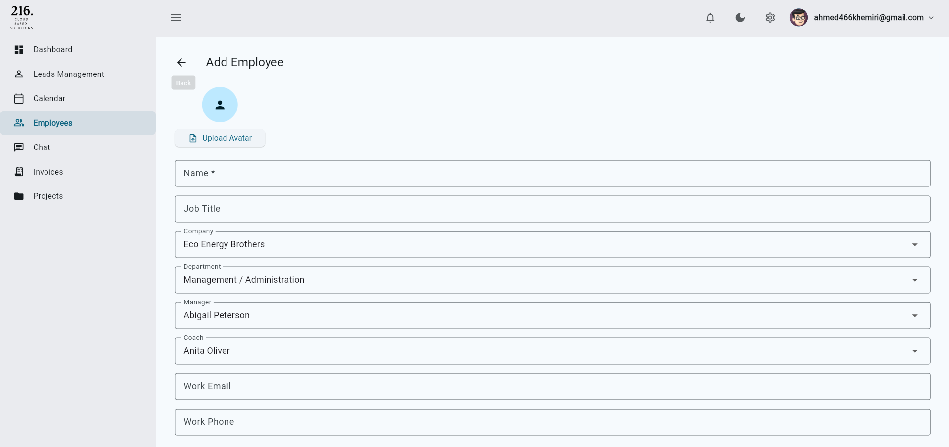
Figure 1: Employee creation form in Odoo, allowing HR managers to add new employees.

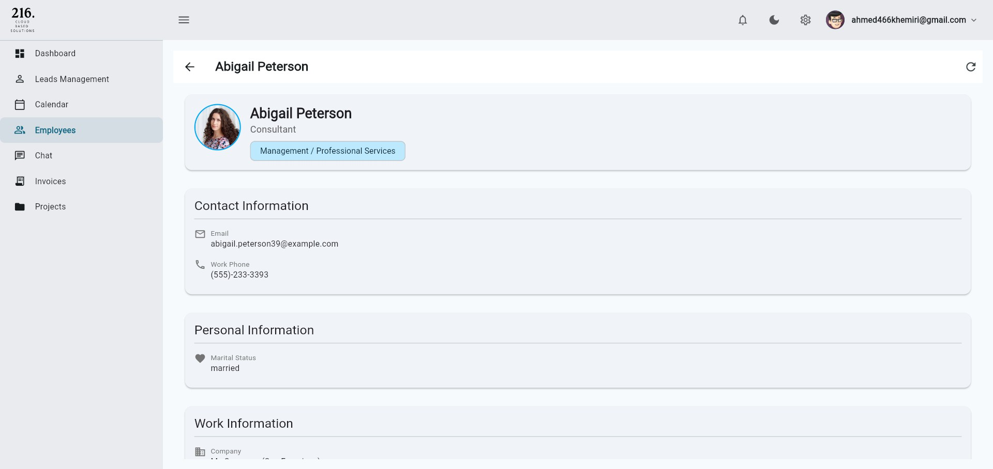
Figure 2: Employee details view, showing personal information and work-related data.

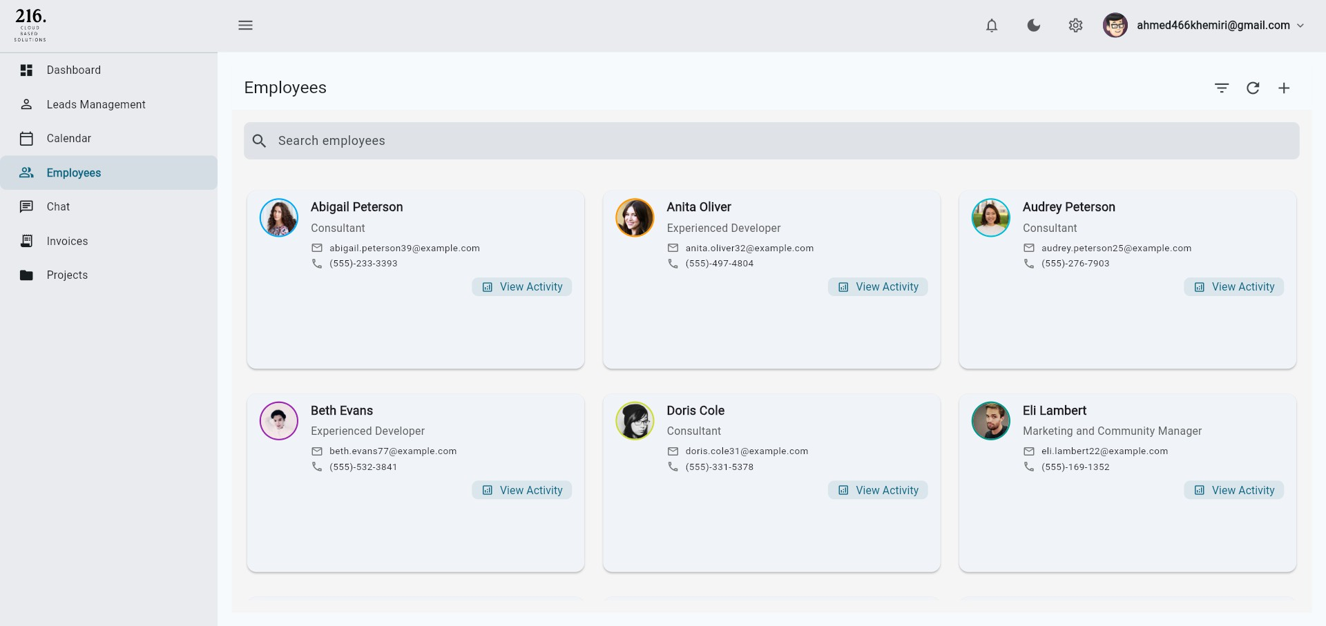
Figure 3: Employee list interface displaying all registered employees in the system.

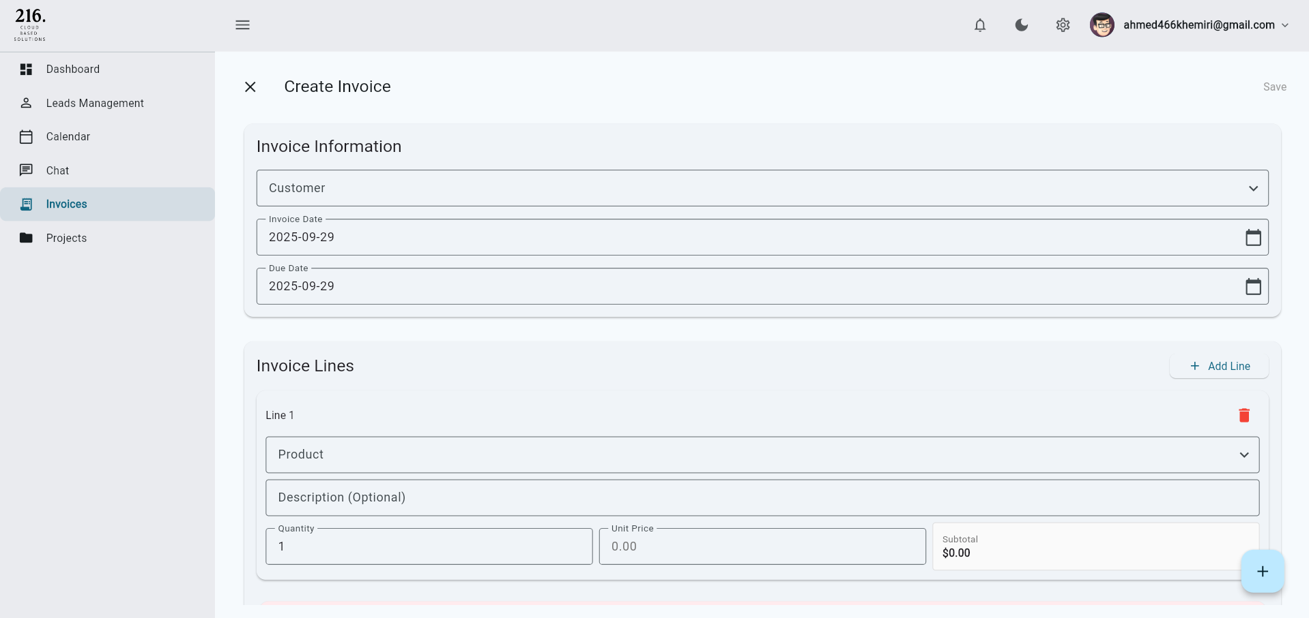
Figure 4: Invoice creation form where users can generate and configure a new invoice.

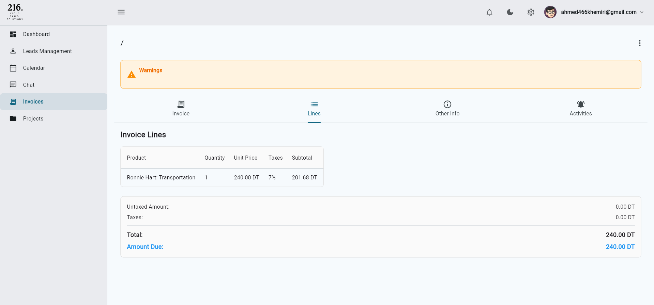
Figure 5: Invoice details page showing the structure of a generated invoice (example 1).

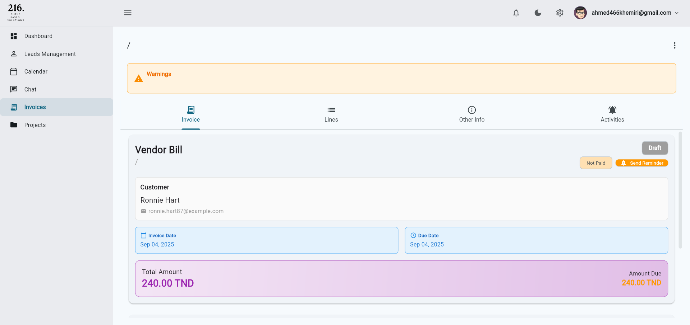
Figure 6: Invoice details page with additional fields and line items (example 2).

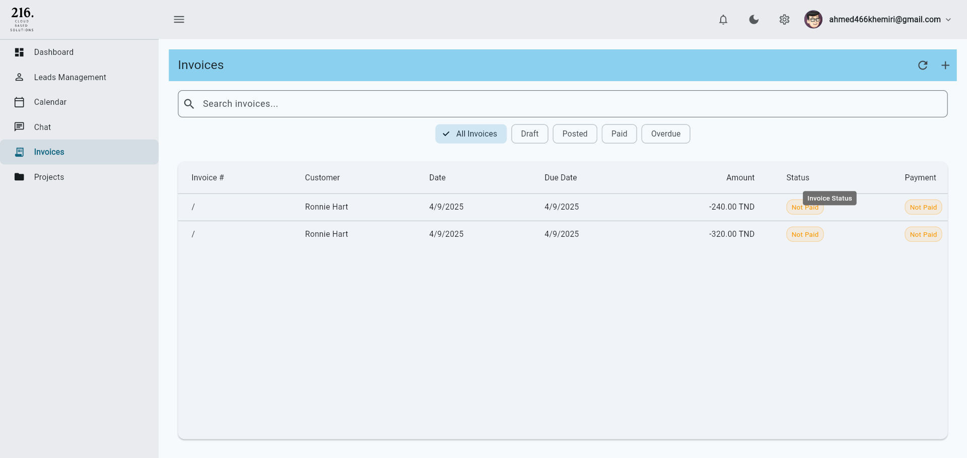
Figure 7: Invoice list view showing all generated invoices and their statuses.

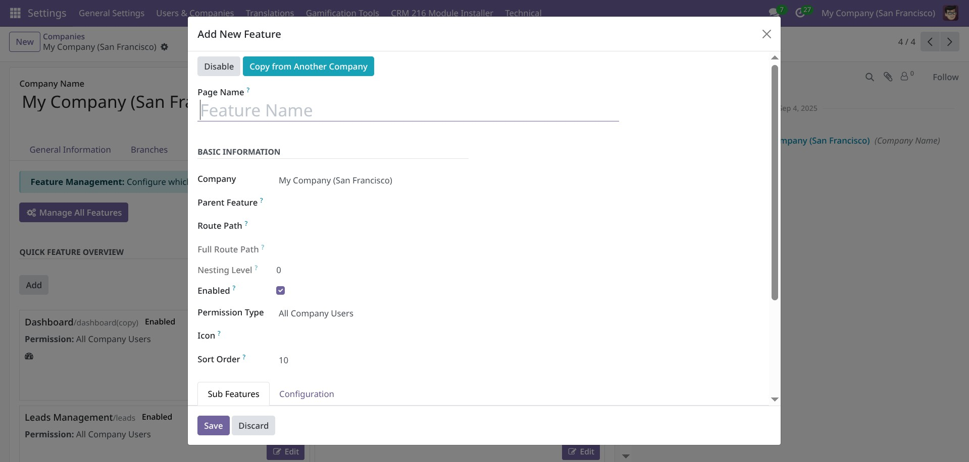
Figure 8: Odoo features interface for creating new functionalities in the system.

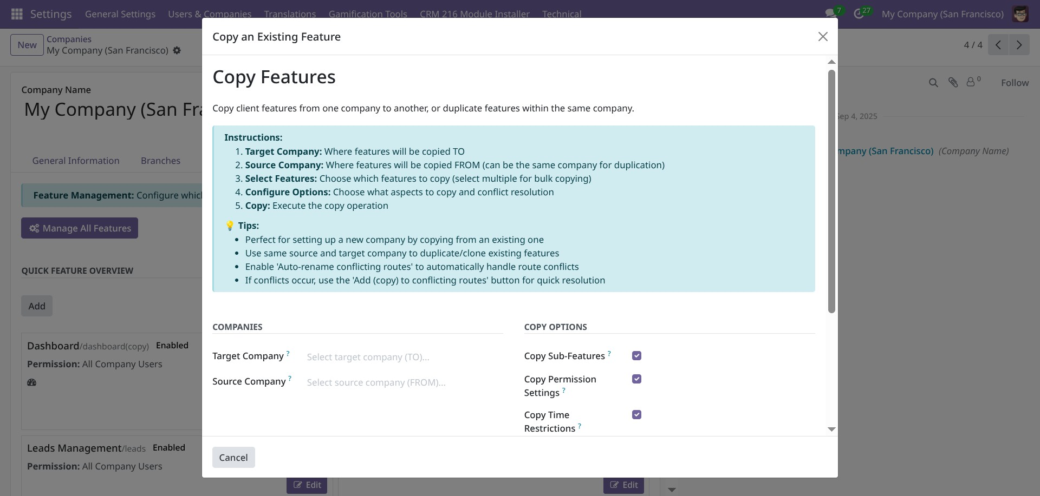
Figure 9: Odoo features replication screen used to duplicate existing modules or workflows.

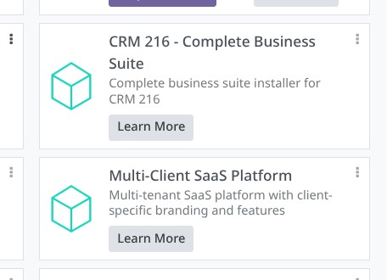
Figure 10: Overview of Odoo modules, illustrating the modular architecture of the platform.

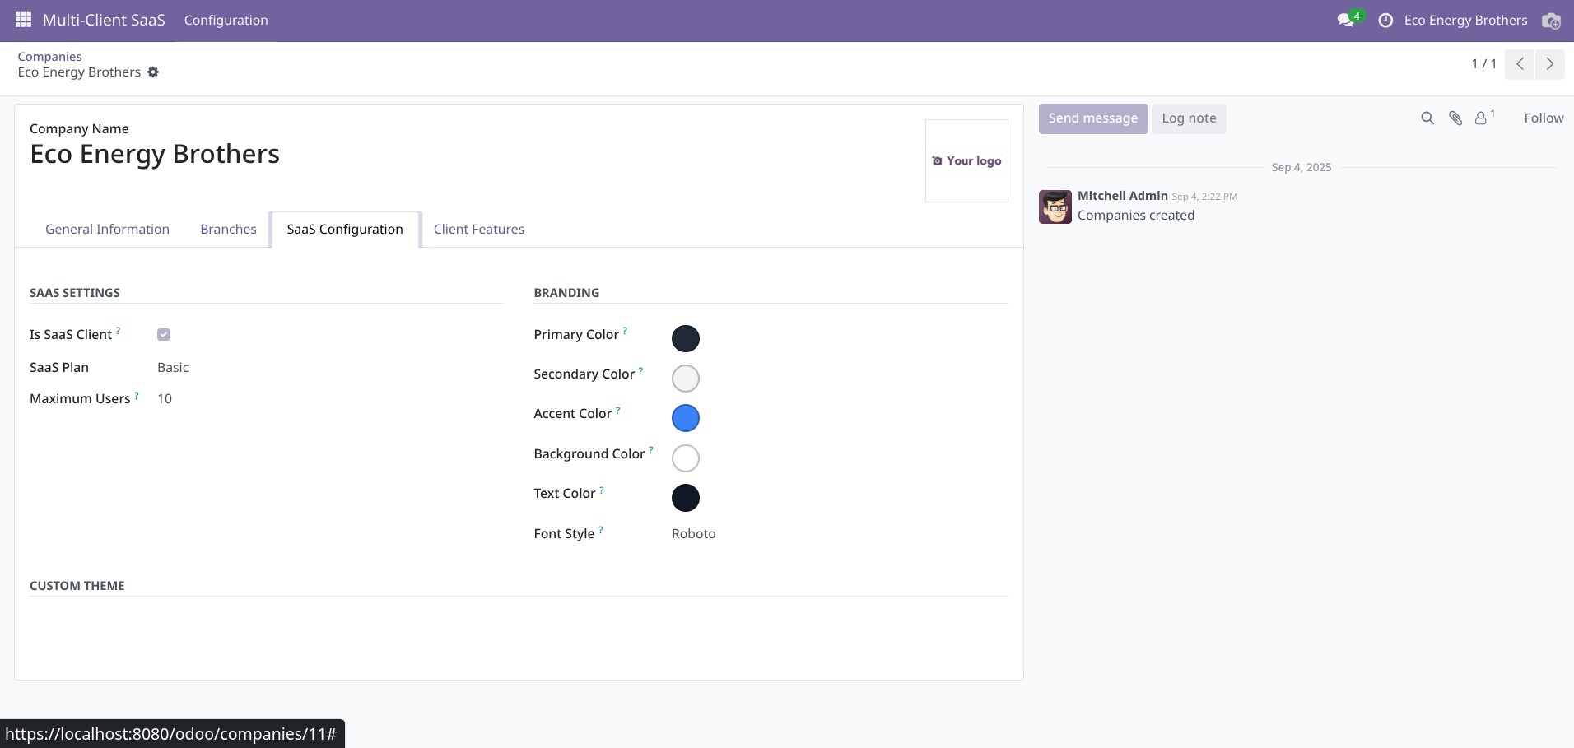
Figure 11: Details of Odoo SaaS configuration, showing multi-tenant setup options.

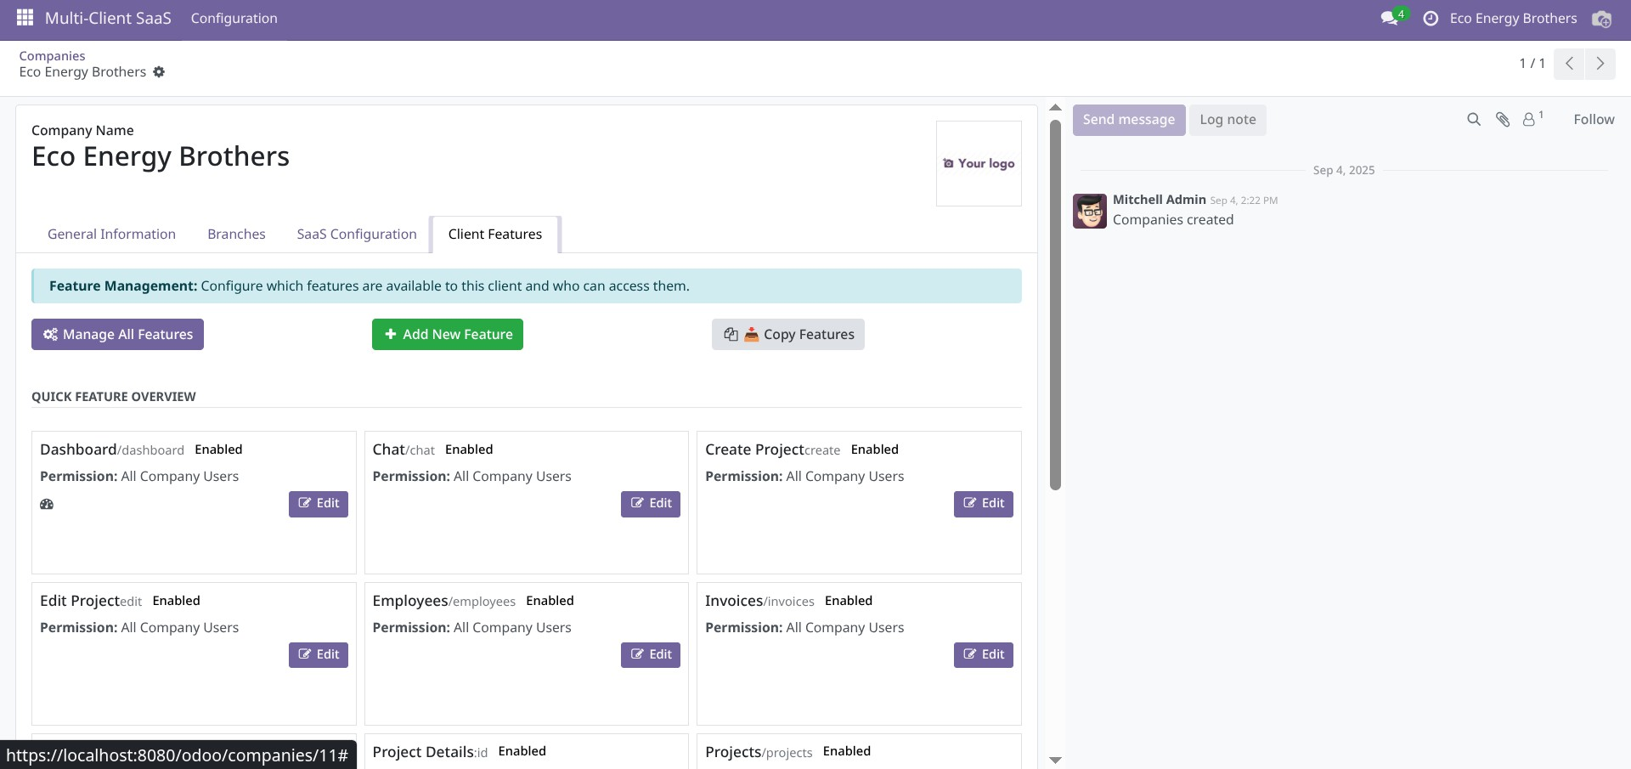
Figure 12: Odoo SaaS features page highlighting cloud-based functionalities.

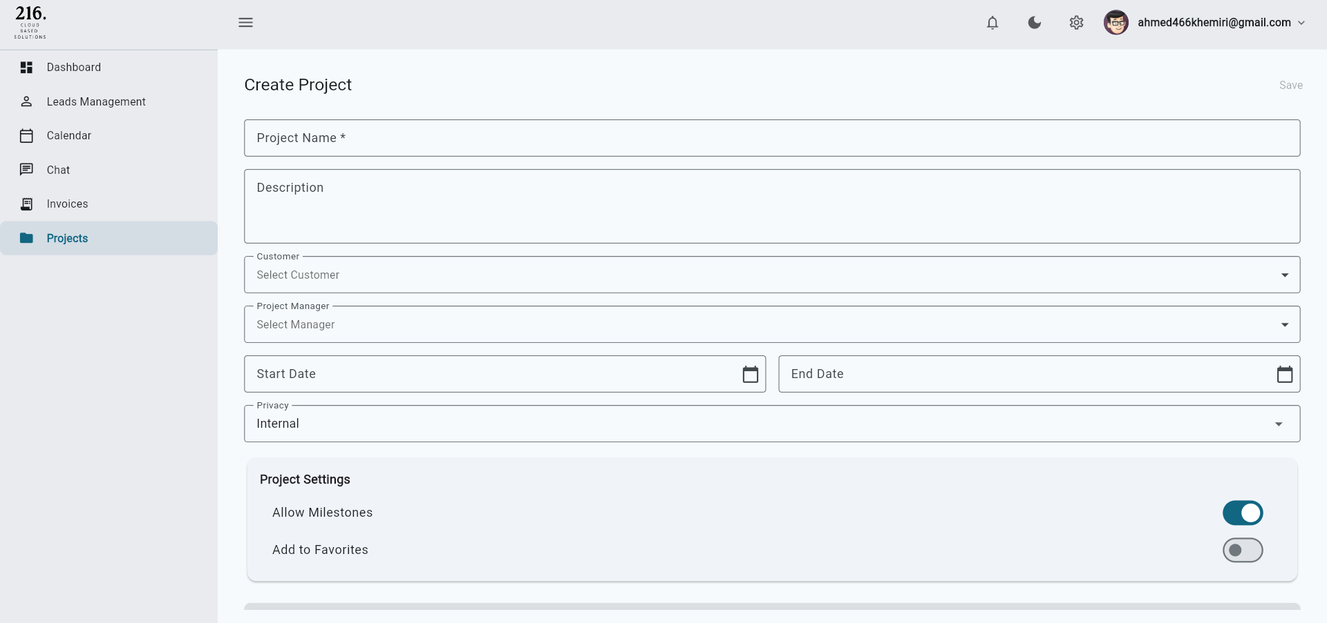
Figure 13: Project creation form where users can define new projects and assign resources.

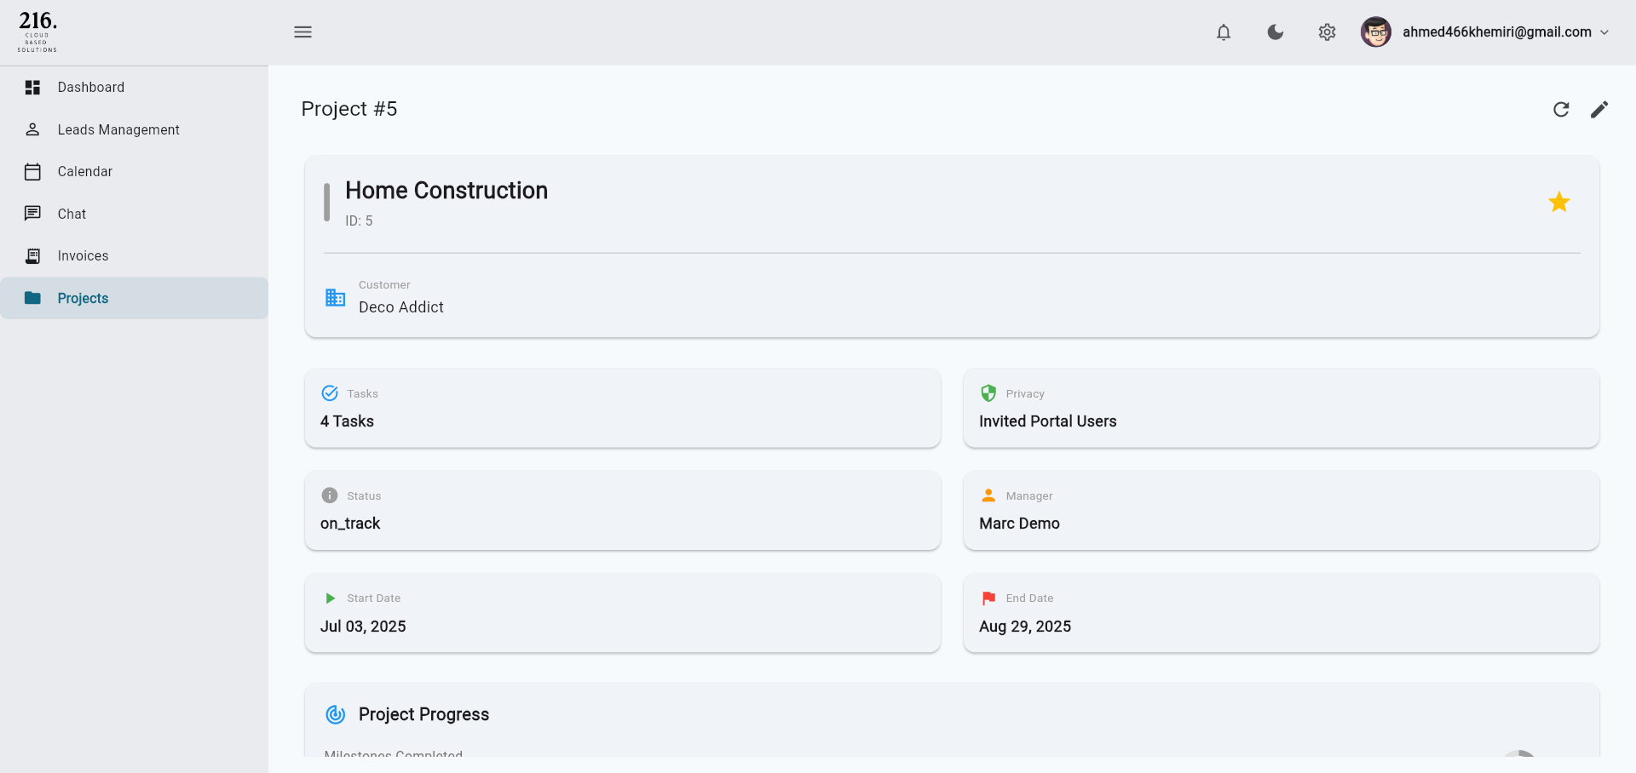
Figure 14: Project details interface showing tasks, deadlines, and project structure.

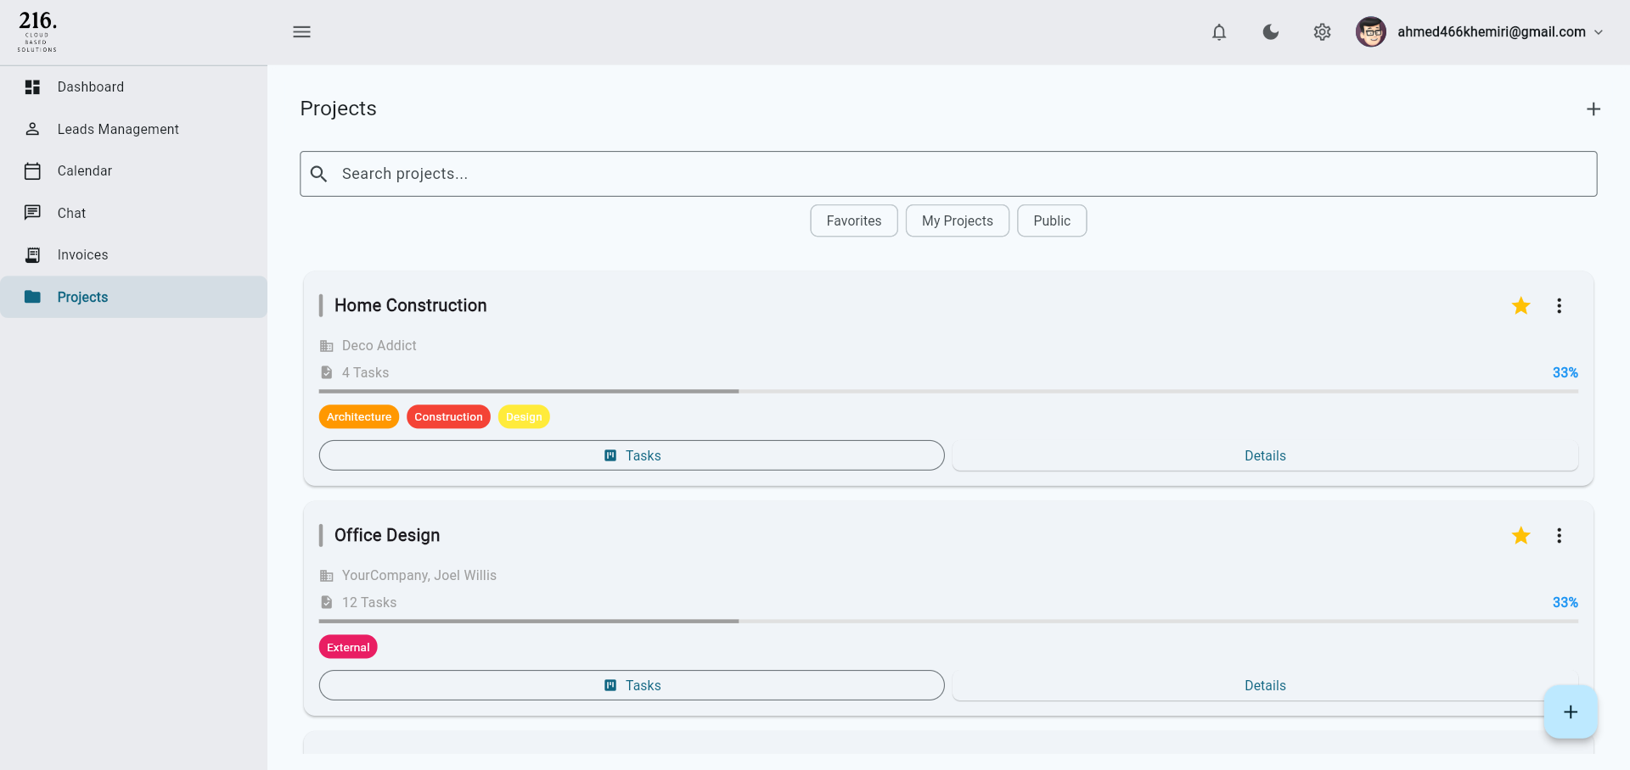
Figure 15: Project list view presenting all projects managed within the platform.

5 LITERATURE REVIEW
This section situates my internship project within existing research and best practices in the fields of SaaS systems, web application development, and CRM software design. The review draws on theoretical frameworks and applied studies to contextualize the technical decisions made during the internship and to critically reflect on their strengths and limitations.

5.1 SaaS Architecture and Multi-Tenancy
The idea of Software as a Service (SaaS), in which software is provided as a subscription- based service as opposed to a one-time installation, forms the basis of the 216.CBS initiative. Multi-tenancy is a crucial difficulty in SaaS system design, according to research: in order to be efficient, applications must separate client data while using the same infrastructure. According to studies, permission-based access control and database-level separation are popular methods for ensuring tenant isolation; nevertheless, they also carry the danger of performance bottlenecks in situations with high concurrency. These trade-offs were evident in my work on Odoo modules, where I had to strike a balance between responsiveness and rigorous isolation during subscription validation.

5.2 Web Application Development Frameworks
The choice of Flutter for Web aligns with recent literature advocating for cross-platform frameworks to reduce development overhead. Flutter’s reactive UI model and strong support for code reuse make it a viable alternative to traditional web frameworks. It was the best choice for our scenario, since we weren’t so sure about how we would scale in the future and which devices we will be adding support to. However, literature also notes performance limitations for highly complex web applications compared to native frameworks. My experience supported this view: Flutter allowed rapid development of a consistent CRM interface, it was worth the trade-off since expanding in the future will be much faster since Flutter is cross-platform.

5.3 State Management and Routing
Modern web apps require predictable state management to handle dynamic data and user interactions. Literature on application architecture emphasizes that predictable state management frameworks (e.g., Redux, Provider, Riverpod) simplify debugging and enhance maintain- ability in complex apps. Similarly, permission-aware routing is described as a crucial practice in multi-user systems to ensure that navigation aligns with user roles and access rights. My implementation of Riverpod providers and GoRouter followed these established principles, validating their relevance in production-grade SaaS applications.

5.4 Data Validation and Security Models
Academic and industry research stresses the importance of server side validation to protect SaaS platforms from threats such as session hijacking, privilege escalation, and data corruption. Client-side validation is useful for user experience but insufficient for security. My project mirrored these best practices by relying on server-side subscription checks, complemented by client-side sanitization of over 200 fields. This approach aligns with literature advocating for defense in depth, where multiple layers of validation reduce the likelihood of successful attacks.

5.5 CRM Systems and Usability
The role of Customer Relationship Management (CRM) software in supporting small and medium enterprises has been widely studied. Research highlights that successful CRM platforms must combine robust backend functionality with intuitive user interfaces. Dashboards and reporting tools, in particular, are noted as key features for improving decision-making. Additionally, I’ve decided to develop the CRM for web platforms / browsers to support a broader range of devices, since some of the clients that we were targeting are restaurants or coffee shops, most of which use Android Tablets instead of computers. Targeting web browsers is more efficient than targeting Android and Windows, especially at the start of the product’s life.

6 METHODOLOGY
I adopted a hands-on approach during my internship at Alwen Co., which allowed me to apply both project management and software engineering methods to the development of the 216.CBS CRM system. Because this was a subscription-based web application that integrated a customized Odoo backend with a Flutter frontend, my methodology combined iterative development practices with structured testing and documentation.

Development Methodology
The team followed Agile practices inspired by Scrum to organize our work. Development was broken down into short sprints, each focused on incremental deliverables such as subscription validation, deployment automation, or routing integration. At the beginning of each sprint, tasks were discussed and prioritized, and daily stand-up meetings ensured progress was tracked and blockers were addressed quickly. This iterative approach was essential, as requirements often evolved in response to client feedback or technical constraints. Agile gave us the flexibility to adapt while maintaining alignment with the overall project goals of delivering a scalable SaaS CRM platform.

Software Development Techniques
On the backend, I worked primarily with Odoo v18, extending its framework through custom modules. The Multi Client SaaS module leveraged Odoo’s security constructs, including groups, record rules, and model access rights, to enforce tenant-level isolation. The 216.CRM Suite module automated installation tasks by chaining module dependencies and initializing system parameters with XML data files and server actions. My approach emphasized modularity and reusability so that new tenants could be onboarded with minimal manual intervention.
On the frontend, I used Flutter for Web to implement a responsive, cross-platform interface. I structured the app with Riverpod for state management and GoRouter for navigation, ensuring a clear separation between authentication routes, feature routes, and core application flows. To handle server communication, I implemented the Odoo Service layer using Dio with interceptors, which provided session persistence, error parsing, and retry/backoff strategies. By centralizing communication through this layer, I ensured consistent request handling and simplified debugging.

Data Management and Integration
Data management was centered on Odoo’s ORM, which stores client, subscription, and CRM records in a PostgreSQL database. I designed data models for tenant subscriptions and feature registries, allowing efficient toggling of functionality per client. On the frontend, I created a field registry that maps Odoo field definitions to type-safe Dart models. This registry supports constant- time lookups and applies sanitizers to over 95% of the system’s 200+ fields, reducing the risk of invalid or unsafe inputs reaching the backend. The integration relied on Odoo’s JSON-RPC API, which was extended by our custom endpoints for subscription validation and feature availability checks.

User Testing and Feedback
Testing was a continuous part of development. I implemented unit tests for every module I’ve implemented, like Employees or Projects, making sure that permission-based routing, edits, and access worked as intended. According to internal project documentation, all eight-unit tests passed successfully, validating field lookups, registry initialization (<10 ms for three models), and permission-based routing logic. Structured logging with contextual metadata was used to monitor API calls and response times, which helped identify performance bottlenecks under load. Informal feedback loops within the development team also guided improvements, particularly in the user-facing modules such as Sales and Projects.

Conclusion
In summary, my methodology combined Agile iteration, modular development, and rigorous testing. On the backend, I emphasized tenant isolation and automation to ensure scalability. On the frontend, I focused on secure session management, permission-aware routing, and reliable data handling. This approach allowed me not only to contribute concrete features to the 216.CBS CRM platform but also to gain deeper insights into best practices for SaaS development. The methodology highlighted the value of collaboration, adaptability, and systematic validation, all of which were crucial in shaping the success of the project.

7 RESULTS AND FINDINGS
During my internship at Alwen Co., I concentrated on two main aspects of the 216.CBS project: building custom Odoo modules for multi-tenant SaaS deployment and developing the Flutter-based web frontend. These contributions gave me practical experience across backend design, secure API communication, and permission-aware user interface development. The most significant results are presented in the following subsections, with figures highlighting the workflows and application interfaces I implemented.

Backend Development

Multi-Client SaaS Module
The Multi-Client SaaS module manages subscription-based feature access. It links client tiers to Odoo permissions, ensuring that users can only access functionality defined by their subscription. The data model connects tenants, features, and permissions, while record rules restrict data visibility at the database level. This enforces strict data isolation and prevents unauthorized access while supporting multiple tenants on a single platform.

CRM Suite Deployment Module
The 216.CRM Suite module automates the installation and configuration of the CRM stack. It ensures dependencies are installed in the correct order, initializes company parameters, and provisions production-ready client instances. Automating this sequence reduced setup time and standardized deployment across multiple clients.

Frontend Web Application

Functional Modules
I contributed to several modules in the CRM system, each providing distinct functionality: Employees: Users can add new employees, view detailed personal and work-related information, and browse the complete employee list. This ensures HR managers can efficiently manage staff records (Figures 1–3).
Invoices: The module allows creating invoices, viewing detailed invoice records, and browsing all invoices in the system. Users can track invoice status and line items, facilitating accurate financial management (Figures 4–7).

Odoo Features: This module enables creating and replicating features across the platform. Users can quickly duplicate existing workflows or add new functionalities, improving system flexibility and maintainability (Figures 8–9).
Odoo Modules Overview: Provides a high-level view of the modular architecture of the platform, making it easy to manage installed modules and dependencies (Figure 10).
Odoo SaaS: Users can configure multi-tenant options and access cloud-based features, supporting scalable SaaS deployments (Figures 11–12).
Projects: Enables creation of new projects, managing project details such as tasks and deadlines, and browsing all projects within the system. This facilitates efficient planning and resource alloca- tion (Figures 13–15).

Performance and Testing
Performance metrics demonstrated the speed and dependability of typical activities across different modules. Response times for user interactions, data retrieval, and registry initialization are constant and appropriate for small to medium datasets. Error monitoring and logging verified con- sistent behavior under numerous concurrent interactions, guaranteeing the system is ready for daily use and production.

8 RECOMMENDATIONS
Based on the results of my internship, I recommend several improvements to strengthen the scalability, reliability, and user experience of the 216.CBS CRM platform. First, enhancing the deployment automation in the 216.CRM Suite module with stronger rollback and idempotency safeguards would make multi-tenant provisioning more reliable and reduce the risk of partial instal- lations. Second, adopting advanced caching strategies in the web application could improve per- formance when handling large datasets, especially in modules like Sales and Invoices. Third, intro- ducing real-time synchronization through WebSockets or a message broker would allow faster up- dates than the current polling approach, though this would require deeper integration with Odoo. Finally, implementing schema validation between Odoo models and the field registry would further increase data integrity, ensuring that new features can be added without compromising stability.

9 CONCLUSION
By improving backend Odoo modules and putting in place a Flutter-based web interface, I helped Alwen Co. construct a multi-tenant SaaS CRM during my internship. In addition to giving me excellent chances to practice collaboration, problem-solving, and actual software deployment, this experience improved my abilities in scalable system design, secure API integration, and cross- platform programming. All things considered, the internship provided a thorough understanding of creating reliable, enterprise-ready applications.

REFERENCES
- Odoo S.A., Odoo Documentation (v18), [Online].
Available: https://www.odoo.com/documentation. [Accessed: Sept. 25, 2025].
- Google LLC, Flutter Documentation, [Online].
Available: https://docs.flutter.dev/. [Accessed: Sept. 25, 2025].
- Riverpod.dev, Riverpod State Management Documentation, [Online]. Available: https://riverpod.dev/. [Accessed: Sept. 25, 2025].
- GoRouter.dev, GoRouter: Declarative Routing for Flutter, [Online].
Available: https://pub.dev/packages/go_router. [Accessed: Sept. 25, 2025].
- D. Crockford, The Application/JSON-RPC Specification, 2005. [Online].
Available: https://www.jsonrpc.org/specification. [Accessed: Sept. 25, 2025].
- K. Beck and C. Andres, Extreme Programming Explained: Embrace Change, 2nd ed., Boston, MA: Addison-Wesley, 2004.
- K. Schwaber and J. Sutherland, The Scrum Guide, Scrum.org, 2020. [Online]. Available: https://scrumguides.org/. [Accessed: Sept. 25, 2025].

