

Department of Computing
BS Computer Science

NASTP Institute of Information Technology

Submitted By: Maisum abbas (023)
Submitted To: Miss Hani

Semester: II
Session: Fall - 2024

Subject: Data Structures

Date of submission: 25 Oct 2025

Lab Report 4

Task1:
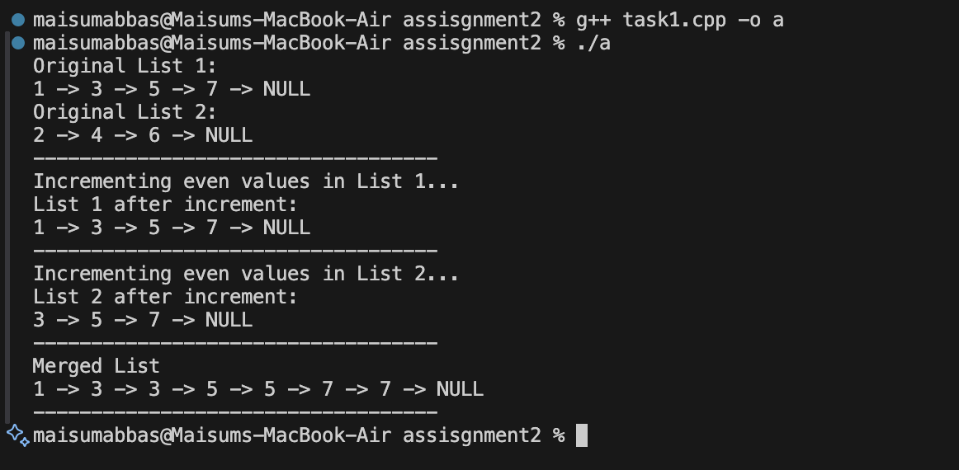
Task2:
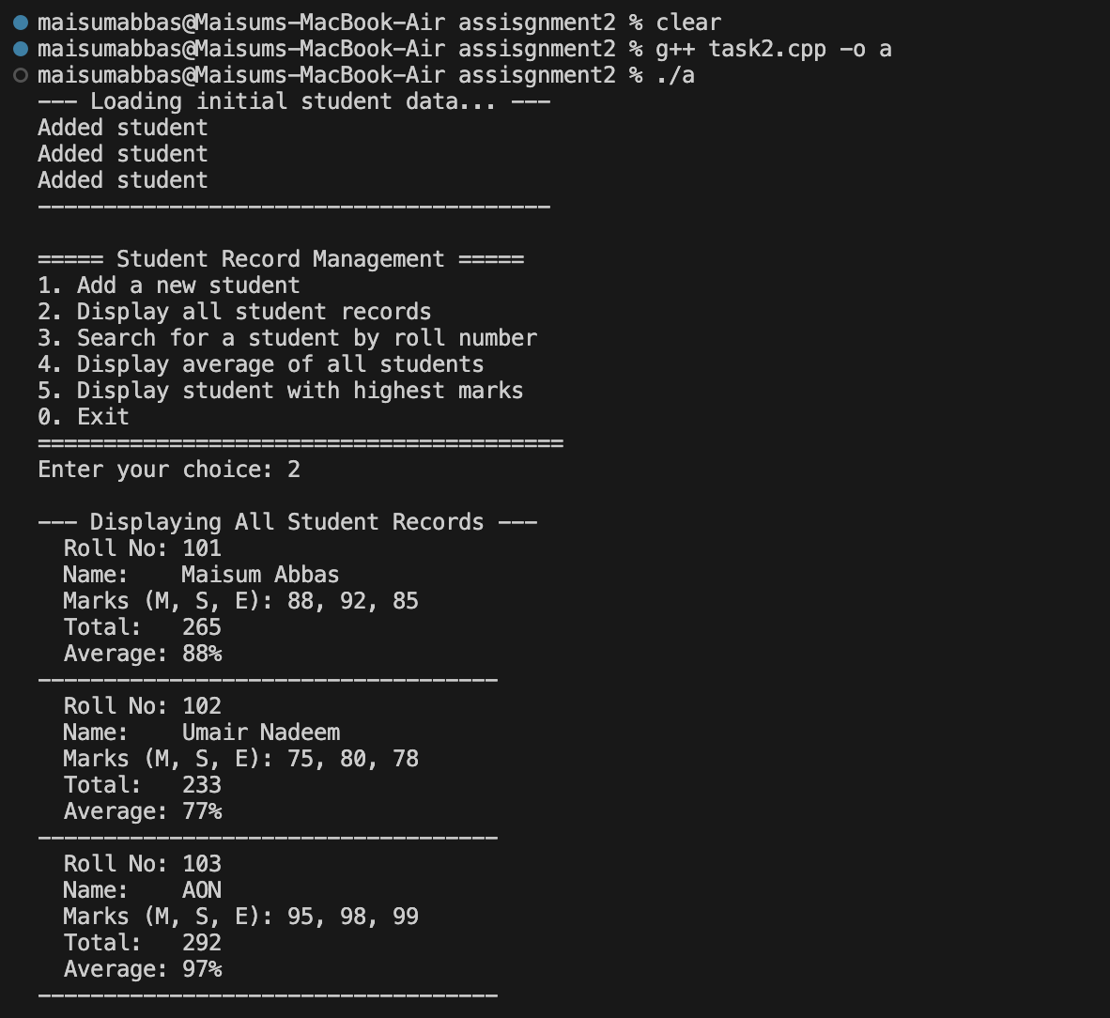

Task3:
