

Department of Computing
BS Computer Science

NASTP Institute of Information Technology

Submitted By: Maisum abbas (023)
Submitted To: Sir Ibaad

Semester: II
Session: Fall - 2024

Subject: Data Structures

Date of submission: 7 Nov 2025

Lab Report 4

Task1:
In the code we make a list that traverse through all the node and in each node take the data and make them factorial and then return the factorial list
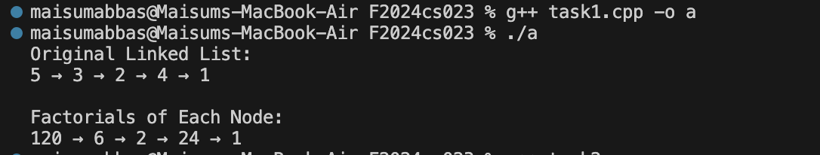
Task2:
In this code we add the funtionalithy to delete a node from start,last and at any position. We use two pointers so that the address of the list remain in the record and furthur be used in the linking process
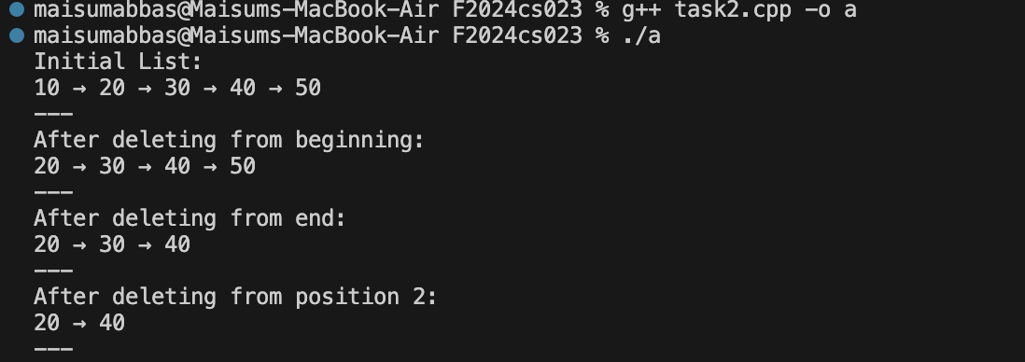

Task3:
It just delete a node and then using loop we can traverse through it all to show data of all the things
