

Department of Computing
BS Computer Science

NASTP Institute of Information Technology

Submitted By: Maisum abbas (023)
Submitted To: Sir Ibaad

Semester: II
Session: Fall - 2024

Subject: Data Structures

Date of submission: 20Dec 2025

Lab Report 9

Task1:
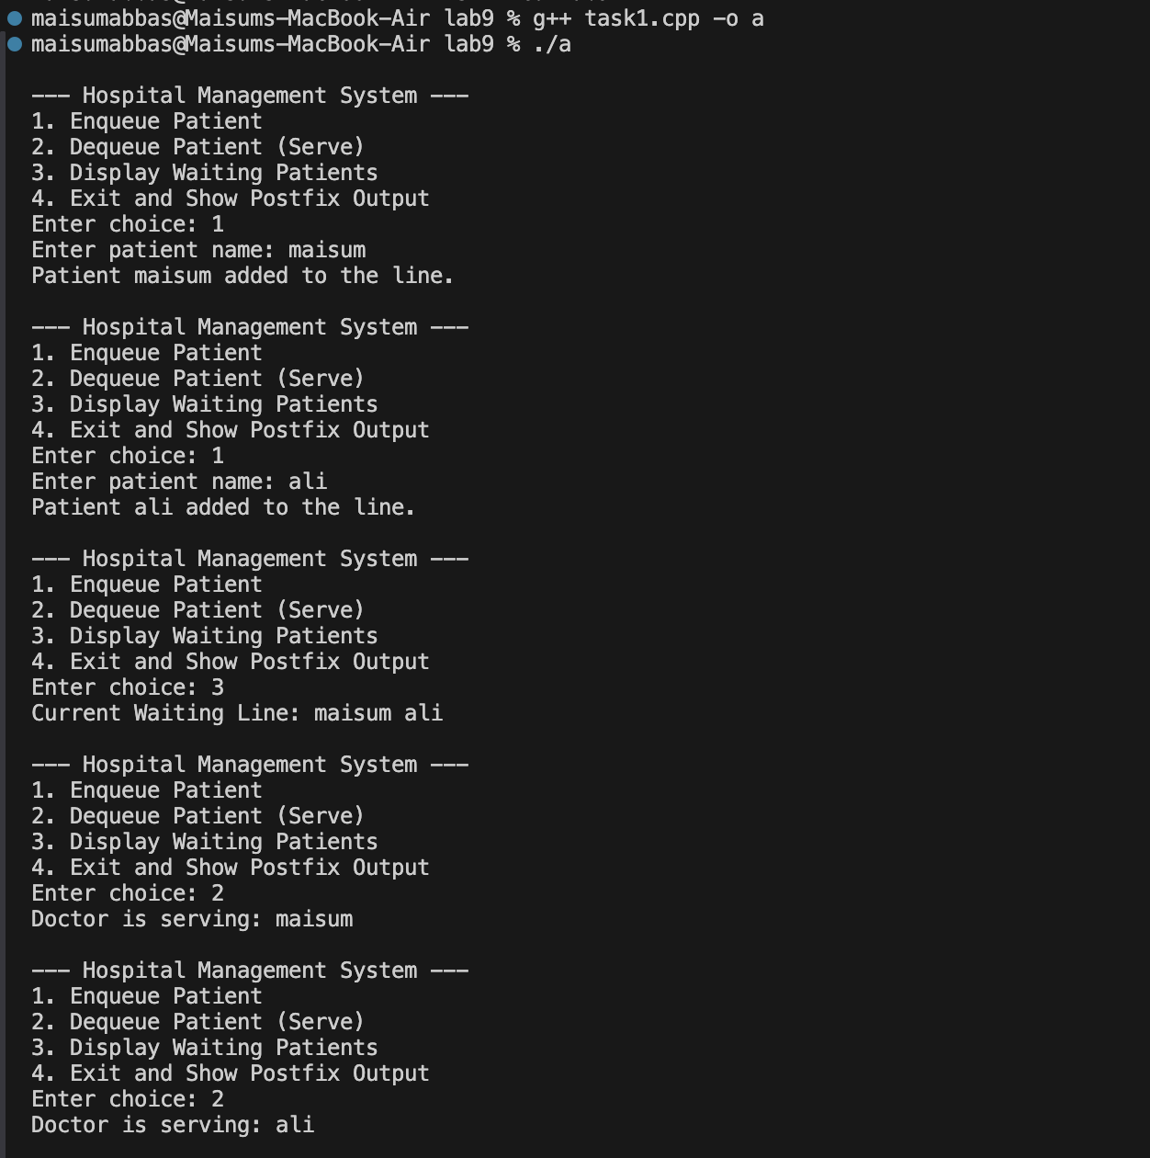Task2:
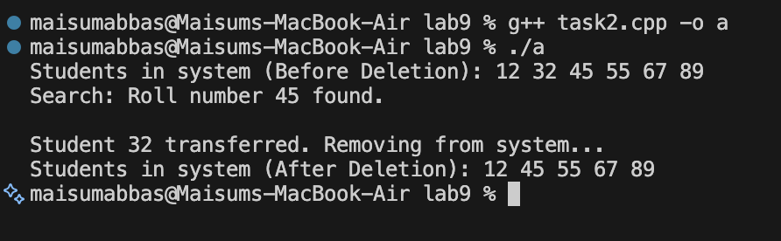

Task3:
