

Department of Computing
BS Computer Science

NASTP Institute of Information Technology

Submitted By: Maisum abbas (023)
Submitted To: Sir Ibaad

Semester: II
Session: Fall - 2024

Subject: Data Structures

Date of submission: 5 Dec 2025

Lab Report 4

Task1:
Two singly linked lists are created, each containing at least five integer nodes.
The program displays both lists by traversing them from head to tail.
It then prints the sum of each pair of corresponding nodes from both lists.
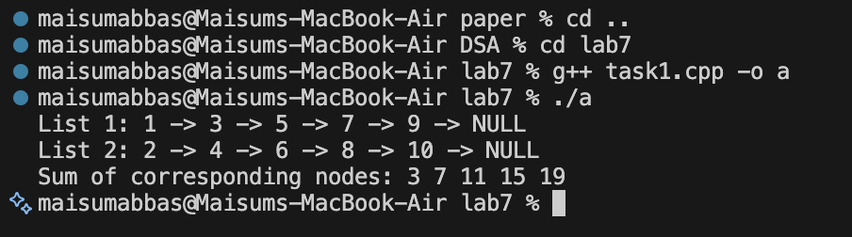

Task2:
A doubly linked list is created containing at least five nodes with stored integer values.
The program displays all nodes in forward direction using next pointers.
It computes and prints the square (power of 2) of each node’s integer value.

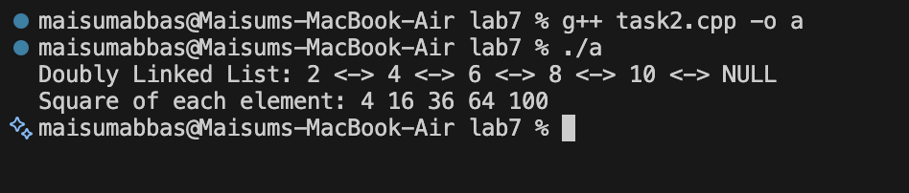

Task3:
1. Add Patient:
A new patient node is created with ID, Name, Age, and Diagnosis.
It is inserted at the beginning, end, or a specific position in the list.
The prev and next pointers are properly updated to maintain the doubly linked structure.
2. Search Patient
The list is traversed from the head node.
Each patient's ID is compared with the target ID.
If a match is found, the patient’s full details are returned.
3. Update Patient
The patient is first located using their unique ID.
If found, the user enters new Name, Age, and Diagnosis values.
The existing record is updated in the same node.
