

Department of Computing
BS Computer Science

NASTP Institute of Information Technology

Submitted By: M.Bilal (040)
Submitted To: Sir Ibaad

Semester: II
Session: Fall - 2024

Subject: Data Structures

Date of submission: 27 Dec 2025

Lab Report 10

Task1:
Is task mein humne aik self-balancing tree banaya hai jo stock IDs ko maintain karta hai. AVL logic ka fayda yeh hai ke jab bhi koi naya ID insert hota hai, tree rotations (Left/Right) use kar ke apni height ko balance kar leta hai.
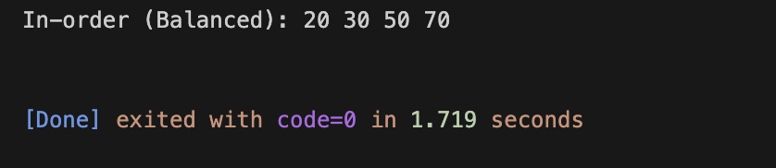
Task2:
CPU scheduler ke liye humne Max Heap ka intekhab kiya taake sabse zyada priority wala task hamesha root (top) par rahe. Is program mein up aur down functions ensure karte hain ke naye task ke aane ya kisi task ke khatam hone ke baad bhi heap ki property barqarar rahe.
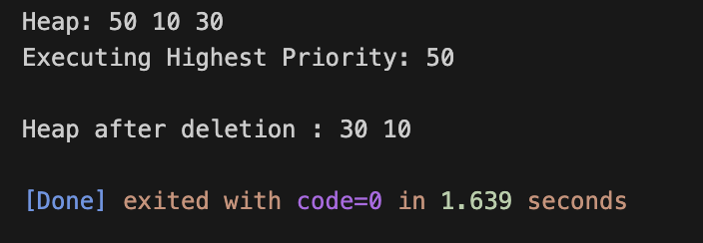

Task3:
Memory management mein efficient allocation ke liye Min Heap ka istamal kiya gaya hai. Is ka maqsad sabse chote available memory block ko root par rakhna hai. Jab koi program memory mangta hai, toh program foran smallest block allocate kar deta hai.
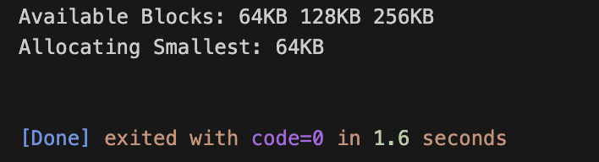
Task4:
The Heap Sort aik aisi sorting technique hai jo O(nlogn) complexity ke saath data ko organize karti hai. Is task mein humne pehle array ko Max Heap mein convert kiya aur phir root element ko swap kar ke array ke end mein bhejte gaye.
