Lab – Data Analysis and Data Modeling in Visio

Overview
In this lab, we will learn to draw with Microsoft Visio the ERD’s we created in class.

Learning Objectives
Upon completion of this learning unit you should be able to:
- Understand the concept of data modeling
- Develop business rules
- Develop and apply good data naming conventions
- Construct simple data models using Entity Relationship Diagrams (ERDs)
- Develop entity relationships and define various types of attributes

Lab Goals
Our lab goals are to:
- Learn to build conceptual models in Microsoft Visio.
- Create the 5 ERDs from class in Microsoft Visio.
You will accomplish this by drawing the 4 diagrams from the class exercise. You will have to hand in all 4 diagrams by FTPing them to your account space on the IST-S-STUDENTS server and then pasting the url to the diagram in the text boxes for this week’s learning unit assessment.

What you will need to begin
- A copy of Microsoft Visio 2003 (or higher)
- The Visio Conceptual Modeling Stencil conceptual modeling.vss (should be with the other files from this week’s lesson)
- The class exercises from this week (should also be with the other files from week’s lesson.)

Part 1: Getting Ready for Using Microsoft Visio for Conceptual Modeling

Overview
This section will explain how to use Microsoft Visio to create conceptual Entity-Relationship data models. Microsoft Visio has built-in database tools for creating logical data models (those that apply the relational database theory to your entity-relationship diagrams), and not very good at conceptual modeling. As a result, using the MS Visio database tools to create the conceptual model diagrams can sometimes feel like trying to jam a round peg into a square hole.
Since not many people are into shoving round pegs into square holes, this guide will explain how you can maximize the Visio database tools for creating conceptual models. For those of you familiar with Visio, here are the heuristics we will follow to make Visio conceptual model friendly:
- Use Database Model Diagrams
- Modify the settings to be more user-friendly
- Do not use the relationship tool – use my stencil instead

Step 1: Create New Document
The first step is to create a new document.
From the Visio Menu, choose: File → New → Software & Database → Database Model Diagram
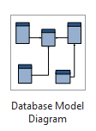
This will create your blank Visio page, and load the default database toolset.
IMPORTANT: The default Visio stencils are for logical modeling. I’ve created a custom stencil for conceptual modeling.

Step 2: Load the Conceptual Modeling Custom Stencil
Download the stencil file from our learning management system and save the conceptual modeling.vss somewhere on the local computer.
From the Shapes Bar, select Shapes → More Shapes → Open Stencil
Use the Open Stencil dialog to browse for the conceptual modeling.vss and open it.
You should see the following:
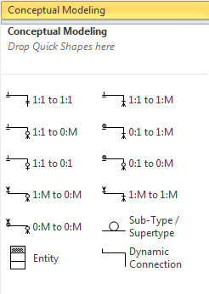

Step 3: Configure Default Settings
This is the most important step. In this step we will tweak the database document settings so that they are favorable to conceptual modeling. The benefits of doing this are there will be very little reworking of the document at the logical modeling step.
From the Visio Ribbon, choose: Database → Display Options
The Database Document Options Dialog will appear. From this dialog, select Relational symbol set, and Conceptual Names visible on the diagram, as displayed in this dialog:
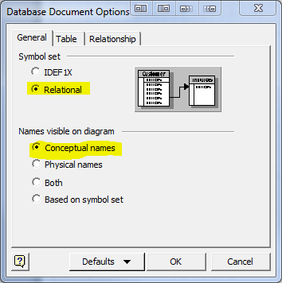
Next, Click on the Table tab:
From this section of the dialog, display everything except annotations and vertical lines, do not show data types, and place primary keys at top, as displayed in the following dialog:
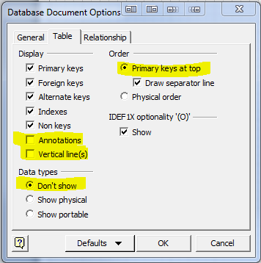
When you’re finished click ok.
This will close the Database Document Options dialog.
NOTE: You might want to save your document at this time. Now that you’ve got things set-up this file can serve as a template for future conceptual modeling diagrams.
As a matter of fact, you can download a pre-built Visio template from the class website with this week’s materials.

Part 2: Microsoft Visio for Conceptual Modeling Walk-Thru

Overview
In this section, we will walk-through creating a conceptual data model with Microsoft Visio. We will use the vBay! (E-bay “like” website case study as an example for conceptual modeling.)

To Create an Entity:
Drag the  icon onto the page and drop. Name the entity in the database properties window:
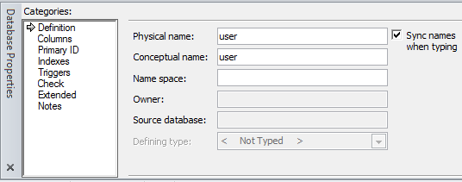

YOU DO IT:
Now add these 4 Entities to your diagram:
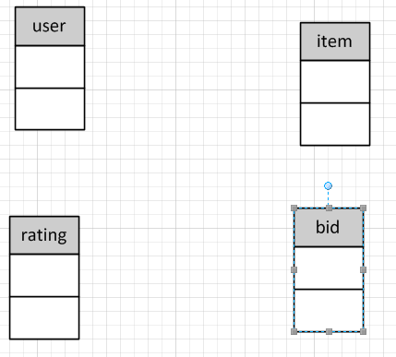

To Add Attributes to the entity:
To add attributes to your entity, simply click on the columns section of the database properties window, and enter in your column names. Be sure to include the appropriate attribute descriptors [rucdm] with the physical name. Ignore the data type Req’d and PK columns. Those are used in logical modeling.
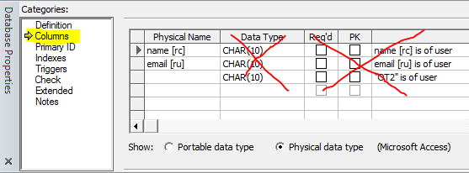

YOU DO IT:
Now add attributes to all 4 entities, like this:
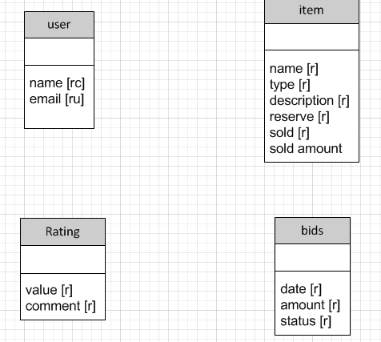

To Add Relationships among the entities:
To Add Relationships, simply drag the appropriate relationship cardinality (for example: 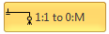) onto the page and connect the ends to each entity. To “snap” the line to the entity drag the line end onto the box until it turns red, like this. Red symbolizes the shapes are glued together:
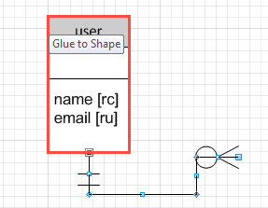
After to glue both ends of the line to an entity, you can double-click on the line to assign it a label. For example:
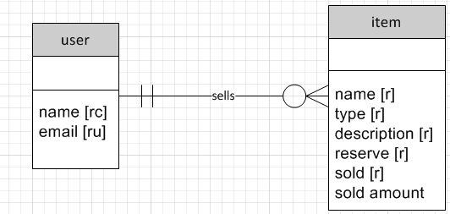

YOU DO IT:
Now add all the relationships to complete the conceptual model, like this:
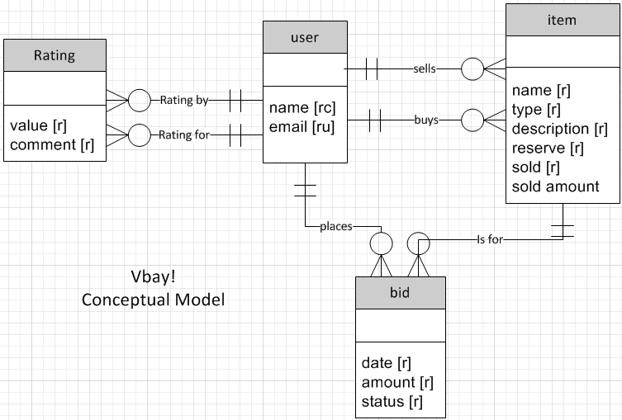
Note: You might have to juggle the shapes and lines around to achieve a best fit. It takes time and a whole lot of patience!

Other Tips
You can place multiple diagrams in one file!
Just keep adding pages. To add a page, from the menu select: Insert → Blank Page 
To rename a page, right-click on the page and choose Rename
You can add text to your diagram!
Use the Text tool in the ribbon. Home → Text. When you’re finished, be sure to select the Pointer Tool again. 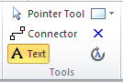

Part 3: Creating the 4 diagrams from class exercise & handing it in.
Take the 4 diagrams from class and draw them in Microsoft Visio.
- Place one diagram on each page.
- Label the pages accordingly
- Save the document
- Upload the document to blackboard

