Code:
import 'package:flutter/material.dart';
void main() {
runApp(const MyApp());
}
class MyApp extends StatelessWidget {
const MyApp({super.key});
@override
Widget build(BuildContext context) {
return MaterialApp(
debugShowCheckedModeBanner: false,
title: 'Counter App',
theme: ThemeData(
useMaterial3: true,
colorScheme: ColorScheme.fromSeed(
seedColor: Colors.yellow,
),
),
home: const MyHomePage(),
);
}
}
class MyHomePage extends StatefulWidget {
const MyHomePage({super.key});
@override
State<MyHomePage> createState() => _MyHomePageState();
}
class _MyHomePageState extends State<MyHomePage> {
int _counter = 0;
// ==============================
// NEW FEATURE #1
// Store the user's name
// ==============================
String _name = "";
// Increase counter
void _incrementCounter() {
setState(() {
_counter++;
});
}
// Reset counter
void _resetCounter() {
setState(() {
_counter = 0;
});
}
@override
Widget build(BuildContext context) {
return Scaffold(
// ==============================
// NEW FEATURE #2
// Custom AppBar styling
// ==============================
appBar: AppBar(
title: const Text("My Flutter Counter"),
centerTitle: true,
backgroundColor: Colors.blue,
foregroundColor: Colors.white,
),
// ==============================
// NEW FEATURE #3
// Gradient background
// ==============================
body: Container(
width: double.infinity,
decoration: const BoxDecoration(
gradient: LinearGradient(
colors: [
Color(0xFF1E3C72),
Color(0xFF2A5298),
],
begin: Alignment.topLeft,
end: Alignment.bottomRight,
),
),
child: Center(
child: Card(
elevation: 12,
shape: RoundedRectangleBorder(
borderRadius: BorderRadius.circular(25),
),
child: SingleChildScrollView(
child: Padding(
padding: const EdgeInsets.all(30),
child: Column(
mainAxisSize: MainAxisSize.min,
children: [
// ==============================
// NEW FEATURE #4
// TextField for user input
// ==============================
TextField(
decoration: const InputDecoration(
labelText: "Enter your name",
border: OutlineInputBorder(),
),
onChanged: (value) {
setState(() {
_name = value;
});
},
),
const SizedBox(height: 20),
const Icon(
Icons.flutter_dash,
size: 80,
color: Colors.blue,
),
const SizedBox(height: 15),
const Text(
"Button Press Counter",
style: TextStyle(
fontSize: 24,
fontWeight: FontWeight.bold,
),
),
const SizedBox(height: 10),
// ==============================
// NEW FEATURE #5
// Display user's name with count
// Example:
// Maith counted 5 times
// ==============================
Text(
_name.isEmpty
? "Enter your name first"
: "$_name counted $_counter times",
textAlign: TextAlign.center,
style: const TextStyle(
color: Colors.grey,
fontSize: 16,
),
),
const SizedBox(height: 25),
// ==============================
// NEW FEATURE #6
// Animated counter
// ==============================
AnimatedSwitcher(
duration: const Duration(milliseconds: 300),
child: Text(
'$_counter',
key: ValueKey(_counter),
style: const TextStyle(
fontSize: 50,
fontWeight: FontWeight.bold,
color: Colors.indigo,
),
),
),
const SizedBox(height: 25),
// ==============================
// NEW FEATURE #7
// Reset button
// ==============================
ElevatedButton.icon(
onPressed: _resetCounter,
icon: const Icon(Icons.refresh),
label: const Text("Reset Counter"),
style: ElevatedButton.styleFrom(
backgroundColor: Colors.redAccent,
foregroundColor: Colors.white,
padding: const EdgeInsets.symmetric(
horizontal: 20,
vertical: 12,
),
),
),
],
),
),
),
),
),
),
floatingActionButton: FloatingActionButton(
onPressed: _incrementCounter,
backgroundColor: Colors.orange,
child: const Icon(
Icons.add,
size: 30,
),
),
);
}
}
Result:
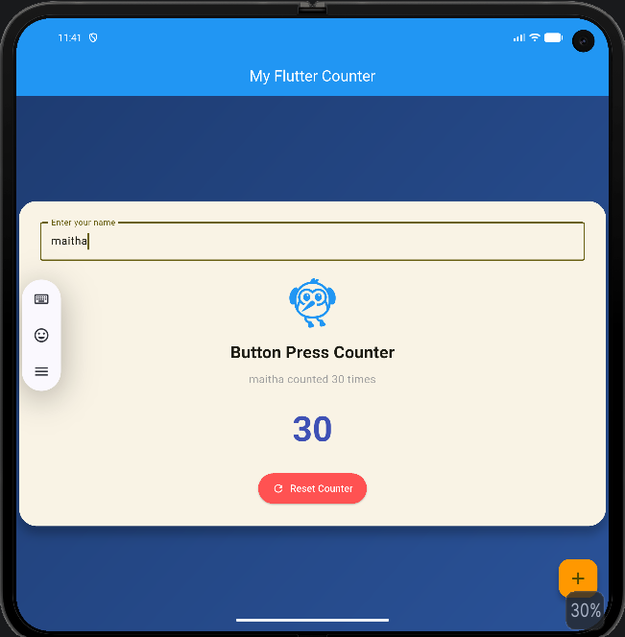
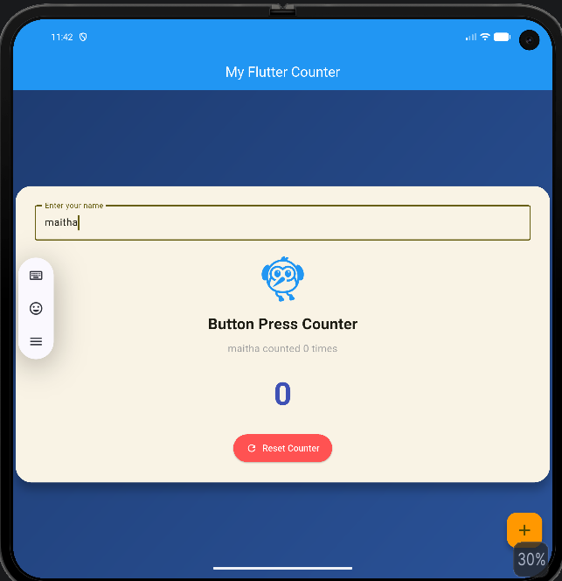
What I learn:
This app is a simple Counter App made with Flutter.
What it does:
- Increases a number when you press the + button
- Resets the counter to 0
- Takes user name input
- Shows message like: “Name counted X times”
- Uses animation when number changes

What I learned:
- StatefulWidget = changing data (counter, name)
- setState() = update UI when data changes
- TextField = get user input
- Variables = store data (_counter, _name)
- Button (FAB + ElevatedButton) = user actions
- AnimatedSwitcher = smooth animation effect
- Scaffold = app structure (AppBar, Body, Button)

Main idea:
The user enters their name, presses the + button to increase the number, and the screen updates right away. The reset button brings the counter back to 0 (using the rest button).

