Code:
import 'package:flutter/material.dart';
void main() {
runApp(
const MyApp(),
);
}
//stateless -- fixed
class MyApp extends StatelessWidget {
const MyApp({super.key});
@override
Widget build(BuildContext context) {
return const MaterialApp(
home: TodoPage(),
debugShowCheckedModeBanner: false,
);
}
}
//stateful -- change
class TodoPage extends StatefulWidget {
const TodoPage({super.key});
//create to do page list
@override
State<TodoPage> createState() => _TodoPageState();
}
class _TodoPageState extends State<TodoPage> {
//list to store tasks
//List<String> tasks = [];
// change for the complete features
List<Map<String, dynamic>> tasks = [];
TextEditingController taskController = TextEditingController();
// Scaffold gives us AppBar, Body, and layout structure
@override
Widget build(BuildContext context) {
return Scaffold(
appBar: AppBar(
title: const Text(
"My Tasks To Do",
style: TextStyle(
fontWeight: FontWeight.bold,
fontSize: 30,
fontStyle: FontStyle.italic,
),
),
centerTitle: true,
backgroundColor: Colors.blue[300],
foregroundColor: Colors.cyan[100],
),
// here we add textfield so users can type the tasks
body: Padding(
padding: const EdgeInsets.all(20),
child: Column(
children: [
TextField(
// add controller to show task
controller: taskController,
decoration: InputDecoration(
labelText: "Enter a task",
border: OutlineInputBorder(
borderRadius: BorderRadius.circular(12),
),
filled: true,
fillColor: Colors.grey[100],
),
),
// button to add tasks
const SizedBox(height: 10),
ElevatedButton(
onPressed: () {
if (taskController.text.isEmpty) return;
setState(() {
tasks.add({
"title": taskController.text,
"done": false,
});
});
taskController.clear();
},
child: const Text("Add Task"),
),
// display list of tasks
const SizedBox(height: 20),
Expanded(
child: ListView.builder(
itemCount: tasks.length,
itemBuilder: (context, index) {
return Card(
margin: const EdgeInsets.symmetric(vertical: 6),
child: ListTile(
// for the checkbox
leading: Checkbox(
value: tasks[index]["done"],
activeColor: Colors.green,
onChanged: (value) {
setState(() {
tasks[index]["done"] = value;
});
},
),
// Task title
title: Text(
tasks[index]["title"],
style: TextStyle(
fontWeight: FontWeight.w500,
decoration: tasks[index]["done"]
? TextDecoration.lineThrough
: TextDecoration.none,
color: tasks[index]["done"]
? Colors.grey
: Colors.black,
),
),
// delete button
trailing: IconButton(
icon: const Icon(Icons.delete, color: Colors.red),
onPressed: () {
setState(() {
tasks.removeAt(index);
});
},
),
),
);
},
),
),
],
),
),
);
}
// to prevent memory leaks
@override
void dispose() {
taskController.dispose();
super.dispose();
}
}

Result:
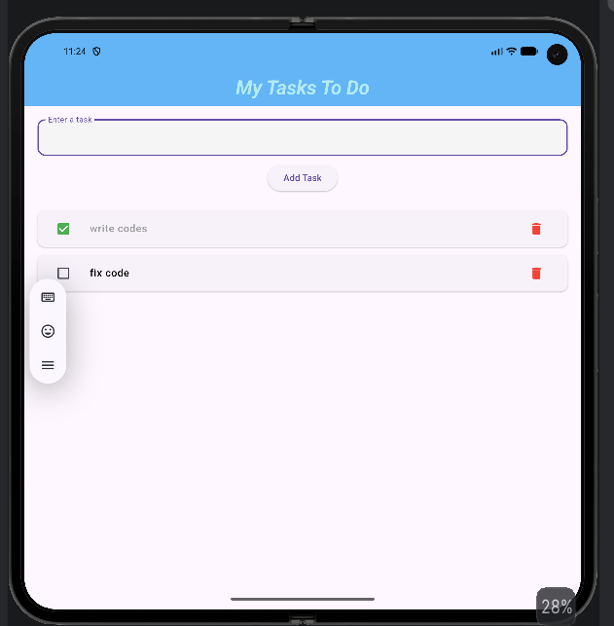
What I learn:
This app is a simple To-Do List made with Flutter.
What it does:
- Add tasks using a text field
- Show tasks in a list
- Mark tasks as completed using a checkbox
- Completed tasks get a line through
- Delete tasks from the list
What I learned:
- StatelessWidget = fixed UI
- StatefulWidget = changing UI
- TextField = user input
- List = store tasks
- setState() = update screen
- ListView = show list of tasks
- Checkbox = complete task
- dispose() = clean memory
Main idea:
User writes a task then clicks add, after that the task appears after they can click if they complete or they can delete it.

