

ADVANCE SOFTWARE DESIGN

**SPEADSHEET APPLICATION**

Version: 1.0

Date: 09 July 2019

Authors: Hoang Thang Mai, Viet Anh Nguyen

Dinh Tung Nguyen, Thanh Cong Pham

# Document History

|  |  |  |  |
| --- | --- | --- | --- |
| **Document Version History** | | | |
| Version | Date | Edited By | Details |
| 1.0 | 09 July 2019 | Hoang Thang Mai  Viet Anh Nguyen  Dinh Tung Nguyen  Thanh Cong Pham | Initialize document  Use cases, UML, design patterns, features, plan |
|  |  |  |  |

# Use Cases

User can input data to the spreadsheet (grid) and operate some simple calculations

Data type format can be:

“” String, everything inside a double quote will be considered as a string

0-9 Number, only contains numbers

[] Reference, only accept [x,y] x and y are numbers

+ - * / Operation, actually not a type but can operate on numbers or strings together

Number/String + Operation = Formula

Grid can be able to show cell value (data).

When user click to the cell, its content will appear, for example, if it’s a formula, the full formula will show so the user can be able to modify if needed.

When the user leaves (enter or click somewhere else) the cell will automatically recalculate the formula.

When user types a reference (only accept [x,y]), it will be replaced by the value of the reference cell

Optional:

* Quick select cell reference by holding shift or control button
* Some constraints to validate data like
  + try to multiply a string and a number
  + Divided by 0

Example screenshot:

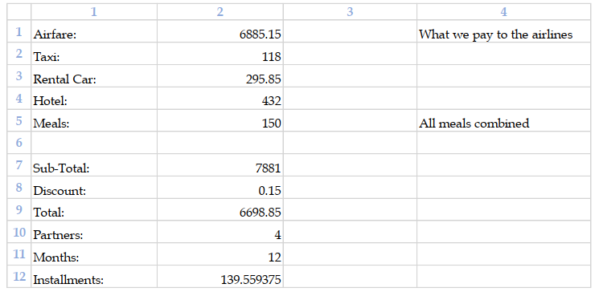

# UML Solution

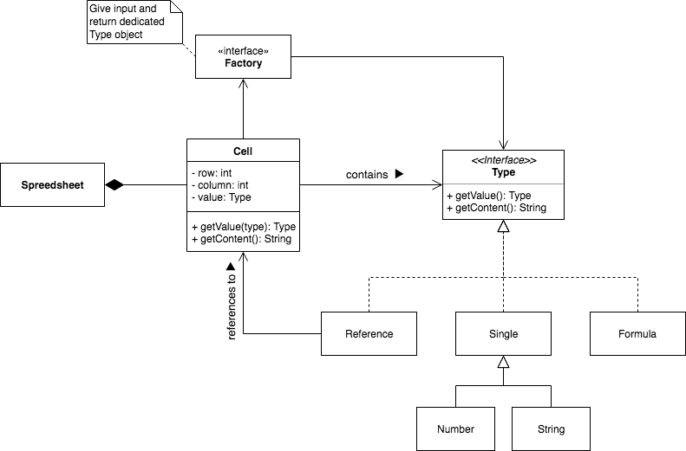

# List of Patterns

|  |  |  |
| --- | --- | --- |
| **Requirements** | **Best Pattern** | **Reasons / features obtained** |
| User enters a formula | Interpreter | The system will have to recognize those operations |
| Formula combines many operations | Composite | Formula will be treated also  as an operation |
| When spreadsheet is changed, all views will be updated | Observer | If value on each cell is changed, spreadsheet scans and updates value for all related cells. |
| Cells can have different type of input | Factory | The cell delegates the instantiating to the factory in order to handle the Type object |

# Concepts:

* Grid: a 2 dimensional array or a matrix contains cells (size can be 1000 x 1000)
* Cell: a unit inside the grid. It has value the actual value after calculating or referencing and content which is an extended reference or a complicated formula like 200*4 + 5 - (10 * 50)
* Operation: receive one or more numbers or strings and do the operation
* Formula: combination of operations

# Project Plan

|  |  |  |
| --- | --- | --- |
| Sprint | Duration | Goal / features |
| 1 | 09 July 2019 | Analyze requirement (UML, design patterns)  Initialize spreadsheet application:  • Element  • Cell  • Contents  • Text  • Spreadsheet  • Application |
| 2 | 10 July 2019 | • Numerical Value  • Reference |
| 3 | 11 July 2019 | • Group  • Numerical Operator  • Add |
| 4 | 12 July 2019 | • Subtract  • Multiply  • Divide |
| 5 | 13 July 2019 | • Read Token  • State Machine  • Parse Number |
| 6 | 15 July 2019 | • Parse Cell |
| 7 | 16 July 2019 | • Parse Cell Reference |
| 8 | 17 July 2019 | • Deal with parenthesis  • Package & release |

# Project Team

* Hoang Thang Mai – 610089 – 11
* Viet Anh Nguyen – 987050 - 24
* Dinh Tung Nguyen – 987007 – 5
* Thanh Cong Pham – 987053 - 21