Executive Summary
Customer churn, in this analysis for FoodCorp, is defined as a customer who has not made a purchase in more than 42 consecutive days. A 42-day inactivity threshold was chosen for defining churn because it balances early detection of at-risk customers with a manageable group size for targeted retention, making interventions both timely and operationally practical for FoodCorp. Applying this threshold, 71% of customers were identified as churned, while the remaining 29% of customers are considered active. This high churn rate signals a pressing business challenge for FoodCorp, emphasizing the need for timely and precise churn prediction.
The project leveraged dataset containing transaction records from July 22, 2020, to March 22, 2022, encompassing the behaviour of 9,288 unique customers and 19,823 distinct products enabling a detailed exploration of purchasing habits, engagement cycles, and long-term behavioural trends within FoodCorp’s customer base.
To deepen the understanding of customer interactions, extensive feature engineering was conducted in SQL . Features were carefully designed to capture both recent and historical dimensions of customer engagement. These included metrics such as number of store visits and total spend over 1-week, 4-week, and 7-week periods, lagged features tracking visits and spend in previous 7-day, 14-day, and 21-day windows, counts of unique products purchased and stores visited, and the number of days since the last purchase. This diverse feature set provided a detailed, time-sensitive view of each customer’s journey.
Model selection process compared Random Forest to both a baseline Logistic Regression and LightGBM, with Random Forest consistently delivering superior results. Hyperparameter tuning was performed using GridSearchCV to optimize model performance. Importantly, model evaluation followed best practice for temporal data: the data was split chronologically, with training conducted on customer transactions from July 22, 2020, to September 30, 2021. Validation was then performed using data from October 1, 2021, to January 15, 2022, while the final testing phase utilized transactions from January 16, 2022, to March 22, 2022. This approach ensured that the model was always assessed on data representing future periods unseen during training.
Among all classifiers, Random Forest model delivered consistently strong results, accurately identifying nearly all customers at risk of leaving while minimizing false positives. With high accuracy, precision, and recall both in validation and on new data, this model gives FoodCorp a dependable tool for targeting retention initiatives and reducing customer churn.
Customer analysis revealed that, there are substantial differences in their overall engagement and shopping patterns for churned and non-churned customers. Loyal customers typically purchase three times as many unique products as churned customers, a clear indicator that broad shopping diversity is closely linked to retention. Analysis also shows that churned customers noticeably decrease their shopping trips and spending in the weeks before leaving, while retained customers visit more than twice as frequently in the previous month. Spotting and addressing declines in customer activity early can help reduce the risk of churn. Additionally, targeted analytics reveal that promotions focused on Fruit and Cigarettes can increase engagement in both groups, as these are popular categories among churned and retained customers alike. To specifically target churned customers, campaigns around Salad and Deli may be most effective, while Paypoint and Milk offers can help further engage loyal, non-churned customers. Pen Portraits showed that churned customers sharply reduce their visits, spend, and product range, while loyal customers shop regularly and broadly. These profiles support more targeted, data-driven marketing to boost retention.

Churn Rate
Churn, within FoodCorp’s retail environment, refers to customers who discontinue engagement or show a significant decline in loyalty, as evidenced by an extended period without purchases. To develop an effective and practical churn prediction system, this analysis evaluated multiple definitions of churn based on the number of days of inactivity, ultimately selecting 42 days as the optimal threshold.
The selection of the 42-day inactivity threshold is directly supported by the ConsultingCorp report’s statistical analysis. For a churn definition of 39 days, approximately 13.07% of active customers are classified as churned; at 26 days, this figure rises to 16.44%, while at 74 days it drops to 9.19%. The 42-day definition was found to capture about 12–13% of the customer base as churners striking a balance between capturing truly at-risk customers and maintaining an intervention group that is focused and operationally feasible for FoodCorp’s resources.
Reviewing the report’s summary tables and cumulative distribution graphs confirms that while shorter inactivity periods, such as 26 or 8 days, would label a larger portion of customers as churned, this would lead to an unmanageably broad segment for retention activities and driving up costs . On the other hand, longer thresholds like 65,70 would delay necessary action, increasing the risk of permanent customer loss.
Features
In developing FoodCorp’s churn prediction model, a targeted set of features was engineered to capture customer behaviour and maximize predictive power.
Key Temporal Features:
- Visit and Spend Windows: Variables such as visits_1w, visits_4w, visits_8w, and their spend counterparts (spend_1w, spend_4w, spend_8w) summarize customer activity over the last 1, 4, and 8 weeks prior to the prediction point. These rolling windows reveal short- and long-term engagement trends.
- Lagged Features: Metrics like visits_lag2week and spend_lag2week capture activity in the weeks preceding the most recent period, highlighting emerging declines or spikes in engagement.
- Recency and Inactivity: Features such as recency_days (days since last purchase) and inactivity_count (consecutive inactive days) serve as early warning signs of customer disengagement.
Key Non-Temporal Features:
- Shopping Diversity: Captures how many different products and stores a customer engaged with recently, signalling loyalty and breadth of engagement.
Output Feature:
- Churn Outcome: Indicates whether a customer is ultimately classified as churned, based on their future purchasing activity.
During model development, features like visits past seven week and unique_categories past seven week were excluded. Their predictive content overlapped with other, more comprehensive variables like visits_8w, unique_products_4w), leading to potential redundancy and collinearity. Streamlining the feature set in this way reduces model complexity, supports interpretability, and helps prevent overfitting.
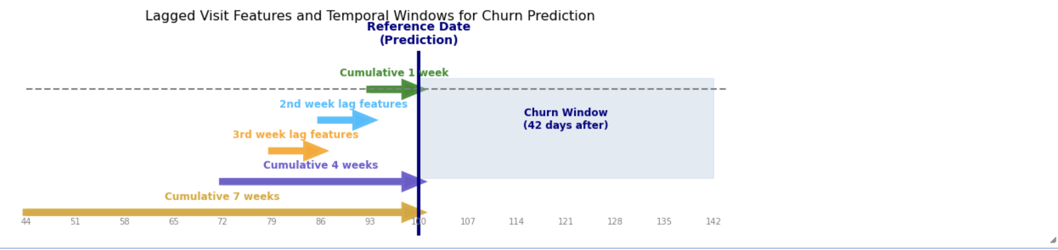
Fig 1. Window Strategy
The windowing and lagged feature strategy illustrates that all input features are calculated strictly up to the reference date (the prediction point). Aggregated over sliding windows (1, 4, and 8 weeks), as well as in specific lagged intervals (e.g., the 2nd and 3rd weeks before the reference date), these features ensure only past and present information is used for prediction. The output label (churn) is then defined based on whether the customer makes a purchase during the 42 day churn window immediately after the reference date. This structure mirrors real-world forecasting, prevents information leakage and ensures actionable predictions.
Prediction Approach
Data Preprocessing:
The analysis began with data validation steps to ensure that all customer, product, and receipt information was complete and consistent. Minimal data cleaning was required, as the transaction records were well-structured. Store data exhibited less than 1% missing transaction days, with only 2–5 days missing out of entire range. Given the negligible amount of missing data, no imputation or exclusion was necessary, and full date grids were utilized for all analyses.
Additionally , it was observed that transaction data for stores 1, 2, and 3 was available from July 22, 2020, while data collection for store 0 began later, on October 14, 2020. The dates are generated starting from July 22, 2020, as this is the earliest transaction date for the majority of stores.
Model Selection:
To ensure robust and unbiased assessment, the dataset was divided into three chronologically ordered sets, preventing data leakage and allowing the model to be tested on truly unseen future data. The training set, covering transactions from July 22, 2020, to September 30, 2021, was used for model development, while the validation set (October 1, 2021, to January 15, 2022) enabled effective hyperparameter tuning and model selection. The test set, comprising data from January 16, 2022, to March 22, 2022, provided an unbiased evaluation for final deployment

The modelling process evaluated a range of algorithms, starting with logistic regression as the baseline due to its interpretability and suitability for binary classification problems. Performance was then compared to LightGBM and Random Forest , known for handling large, tabular datasets efficiently and robustness to outliers. On the validation set, Logistic Regression and LightGBM both delivered solid baseline results, with accuracies around 78–79% and reasonable balance between precision and recall. LightGBM had slightly higher precision, but lower recall than Logistic Regression, meaning it missed more true churners. Random Forest outperformed both, achieving 89% accuracy, 87% precision, and an exceptional 99% recall, successfully identifying nearly every at-risk customer. Its F1 score and ROC AUC were also the highest, making Random Forest the most reliable and effective choice for FoodCorp’s churn prediction.
Meta-Parameter Tuning:
For each algorithm, hyperparameters were tuned using GridSearchCV. Custom cross-validation folds were constructed based on reference dates, ensuring each fold trained on historical data and validated on future weeks. This approach prevented information leakage and closely mirrored the intended use case for churn prediction. The primary evaluation metric during tuning was ROC-AUC, ensuring that model selection prioritized robust discrimination between churned and non-churned customers.
- n_estimators (100, 200): This parameter determines the number of trees in the forest. A range of 100 to 200 was explored to balance prediction accuracy and computational efficiency.
- max_depth (None, 15, 20): This parameter sets the maximum depth of each tree. Allowing unlimited depth (None) as well as limiting depth (15, 20) provided flexibility for capturing complex patterns while guarding against overfitting.
- min_samples_split (2, 3): This parameter specifies the minimum number of samples required to split an internal node. Smaller values enable the model to learn subtle distinctions, but can also increase the risk of overfitting if not carefully validated.
Selected Hyperparameters and Performance:
Using GridSearch_CV, the best performing parameters for Random Forest are found as
- n_estimators: 100
- max_depth: None
- min_samples_split: 2
This configuration achieved a mean cross-validated ROC-AUC of 0.82 which indicates the model has a good ability to rank customers by their risk of churn, providing FoodCorp with reliable predictions for targeted retention efforts
Final Model Evaluation:
Random Forest was selected as the best-performing model due to its outstanding validation results, as reflected in both the confusion matrix and the evaluation metrics. The model achieved a high accuracy of 0.89, meaning that the vast majority of its predictions were correct. Its recall of 0.99 indicates that almost all actual churned customers were successfully identified, minimizing the risk of missing at-risk individuals. Precision was also strong at 0.87, ensuring that most customers flagged for churn were indeed at risk. The F1 score of 0.93 shows an excellent balance between capturing churners and avoiding false alarms. The ROC-AUC of 0.90 further confirms the model’s ability to reliably distinguish between churned and non-churned customers. This combination of high recall, precision, and overall discrimination makes Random Forest the optimal choice for FoodCorp’s churn prediction needs.
After hyperparameter tuning, the best Random Forest model was retrained on all training and validation data and then evaluated on the reserved test set, consisting exclusively of the most recent period. The strong results on the validation set demonstrate that the model can accurately identify churned customers during development, while the consistent performance on the test set confirms the model’s reliability and ability to generalize to new, unseen customer data. This means FoodCorp can trust the model to provide accurate churn predictions for future business decisions.
Technical Approach Summary
In developing FoodCorp’s churn prediction model, a range of features capturing customer spending, visit patterns, and shopping diversity were engineered, with special emphasis on temporal trends. Features were selected based on their relevance and contribution to predicting churn.
The machine learning workflow included thorough data validation, preprocessing, and the comparison of multiple predictive algorithms, including logistic regression, LightGBM, and Random Forest. Hyperparameter tuning was conducted using grid search with time-based cross-validation. Among the tuned models, Random Forest achieved the highest accuracy, recall, precision, F1 score, and ROC-AUC on the validation set. The model also delivered strong, consistent results on the reserved test set, ensuring it is both robust and reliable for future churn predictions.
Insight Report-Section 1
Visit Frequency and Engagement Patterns:
Analysis shows that churned customers noticeably decrease their shopping trips and spending in the weeks before leaving, while retained customers visit more than twice as frequently in the previous month. Spotting and addressing declines in customer activity early can help reduce the risk of churn.
Diversity in Product Purchases:
A greater range of product purchases is closely linked to loyalty. Non-churned customers purchase about three times more unique products than churned customers over their shopping history. Promoting variety, new arrivals, or coupon deals may help strengthen, long-term customer relationships.
Category Preferences:
Promotions focused on Fruit and Cigarettes can increase engagement in both groups, as these are popular with both churned and retained customers. To specifically target churned customers, campaigns around Salad and Deli may be most effective, while Paypoint and Milk offers can help further engage loyal, non-churned customers.
Pen Portraits :
Analysis showed that churned customer is someone who show a steep drop off in visits, spend, and product diversity. Loyal customers are regular, high value, and diverse in their purchasing. Developing “win-back” strategies for profiles matching churned customer behaviour, and cultivate loyalty programs for those matching the non-churner portrait can help to reduce churners.

Insight Report-Section 2
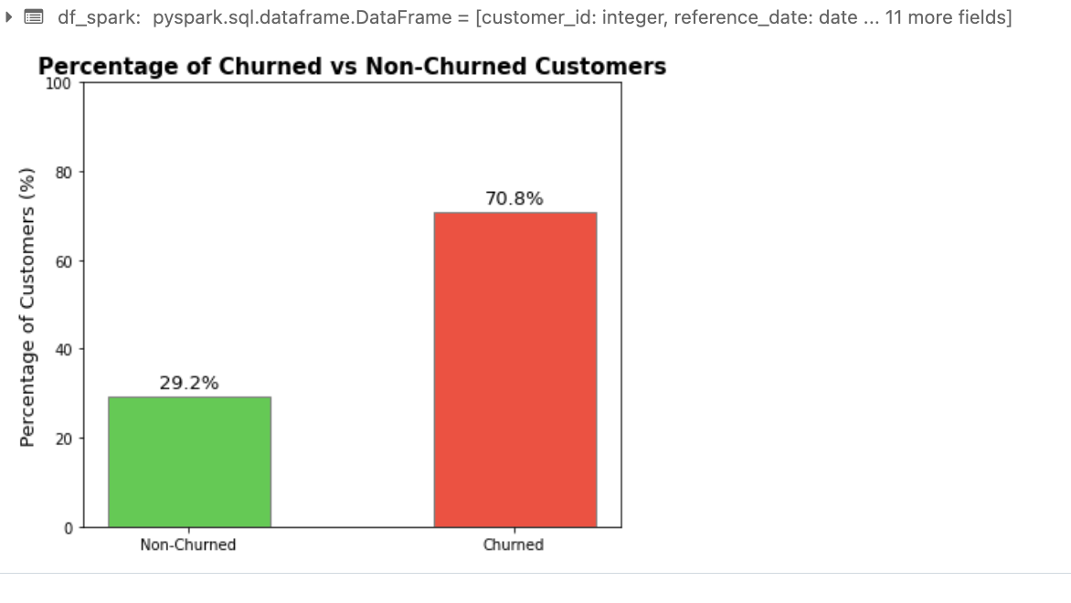
Fig 2. Churned Vs Non Churned
A high churn rate observed in the analysis where 70.8% of customers became inactive after 42 days further justifies the focus on variables that capture recent activity and diversity. This substantial at-risk segment underscores the necessity of precise churn prediction and robust customer segmentation, guiding both model development and actionable marketing strategies.
The ML pipeline was designed to maximize interpretability and predictive power by focusing on variables identified as most influential to churn. As shown in the feature importance bar chart (Permutation Importance), the key predictors were:
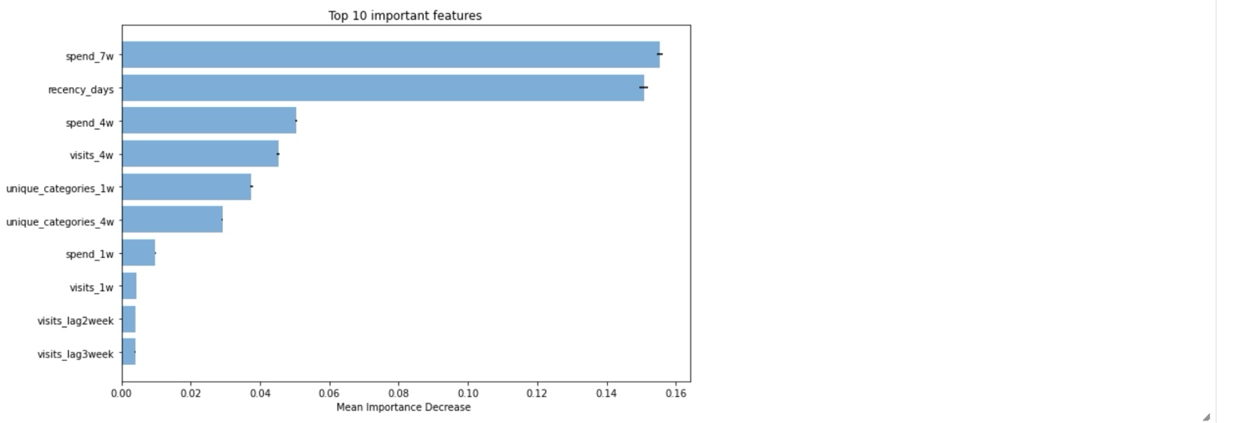
Fig 3. Top 10 important features
- Recent Spend and Recency Dominate: The two most influential features by far are total customer spend in the last 7 weeks and days since last purchase, highlighting that a customer’s most recent spending behaviour and time since last activity are critical predictors of churn risk. This aligns with business intuition: customers who have spent recently or frequently are less likely to churn.
- Medium-term Trends : Spend and visit counts over the previous 4 weeks are also highly ranked. This suggests that not only immediate but also medium-term engagement patterns are important signals for predicting future inactivity.
- Product Engagement Features: The diversity of product categories purchased in recent weeks provide meaningful incremental information. Customers purchasing from a broader range of categories are less likely to churn, likely reflecting deeper brand engagement.
- Short-term and Lagged Activity: Shorter-term spend and lagged visit features are less important but still contribute to model performance, capturing recent changes or irregularities
Overall, the feature importance results validate the business-driven feature engineering process, with a clear pattern: recent, frequent, and diverse purchasing behaviour are the most effective signals for churn prediction.
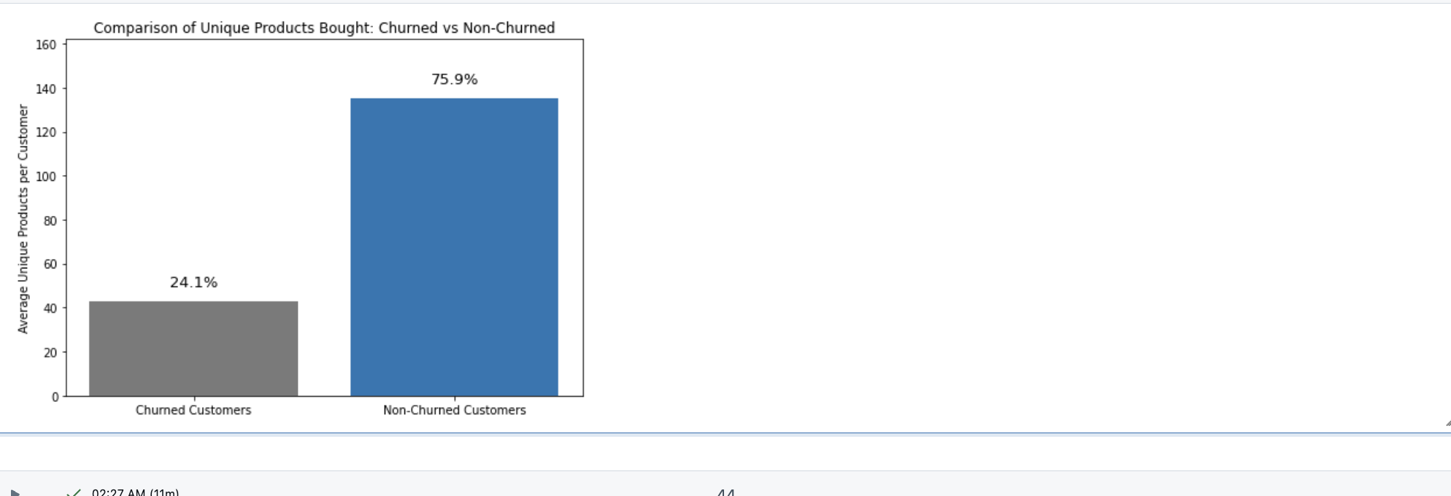
Fig 4. Unique Product Distribution
The comparison of unique product diversity, given in fig 4, revealed that loyal customers typically purchase three times as many different products as churned customers. This quantitative distinction informed both the variable selection process and the marketing segmentation, reinforcing the value of shopping diversity as a core engagement metric.
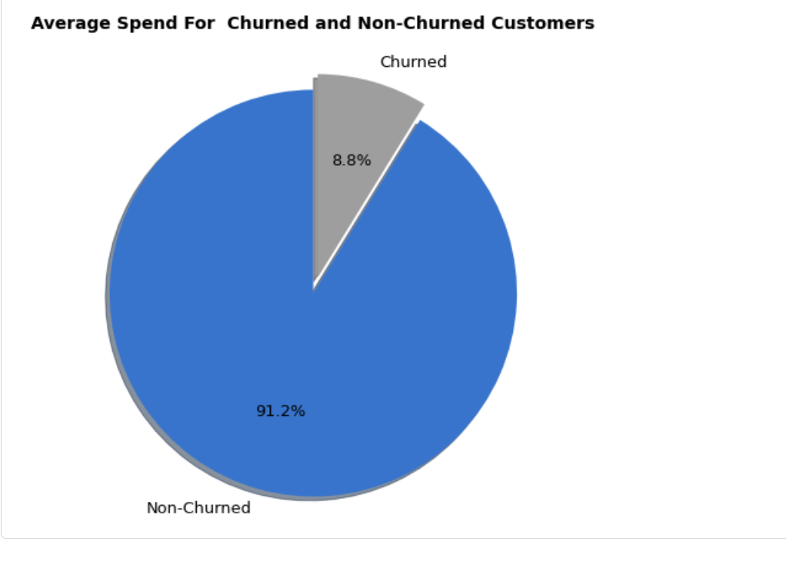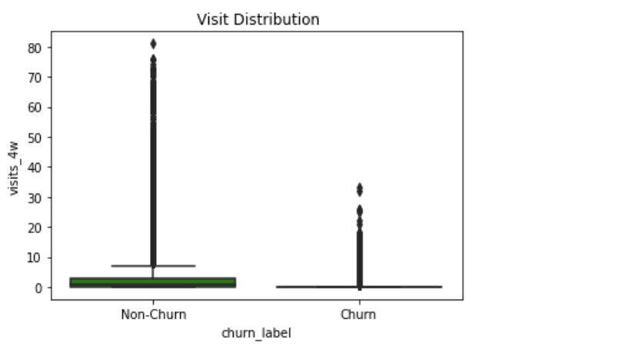 Fig 5. Average Spend Fig 6. Average Spend
Through Fig 5 and 6, spend and visit frequency further informed that churned customers make fewer store visits and spend less in the critical period before leaving, while the large majority (over 90%) of the customer base remains engaged. These findings further strengthen focusing model inputs on measures of recent spend, visit patterns, and shopping diversity.
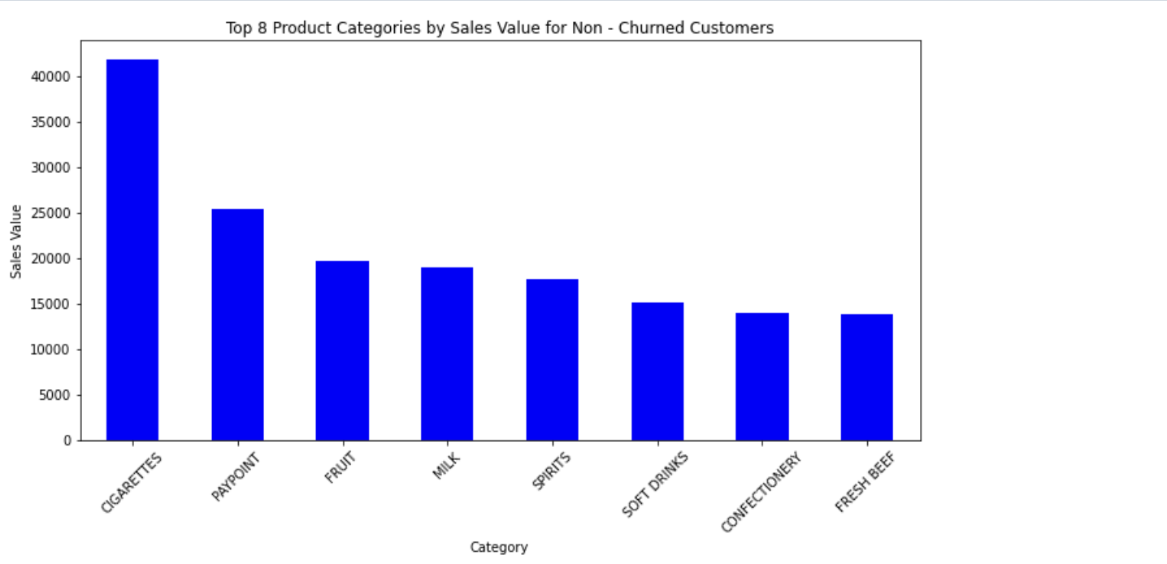
Fig 7.Product Preferences For Non Churned Customers
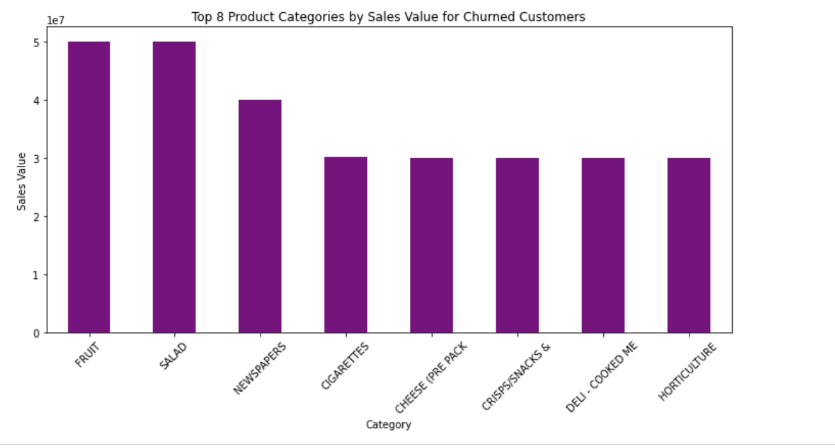
Fig 8.Product Preferences For Churned Customers
Category preference analysis, visualized through product category bar charts, indicated that churned and non-churned customers are drawn to different core offerings fruit, salad, and deli for churners; cigarettes, milk, and Paypoint for retained customers. These distinctions, surfaced through targeted analytics, guided both the pen portraits and the development of actionable segments for marketing.

