**NGINX**

**Assessment**



Name – Maithely Sharma

College – University of Petroleum and Energy Studies

EmployeeID – 4057

1. What is the advantage of using a “reverse proxy server”?

* Creates a single point of access to your file transfer servers
* Reduces risks to sensitive data.
* A reverse proxy server can act as a “traffic cop,” sitting in front of your backend servers and distributing client requests across a group of servers in a manner that maximizes speed and capacity utilization while ensuring no one server is overloaded, which can degrade performance.
* Reverse proxies can compress inbound and outbound data, as well as cache commonly requested content, both of which speed up the flow of traffic between clients and servers.

1. Why and where Nginx is a better choice than apache.

* **NGINX** is about 2.5 times faster **than Apache** based on the results of a benchmark test running up to 1,000 concurrent connections.
* Clearly, **NGINX** serves static content much faster **than Apache**.
* If you need to serve a lot of static content at high concurrency levels, **NGINX** can be a real help.

1. What are worker nodes and worker connections? How to calculate the max server capacity using the above two?
2. From what directory will NGINX automatically load server (virtual host) configurations when using the default /etc/nginx/nginx.conf configuration?

from /etc/nginx/sites-enabled

1. How to configure different log_format for different “location” block/directive?

log_format myFormat '$remote_addr - $remote_user [$time_local]'"';

combined

1. Host a site ABC.COM
   1. Create an index page and a fail-safe page. If a page for URI is not available, the fail-safe page is served.

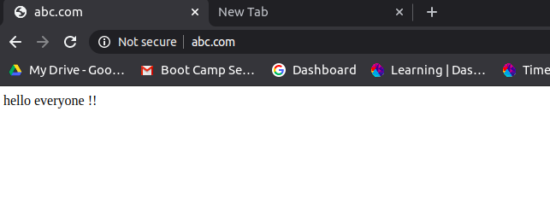

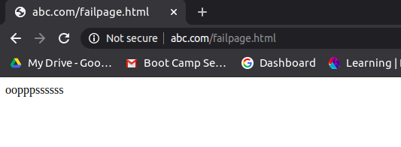

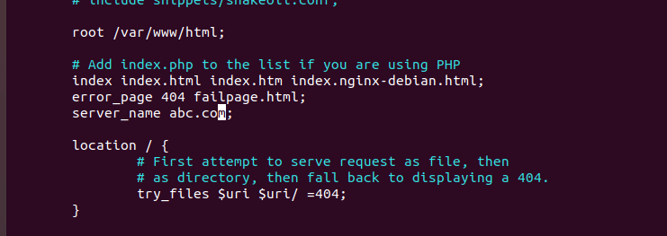

* 1. proxy pass to a website xyz.com on a particular URI.

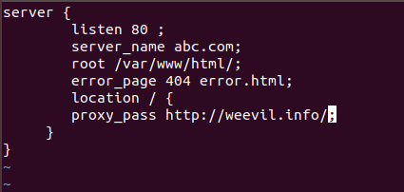

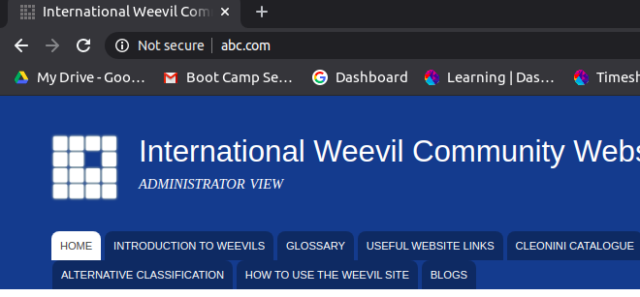

* 1. redirect to above URI on /redirect/

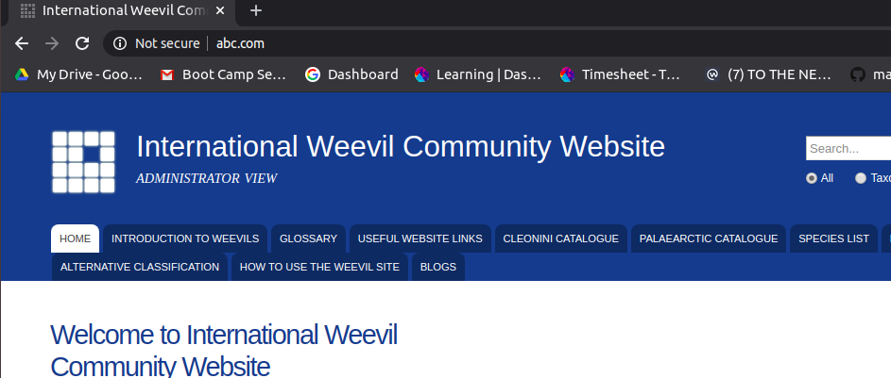

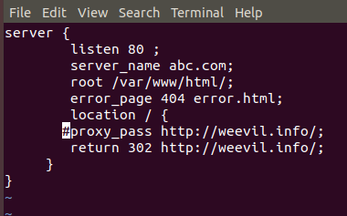

* 1. perform an HTTP to HTTPS redirection including non-www to www redirection.

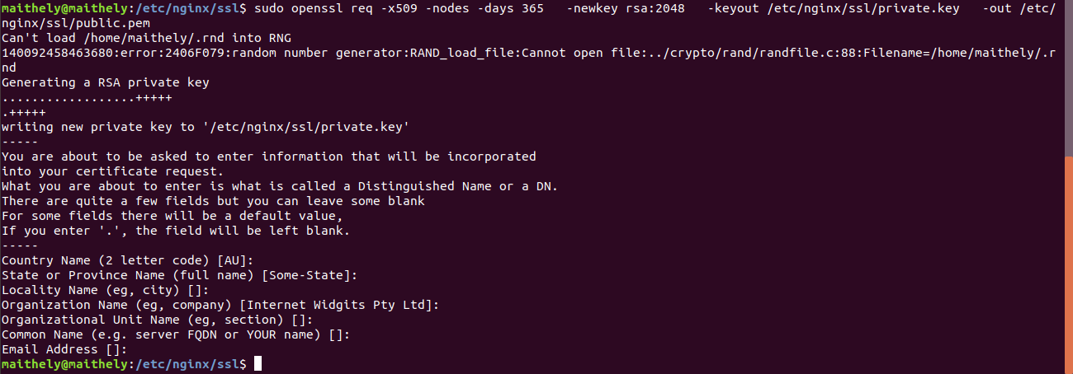

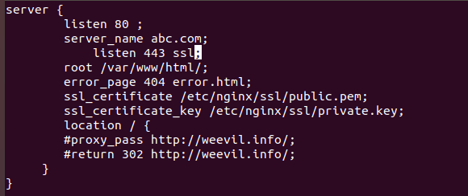

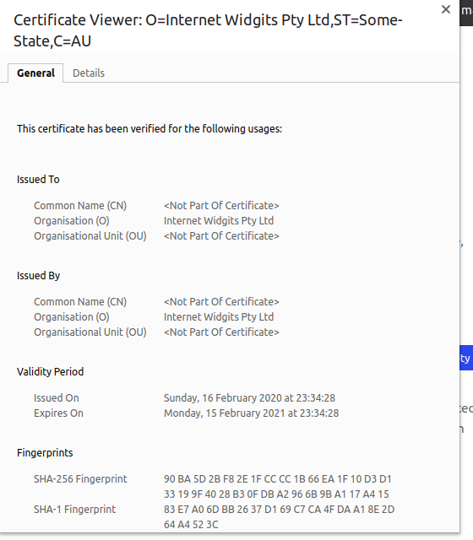

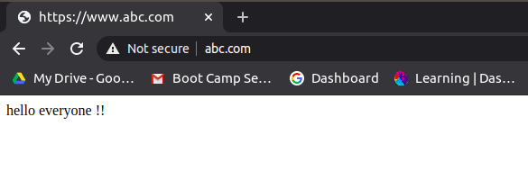

* 1. Allow access to a set of particular IPs on a location block and return 405 to other IPs no matter if the page in that location exists.

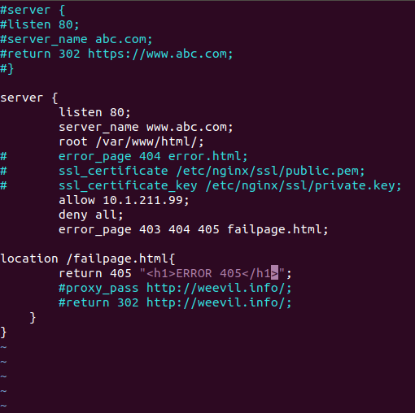

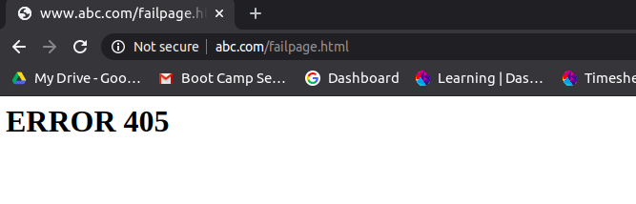

* 1. Place your images at /var/www/html/images. Only accept jpg/png/jpeg. Discard rest

1. Create a load balancer with 5 backends. Explain different types of load balancing methods.

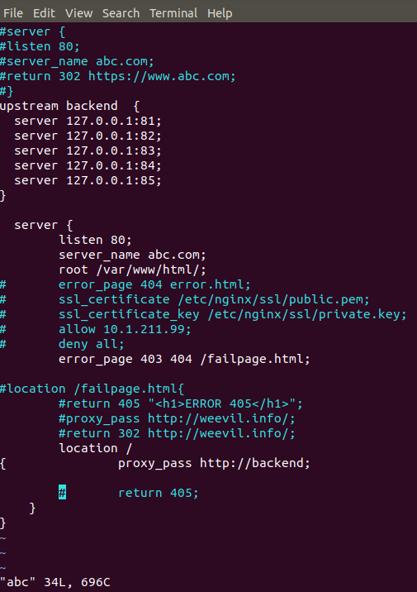

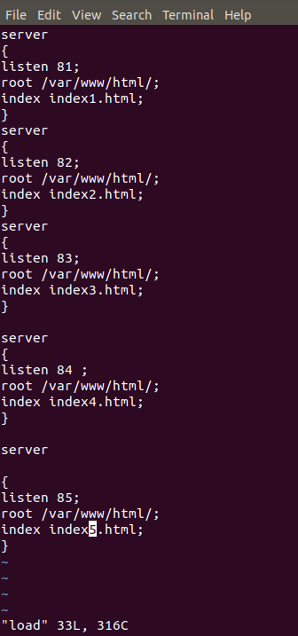

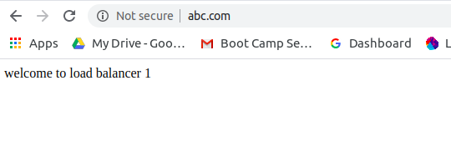

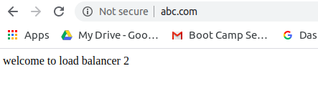

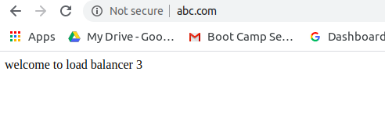



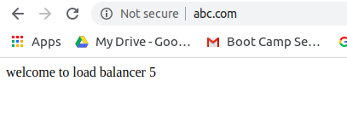

1. Setup Basic Auth (Popup asking for username and password) in a particular location block. (The Basic Auth should not be asked for TTN IP)