Refer Playwright doc for further knowledge.

JavaScript basics

Hello world program
console.log(“Hello world”);

Data types

Difference between var, let and const
In previous version of JS i.e. ES5, we had var type
With ES6, const and let types were introduced

Difference between var and let -
Both are very similar, we can declare the variables with these types without initializing them.
Only difference is we cannot redeclare with let type
For e.g. -
var A = 4
var A = “maithili”
Both let and var types can be reassigned
E.g. -
let A = 4
A = “maithili”

Const type
As the name suggests, this type of variable cannot be redeclared or reassigned, it remains constant throughout
So, if I use a negation operator as the condition in one of the loops, then it will be considered because we are not reassigning any value to it, we are just checking the condition
Example in below while loop example

Scopes for var, let and const
Var – This has either global scope or functional scope. This does not has block level scope e,g, if condition block or for loop block.
Let – This has either global scope or block scope – code within { }.

Variable types
number, string, boolean, array

Operators
+, -, ==, *, /, !, ==, &&, || (not operator -> can be used with boolean operator, reverses the actual value)

If, else condition
Let flag = true
If (flag)
{
Console. Log(“condition satisfied”)
}
Else If (!flag)
{
Console. Log(“condition not satisfied”)
}

While loop
Let a=1
While (a<=10)
{
a++
Console.Log(“hello”)
}

Do While Loop
do
{
a++;
} while (a<10);
console.log(a);

In this case, a++ will be executed without checking anu condition and then condition will be checked, if it’s true then again, the code is executed otherwise it comes out of the loop. Highlighted semicolon is compulsory in do while loop. In above case, only 10 will be displayed in console.

For loop
//Factors

let d=16;
for(let j=1; j<=d; j++)
{
if(d%j==0)
{
console.log(j);
}}

Arrays
When we know size of the array, we can declare the array like this
let marks = Array(6); //Syntax 1

When we have to initialize the array elements, we need to create an object to do so
let marks2 = new Array(20, 30, 10, 60, 100, 70); //Syntax2

If we want to declare an array directly with the elements
let marks3 = [23, 56, 64, 65, 64]; //Syntax3

Array Methods
- .length – To get array count
- .[index] – To access any array element
- .push(43) – A new element will be appended at the end of the array
- .pop() – Last element from the array will be removed
- .unshift(34) – A new element will be added at the start of the array
- .indexOf(element) – This gives index of the specified element in the array
- .includes(78) – This return a Boolean value, depending on whether the element is present in the array or not
- .slice(2,5) – This will return a sub-array between elements 2 (included) and element(5-1) which is 4 from the original array
In this, we do not need to mention the data type of the subarray formed as it will have the same data type as original array
- .reduce(arg 1, arg 2) –
- arg1 is an anonymous function with 2 parameters and the execution code, 1 variable to store the results and the other variable on which the whole array iterates
arg 2 is initial value which we want to give to the variable in which results will be stored
In below function,
yellow highlight = anonymous function with 2 parameters
blue highlight = execution code
purple highlight = initialization of total
var totalMarks = marks.reduce((total,mark)=>total+mark,0);
console.log(totalMarks);
- .filter() – num is the variable on which the original array is iterated, num%2 ==0 is the condition
var filterNewArray = numbers.filter(num=>num%2==0)
- .map() – this method is used to map existing array elements to new elements like multiplication or mod
var mapArray = filterNewArray.map(nums=>nums*3);
- .sort() – If we use this method for an array of strings, all the elements will be sorted in alphabetical order
- .reverse() – If we use this method for an array of strings, all the elements will be sorted in reverse alphabetical order
- Sorting numbers array ->
console.log(sortNums.sort((a,b) => a-b)); //Ascending
console.log(sortNums.sort((a,b) => b-a)); //Descending

Strings
Similar to Arrays

String methods
- .length
- .slice(a,b)
- String[3]
- .split(“char”)
- .trim() – Trims the white spaces from start or end
- parseInt(“string”) – Converts string to number
- .toString() – Converts number to string
- To concat strings we use + operator
day + “ is wow”
- .indexOf(“string”) – gives the index of specified string
- .indexOf(“string”,5) – Here, 2nd parameter means that we need to search for mentioned string from 5th character
If the given string is not found at any index, -1 is returned

Objects
Objects are collection of properties.
- We can add any data type of properties in it like string, number, function.
- We can access these properties by objectName.propertyName or objectName[‘propertyName’].
- For function property, we need to use () after the name, E.g. – person.fullName().
- If we want to use property value in the same object, we need to use this keyword.

person = {
firstName: "Maithili",
lastName: 'Mhatre',
age: 27,
fullName: function()
{
console.log(this.firstName + this.lastName)
}
}

- We can reassign these properties by simply = operator
person.firstName = 'Changed name';
- We can add new properties in the object
person.gender = 'Female'
- We can delete any of the property
delete person.gender;
- We can check whether the property is present in the object or not using in operator
console.log('gender' in person);
- Iterating through all objects
for (let key in person) //Enhanced for loop
{
console.log(person[key]);
}

Class
Classes were introduced with ES6 engine. Previously objects were used to define any properties for an entity.
- Here also we can add all kind of data types – string, number, multiple lines of code through getter methods.
- Properties of class are also known as class variables.
- When we add get in front of the function, it is treated as property of the class. So need not add () while accessing it because it turns into property once we add get.
- Class name and Class file name should be same.

Constructor
This is a method which executes by default when you create object of the class.
- We can create it by using constructor keyword.
- Parameter used with constructor are called as instance variables. Using these we can have new parameters with multiple objects.
E.g. constructor(firstName,lastName)
I can have new firstname and lastname with every new object created.
- Class variables cannot be changed using objects like instance variables.
- All instance variables are declared inside the constructor.

Public class
- We can make classes public so that they can be accessed in other files. For that we need to use –
Module.exports = class Person { code }
- The file in which we need to use this class, we need to give
const Person = require (“./classFileName”)
- Create an object of this class and we can access the properties

Inheritance
- Main pillar of object oriented programming language where one class can inherit/acquire properties and methods of another class
- Class which inherits the properties of other class is known as Subclass/Derived class/Child class
- Class whose properties are inherited is known as Super class
- In order to inherit we need to use extends keyword
Pets extends Person
- If parent class has any constructor then the child class should also have the same constructor
- We need to call parent class constructor as the 1st step in your child class constructor with the same arguments
- We can override the parent class properties by redefining the properties in child class

Accessing and modifying Excel files using JS
To access Excel files using JS, we need exceljs library, which ca be installed using cmd terminal.

Steps:
- Give this command in terminal to create a folder named ExcelJSUtil - mkdir ExcelJSUtil
- Then to enter in this folder, add – cd ExcelJSUtil
- Then to initialise a node project, enter - npm init
- Say yes to all the questions asked for creating a package.json file – No need to add anything explicit from our end, keep everything default
- Then to add exceljs dependencies, add - npm install exceljs in the same terminal or open the created folder in VSCode, there also we can run the same command for installing excel.js dependencies
- Now start programming by adding new files.js in the folder

Code of printing all the cell values in console:
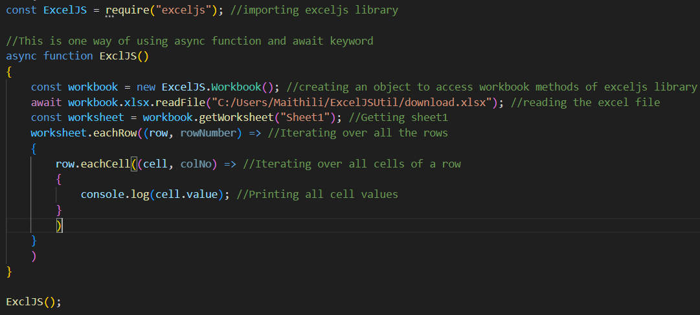

Other way using promise method then, replacement of async-await function:
Same lines of code just in then(function(){ code })
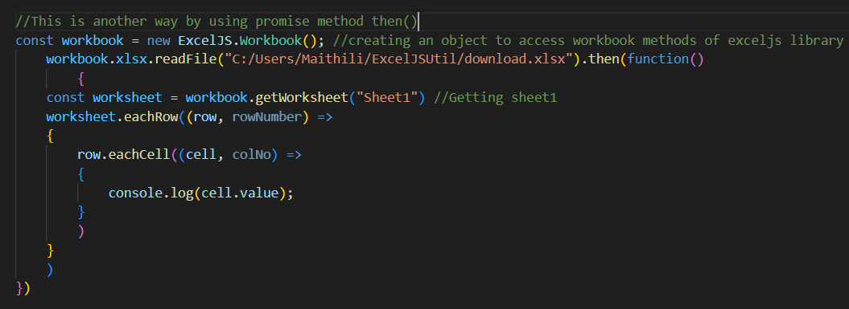
Rewriting a cell value and saving the excel file using WriteFile method.
Creating a global object for row number and cell number.
