WEEK 4 INTERNSHIP REPORT
Exploratory Data Analysis and Feature Engineering
Beauty & Wellness | Data Science with Python Internship
Prepared by: S. Maithili
Week: 4
Date: 24 October 2026

1. Executive Summary
This report describes an exploratory data analysis (EDA) and feature-engineering workflow for the skincare catalogue dataset used in Weeks 1–3. The current data contains 1,138 product records. Available fields describe product names, URLs, product types, ingredient lists, and listed price. The dataset has no explicit customer demographics, ratings, review counts, transactions, sales, or revenue. Therefore, EDA will focus on product catalogue structure, price-field quality, and ingredient-list characteristics. Engineered features such as normalized product type, numeric price, ingredient count, and ingredient-presence flags can support descriptive analysis and future catalogue segmentation, but cannot by themselves predict customer behavior or sales.

2. Business Problem and Scope
Business question: How can skincare catalogue data be explored and transformed to reveal product-type coverage, listed-price patterns, and ingredient representation that may inform product assortment and product-page communication?
Scope: This is a catalogue-level study. It does not measure actual customer preferences or sales performance. The price field is described by the dataset source as GBP and its currency should be checked before comparison. The Kaggle page displayed the licence as Unknown, so reuse permissions must be checked before redistributing the raw data.

3. Dataset Overview and EDA Readiness
Input file used: skincare_products_preprocessed_week3.csv. Records: 1,138. Fields available include: product_name, product_url, product_type, clean_ingreds, price, product_type_clean, price_numeric, price_currency_symbol, ingredients_list, ingredient_count.
First inspect shape, dtypes, null counts, duplicate records, category counts, numeric summaries, currency-symbol counts, and ingredient-list parsing. Retain the raw columns alongside engineered columns to preserve traceability.

4. EDA Workflow
Step 1 — Structural checks: Review dimensions, column names, data types, missing values, duplicate rows, repeated URLs, and unique values.
Step 2 — Univariate analysis: Use counts for product types, summary statistics for parsed price amounts, and histograms for numeric distributions.
Step 3 — Category comparisons: Compare price summaries by product type only after confirming currency consistency; use box plots and group summaries.
Step 4 — Ingredient exploration: Calculate ingredient-count distributions, top ingredient frequencies, and ingredient presence by product type.
Step 5 — Relationships and anomalies: Explore product type versus ingredient count, price versus ingredient count, and unusual prices. Treat associations as descriptive rather than causal.
Step 6 — Summarize insights: Document each chart's question, variables, method, result, business implication, and limitation.

5. Statistical and Visualization Methods
Analysis question | Method | Visualization | Interpretation caution
Which product types are most represented? | Frequency counts and percentages | Sorted bar chart | Dataset representation is not the same as market share or demand.
What does the price field look like? | Mean, median, quartiles, range, standard deviation; outlier flags | Histogram and box plot | Verify currency and units; numeric parsing alone does not make prices comparable.
Do prices differ across product types? | Group summaries; optionally Kruskal–Wallis if data suitability and assumptions are checked | Grouped box plots | Only compare if currencies/units are consistent; association is not causal.
How many ingredients are listed per product? | Mean, median, quartiles, distribution | Histogram or box plot | Ingredient count does not measure quality or effectiveness.
Which ingredients appear most often? | Frequency counts and distinct-product counts | Horizontal bar chart | Common occurrence does not imply safety, benefit, or customer popularity.
Are ingredient counts different by product type? | Group summaries; optional Kruskal–Wallis for exploratory comparison | Box plot by product type | Interpret as catalogue patterns only.

6. Initial Exploratory Visuals
The following charts were generated from the available dataset for illustration of the EDA workflow. They are descriptive outputs, not evidence of sales or customer behavior.
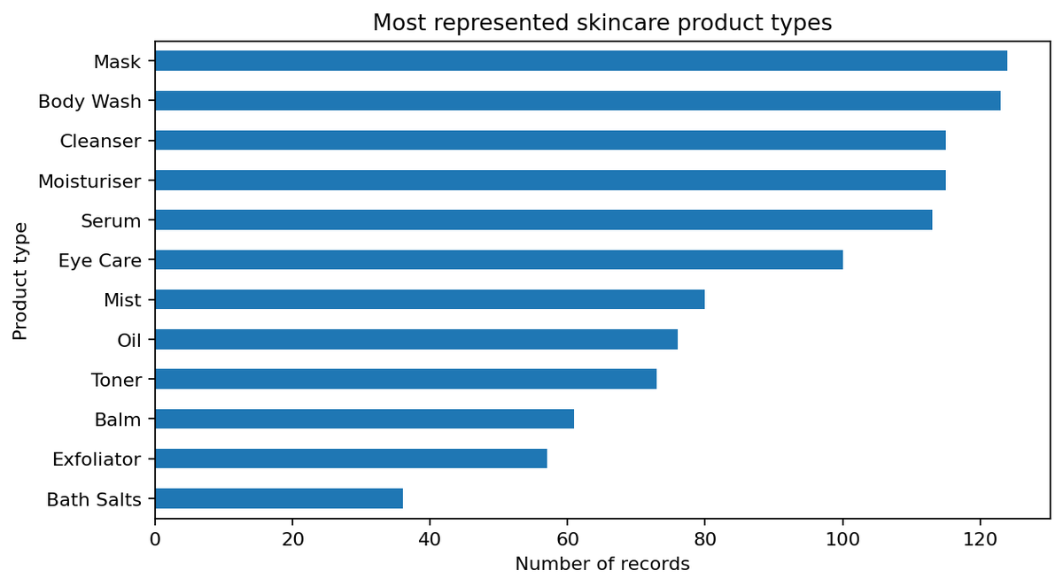
Product Types
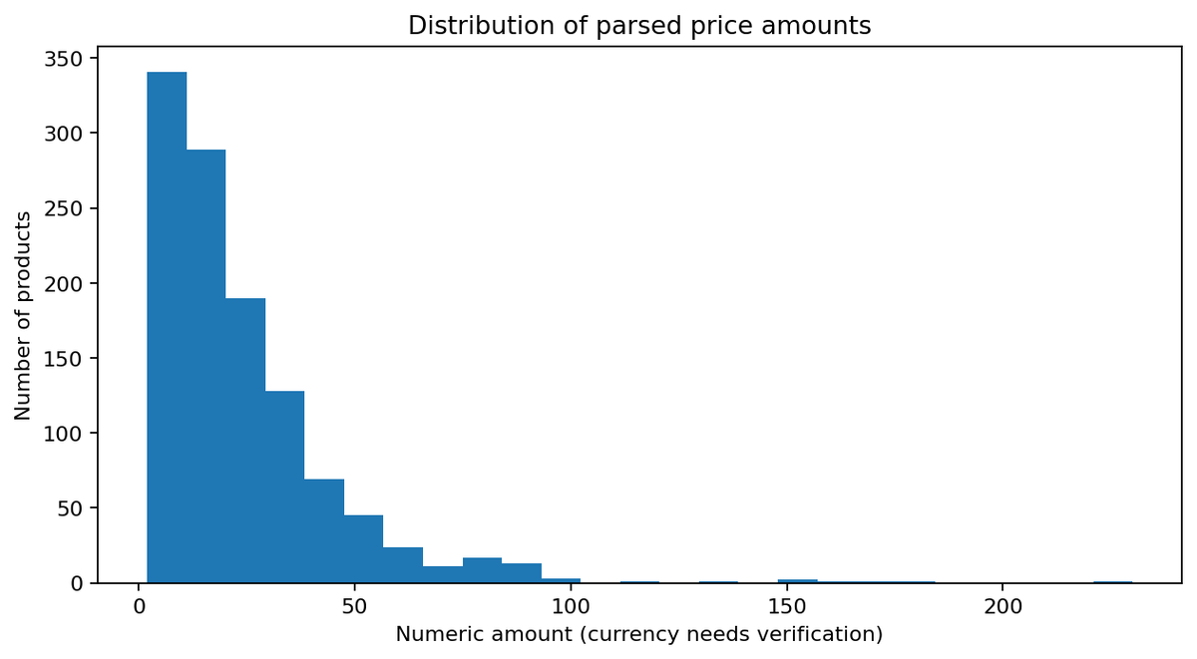
Price Distribution
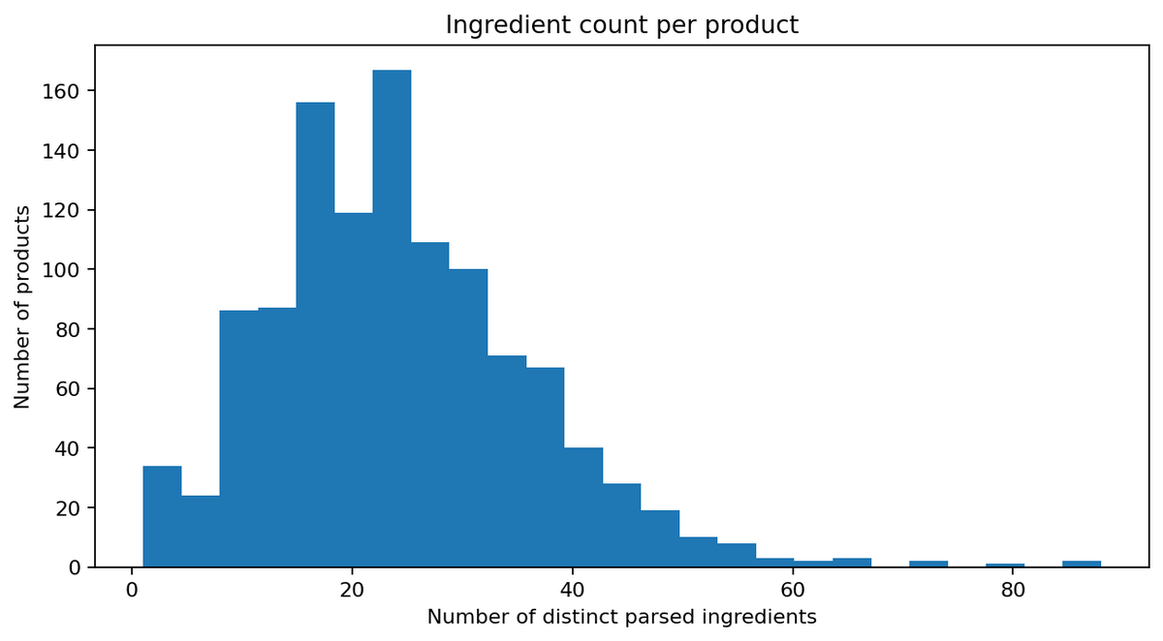
Ingredient Count

7. Feature Engineering Plan
Feature | How to create it | Why useful | Caution
product_type_clean | Trim whitespace, standardize case and repeated spaces | Consistent category summaries and encoding | Keep original category for traceability.
price_numeric | Extract numeric amount from price text; retain currency separately | Enables numeric summaries and plotting | Do not compare across currencies or convert without a dated exchange-rate method.
ingredient_count | Count distinct normalized ingredient names per product | Describes ingredient-list length; possible product complexity proxy | Not a measure of quality or efficacy.
ingredient_presence_* | Binary 0/1 flag for selected common ingredients | Compare catalogue distribution of selected ingredients | Choose features using a documented rule; avoid huge sparse matrices unnecessarily.
price_log | log1p(price_numeric) if positive and currency consistent | May reduce right skew for statistical models | Only use after currency/price validity checks; explain transformation.
price_zscore or MinMax | Standardize or scale numeric price feature | Makes numeric features comparable for some models | Fit scalers on training data only when modeling; scale within meaningful comparable units.
product_type_encoded | One-hot encode categories | Allows categorical input in compatible models | Fit encoder on training data; handle unknown categories.
ingredient_count_by_type | Compare ingredient count to product-type median or create group-level summary | Highlights category-specific catalogue patterns | Avoid target leakage if used in a future predictive setting.

8. Example Feature Engineering Code
import pandas as pd
import numpy as np
import ast
import re
from sklearn.preprocessing import OneHotEncoder, StandardScaler
df = pd.read_csv("skincare_products_preprocessed_week3.csv")
# Normalize category labels
df["product_type_clean"] = (
df["product_type"].astype("string")
.str.strip().str.replace(r"\\s+", " ", regex=True)
.str.title()
)
# Numeric price feature (preserve currency separately)
df["price_numeric"] = pd.to_numeric(df["price_numeric"], errors="coerce")
df["price_log"] = np.where(df["price_numeric"] > 0,
np.log1p(df["price_numeric"]), np.nan)
# Count distinct parsed ingredients
def parse_list(v):
if pd.isna(v):
return []
try:
x = ast.literal_eval(str(v))
if isinstance(x, (list, tuple, set)):
vals = list(x)
else:
vals = str(v).split(",")
except Exception:
vals = str(v).split(",")
return sorted(set(str(a).strip().lower() for a in vals if str(a).strip()))
source_col = "clean_ingreds" if "clean_ingreds" in df.columns else "ingredients_list"
df["ingredients_parsed"] = df[source_col].apply(parse_list)
df["ingredient_count"] = df["ingredients_parsed"].apply(len)
# Binary feature for a selected ingredient
df["has_glycerin"] = df["ingredients_parsed"].apply(
lambda items: int("glycerin" in items)
)
# Encode categories for later modeling (fit only on training data in a real model)
encoded = pd.get_dummies(df["product_type_clean"], prefix="type", dtype=int)
df = pd.concat([df, encoded], axis=1)
This is an example pipeline. Before using it for modeling, validate ingredient parsing and price currency. For machine learning, fit preprocessing transformations only on training data and apply the same fitted transformations to validation/test data.

9. Hypothetical Business Scenario
Suppose a skincare retailer wants to improve catalogue organization and plan product-page content. EDA shows that some product types have more listings than others and that ingredient lists vary in length. An ingredient-count feature and binary ingredient-presence features could help group similar catalogue records and identify which ingredient terms are commonly listed within each category. A standardized product_type feature could support consistent category-level reporting. These features may improve catalogue segmentation and exploratory comparisons. They would not establish what customers prefer or which products sell best without transaction or review data.

10. How Features Support Later Modeling
- One-hot encoded product type can represent categories in suitable statistical or machine-learning models.
- Ingredient presence features can represent product composition as binary variables.
- Ingredient count can summarize list length and can be compared across product types.
- Log transformation or scaling can make numeric price features more suitable for certain algorithms when the currency is consistent.
- To model sales, sentiment, or customer behavior, a future dataset must include a valid target variable such as sales, ratings, or review sentiment. This dataset does not.

11. Tools and Libraries
Tool | Role
Pandas | Data inspection, grouping, feature creation, missingness summaries.
NumPy | Numeric transformations and missing-value handling.
Matplotlib / Seaborn | Histograms, box plots, bar charts, heatmaps, and exploratory visualizations.
SciPy | Optional statistical tests such as Kruskal–Wallis or chi-square when assumptions and data design are appropriate.
scikit-learn | Optional encoding, scaling, and future modeling; prevent leakage by fitting on training data only.
Jupyter Notebook | Document code, outputs, interpretation, and decisions reproducibly.

12. Quality, Bias, and Ethics
- Do not treat product listing frequency as sales or market share.
- Do not infer skin suitability, safety, or efficacy from ingredient frequency.
- Keep raw values and document transformations.
- Check the unknown licence status before redistributing the source dataset.
- Record currency, collection date, and data provenance.
- Use only public, permitted data and avoid collecting personal or sensitive information.

13. Reproducibility Checklist
- Record the input filename, source URL, access date, and licence status.
- Keep original columns and create new feature columns separately.
- Document feature definitions and transformations.
- Save notebook/script, output CSV, and charts with stable filenames.
- Record software/library versions and any exclusions.
- Validate row counts, feature distributions, and output schema after preprocessing.

14. Work Plan (30–35 Hours)
Activity | Hours | Output
Dataset review and EDA questions | 4 | EDA checklist
Descriptive statistics and chart planning | 7 | Statistics and visualization plan
Generate and interpret initial charts | 6 | EDA figures and notes
Design feature-engineering variables | 6 | Feature dictionary
Write and test example code | 5 | Reproducible examples
Report writing and review | 4 | Final Week 4 document
Total | 32 | Week 4 deliverable

15. Conclusion
This Week 4 plan links exploratory data analysis to feature engineering for skincare catalogue data. It prioritizes valid descriptive analysis of product types, price-field quality, and ingredient lists, then proposes normalized categories, numeric price amounts, ingredient counts, ingredient-presence flags, and encoded categories as engineered features. These transformations can support consistent catalogue analysis and future modeling when appropriate outcome data is available. The report clearly separates catalogue-level findings from customer behavior and sales claims.

References
- Kaggle. “Skincare Products Clean Dataset.” https://www.kaggle.com/datasets/eward96/skincare-products-clean-dataset (accessed 24 October 2026; licence displayed as Unknown).
- Pandas documentation. https://pandas.pydata.org/docs/
- NumPy documentation. https://numpy.org/doc/
- SciPy documentation. https://docs.scipy.org/doc/scipy/
- Matplotlib documentation. https://matplotlib.org/stable/
- scikit-learn documentation. https://scikit-learn.org/stable/

