WEEK 1 INTERNSHIP REPORT
Data-Driven Exploratory Analysis of Skincare Products
in the Beauty & Wellness Industry
Data Science Orientation & Problem Definition
Prepared by: S. Maithili
Internship: Data Science with Python
Week: 1
Date: 24 October 2026

Abstract / Executive Summary
This report defines a data-science business problem in beauty and wellness and demonstrates an initial exploratory inspection of a public skincare-product dataset. The uploaded CSV contains 1,138 records and 5 original fields: product_name, product_url, product_type, clean_ingreds, and price. The file contains no explicit ratings, review counts, sales, or revenue fields; therefore, the analysis focuses on product mix, listed price amounts, and ingredient-list patterns rather than claiming to predict sales. The dataset's displayed prices include currency symbols that must be verified before cross-product price comparisons are interpreted.

1. Introduction
Beauty and wellness businesses compete through product selection, price positioning, ingredient communication, and online discovery. Skincare product catalogues contain structured information that can be analyzed to describe category coverage, price ranges, and ingredient representation. This report uses a dataset-led approach: first define a business question, inspect real available data, and only then decide which analyses are valid.

2. Industry Background and Research
NIQ's report “The New Face of Indian Beauty” (26 June 2025) is a relevant industry source for understanding changes in Indian beauty shopping and consumer expectations [1]. A screenshot supplied for this project shows the report landing page and publication date.
A second NIQ webpage, “The Digital Makeover,” describes the role of online beauty shopping, social discovery, personalization, and e-commerce in India's beauty market. The screenshot supplied by the student includes the page's overview and a list of report topics. These sources provide business context, but do not directly validate any pattern in the skincare CSV.
The dataset is a cleaned version of a Kaggle skincare-products dataset and is described by its publisher as containing over 1,000 products and cleaned ingredient lists. The Kaggle page lists its licence as “Unknown”; reuse permissions should therefore be checked before redistributing the raw data. The CSV is used here for educational inspection, and its source and limitations are documented.

3. Business Problem Statement
Skincare brands and retailers need a clear view of the product categories and ingredient information represented in their product catalogues, and how listed prices vary across the available products. Without structured analysis, it is difficult to summarize category coverage, identify commonly listed ingredients, or assess whether the price field is consistent enough for meaningful comparison.
Business question: How can product catalogue data be analyzed to summarize skincare category coverage, listed price patterns, and ingredient representation in a way that supports product assortment and marketing planning?
Scope boundary: this dataset does not contain explicit sales, revenue, customer ratings, or review counts. Consequently, this report does not claim to identify best-selling products, customer sentiment, or causal drivers of purchases.

4. Aim and Objectives
- Inspect and document the structure and completeness of the skincare product dataset.
- Describe the distribution of records across product types.
- Summarize the listed price field after checking its currency and formatting.
- Identify frequently occurring ingredient names in the ingredient lists.
- Translate descriptive findings into cautious ideas for product assortment and marketing communication.
- Record data-quality, licence, and generalization limitations.

5. Research Questions
- How many product records are available, and what fields do they contain?
- Which product types are most and least represented in the dataset?
- What is the distribution of the numeric amount extracted from the listed price field, and is the currency consistent?
- Which ingredient names occur most frequently across the ingredient lists?
- How could these descriptive patterns support catalogue organization and product communication?

6. Hypotheses / Exploratory Propositions
Because this is a catalogue dataset without customer or sales outcomes, the Week 1 investigation uses exploratory propositions rather than unsupported claims about customer behavior.
- P1: Product records are not distributed equally across all product types.
- P2: The numeric amounts in the price field vary across product records; interpretation depends on confirming currency and units.
- P3: Some ingredient names appear in more product ingredient lists than others.
These propositions will be checked using descriptive counts and summaries. They do not imply that an ingredient causes a product to perform better or that a category is more popular among consumers.

7. Dataset Description and Data Quality
Dataset file: skincare_products_clean.csv (provided by the student). Dataset landing page: https://www.kaggle.com/datasets/eward96/skincare-products-clean-dataset
Observed dimensions: 1,138 rows × 7 columns. Missing values by original column: product_name: 0; product_url: 0; product_type: 0; clean_ingreds: 0; price: 0; price_numeric: 0; currency_symbol: 0.
Column | Type / content | Use in this project
product_name | Text | Identify products and describe catalogue entries.
product_url | URL | Trace a record to its source product page; do not assume current page data is unchanged.
product_type | Category | Count and compare the product mix.
clean_ingreds | List-like text | Count ingredient mentions and identify common ingredients.
price | Text with currency symbol | Parse numeric amount; confirm currency before making direct comparisons.

8. Initial Exploratory Findings
The uploaded dataset contains 1,138 rows and 7 columns. No missing values were detected in the five original columns during the initial CSV inspection.
Product type counts:
Product type | Number of records
Mask | 124
Body Wash | 123
Cleanser | 115
Moisturiser | 115
Serum | 113
Eye Care | 100
Mist | 80
Oil | 76
Toner | 73
Balm | 61
Exfoliator | 57
Bath Salts | 36
Bath Oil | 33
Peel | 32
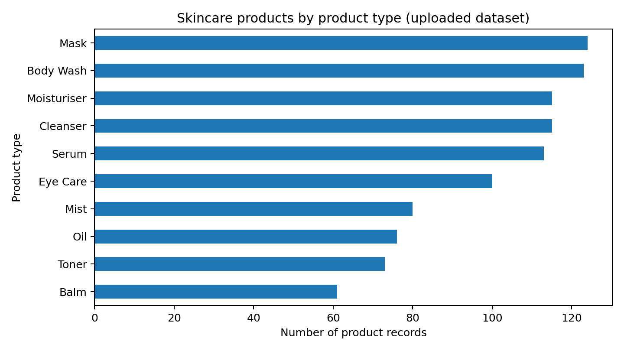
Figure 1. Product-type counts generated from the uploaded CSV.
Price field: 290 distinct raw price strings were observed. After removing non-numeric characters, 1,138 values could be parsed as numeric amounts. The raw sample includes the currency symbol(s): £. The numeric extraction is preliminary and does not establish that all amounts use the same currency or unit.
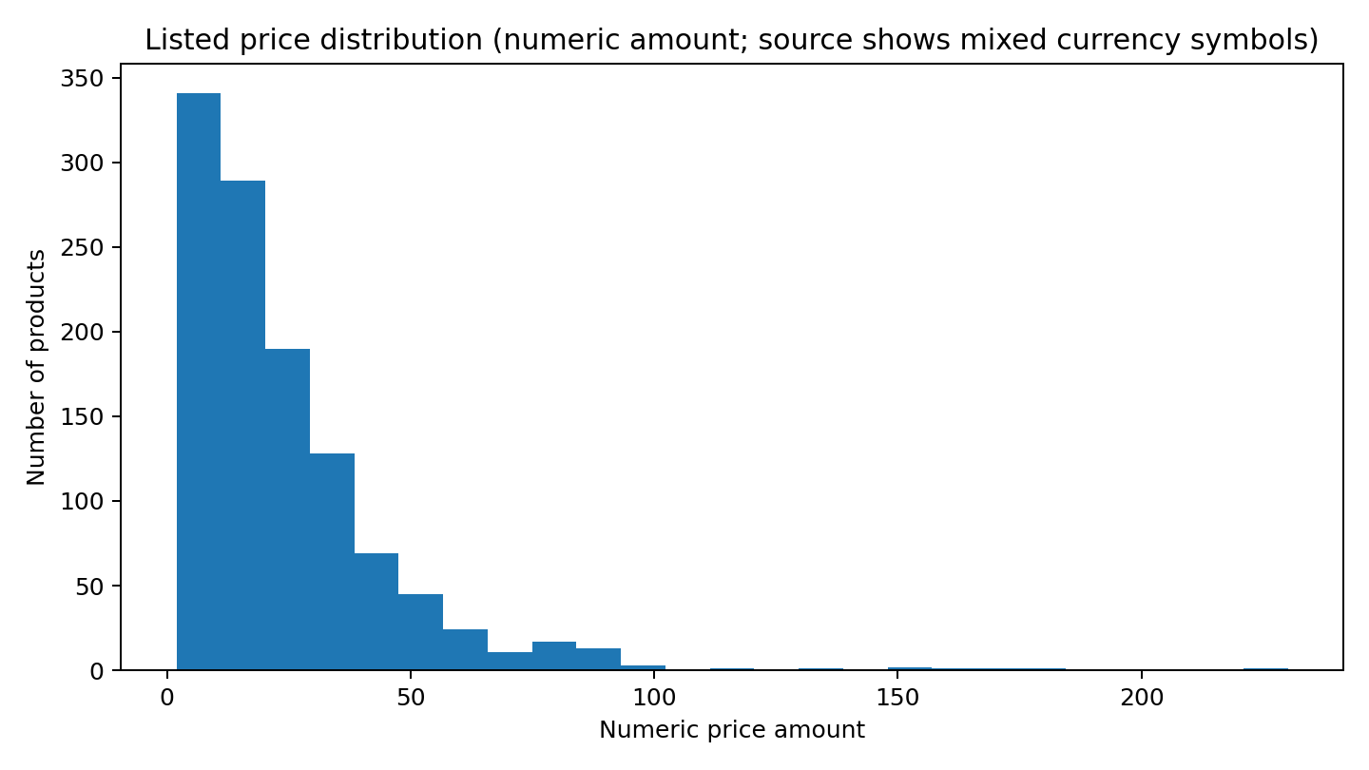
Figure 2. Preliminary distribution of numeric price amounts; currency consistency must be verified before interpretation.
Most frequent ingredient names in ingredient lists (counted as occurrences, not necessarily unique products):
Ingredient | Occurrences
glycerin | 794
phenoxyethanol | 617
parfum | 580
linalool | 411
limonene | 402
citric acid | 397
disodium edta | 364
tocopherol | 362
butylene glycol | 335
sodium hyaluronate | 318

9. Proposed Analysis Methodology
1. Data validation: Confirm the dataset source, licence, file date, and field definitions.
2. Data cleaning: Parse price strings, verify currency consistency, normalize product-type labels, and inspect duplicates.
3. Product mix analysis: Count records per product type and visualize category representation.
4. Price analysis: After confirming currency consistency, calculate summary statistics and compare distributions by product type.
5. Ingredient analysis: Parse ingredient lists and count ingredient occurrences; optionally count the number of distinct products containing each ingredient.
6. Interpretation: Discuss catalogue and communication implications without inferring consumer demand or medical efficacy.
7. Reporting: Save code, note decisions, label all charts, and cite the dataset and industry sources.

10. Tools and Technologies
Tool | Purpose
Python | Data analysis
Pandas | Load, clean, summarize the CSV
Matplotlib | Generate charts
Jupyter Notebook | Document reproducible analysis
Excel | Optional quick inspection

11. Expected Business Value
- A clear view of catalogue coverage across product types.
- A list of commonly represented ingredients that may support catalogue tagging or content organization.
- An understanding of whether the price field is sufficiently consistent for valid comparison.
- A foundation for a later, separate study using sales or customer-review data if those outcomes are needed.

12. Limitations and Ethics
- The dataset has no explicit sales, revenue, ratings, review counts, or customer demographics.
- The dataset page shows the licence as Unknown; reuse and redistribution permissions need confirmation.
- The product URLs refer to a retailer catalogue and may not represent the entire Indian market; price currency shown in the sample is GBP (£), not INR.
- Price parsing removes currency symbols for exploratory purposes; this does not make values comparable across currencies or time.
- Ingredient frequency does not prove safety, effectiveness, or suitability for a particular skin condition.
- The dataset is a snapshot and may not reflect current listings or prices.

13. Work Plan (30–35 Hours)
Activity | Hours | Output
Problem definition and scope | 4 | Business question and objectives
Industry / academic research | 7 | Literature notes and citations
Questions and propositions | 6 | Research framework
Dataset inspection and analysis plan | 7 | Data dictionary and initial EDA
Report writing and quality check | 8 | Final report
Total | 32 | Week 1 deliverable

14. Evidence Screenshots
Figure 3. Student-supplied screenshot of NIQ’s “The New Face of Indian Beauty” landing page, showing its title and publication date.
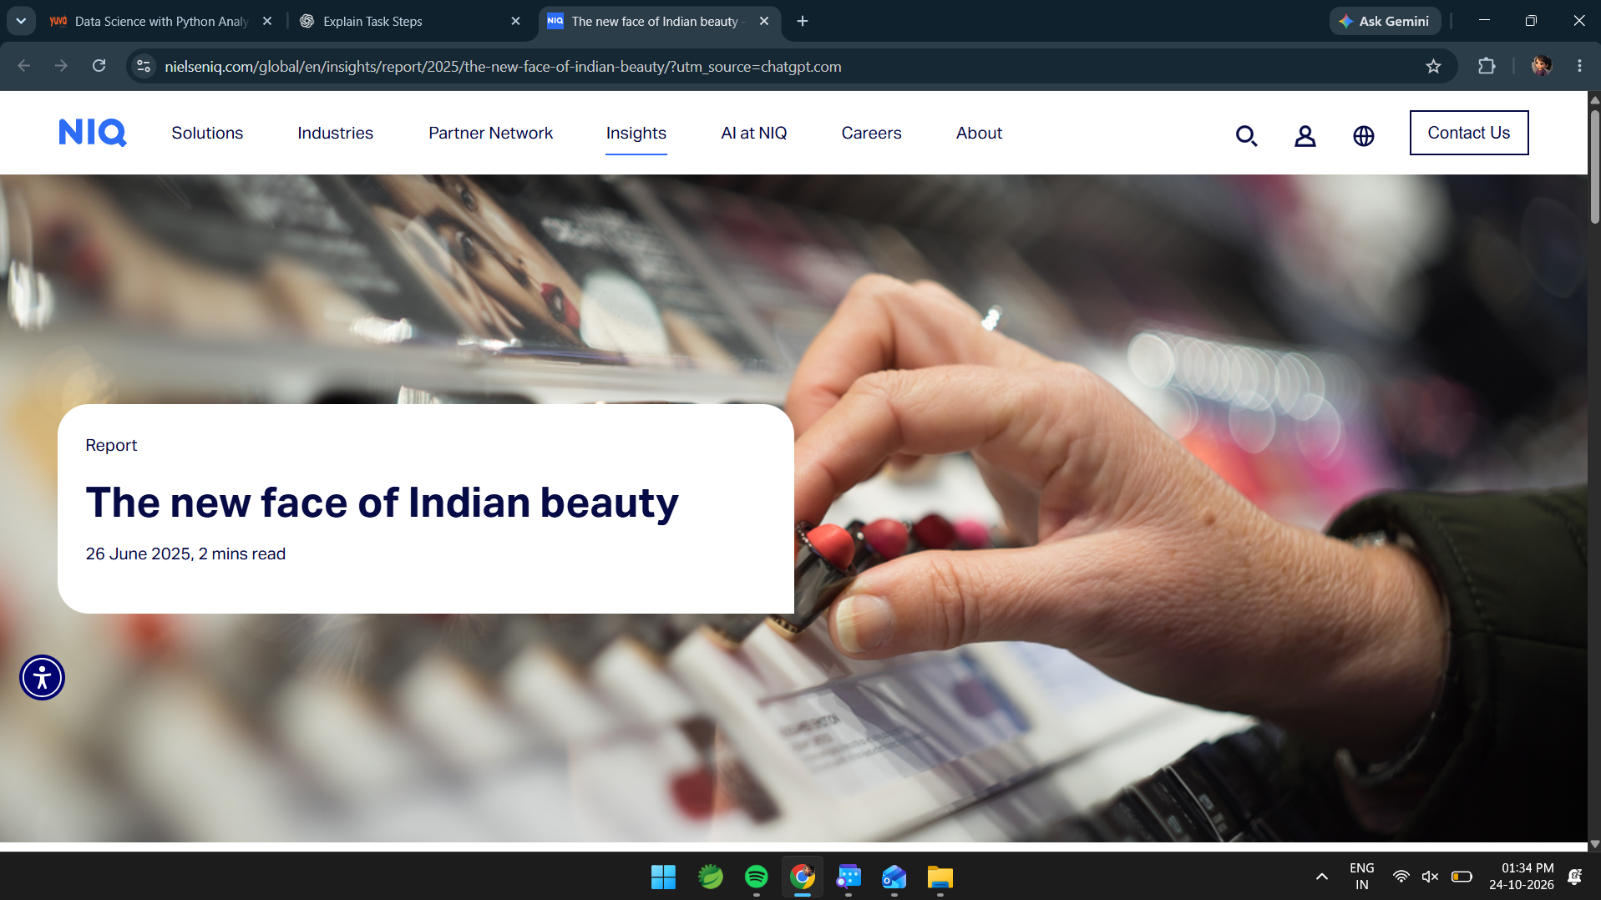
Figure 4. Student-supplied screenshot of NIQ’s “The Digital Makeover” webpage, showing its overview of online beauty shopping and digital discovery.
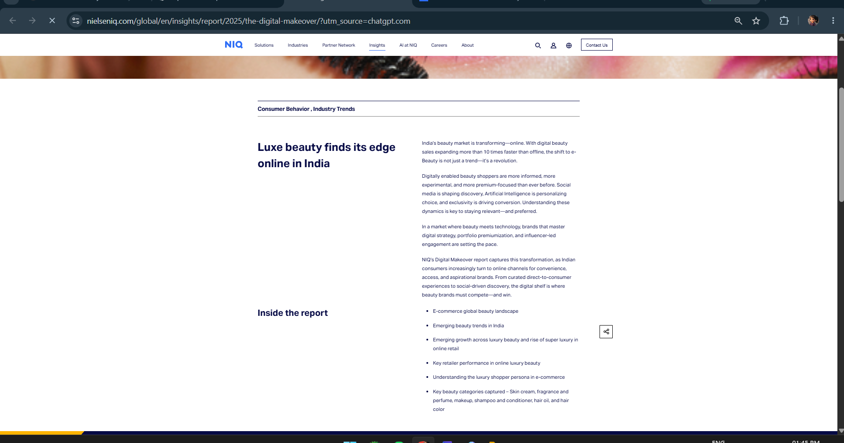
Figure 5. Student-supplied Kaggle dataset page showing the dataset title, description, and listed licence status.
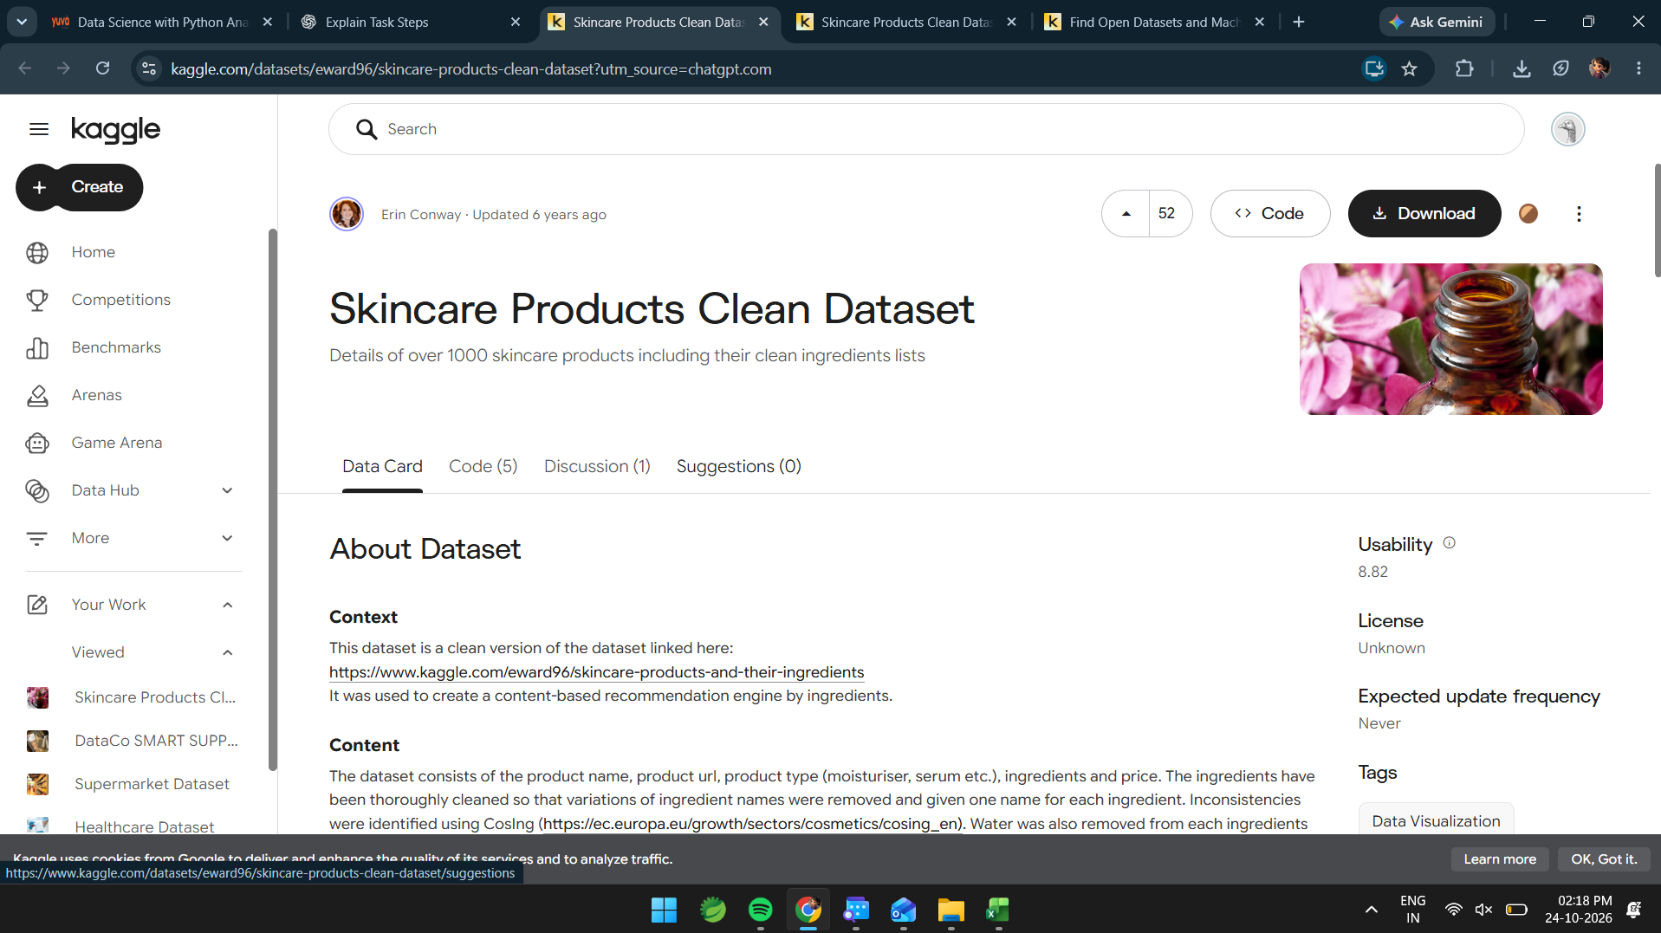
The dataset CSV itself was also supplied and inspected directly; the tables and charts in Section 8 are generated from that file.

15. Conclusion
The project establishes a practical beauty-industry problem focused on understanding skincare catalogue structure, listed price fields, and ingredient representation. Initial inspection of the supplied dataset confirms that it contains 1,138 product records and five fields, with no missing values in the original columns. Because the dataset lacks sales and customer-feedback outcomes and its licence is unknown, the conclusions are limited to descriptive catalogue analysis. Further work should verify the licence and currency consistency before extending the analysis.

References
- [1] NielsenIQ. (2025, June 26). “The new face of Indian beauty.” https://nielseniq.com/global/en/insights/report/2025/the-new-face-of-indian-beauty/
- [2] NielsenIQ. “The Digital Makeover” webpage. https://nielseniq.com/global/en/insights/report/2025/the-digital-makeover/ (accessed 24 October 2026).
- [3] Conway, E. “Skincare Products Clean Dataset.” Kaggle. https://www.kaggle.com/datasets/eward96/skincare-products-clean-dataset (accessed 24 October 2026; licence shown as Unknown on the page).

